A Machine Learning Approach for Tracking and Predicting Student Performance in Degree Programs
In this project in propose work we were predicting student performance as HIGH or LOW but not predicting based on performance which future course is suitable for him. So in extension work we changed dataset and algorithms prediction to predict not only student performance grade but also predict future suitable courses for him based on past performance.
SCREEN SHOTS
To run project double click on ‘run.bat’ file to get below output
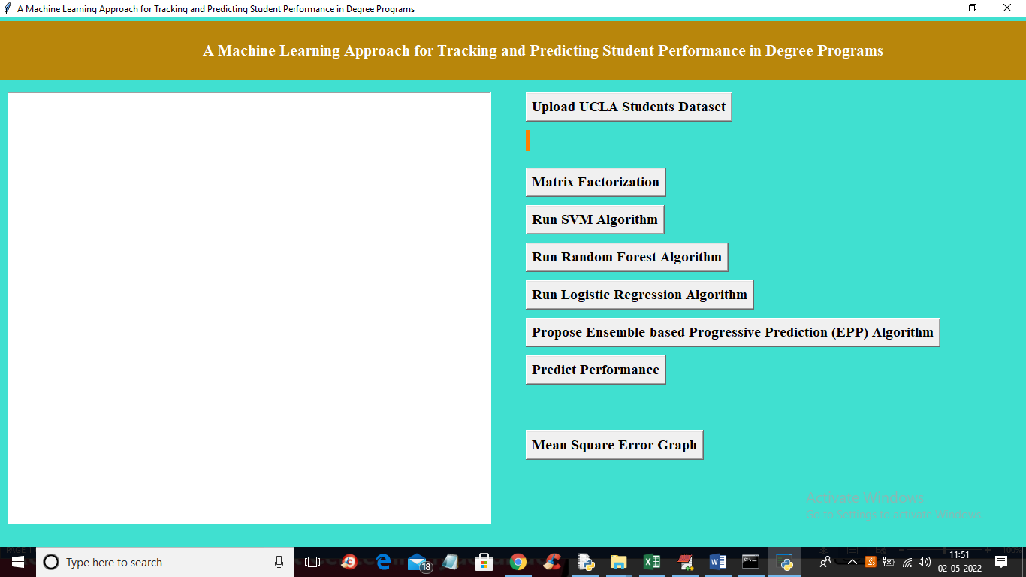
In above screen click on ‘Upload UCLA Students Dataset’ button to upload dataset and then run all buttons one by one and in “predict Performance’ button you need to upload ‘extension_new_test_records.csv’ file to predict student performance and future courses.
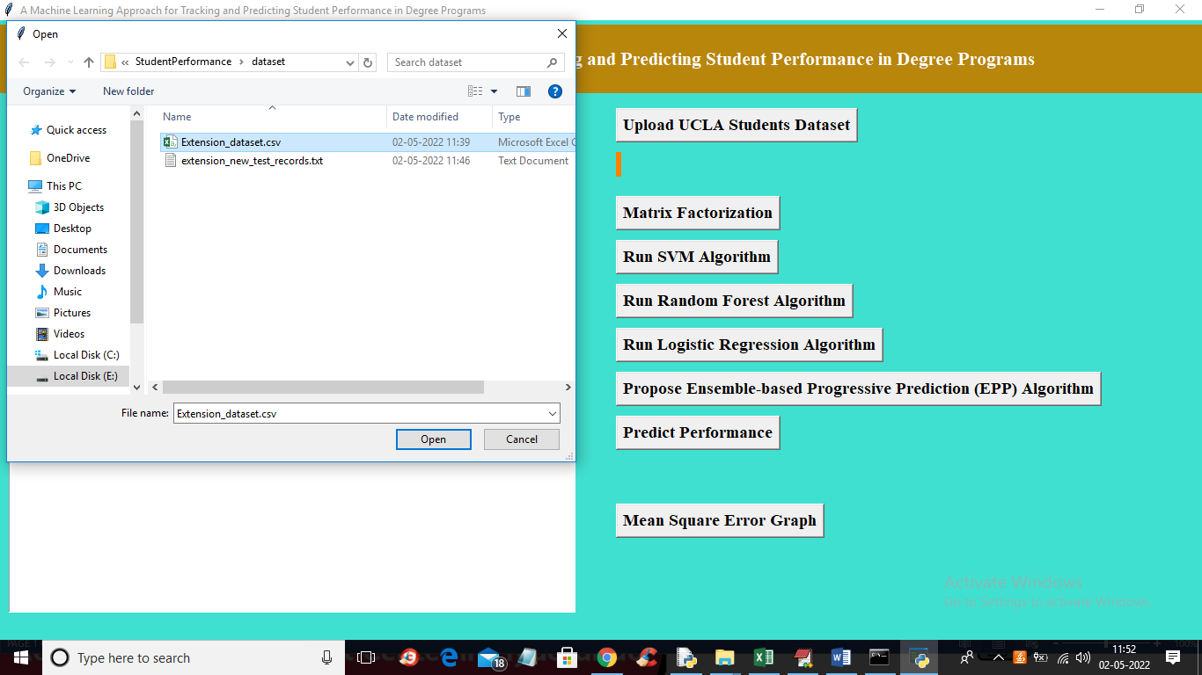
In above screen selecting and uploading ‘extension_dataset.csv’ file and then click ‘Open’ button to load dataset and run all buttons
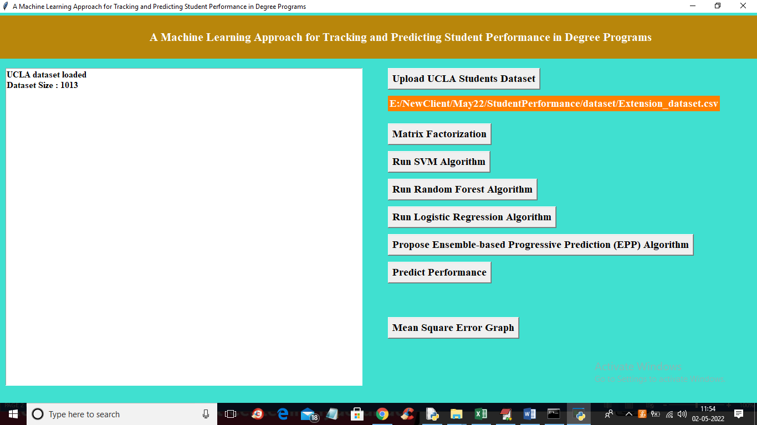
In above screen dataset loaded and now run all buttons
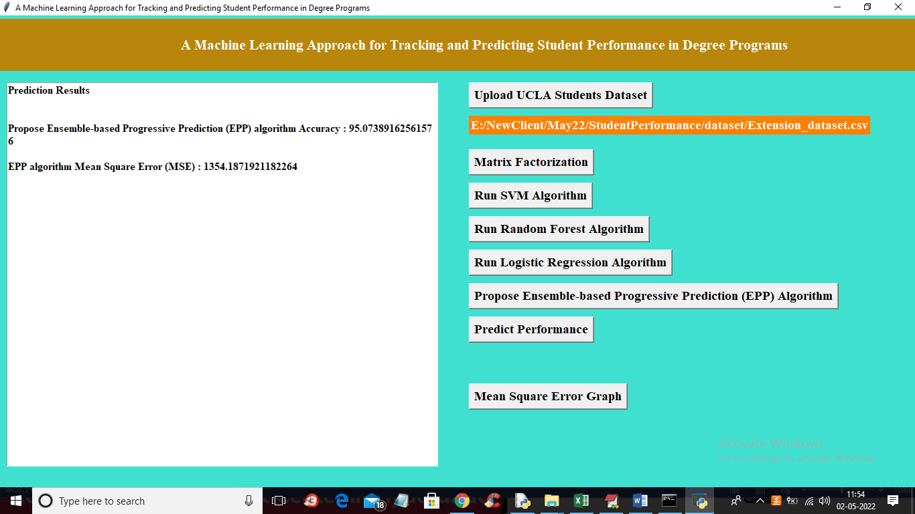
In above screen with propose EPP algorithm we got 95% accuracy and now click on ‘Predict Performance’ button to upload test data and get below output
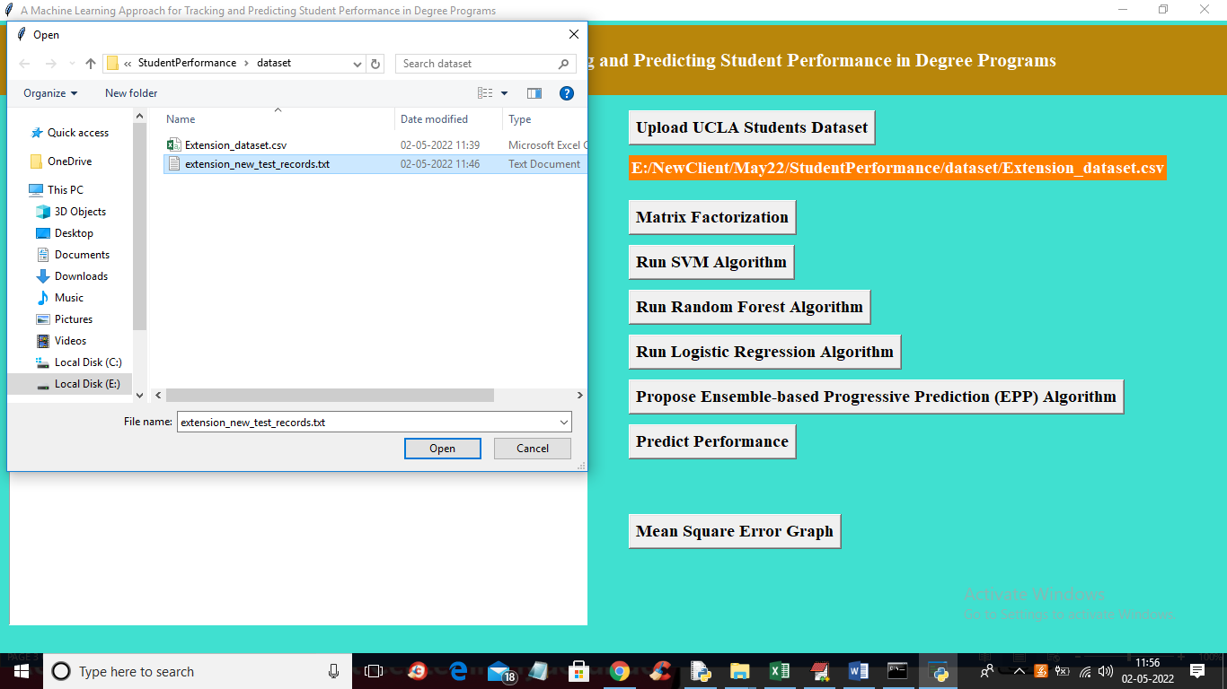
In above screen selecting and uploading ‘extension_new_test_record.txt’ file and then click on ‘Open’ button to get below output
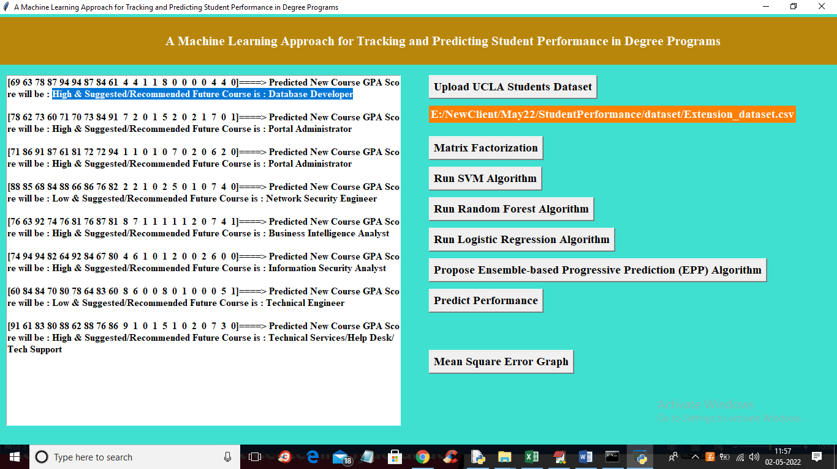
In above screen in square brackets we can see student performance data and after square bracket and arrow symbol we can see predicted performance as HIGH or LOW with recommended or suggested future course.
So by using extension works students not only predict grade but also can know their suitable future courses

