**CS460 Assignment4 Physically based Simulation**

**Ryan Kim**

**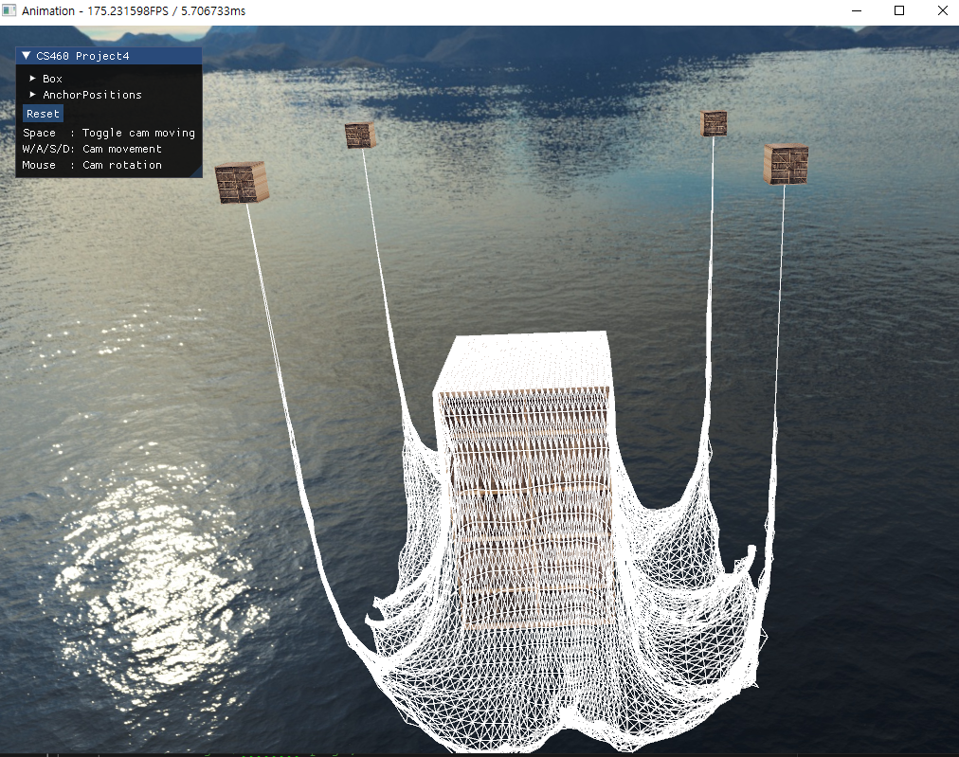  
Option C was implemented  
(900+ mass points and interaction with other object)**

**Description on algorithm implemented**

**In PhysicsSimlation.cpp,**

**InitializeSimulation ()**: Initialize massPoints with anchor positions, set offset between points with difference in x,z in anchor positions. After initializing massPoints, initialize springs with position of massPoints. Each springs owns 2 mass points.  
 **UpdateSimulation (dt, box):** Update simulation system.  
 **Draw (projViewMat):** Call simSystem draw(projViewMat)

**In MassSpringSystem.cpp,**

**AddSpring(), Addmass()** –Add spring, mass to vectors  
 **Update() –** Call update() in every mass and change spring’s positions in vector  
**Draw(projViewMat)** – Call glDrawArrays(point) for massPoints, call glDrawArrays(line) for springs.

**In Mass.cpp,**

**Update (dt, box)** – first, check collision with box, if this position was inside of box’s position + size, return immediately. If not, run physics simulation,

1. Calculate acceleration first, get fg ((0, -9.81, 0) / (mass / 2)).
2. Calculate fs, fd for linked springs. Accumulate every string force in fs, accumulate damping forces in fd  
   . 텍스트이(가) 표시된 사진

   자동 생성된 설명  
   and return total force.  
     
   For Springforce, apply HooksLaw.  
   텍스트이(가) 표시된 사진

   자동 생성된 설명  
   텍스트이(가) 표시된 사진

   자동 생성된 설명
3. For Dampingforce,   
   텍스트, 화면, 스크린샷이(가) 표시된 사진

   자동 생성된 설명
4. With this acceleration, we can calculate next position, I put this in CalcPosition () function.  
   텍스트이(가) 표시된 사진

   자동 생성된 설명
5. Render points / strings with this modified massPositions[]
6. For numerical accurate, I used Runge-Kutta 4th order numerical integration.  
   텍스트, 모니터, 화면, 스크린샷이(가) 표시된 사진

   자동 생성된 설명  
   Apply this method with velocity & next velocity (applied acceleration).

**Instructions on compiling running the executable**

Build instruction – Open visual studio with given .sln file in folder, press build or ‘F5’, there some warnings in the output, but it’s related with glm header files. When build is done, executable .exe file will be generated in Release folder.

Running executable – launch .exe file.

I will leave .exe file in Release folder for just in case.