DRAFT SPATIAL DECISION SUPPORT FOR DESERT TORTOISE RECOVERY:
A TOOL FOR EVALUATING RECOVERY ACTION EFFECTIVENESS

A. INTRODUCTION
The Desert Tortoise Recovery Office spatial decision support system identifies and prioritizes actions that are most likely to ameliorate threats to tortoise populations at any geographic extent (>1 square kilometer) within the tortoise’s range. To do this, the decision support system relies primarily on GIS data of the spatial extent of threats (i.e., where threats occur geographically) to calculate how changes in threats contribute to changes in tortoise population numbers. Initial data were compiled mostly through existing (published) sources and partly through consultation with field biologists and land managers. The decision support system also makes use of institutional understanding of recovery action-threat relationships (i.e., what are the most appropriate actions given a set of threats faced by the species?) and the relationship between threats and tortoise mortality (e.g., some threats are more deadly than others). Future versions of the decision support system may permit managers to conduct gap analysis on their current/planned recovery actions (i.e., compare ideal to current or planned management actions to identify gaps in management prescriptions for a given area) or to evaluate actions in terms of their near- vs. long-term contribution to recovery. The decision support system may also be used to develop prioritizations that account for economic, political, and operational constraints that managers face when implementing recovery. All data and underlying models will be updated and evaluated on a regular basis. The standard lexicon for biodiversity conservation as in Salafsky et al. (2008) is utilized in the system.

B. Decision Support System Road Map
This document describes the processing steps, data inputs, and the outputs of the decision support system for desert tortoise recovery management. The following flow chart diagram (Figure 1) illustrates the overall modeling process. It can be used as a “road map” to the text description that follows. While the diagram may seem complex, each component essentially represents a separate model, with its own scientific or management utility. Each model is leveraged on the previous to produce the overall assessment of risk (threat severity) to desert tortoise populations and management priorities to mitigate that risk. It is important to note that what is described here is a prototype system, which we are continually improving (Starfield and Bleloch 1991; Starfield 1997). Each model is transparent and can be evaluated and revised independently of the others as new information or better models become available. For example, at the time of publication of the revised recovery plan, several simple models describing the distribution of particular threats are being updated based on those published by Leu et al. (2008). In addition, sensitivity analyses still need to be conducted to determine the relative importance of different assumptions (e.g., relative impacts of threats to tortoise demography or relative effectiveness of recovery actions on abating threats) and to identify priorities for model improvement (Freick and Hall 2004; Malczewski 2006). A notable value of this prototype system is that the relative importance of the various components can be evaluated in light of the big picture (Nicholson et al. 2002). The steps and component models can be summarized as follows:

Spatial Threats: utilizes spatial data to represent where threats occur geographically

Stress to Population models
Threat-Stress Interaction Model: estimates the contribution of each threat to stress to the population
Relative Stress Model: estimates the contribution of each stress to overall population change
Demographic Impact Model: estimates contributions of each threat to overall demographic impacts

Models of the risk to tortoise populations on the ground (threat severity)
Single Risk/Threat Model: combines degrees of threat with stress/demographic impact to estimate severity of each threat to the population
Pre-action Aggregate Risk Model: estimates the aggregate measure of the risk/severity posed to the population by all threats

Recovery action models
Recovery Action Effectiveness Model: estimates the effectiveness of recovery actions in mitigating threats
Recovery Action Risk Reduction Model: combines the estimated risk to populations with recovery action effectiveness to estimate the reduction in risk/threat severity
Post-action Aggregate Risk Model: estimates the aggregate measure of the risk/threat severity posed to the population by all threats after management actions are applied

Spatial Summary/Prioritization: prioritizes recovery actions by their estimated effectiveness in risk reduction

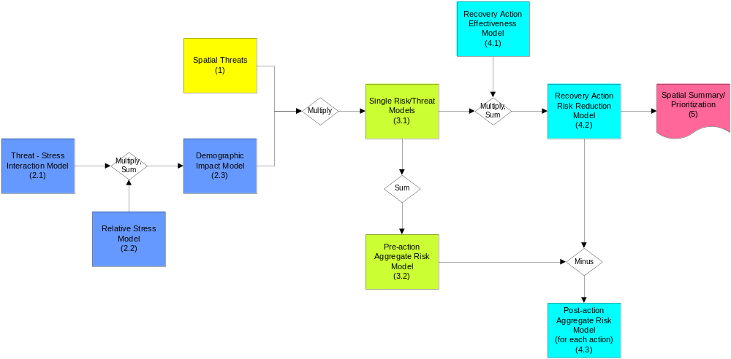

Figure 1. Flowchart illustrating the decision support system for desert tortoise recovery. The numbers in the boxes refer to section numbers in the text.
- Compile and Evaluate Spatial Threats Data
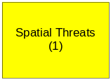
The Spatial Threats Model utilizes GIS data of the spatial extent of threats. For each threat, GIS layers from multiple sources illustrating where threats occur geographically were integrated into a single layer. Initial sources of threat data included previously published datasets and outputs of published models and mosaic datasets verified by local biologists and managers. These data will be updated by Recovery Implementation Teams as new information becomes available.

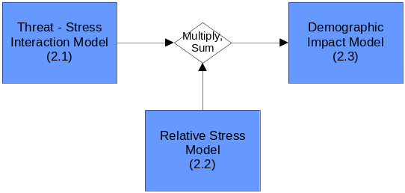Estimate Contribution of Each Threat to Overall Demographic Impact
Even though very little is known about the demographic impacts of individual threats on desert tortoise populations or the relative contributions each threat makes to population numbers (Boarman 2002; Tracy et al. 2004), we must still estimate the relative impact of the various threats to tortoise populations. This involves rating the ‘severity’ of each threat with regard to tortoise demography and is accomplished by combining two submodels: 1) the Threat-Stress Interaction Model, which estimates the contribution of each threat to population stresses, and 2) the Relative Stress Model, which estimates the contribution of each population stress to overall change in tortoise population numbers.
2.1 Estimate the contribution of each threat to stress
The Threat-Stress Interaction Model uses conceptual models of the interrelationships of threats and stresses and a threat interaction survey. This survey is intended to assist in analyzing the extent to which various potential threats interact with each other and how they contribute to stresses to the tortoise population. Survey responses relate to range-wide (or recovery unit-wide) threat conditions and are not specific to more localized areas. In the prototype system, data from 35 respondents from the tortoise science and management community were available at the time of decision support system development. In the survey, respondents were asked to rate the effect of individual threats on individual stresses (Figure 2).

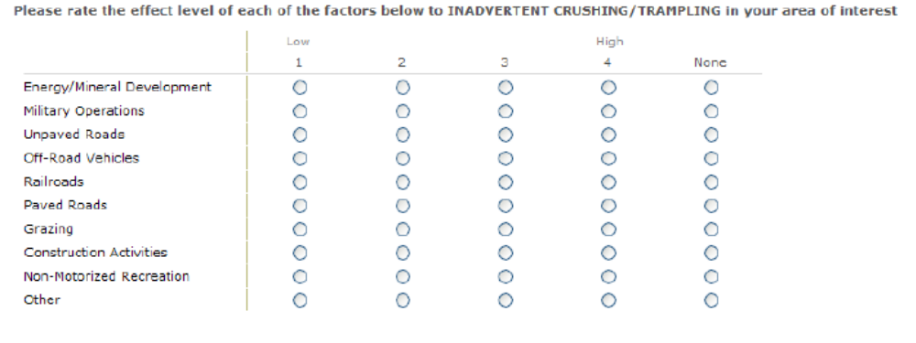
Figure 2. The threats interaction survey asked respondents to rate the influence of threats on populations stresses on a scale of 1 (low) – 4 (high). These ratings were used to derive a rating for each threat’s contribution to overall population change.

Using the conceptual models and survey responses, an average contribution of each threat to overall population change can be calculated. When determining a threat’s contribution to a stress, both direct and indirect threat contributions were considered, as illustrated in Figure 3. Indirect contributions are links between threats that lead to a stress.

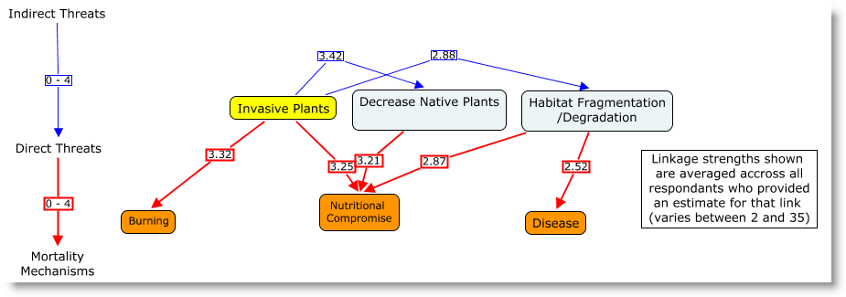
Figure 3. Illustration of how direct and indirect threats contribute to stresses from the perspective of the threat, Invasive Plants. Yellow = threat; Light blue = indirect threat; Orange = stress.

2.2 Estimate the contribution of stresses to overall change in population
In the Relative Stress Model, each stress was assigned a weight that described its significance relative to its demographic impact, as per our conceptual models of threat-stress relationships. For this iteration of the system, we are considering only two age classes: pre-reproductive and reproductive. And we are considering only two demographic factors, death rate and birth rate (reproductive output). Immigration and emigration rates will be considered in future versions of the system. To generate these weights, the contribution of each stress to the demographic impact was weighted on a significance scale, which resulted in an overall set of relative weights for each stress to the populations (Table 1). Note that these same weights could be replaced with quantitative data from future research to provide more reliable results. The relative contribution of each demographic factor (change in birth rate, pre-reproductive death rate, and reproductive death rate) to overall population change was determined by assessing outputs of population viability analyses (Reed et al. 2009).
Table 1. Example estimated relative contributions of stresses to increased mortality or decreased birth rate.
Stress | Contribution to Morality of Reproductives (%) | Contribution to Morality of  Pre-reproductives (%) | Contribution to Decrease in Birth Rate (%)
Permanent Habitat Loss | 32 | 15 | 17
Inadvertent crushing/trampling | 17 | 12 | 3
Predation | 8 | 30 | 2
Dehydration | 7 | 10 | 27
Disease | 7 | 5 | 15
Nutritional compromise | 4 | 10 | 30

2.3 Calculate the contribution of each threat to overall change in population
This step produces the Demographic Impact Model by combining the results from the previous steps to derive an overall weighted score for each threat. That score describes the contribution of a single threat to overall tortoise mortality. Table 2 illustrates how each factor was combined to produce the overall score for each threat.

Table 2. Illustration of how overall threat contribution to change in population numbers is calculated.
Single Threat | Contribution to Mortality of Reproductives | Stress | Contribution of Stress to Population Change | Overall Contribution of Threat to Population Change
Invasive Plants | 20.61% | Burning | 9% | 20.61% x 9% = 1.86%
Invasive Plants | 16.93% | Nutritional Compromise | 4% | 16.93% x 4%= 0.68%
Invasive Plants | 1.72% | Disease | 7% | 1.72% x 7% = 0.02%
Total Estimated Contribution of Invasive Plants to Desert Tortoise Mortality 2.56%

- Model Risk to Populations

Combine Degree of Threat with Population Change Factor to Estimate Threat Severity
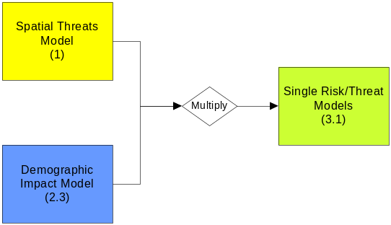This step creates the Single Risk/Threat Model by combining the measures of degree of threat described in Section 2 with the threat contribution to population change in Section 3. This step yields a severity rating for each threat to desert tortoise populations within a geographic area of interest (e.g., recovery unit). The rating represents both degree of threat (intensity and frequency) and the risk to population associated with that threat, as calculated in the previous step.

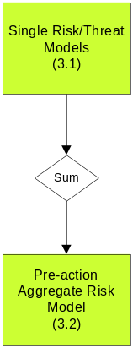 Estimate Aggregate Threat Severity
This step provides a synopsis of threats across the tortoises’ range. It is a GIS processing step that involves summing each threat layer using the severity ratings developed in the previous step (3.1). The output is an aggregate rating of threat severity (risk) posed to the desert tortoise, reported at the spatial unit of 1 square kilometer (Figure 4).

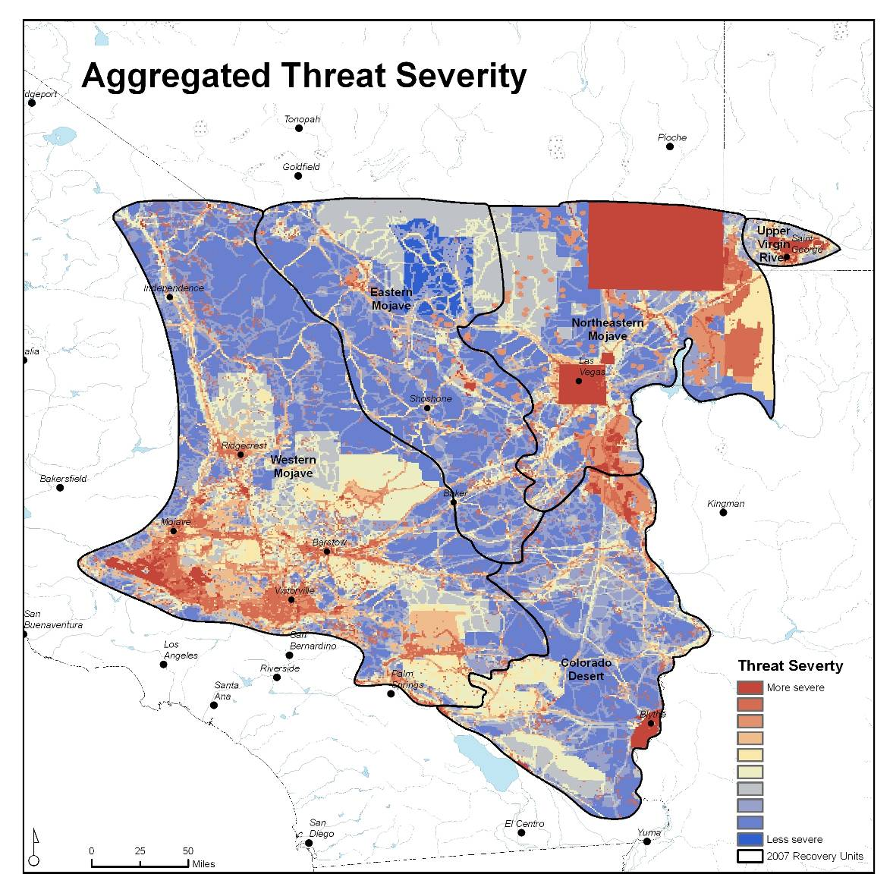
Figure 4. Example of aggregated severity of threats across the range of the Mojave population of the desert tortoise. Warmer colors indicate greater severity of threats to the tortoise. Note that this representation is preliminary and is based on incomplete data and provisional underlying models.

Estimate Effects of Recovery Actions

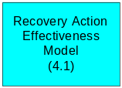 Effectiveness of Action on Threat
The Recovery Action Effectiveness Model relates recovery actions to the threats they address, as per our conceptual models of recovery action-threat-stress relationships. Relationships between recovery actions and threats were rated on a scale of high, medium, and low, with manager input during recovery planning workshops. A ranking of high meant that the action was well suited to addressing a particular threat; “not applicable,” indicated no relationship between an action and a threat. Table 3 illustrates the results of that exercise. A more thorough quantification of these relationships will provide more reliable results as the model assessment process proceeds.

Table 3. Land managers rated the strength of relationships between recovery actions and threats in terms of effectiveness using a HIGH (3) to LOW (1) scale.
Recovery Actions | Threats
Recovery Actions | Agriculture | Air Pollution | Captive Releases | Collection | Designated OHV Areas | Disease
Close Roads |  | 1 | 3 | 1.5 |  | 1
Connect Functional Habitat |  |  |  |  |  | 1
Control Ravens
Route restoration |  | 1 |  | 1.5 | 2 | 1
Environmental Education | 3 | 1 | 2.67 | 2.25 | 2.5 | 1.5
Fence Roads |  |  | 1 | 3 |  | 1

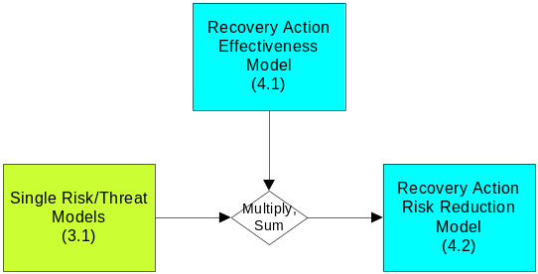 Threat Severity (Risk) Reduction as a Result of an Action

The Recovery Action Risk Reduction Model combines the threat severity (risk) before an action (calculated in 3.1) with the effectiveness of that action on a given threat. The result of this calculation yields an estimated reduction of a threat as a result of an action or suite of actions. Figure 5 illustrates this calculation.
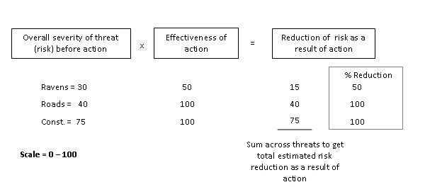
Figure 5. Illustrative example of how the reduction in risk as a result of an action is calculated. Effectiveness of action is expressed as a percentage.

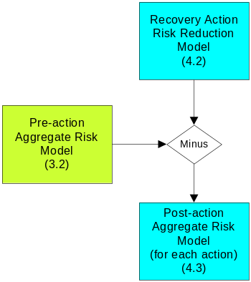 Estimate Aggregate Measure of the Risk Posed to the Population by All Threats After Recovery Actions are Implemented

This step provides a synoptic view of remaining threat risk across the tortoises’ range after individual recovery actions are implemented. It is a GIS processing step that involves subtracting the estimated reduction of a threat as a result of an action (4.2) from the aggregate risk model produced in 3.2. The output is a visual representation of the aggregate rating of threat (risk) posed to desert tortoise reported at the spatial unit of 1 square kilometer across the tortoises’ range (Figure 6).

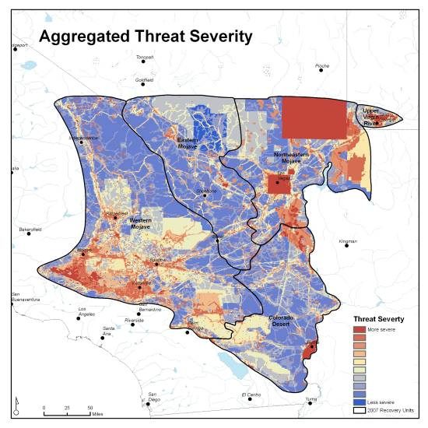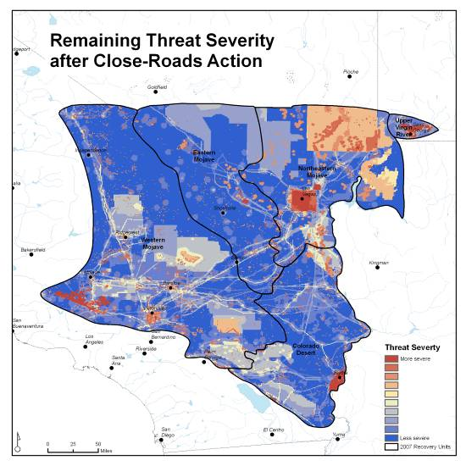
Figure 6. Expected risk reduction as a result of the hypothetical action of closing roads across the range of the desert tortoise. The left map represents the aggregate threat severity (risk) from Figure 4, and the right map represents post-action threat severity (risk) as a result of the hypothetical action of closing all roads. Warmer colors indicate greater risk to the tortoise. Note that this representation is hypothetical, preliminary, and based on incomplete data and provisional underlying models.

- 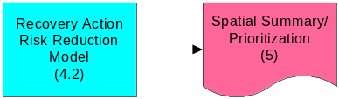Prioritize Recovery Actions
When the estimated risk reduction is calculated for all possible actions within a given area, these can then be prioritized according to total risk reduction, as illustrated in Table 4.

Table 4. Highest and lowest ranked recovery actions by risk reduction estimated by the prototype decision support system for the Upper Virgin River (UVR) Recovery Unit.
ACTION | Risk reduction estimates for UVR | RANK
Law Enforcement | 5.51 | 1
Fence Roads | 4.75 | 2
Environmental Education | 4.58 | 3
: | : | :
Manage Burros/Horses | 0.01 | 16
Install Railroad Barriers | 0.00 | 17
Remove Toxicants / Unexploded Ordnance | 0.00 | 18

- Potential Alternative Applications of the decision support system
There are several alternative uses of the decision support system that may be worthwhile at an operational level by land managers. Following is a partial description.

Conduct GAP Analysis of Existing Management Actions
The decision support system can be used to compare the effects of a variety of management actions on threats in any geographic unit. Specifically, the prioritized list and maps of recovery actions produced by the decision support system can be compared to existing management actions to identify gaps in management prescriptions for a given area.

Comparing Actions with Near- And Long-Term Implications for Recovery
In its current state, the prototype decision support system prioritizes actions that would lead to decreases in tortoise population declines, in terms of mortality and reproductive output. In some cases, however, it may be advantageous to prioritize actions based on effect on habitat, since habitat response is generally considered to be observable in shorter time periods than tortoise population effects. In effect, this type of assessment would guide managers toward actions for which the effects can be observed earli er in the recovery process. These results may be compared to the mortality-based assessment to identify how well actions rate according to both habitat and population effects.

Land Manager Prioritization Model
The outputs of this model can be customized to help land managers develop their own prioritizations. This application may be used for ‘if-then’ scenarios where land managers want to envision the amount of threat reduction they might expect to see when an action is implemented only partially. For example, a land manager may use this feature to see how much he/she can reduce the threat of invasive species by removing 50 percent of invasive plants from an area rather than 100 percent of them. This type of calculation can be associated with implementation cost (i.e., how much will a $15,000 investment in weed control reduce the threat of invasive species in a given area?) and other management-related factors. This would incorporate management constraints (e.g., budget, available personnel, degree of controversy) into the overall recovery action recommendations. Including implementation effort, which would affect the recommended actions, land managers could input their own actions, rate their effectiveness, weight their own mortality mechanisms and threat contributions, and run the model to get customized outputs of risk reduction.

Literature Cited

Boarman, W.I. 2002. Threats to desert tortoise populations: A critical review of the literature. U.S. Geological Survey, Western Ecological Research Center, Sacramento, California.
Feick, R., and B. Hall. 2004. A method for examining the spatial dimension of multi-criteria weight sensitivity. International Journal of Geographic Information Science 18:815-840.
Leu, M., S.E. Hanser, and S.T. Knick. 2008. The human footprint in the West: a large-scale analysis of anthropogenic impacts. Ecological Applications 18:1119-1139.
Malczewski J. 2006. GIS-based multicriteria decision analysis: a survey of the literature. International Journal of Geographical Information Science 20:249-268.
Nicolson, C.R., A.M. Starfield, G.P. Kofinas, and J.A. Kruse. 2002. Ten heuristics for interdisciplinary modeling projects. Ecosystems 5:376-384.
Reed, J. M., N. Fefferman, and R. C. Averill-Murray. 2009. Vital rate sensitivity analysis as a tool for assessing management actions for the desert tortoise. Biological Conservation 142:2710-2717.
Salafsky, N., D. Salzer, A.J. Stattersfield, C. Hilton-Taylor, R. Neugarten, S.H. Butchart, B. Collen, N. Cox, L.L. Master, S. O’Connor, and D. Wilkie. A standard lexicon for biodiversity conservation: unified classifications of threats and actions. Conservation Biology 22: 897-911.
Starfield, A.M. 1997. A pragmatic approach to modeling for wildlife management. Journal of Wildlife Management 61:261-270.
Starfield, A.M., and A.L. Bleloch. 1991. Building models for conservation and wildlife management. Interaction Book Company, Edina, Minnesota.
Tracy, C.R., R.C. Averill-Murray, W.I. Boarman, D. Delehanty, J.S. Heaton, E.D. McCoy, D.J. Morafka, K.E. Nussear, B.E. Hagerty, and P.A. Medica. 2004. Desert Tortoise Recovery Plan Assessment. Report to the U.S. Fish and Wildlife Service, Reno, Nevada.

