Conceptual Modeling for Spatial Decision Support
Another 12-step process
Goal: Isolate and define the paths by which 1) threats impact population numbers, and 2) conservation actions impact target species. These paths can then be quantified with interaction strengths to model threat severity.
- Create a list of known threats to the species (compiled from all available information including but not limited to the listing package, recovery plan, 5-year review, biological opinions, scientific publications, etc).
  - When developing a list of threats, begin with Salafsky et al.(2008)’s list and definitions. Take time to create a comprehensive list.
  - In general, you will eventually want a spatial data layer for each threat you identify.
- Pick one threat from your list (this threat becomes your first focal threat). It is helpful to start with a high-level land-use threat, such as “Urbanization.” Place your focal threat in the center of you diagram.
- Using Salafsky et al. (2008), define exactly what your focal threat means to you. For example,
From Salafsky et al.: 1st level threat: Residential and commercial development: human settlements or other nonagricultural land uses with a substantial footprint.
Under this 1st level threat, we included our focal threat “Urbanization/Human Development:” Urban and suburban development and associated infrastructure; NLCD data include developed/urban landscapes from high density, entirely impervious surfaces, to areas of single family homes, to golf courses.
If you know what spatial data you will be using to analyze the extent of the focal threat, it is often useful to include this in the definition of the threat.
- Using your list of threats, identify any of threats that occur as a result of your focal threat. These are your corollary threats. For example, both urbanization and paved roads are threats to the desert tortoise. Paved roads are one result of urbanization. Thus, when urbanization is your focal threat, paved roads will be identified as a corollary threat. Each of your corollary threats will have its turn as a focal threat.
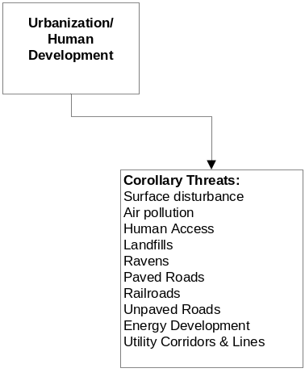
Figure 1. The focal threat is “Urbanization/Human Development.” Those threats which occur as a result of the focal threat are listed as “Corollary Threats.”
  - When building links between focal and corollary threats (or threats to stresses as in step 6), keep in mind that these connections are the paths that will later carry the interaction strengths. Thus, take care to differentiate the focal from corollary threats.
- It is useful to document the information that you used to determine your focal threat’s corollary threats, including citations where appropriate. For example:
Threat: Urbanization/Human Development
Corollary Threats
Surface disturbance
Disruption or removal of natural surface soil and vegetation within desert tortoise habitat is often a result of urbanization and human development (USFWS 1990, 1994, 2010; Boarman 2002).
Air pollution
Increased levels of atmospheric pollution and nitrogen deposition related to increased human presence and combustion of fossil fuels can cause increased levels of soil nitrogen, which in turn may result in significant changes in plant communities (Aber et al. 1989)
Human Access
Human development provides the ability to enter, approach, or pass to and from otherwise remote regions of desert tortoise habitat, which facilitates both authorized and unauthorized land uses that may negatively affect desert tortoises and their habitats.
Landfills
Human developments often include landfills.
Ravens
Human settlements in the desert result in increased infrastructure and subsidies for ravens (USFWS 1994, Boarman 2002).
Railroads
Human settlements result in the proliferation of railroads to transport people and goods.
Paved Roads
Urbanization results in the proliferation of paved access roads to transport people and goods.
Unpaved Roads
Urbanization result in the proliferation of unpaved access roads to transport people and goods.
Energy development
Renewable energy development is a high priority and is being pursued as a means to combat global climate change, ensure energy independence in the US, and accommodate an increasing human population. The vast majority of development is expected to occur in the desert southwest where solar and wind resources are abundant.
Utility Corridors & Lines
Human development is coupled with an increased need for power resulting in utility lines and corridors (USFWS 1994, Boarman 2002).
- Focus again on your focal threat. Identify the stresses (Salafsky et al. 2008) to your population that occur as a direct result of the focal threat (Figure 2). It is important at this stage to remember that you are thinking only of the stresses which result from the focal threat, and not from the corollary threats. Each corollary threat will have its own turn as the focal threat. We identified which demographic parameter of the desert tortoise is affected by each stress (B: birth rate; D: death rate; E: emigration rate; I: immigration rates).
  - When building links between focal and corollary threats (or threats to stresses as in step 6), keep in mind that these connections are the paths that will later carry the interaction strengths. Thus, take care to develop stresses only for the focal, not the corollary threat so that you have clearly identified the paths by which actions can impact the target your species. This is required at a minimum to have a currency for prioritizing actions, developing connections with monitoring, and reducing uncertainty.

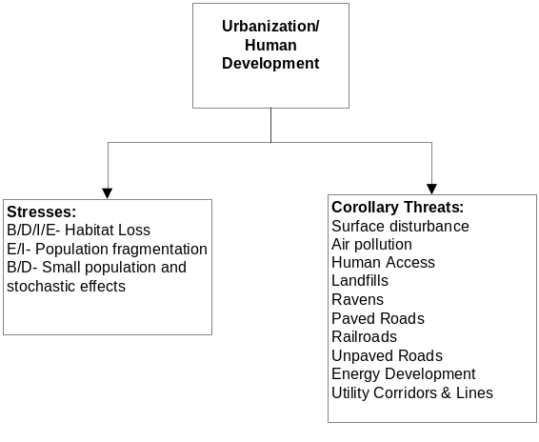
Figure 2. The focal threat is “Urbanization/Human Development.” Stresses to the population that occur as a direct result of the focal threat only (not the corollary threats) are identified.
- It is useful to document the information that you used to determine the stresses to your species which are a direct your focal threat, including citations where appropriate. For example:
Threat: Urbanization/Human Development
Stresses
B/D/I/E- Habitat Loss
Urbanization and human development pose a threat to desert tortoises through habitat loss and fragmentation (USFWS 1990; Boarman 2002).
E/I- Population fragmentation
Urban areas form barriers to movement and tend to create small, local populations which are much more susceptible to extinction than large, connected populations (Wilcox and Murphy 1985). Impacts of population fragmentation on loss of genetic diversity, inbreeding depression, and increased extinction risk depend on the level of gene flow that is lost among the fragments (Frankham et al. 2004)
B/D- Small population and stochastic effects
Human-related factors often reduce populations to sizes where species are susceptible to stochastic, or accidental, effects. Reduced population sizes are more likely to be extirpated by chance events. Environmental and demographic stochasticity and the impact of catastrophes interact with genetic diversity in their adverse effects on populations. If populations become small, they become more inbred, further reducing population size and increasing inbreeding. At the same time, smaller populations lose genetic variation and consequently are less able to adapt to changing environments and more susceptible to catastrophic effects of stochasticity creating a feedback loop of increased risk of extinction (Frankham et al. 2004).
- Define your identified stresses in the context of Salafsky et al. (2008). For example,
From Salafsky et al.’s deconstruction of stresses--2. Species stresses: stresses that affect specific species or guilds/groups of species; then 2.2 species disturbance: direct damage to a species
Under 2.2, we included our definition of the species stress Habitat Loss: “Habitat loss: Land area subject to the complete or absolute removal of elements necessary for desert tortoise occupation (i.e., grading or paving of the landscape, removing all feeding, sheltering or breeding resources) or that falls below other identified thresholds of habitat quality required to support desert tortoises.”
- Next, identify any recovery actions/implementation activities (e.g. conservation actions as in Salafsky et al. 2008) that can address the stresses which directly result from your focal threat. For example, the stresses to the population caused by urbanization can be addressed or ameliorated by the recovery actions: 1) land acquisition and/or 2) protect intact habitat.
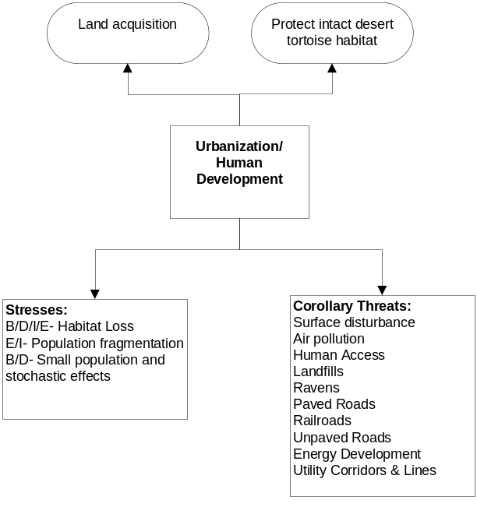
Figure 3. The focal threat is “Urbanization/Human Development.” Recovery actions which can ameliorate the stresses to the population that occur as a direct result of the focal threat only are identified.
- It is useful to document the information that you used to determine the recovery actions which can ameliorate the identified stresses. For example:
Threat: Urbanization/Human Development
Recovery Actions
Land acquisition (2.9)
Land acquisition can counter permanent habitat loss, protects tortoises, and/or can serve as corridors or buffers to decrease fragmentation effects. Acquisitions should be conducted in a strategic manner that targets acquisition of lands that would connect functional habitats or improve management capabilities of surrounding areas.
Protect intact desert tortoise habitat (2.1)
The preclusion of land disturbances within tortoise conservation areas, such as disturbances caused by development, off-highway-vehicle use, overgrazing by domestic livestock, increased fire frequency, new roads, and other surface disturbing activities can prevent or mitigate the effects of permanent or temporary habitat loss.
- Next, define your individual recovery action in the context of Salafsky et al. (2008)’s conservation actions.
From Salafsky et al.’s deconstruction of conservation actions-- 1. Land/water protection: actions to identify, establish or expand parks and other legally protected areas, and to protect resource rights; then 1.1 site/area protection: establishing or expanding public or private parks, reserves, and other protected areas roughly equivalent to IUCN categories I-VI
Under 1.1, we included our definition of the recovery action Protect intact desert tortoise habitat: “1.1.1. Protect intact desert tortoise habitat: Preclude land disturbances within tortoise conservation areas, such as disturbances caused by development, off-highway-vehicle use, overgrazing by domestic livestock, increased fire frequency, new roads, and other surface disturbing activities can prevent or mitigate the effects of permanent or temporary habitat loss.”

- Now can be a good time in the conceptual modeling process to identify the monitoring metric that would be most appropriate for determining 1) whether a recovery action was implemented; and 2) whether a recovery action was effective. It is useful to identify both an implementation and effectiveness measure for each recovery action. These metrics can be associated with the link between the recovery action and the focal threat itself or the recovery action and the stress to the population. For example:
Threat: Urbanization/Human Development
Monitoring metrics
Land acquisition (2.9)
Implementation metric-number of hectares/acres acquired to counter desert tortoise habitat loss and fragmentation to urbanization
Effectiveness metric- What would be the effectiveness metric? What would we measure to determine if land acquisition was effectively ameliorating the effects of habitat loss, pop fragmentation, and stochastic effects associated with urbanization?
Protect intact desert tortoise habitat (2.1)
Implementation metric- number of hectares/acres protected to ameliorate desert tortoise habitat loss and fragmentation due to urbanization.
Effectiveness metric- What would be the effectiveness metric? What would we measure to determine if land that was protected was effectively ameliorating the effects of habitat loss, pop fragmentation, and stochastic effects associated with urbanization?

You have now completed a conceptual model of your focal threat. Next, revisit your list of threats and complete this process giving each of your threats its turn as the focal threat. The result of this process will be an inter-connected web of threats to your species, with each threat’s stresses to the population and appropriate recovery actions identified.

