Malaysian-Japan International Institute of Technology

SECP1513 : TECHNOLOGY AND INFORMATION SYSTEM

ASSIGNMENT 1 - DESIGN THINKING

BIG DATA AND ARTIFICIAL INTELLIGENT NEW INNOVATION, CAREERHUB

Group BBG

Lecturer Name: Dr. Halinawati Hirol

|  |  |
| --- | --- |
| Name | Matric number |
| Salma Annis binti Abdul Rahman | A23MJ8005 |
| Nur Uzma Umaira Binti Awang Harisfadillah | A23MJ8025 |
| Muhammad Nabil Danish bin Ahmad  Khir | A23MJ8007 |
| Muhammad Syafi bin Mohd Fauzi | A23MJ8016 |
| Muhammad Hadi Bin Ab Llah | A24MJ5011 |
| Adam Iskandar Bin Mazlan | A23MJ8056 |

Contents

1.0 Introduction 3

2.0 Detailed Step and Description of Design Thinking 3

2.1 Phase 1 – Empathise 4

2.2 Phase 2 – Define 4

2.3 Phase 3 - Ideate 4

2.3 Phase 4 – Prototype 6

2.5 Phase 5 – Test 6

3.0 Description of Problem, Solution and Teamwork 6

3.1 Problem Description 7

3.2 Solution Description 7

3.3 Team Individual Self-reflection 7

3.4 Teamwork Description 9

4.0 Design Thinking Evidence – Appendix 10

4.1 Empathise Questionnaires 10

4.2 Define – User Need Statement 10

4.3 Ideate – Meeting Proof 10

4.4 Prototype UI 11

4.5 Test – User Reviews 11

**Table of Figures**

Figure 1 Website initial sketch 6

Figure 2 group meeting photo 11

Figure 3 Website UI 12

# 1.0 Introduction

In the modern age of transformation where Big Data and Artificial Intelligence (AI) are transforming industries by enabling organisations to make decision based on data and innovate at unprecedented pace. Big data refers to the vast amount of structured and unstructured data generated daily while AI will use the data to mimic human intelligence and solve daily or complex problems. Together, they play a crucial role in various fields of healthcare, finance, education and many more. The combination of these two technologies gives the user an opportunity for a seamless user experience that is more accurate and efficient.

This report focuses on the topic of using Design Thinking to tackle a real-life issue by leveraging Big Data and AI. Design Thinking is a human centred approach that fosters creativity and collaboration to develop effective solutions by applying it’s 5 phases of empathy, define, ideate, prototype and test. The aim of this method is to understand user needs deeply and then identify the requirements in order to create the solutions or system that address the effectively.

The objective of this report is to create an AI and Big Data powered career guidance tool that helps individuals to make decision on their career. The development of this solution is approached using Design Thinking method. In order to accomplished this, the use of 5 phase such as:

1. Empathize with target user to understand their requirements
2. Define the core problem based on user requirements
3. Ideate potential solutions through brainstorming and collaboration
4. Prototype a functional tool
5. Test the solution with users to gather feedback and improve it’s effectiveness

Through this report, our group aims to demonstrate how Big Data and AI can be harnessed to solve meaningful problems and provide lasting values to users.

# 2.0 Detailed Step and Description of Design Thinking

The Design Thinking Process is a systematic approach to ensure a human centred solutions to problems. For this project, we adopted the 5 phases of Empathize, Define, Ideate, Prototype and Test to design an AI and Big Data powered career decision maker website.

## 2.1 Phase 1 – Empathise

The Empathise phase is the initial part of the Design Thinking process that involves researching and understanding user behaviour. This project aims to provide user a personalized career guidance tool

Steps Taken:

1. Target Audience Identification

Primary User: Young adults aged from 18 – 25 looking for their future career.

1. User Research

* Conducted online research through various social platform such as Threads, Instagram, X and TikTok.
* Findings: Users require an easily navigated and free website to finds out the suitable career for them based on interest, personality and education background.

## 2.2 Phase 2 – Define

The Define phase involves analysing the issues to define the core problems. This involves synthesizing observations to articulate user need and challenges clearly to create an accurate problem statement. This phase will ensure the team is able to focuses on creating the actual solution to user requirements.

Steps Taken:

1. Key Problems

* User needs a personalized website to help them make a decision on their future career

1. Solution Goals

* Design an advanced AI-driven and Big Data powered website that acts as a personalized career architect. Users will input details such as their personality traits, interests, and educational background. The website will then analyse this information to generate a list of career opportunities that align with their unique profile

## 2.3 Phase 3 - Ideate

The Ideate phase is where creativity and collaboration between the teams will generate a solution on user requirements. During this phase, a couple of brainstorming sessions has been refined to select the best idea for this project.

Steps Taken :

1. Brainstorming Session

* Conducted a team meeting on 20th January 2025
* A total of 15 potential features and functionalities are proposed
* The followings are list of the proposed ideas :

1. Personalised Career Recommendations
2. Interactive Career Quiz
3. Personalized Interactive Profile
4. AI Driven Insight
5. Career Comparison Tools
6. Skill Gap Analysis
7. Learning Path Suggestions
8. Real Time Job Market Trends
9. Resume Builder
10. Interview Preparation Tips
11. Personalised Career Roadmap
12. Peer Reviews and Feedback
13. Networking Opportunities
14. Mentorship Program
15. Progress Tracker
16. Idea Evaluation

* Discussion on each idea to assess each idea based on feasibility of user requirements and team capability.

1. Final Decision on Website Functionalities

* The following are the agreed list of the functionalities that matches the requirement of user needs :
* Personalised Career Recommendations
* Interactive Career Quiz
* AI Driven Insight
* Career Comparison Tools
* Learning Path Suggestions

1. Sketching Website Design

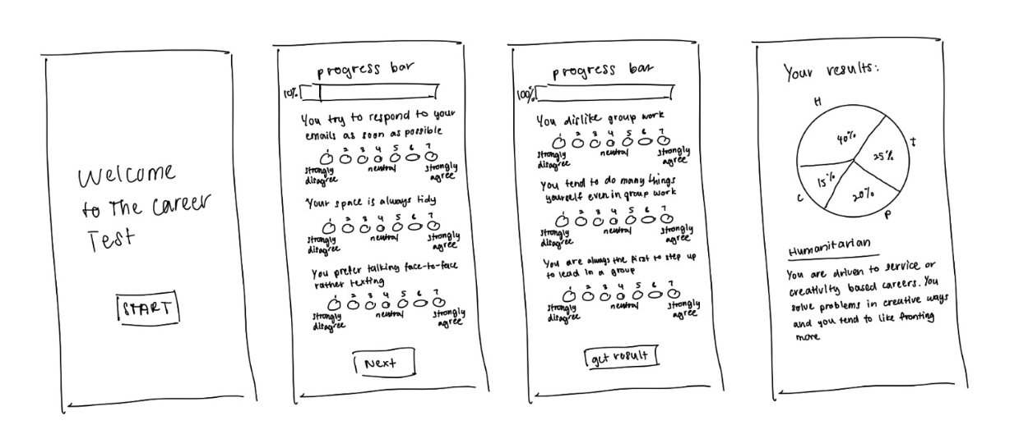

Figure 1 Website initial sketch

## 2.3 Phase 4 – Prototype

The Prototype phase involves creating a scaled down version of potential solutions. Our team managed to create a Figma version of the website that demonstrates the key features and functionalities that user will be able to interact with.

Steps Taken:

1. Prototype Development using Figma for the interface design

## 2.5 Phase 5 – Test

The Test phase was dedicated to evaluating the previously designed prototype [performance through user feedback. This phase allows the team to refine the solution based on given critic by user.

Steps Taken:

1. User Testing

* Conducted testing with 5 user using the prototype
* User were asked to interact with the website where they have to complete the career preference quiz and review the recommendations provided.

# 3.0 Description of Problem, Solution and Teamwork

## 3.1 Problem Description

In today fast transiting era of technology, young adults struggle with overloaded information on the Internet. Users are overwhelmed with the amount of information online and is in need of a personalised recommendation.

## 3.2 Solution Description

To address the above problem, our team designed an AI powered career guidance platform that able to generate a personalised career recommendation by analysing user interest, personality and education backgrounds. The user needs to complete an interactive Career Quiz then the website will generate a Career Recommendation, Learning Path and Career Comparison.

## 3.3 Team Individual Self-reflection

For the individual self-reflection, we are tasked to reflect on these questions:

1. What is your goal/dream with regard to your course/program?
2. How does this design thinking impact on your goal/dream with regard to your program?
3. What is the action/improvement/plan necessary for you to improve your potential in the industry?

|  |  |
| --- | --- |
| Salma: | 1. My goal in undertaking this course is to place myself in a stable career that can easily adapt to the everchanging economic climate. 2. Design thinking has helped me understand that having empathy is important in solving problems. This is especially important for a software engineer as this field of work focuses on providing solutions and understanding the client’s requirements. 3. First, I must further hone my skills in both soft skills and hard skills by studying and doing sufficient exercises on my course and involving myself in non-class related activities that can improve my communication skills. Next, is getting more exposure on industrial experience and lastly, getting myself more involved in programmes related in this course |
| Uzma: | 1. My dream is to specialize in front-end development, creating interactive and functional digital experiences. 2. This Design Thinking project taught me the value of user-centric design and systematic problem-solving. To boost my potential in the industry 3. I want to deepen my coding expertise by staying updated on the latest technologies and collaborate more with designers and researchers to deliver seamless user experiences |
| Nabil: | 1. My goal in this course is to become a competent leader in tech projects that provide innovative solutions for society's challenges. 2. Design Thinking has shown me how structured approaches, such as empathizing with user needs, can lead to impactful and meaningful solutions, emphasizing the value of teamwork and leadership in driving success. 3. To improve, I aim to develop stronger project management and leadership skills by leading group projects and taking up mentorship roles. I also plan to broaden my technical knowledge and keep updated with emerging industry trends to be a more effective leader. |
| Syafi: | 1. My goal in this course is to build a career in data analytics, utilizing Big Data to generate meaningful insights that support better decision-making. 2. Through Design Thinking, I learned the importance of understanding user needs and developing data-driven solutions that align with those requirements. It highlighted the value of combining data analytics with a human centred approach to problem-solving. 3. I aim to deepen my technical expertise by mastering advanced analytics tools and frameworks. Additionally, gaining hands-on experience through internships and collaborative projects will help me effectively apply my skills to address real-world challenges |
| Hadi: | 1. Focus on artificial intelligence and make things that can help people and solve real-life problems. 2. The need to match technology with what people need. It showed me how AI can create helpful tools like the career guidance website we worked on. 3. Keep learning programming and algorithms by doing more courses and projects. Joining AI competitions and getting internships will also give me the practice I need to do well in this field. |
| Adam: | 1. I want to be a good software developer and create apps that people find useful and interesting. 2. This Design Thinking project taught me how important it is to think about what users actually need. It also showed me how working with others and sharing ideas can lead to better results. 3. To get better, I need to practice coding more and try making different projects. I also want to join events, internships, and workshops to learn more and gain experience in the tech field. |

## 3.4 Teamwork Description

Team collaboration among use is a significant part of this project. Each member contributed own skills and ideas to ensure the project is executed well.

Team Roles :

1. Leader : Nabil

Oversees the progress and initiate meeting to ensure the deadlines of this project were met

1. Research Team : Hadi , Syafi and Adam

Conducted research to gather required data

1. Design and Development Team : Salma and Uzma

Designing the prototype using Figma.

# 4.0 Design Thinking Evidence – Appendix

## 4.1 Empathise Questionnaires

1. What is your current age?
2. What is your current status?
3. How do you usually explore career options?
4. How important is it for a career guidance tool to be easy to navigate?
5. What features would you find most useful in a career guidance platform?
6. How likely are you to use a free website for career guidance?
7. What type of content would you prefer on the platform?
8. What challenges do you face when exploring career options?
9. What would motivate you to actively use a career guidance website?
10. On a scale of 1 to 5, how confident are you that a career guidance platform could help you find the right career path?
11. Is there anything else you would like a career guidance platform to offer?

## 4.2 Define – User Need Statement

1. Undecided Aisyah needs a way to explore career options based on her interests and values because she feels uncertain about what will truly fulfill her in the long term.
2. Aspiring Alex needs personalized career suggestions based on his personality and education background to help him make an informed decision that matches his strengths.
3. Stressed Farah needs a simple, easy-to-navigate platform to compare career paths because she feels overwhelmed by the number of options available and doesn't know where to start.
4. Ambitious Aqil needs a platform that combines career advice with real-world job market data to better understand the opportunities available in his field of interest and make data-driven decisions.
5. Confused Hani needs clear, step-by-step guidance on career exploration because she doesn't know how to connect her education to potential job paths and fears making the wrong choice.
6. Motivated Rahimi needs a career resource that provides real-time insights and trends to stay updated on which skills and industries are in demand for his desired career path

## 4.3 Ideate – Meeting Proof

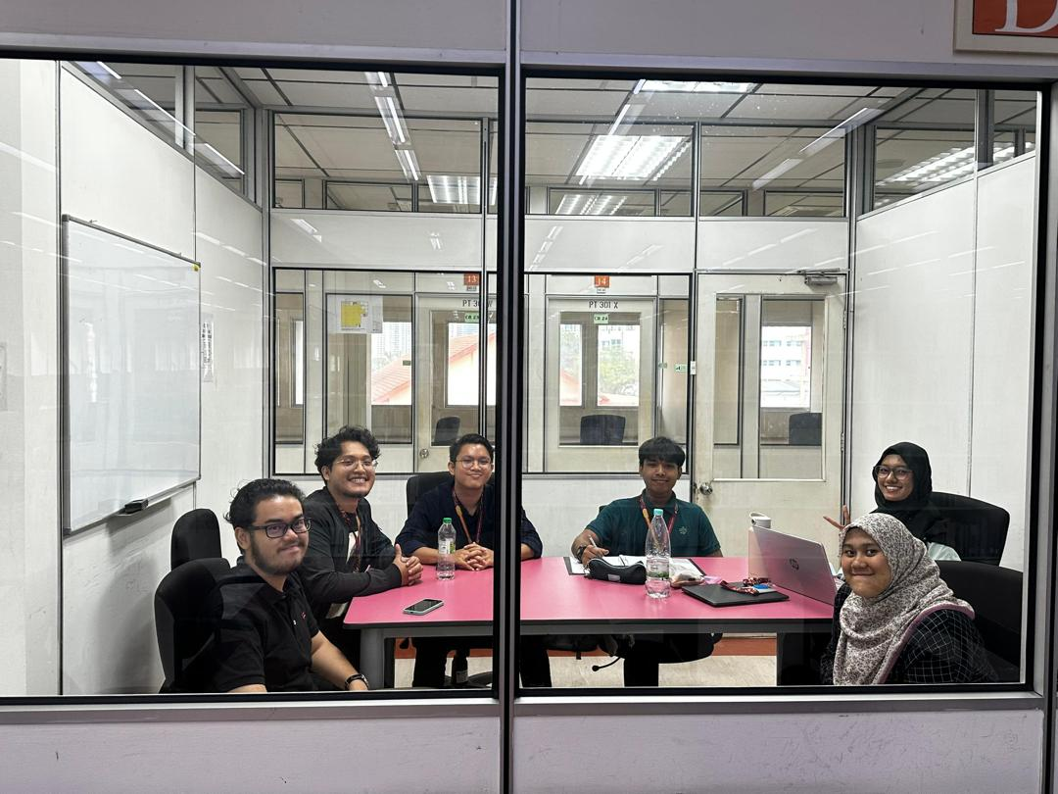

Figure 2 group meeting photo

The meeting was conducted on 20th January 2025 physically in UTMKL Library. The meeting has successfully achieved the objective of a brainstorming session to discuss the features that CareerHub needed.

4.4 Prototype UI

Figure 3 Website UI

## 4.5 Test – User Reviews

We let the user test our website prototype and let them review the experience. Below are some of the remarks.

Tester 1:

"The prototype has some cool features, but it's hard to enjoy since it's incomplete. Navigation was a bit clunky, and some buttons didn't work. It's tough to get a real feel for the final site."

Tester 2:

"The design looks good, but a lot of key features are missing. The interactions were a bit rough, and I ran into broken links. It's clear this is just a prototype, but hard to get into it."

Tester 3:

"The site has potential, but it's not fun to use right now. There are placeholders and things that don't work. I get it's just a prototype, but it felt more like a rough draft than a real experience."