Nama : Salamah Nur Aqidah

Kelas : Web

Program : Tech Muda 4

**Menampilkan dan Menambahkan Data Jabatan**

* Tampilan master data jabatan

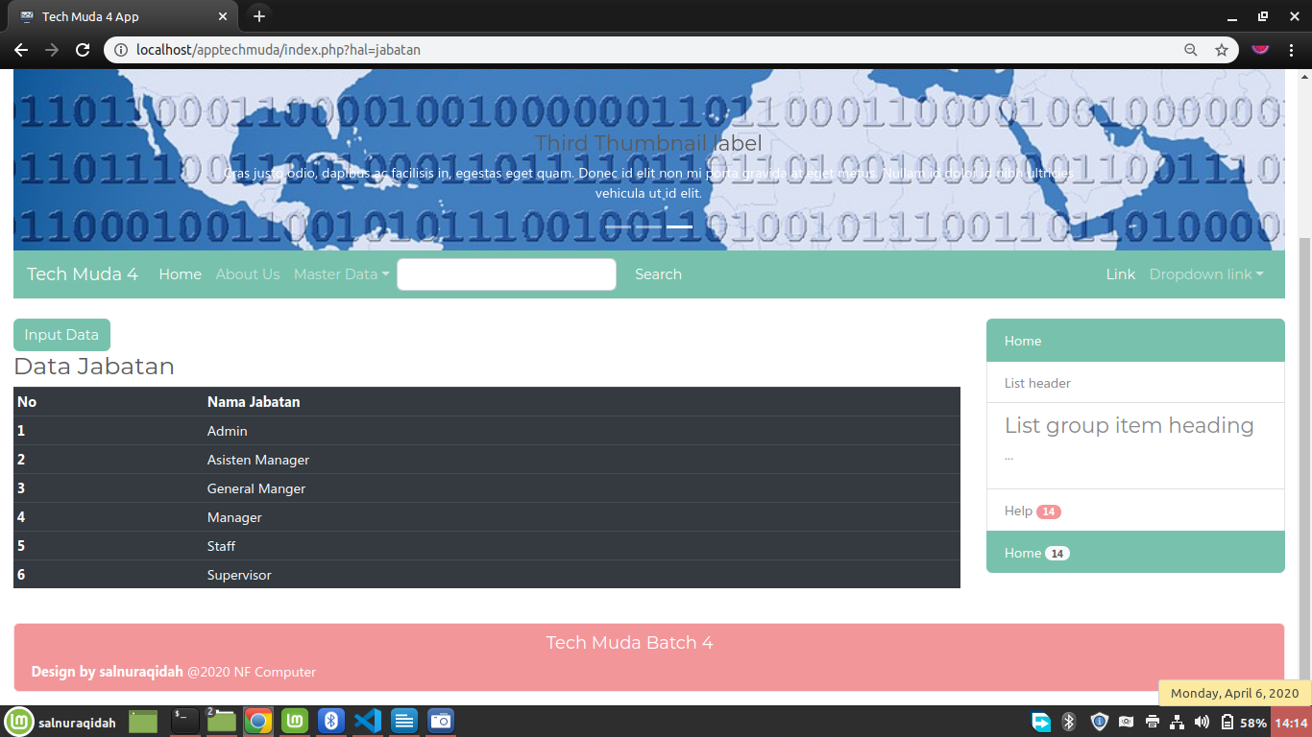

* Tampilan input data jabatan

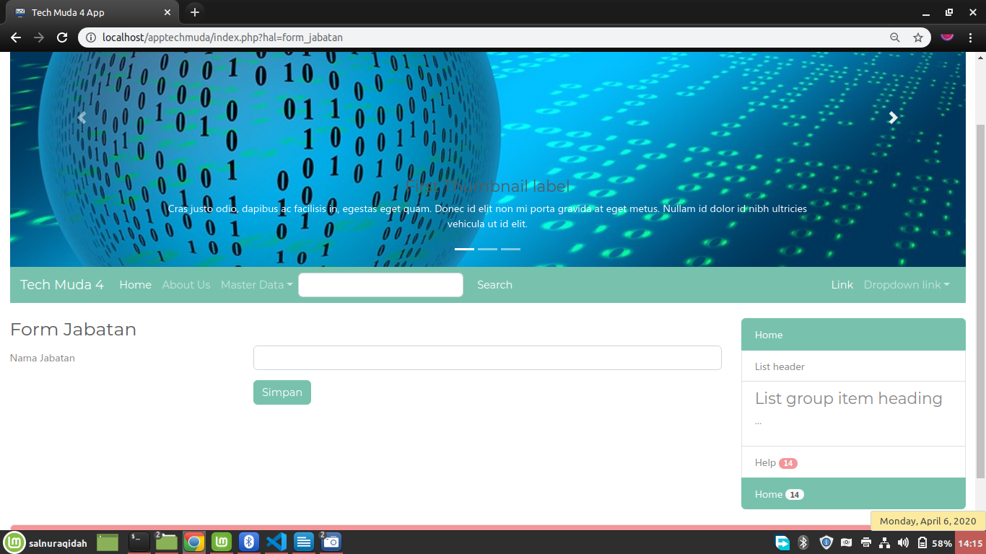

* Models/Jabatan.php

<?php

class Jabatan{

//member1 var

private $koneksi;

//member2 constructor

public function __construct(){

global $dbh; //panggil var instance pdo

$this->koneksi = $dbh;

}

//member3 fungsi2 crud

public function dataJabatan(){

$sql = "select * from jabatan";

//prepare statement PDO

$ps = $this->koneksi->prepare($sql); //persiapan

$ps->execute(); //eksekusi

$rs = $ps->fetchAll(); // ambil seluruh baris data

return $rs;

}

public function input($data){

$sql = "insert into jabatan (nama) values (?)";

//prepare statement PDO

$ps = $this->koneksi->prepare($sql); //persiapan

$ps->execute($data); //eksekusi

}

};

?>

* controller_jabatan.php

<?php

include_once 'koneksi.php';

include_once 'models/Jabatan.php';

//1. get request form

$nama = $_POST['nama'];

//2. save to array data

$data = [$nama];

//3. excecution button

$tombol = $_POST['proses'];

//create object

$model = new Jabatan();

switch ($tombol) {

case 'simpan': $model->input($data); break;

default:

# code...break;

}

//4. landing page

header('location:index.php?hal=jabatan');

* form_jabatan.php

<h3>Form Jabatan</h3>

<form method="POST" action="controller_jabatan.php">

<div class="form-group row">

<label for="nama" class="col-4 col-form-label">Nama Jabatan</label>

<div class="col-8">

<input id="nama" name="nama" type="text" class="form-control" required="required">

</div>

</div>

<div class="form-group row">

<div class="offset-4 col-8">

<button name="proses" value="simpan" type="submit" class="btn btn-primary">Simpan</button>

</div>

</div>

</form>