Nama : Salamah Nur Aqidah

Kelas : Web

Program : Tech Muda 4

**CRUD Data Jabatan**

* Tampilan data jabatan

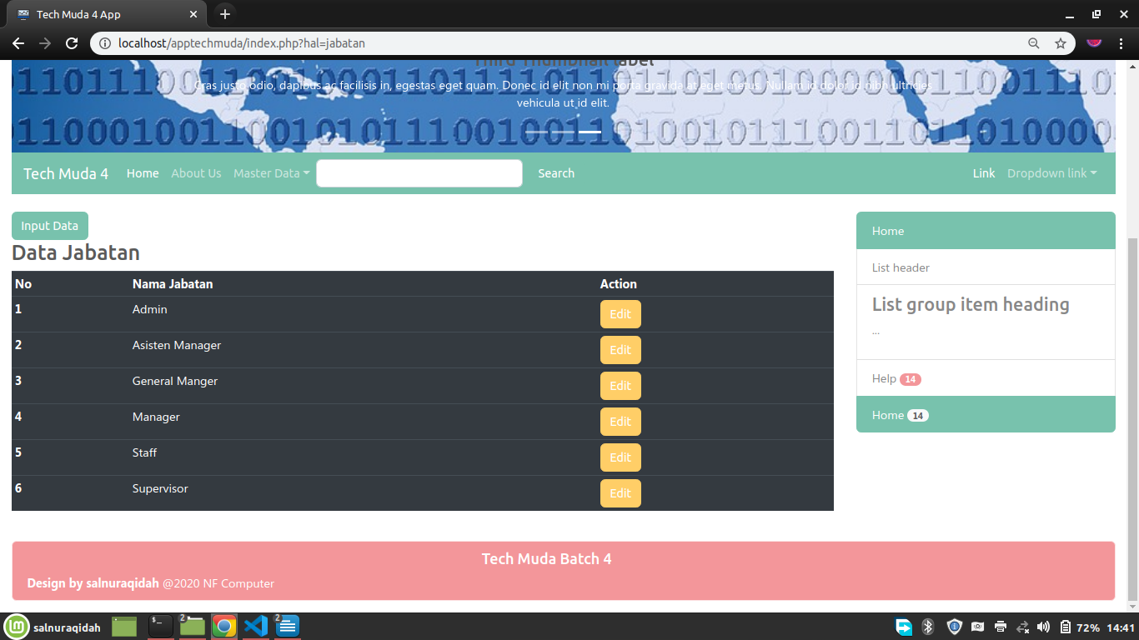

* Tampilan edit data jabatan

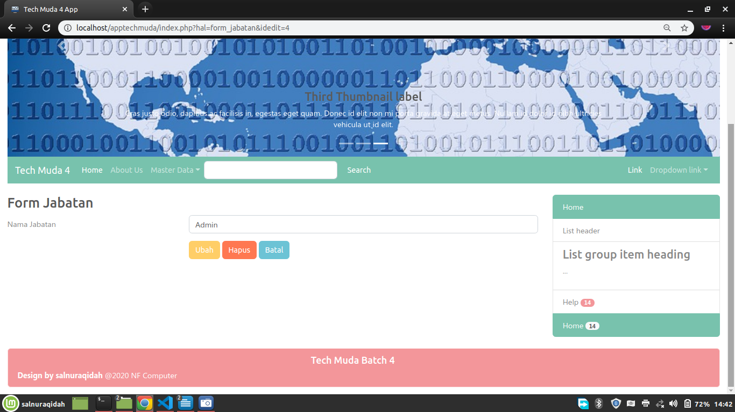

* Models/Jabatan.php

|  |
| --- |
| <?php  class Jabatan{  //member1 var  private $koneksi;  //member2 constructor  public function __construct(){  global $dbh; //panggil var instance pdo  $this->koneksi = $dbh;  }  //member3 fungsi2 crud  public function dataJabatan(){  $sql = "select * from jabatan";  //prepare statement PDO  $ps = $this->koneksi->prepare($sql); //persiapan  $ps->execute(); //eksekusi  $rs = $ps->fetchAll(); // ambil seluruh baris data  return $rs;  }  public function input($data){  $sql = "INSERT INTO jabatan (nama) values (?)";  //prepare statement PDO  $ps = $this->koneksi->prepare($sql); //persiapan  $ps->execute($data); //eksekusi  }  public function getJabatan($id){  $sql = "select * from jabatan where id=?";  //prepare statement PDO  $ps = $this->koneksi->prepare($sql); //persiapan  $ps->execute($id); //eksekusi  $rs = $ps->fetch(); // ambil satu baris data yang mau diedit  return $rs;  }  public function ubah($data){  $sql = "update jabatan set nama=? where id=?";  //prepare statement PDO  $ps = $this->koneksi->prepare($sql); //persiapan  $ps->execute($data); //eksekusi  }  public function hapus($id){  $sql = "delete from jabatan where id=?";  //prepare statement PDO  $ps = $this->koneksi->prepare($sql); //persiapan  $ps->execute($id); //eksekusi  }  };  ?> |

* controller_jabatan.php

|  |
| --- |
| <?php  include_once 'koneksi.php';  include_once 'models/Jabatan.php';  //1. get request form  $nama = $_POST['nama'];  //2. save to array data  $data = [$nama];  //3. excecution button  $tombol = $_POST['proses'];  //create object  $model = new Jabatan();  switch ($tombol) {  case 'simpan': $model->input($data); break;  case 'ubah':  $data[] = $_POST['idx']; // tangkap hidden field tanda tanya kedua di model  $model->ubah($data); break;  case 'hapus':  unset($data);  $id = [$_POST['idx']];  $model->hapus($id); break;  default: header('location:index.php?hal=jabatan');  }  //4. landing page  header('location:index.php?hal=jabatan'); |

* form_jabatan.php

|  |
| --- |
| <?php  //1. tangkap request di url (idedit)  $idedit = $_GET['idedit'];  //2. simpan ke sebuah data array  //$id = [$idedit];  if(!empty($idedit)){ //---modus edit data lama----  $model = new Jabatan();  //$rs = $model->getDivisi($id);  $rs = $model->getJabatan([$idedit]);  }  else{ //---modus entry data baru----  $rs = [];  }  ?>  <h3>Form Jabatan</h3>  <form method="POST" action="controller_jabatan.php">  <div class="form-group row">  <label for="nama" class="col-4 col-form-label">Nama Jabatan</label>  <div class="col-8">  <input id="nama" name="nama" value="<?= $rs['nama'] ?>" type="text" class="form-control">  </div>  </div>  <div class="form-group row">  <div class="offset-4 col-8">  <?php  if(empty($idedit)){ //--------modus entry data baru--------  ?>  <button name="proses" value="simpan" type="submit" class="btn btn-primary">Simpan</button>  <?php  }  else{ //--------modus edit data lama--------  ?>  <button name="proses" value="ubah" type="submit" class="btn btn-warning">Ubah</button>  <button name="proses" value="hapus" type="submit"  onClick="return confirm('are you sure?')" class="btn btn-danger">Hapus</button>  <!-- hidden field untuk melempar idedit ke controller -->  <input type="hidden" name="idx" value="<?= $idedit ?>" />  <?php } ?>  <button name="proses" value="batal" type="submit" class="btn btn-info">Batal</button>  </div>  </div>  </form> |