Nama : Salamah Nur Aqidah

Kelas : Web

Program : Tech Muda 4

**Menampilkan dan Menambahkan Data Gaji**

* **View**

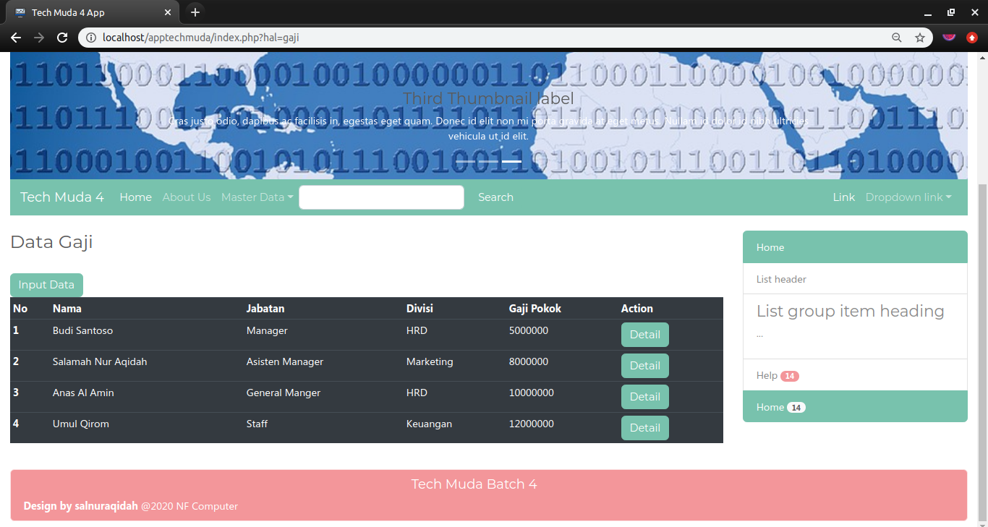

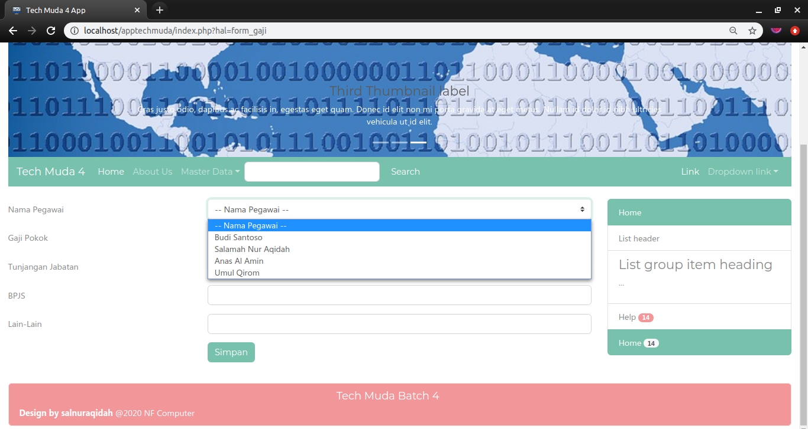

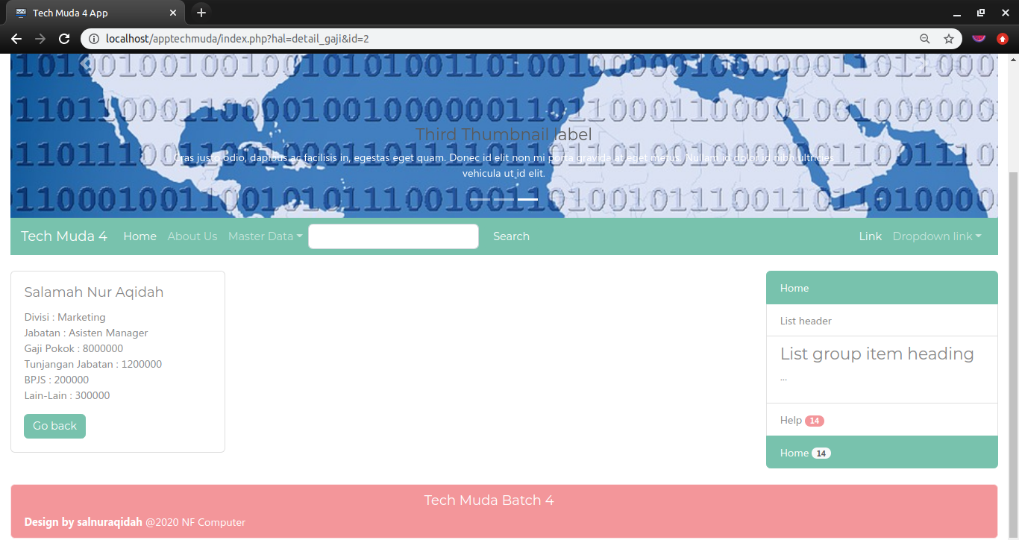

* **Models**

|  |
| --- |
| <?php  class Gaji{  private $koneksi;  public function __construct(){  global $dbh;  $this->koneksi = $dbh;  }  public function dataGaji(){  $sql = "SELECT g.*, p.nama, d.nama as divisi, j.nama as jabatan  FROM gaji g  INNER JOIN pegawai p ON p.id = g.pegawai_id  INNER JOIN divisi d ON d.id = p.iddivisi  INNER JOIN jabatan j ON j.id = p.idjabatan";  $ps = $this->koneksi->prepare($sql);  $ps->execute();  $rs = $ps->fetchAll();  return $rs;  }  public function simpan($data){  $sql = "INSERT INTO gaji(pegawai_id,gapok,tunjab,bpjs,lain2)  VALUES (?,?,?,?,?)";  $ps = $this->koneksi->prepare($sql);  $ps->execute($data);  }  public function detailGaji($id){  $sql = "SELECT g.*, p.nama, d.nama as divisi, j.nama as jabatan  FROM gaji g  INNER JOIN pegawai p ON p.id = g.pegawai_id  INNER JOIN divisi d ON d.id = p.iddivisi  INNER JOIN jabatan j ON j.id = p.idjabatan  WHERE g.id = ?";  $ps = $this->koneksi->prepare($sql);  $ps->execute($id);  $rs = $ps->fetch();  return $rs;  }  } |

* **Controller**

|  |
| --- |
| <?php  include_once 'koneksi.php';  include_once 'models/Gaji.php';  $nama = $_POST['nama'];  $gapok = $_POST['gapok'];  $tunjab = $_POST['tunjab'];  $bpjs = $_POST['bpjs'];  $lain2 = $_POST['lain2'];  $data = [  $nama, $gapok, $tunjab, $bpjs, $lain2  ];  $tombol = $_POST['submit'];  $model = new Gaji();  if ($tombol == 'simpan') { //simpan adalah value dari button submit  $model->simpan($data);  }  else{ //tombol batal tidak ada perubahan data baru  header('Location:index.php?hal=gaji');  }  //4. selesai proses redirect / landing page (ada perubahan data)  header('Location:index.php?hal=gaji'); |