Nama : Salamah Nur Aqidah

Kelas : Web

Program : Tech Muda 4

**CRUD Data Gaji**

* **View**

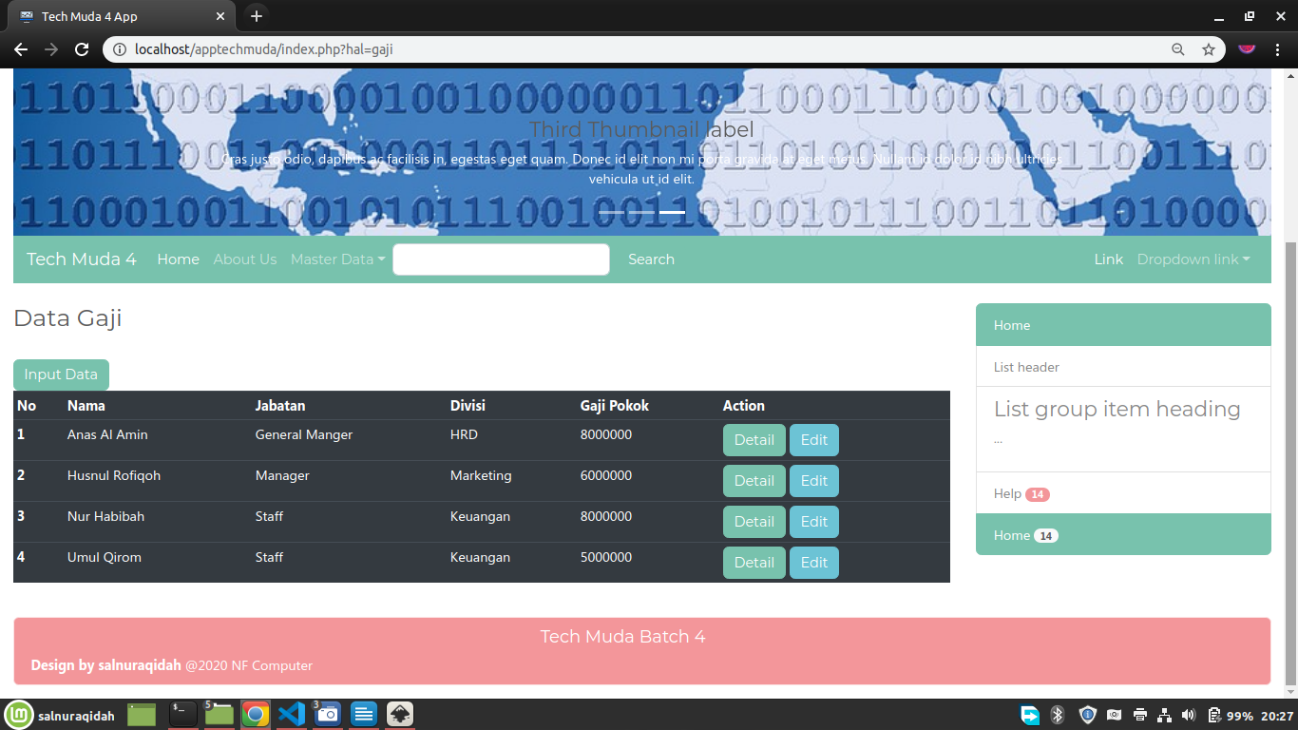

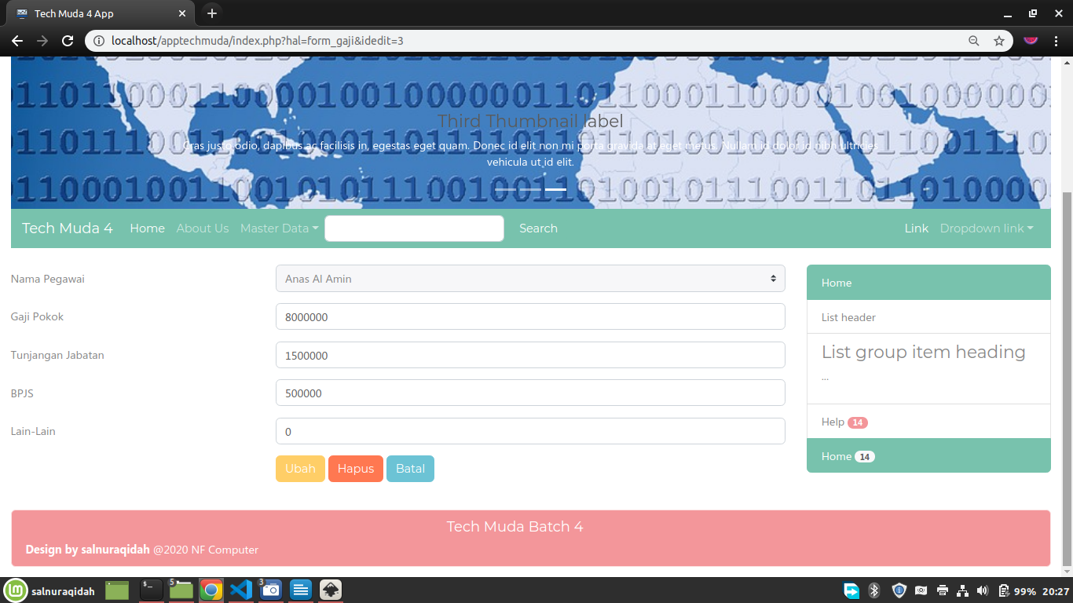

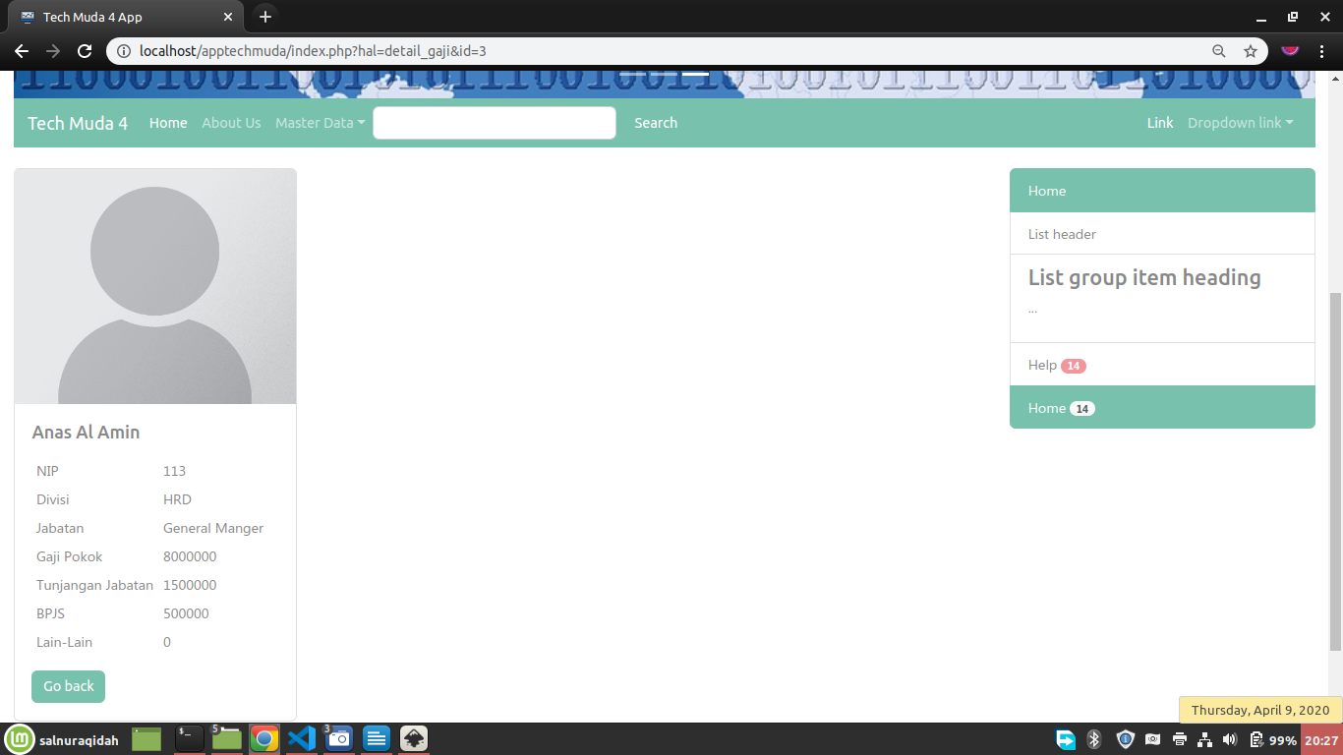

form_gaji.php

|  |
| --- |
| <?php  $idedit = $_REQUEST['idedit'];  $model = new Gaji();  if (!empty($idedit)) {  $rs = $model->getGaji([$idedit]);  } else {  $rs = [];  }  $obj2 = new Gaji();  $pegawai2 = $obj2->dataBelumDigaji();  $obj = new Pegawai();  $pegawai = $obj->dataPegawai();  ?>  <form method="POST" action="controller_gaji.php">  <div class="form-group row">  <label for="nama" class="col-4 col-form-label">Nama Pegawai</label>  <div class="col-8">  <?php  $dis = ($pegawai['id'] == $rs['pegawai_id']) ? '' : 'disabled';  ?>  <select id="nama" name="nama" class="custom-select" <?= $dis ?>>  <option value="">-- Nama Pegawai --</option>  <?php  foreach ($pegawai as $peg) {  if ($peg['id'] == $rs['pegawai_id']) {  ?>  <option value="<?= $peg['id'] ?>" selected><?= $peg['nama'] ?></option>  <?php }  }  foreach ($pegawai2 as $peg2) {  ?>  <option value="<?= $peg2['idp'] ?>"><?= $peg2['nama'] ?></option>  <?php }  ?>  </select>  </div>  </div>  <div class="form-group row">  <label for="gapok" class="col-4 col-form-label">Gaji Pokok</label>  <div class="col-8">  <input id="gapok" value="<?= $rs['gapok'] ?>" name="gapok" type="text" class="form-control">  </div>  </div>  <div class="form-group row">  <label for="tunjab" class="col-4 col-form-label">Tunjangan Jabatan</label>  <div class="col-8">  <input id="tunjab" name="tunjab" value="<?= $rs['tunjab'] ?>" type="text" class="form-control">  </div>  </div>  <div class="form-group row">  <label for="bpjs" class="col-4 col-form-label">BPJS</label>  <div class="col-8">  <input id="bpjs" name="bpjs" value="<?= $rs['bpjs'] ?>" type="text" class="form-control">  </div>  </div>  <div class="form-group row">  <label for="lain2" class="col-4 col-form-label">Lain-Lain</label>  <div class="col-8">  <input id="lain2" name="lain2" value="<?= $rs['lain2'] ?>" type="text" class="form-control">  </div>  </div>  <div class="form-group row">  <div class="offset-4 col-8">  <?php  if (empty($idedit)) { //--------modus entry data baru--------  ?>  <button name="proses" value="simpan" type="submit" class="btn btn-primary">Simpan</button>  <?php  } else { //--------modus edit data lama--------  ?>  <button name="proses" value="ubah" type="submit" class="btn btn-warning">Ubah</button>  <button name="proses" value="hapus" type="submit" onClick="return confirm('are you sure?')" class="btn btn-danger">Hapus</button>  <!-- hidden field untuk melempar idedit ke controller -->  <input type="hidden" name="idx" value="<?= $idedit ?>" />  <?php } ?>  <button name="proses" value="batal" type="submit" class="btn btn-info">Batal</button>  </div>  </div>  </form> |

detail_gaji.php

|  |
| --- |
| <?php  //tangkap request id di url  $id = $_GET['id'];  $model = new Gaji();  $gaji = $model->getGaji([$id]);  ?>  <div class="card" style="width: 20rem;">  <?php  if (empty($gaji['foto'])) {  ?>  <img src="images/no_photo.png" class="card-img-top" alt="..." />  <?php } else {  ?>  <img src="images/<?= $gaji['foto'] ?>" class="card-img-top" alt="...">  <?php } ?>  <div class="card-body">  <h5 class="card-title"><?= $gaji['nama'] ?></h5>  <p class="card-text">  <?php  $ar_judul = [  'NIP' => $gaji['nip'], 'Divisi' => $gaji['divisi'], 'Jabatan' => $gaji['jabatan'],  'Gaji Pokok' => $gaji['gapok'], 'Tunjangan Jabatan' => $gaji['tunjab'],  'BPJS' => $gaji['bpjs'], 'Lain-Lain' => $gaji['lain2']  ];  ?>  <table cellpadding="5">  <?php  foreach ($ar_judul as $k => $v) {  ?>  <tr>  <td><?= $k ?></td>  <td><?= $v ?></td>  </tr>  <?php } ?>  </table>  </p>  <a href="index.php?hal=gaji" class="btn btn-primary">Go back</a>  </div>  </div> |

* **Controller**

|  |
| --- |
| <?php  include_once 'koneksi.php';  include_once 'models/Gaji.php';  $nama = $_POST['nama'];  $gapok = $_POST['gapok'];  $tunjab = $_POST['tunjab'];  $bpjs = $_POST['bpjs'];  $lain2 = $_POST['lain2'];  $data = [  $nama, $gapok, $tunjab, $bpjs, $lain2  ];  $data2 = [  $gapok, $tunjab, $bpjs, $lain2  ];  $tombol = $_POST['proses'];  $model = new Gaji();  if ($tombol == 'simpan') { //simpan adalah value dari button submit  $model->simpan($data);  }  else if($tombol == 'ubah'){  $data2[] = $_POST['idx'];  $model->ubah($data2);  }  else if($tombol == 'hapus'){  unset($data); //hapus ? di atas  $id = [$_POST['idx']];  $model->hapus($id);  }  else{ //tombol batal tidak ada perubahan data baru  header('Location:index.php?hal=gaji');  }  //4. selesai proses redirect / landing page (ada perubahan data)  header('Location:index.php?hal=gaji'); |

* **Model**

|  |
| --- |
| <?php  class Gaji{  private $koneksi;  public function __construct(){  global $dbh;  $this->koneksi = $dbh;  }  public function dataGaji(){  $sql = "SELECT g.*, p.nama, p.nip, d.nama as divisi, j.nama as jabatan  FROM gaji g  INNER JOIN pegawai p ON p.id = g.pegawai_id  INNER JOIN divisi d ON d.id = p.iddivisi  INNER JOIN jabatan j ON j.id = p.idjabatan";  $ps = $this->koneksi->prepare($sql);  $ps->execute();  $rs = $ps->fetchAll();  return $rs;  }  public function simpan($data){  $sql = "INSERT INTO gaji(pegawai_id,gapok,tunjab,bpjs,lain2)  VALUES (?,?,?,?,?)";  $ps = $this->koneksi->prepare($sql);  $ps->execute($data);  }  public function getGaji($id){  $sql = "SELECT g.*, p.nip, p.nama, p.foto, d.nama as divisi, j.nama as jabatan  FROM gaji g  INNER JOIN pegawai p ON p.id = g.pegawai_id  INNER JOIN divisi d ON d.id = p.iddivisi  INNER JOIN jabatan j ON j.id = p.idjabatan  WHERE g.id = ?";  $ps = $this->koneksi->prepare($sql);  $ps->execute($id);  $rs = $ps->fetch();  return $rs;  }  public function dataBelumDigaji(){  $sql = "SELECT pegawai.id as idp, pegawai.nama  FROM pegawai  LEFT JOIN gaji ON pegawai.id = gaji.pegawai_id  WHERE gaji.pegawai_id IS NULL";  $ps = $this->koneksi->prepare($sql);  $ps->execute();  $rs = $ps->fetchAll();  return $rs;  }  public function ubah($data2){  $sql = "UPDATE gaji SET gapok=?,tunjab=?,bpjs=?,lain2=?  WHERE id=?";  $ps = $this->koneksi->prepare($sql);  $ps->execute($data2);  }  public function hapus($id){  $sql = "DELETE FROM gaji WHERE id=?";  $ps = $this->koneksi->prepare($sql);  $ps->execute($id);  }  } |