COURSEWORK SUBMISSION FORM
STUDENT USE |  | STAFF USE
Module Name | Machine Learning and Data Analytics | First Marker’s  (acts as signature)
Module Code | 6COSC017C-n | Se000cond Marker’s  (acts as signature)
Lecturer Name | Hamid Shahbazkia | Agreed Mark
UoW Student IDs |  | For Registrar’s office use only (hard copy submission)
WIUT Student IDs | 00009998
Deadline date | 06.06.2023
Assignment Type | Group √ Individual

SUBMISSION INSTRUCTIONS

COURSEWORKS must be submitted in both HARD COPY (to the Registrar’s Office) and ELECTRONIC unless instructed otherwise.
For hardcopy submission instructions refer to: http://intranet.wiut.uz/Shared%20Documents/Forms/AllItems.aspx - Coursework hard copy submission instructions.doc
For online submission instructions refer to: http://intranet.wiut.uz/Shared%20Documents/Forms/AllItems.aspx - Coursework online submission instructions.doc

MARKERS FEEDBACK (Continued on the next page)

Table of Contents:

Introduction ------------------------------------------------------------------------------------------------- 3

Exploratory Data Analysis -------------------------------------------------------------------------------- 3

Data Preparation -------------------------------------------------------------------------------------------- 8

Model Selection ------------------------------------------------------------------------------------------- 13

Conclusion ------------------------------------------------------------------------------------------------- 15

Introduction
The dataset is about data of 1025 hotels in Saudia Arabia in specific date 24 April 2020. This dataset contains the most hotels in the KSA ( Kingdom of Saudi Arabia ), collected from the most common booking website in the world Booking.com. You can get an overview of each hotel, resort, or accommodation by the 21 features provided in the dataset .
Link to the dataset: https://www.kaggle.com/datasets/moayadmagadmi/saudi-arabia-bookingcom
Descriptive and Predictive analysis are suitable for the selected dataset.
As the name suggests, descriptive analysis and statistics describe or summarize raw data to create something that can be understood by people.
The likelihood of a future outcome is estimated through predictive analytics.
In this analysis, I am trying to predict hotel prices in Kingdom of Saudi Arabia, using Regression model. So, Predictive analysis is more suitable for my current analysis.
Exploratory Data Analysis
There are 1025 rows and 21 columns in the dataset for the analysis

Dataset Columns and their data types
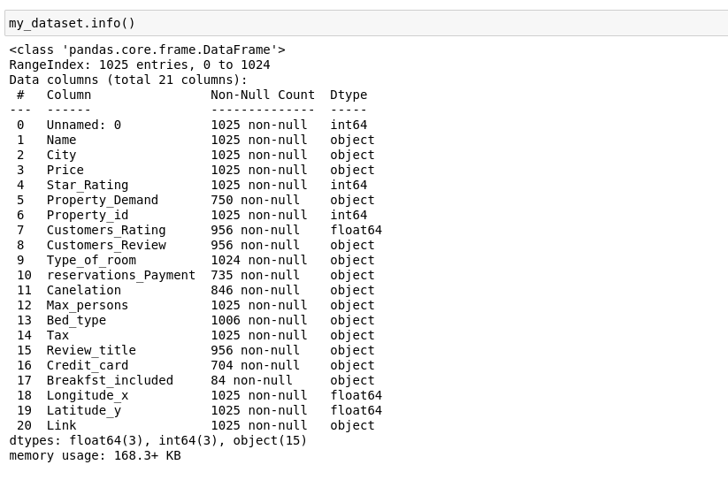
There are 3 data types in the dataset, including int64(3 columns), object(15 columns), float64(3 columns). There are some missing values in the dataset columns. For example, “Customers_Rating”, “Customers_Review”, “Type_of_room”, “reservations_Payment”, “Canelation”, “Bed_type”, “Review_title”, “Credit_card”, “Breakfast_included”.
Descriptive statistics
Numerical columns:
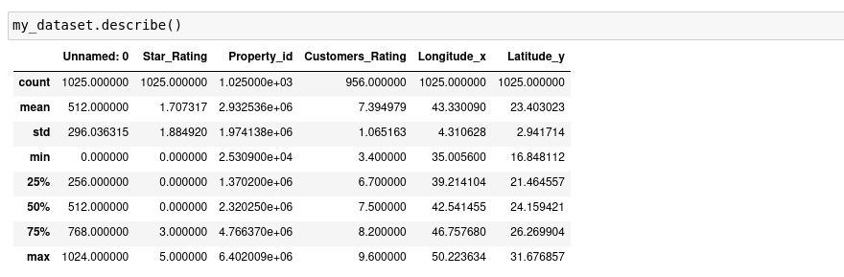
Observations for numerical columns:
- In numerical columns, there are not any outliers
- Customers_Rating column has some missing values.
Categorical columns:
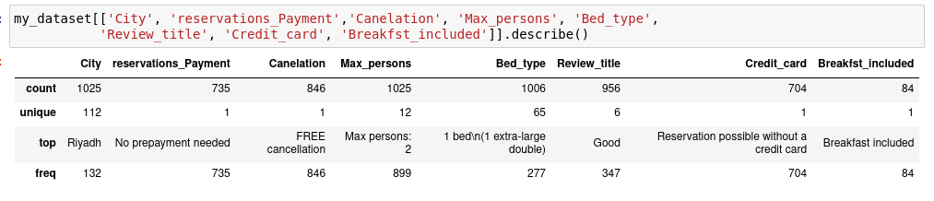
Observations:
- Some Categorical columns such as "reservations_Payment", "Canelation",
"Credit_card", "Breakfst_included" contain only one unique value. So, we consider
to delete these columns in data preparation process
- Some categorical columns contain missing values. We consider these columns
in data preparation process.
As you can see from the bar chart below, the frequency of the value "Exceptional" in "Review_title" column is around 5. At the same time, the frequency of the value "Good" in the same column is around 350. If we remove the value "Exceptional" from "Review_title" column, It will not significantly affect our analysis. As I mentioned above, it is difficult to understand how different values of the variable affects the outcome, but if there were 4–5 categories, this could be quickly figured.
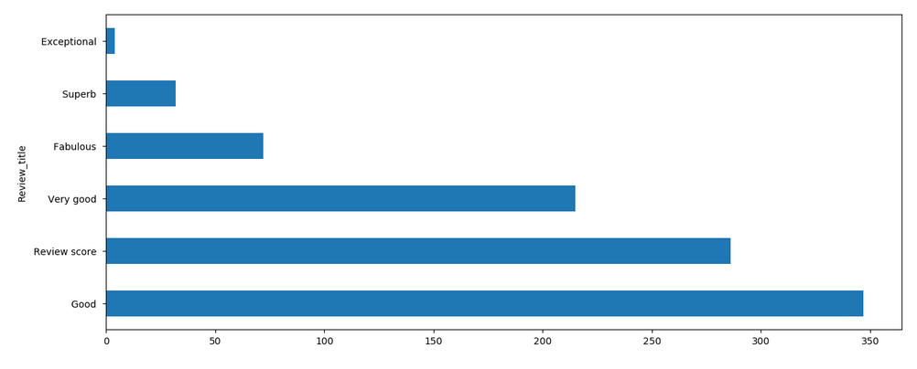
You can see the same situation in the bar chart below
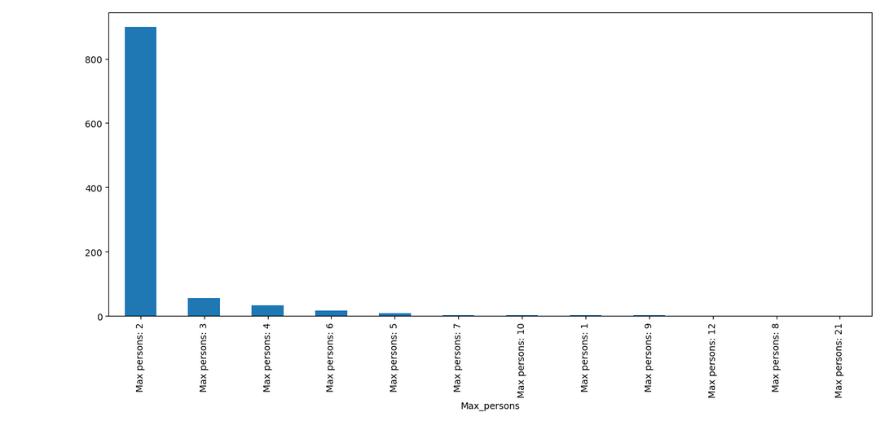

Correlation of Ratings and Locations
It can be seen that customer rating and star rating columns have a positive correlation with each other. But, Longitude_x and Star_Rating columns have a weaker correlation.
Longitude_x and Longitude_y columns have a positive correlation with each other. But, Longitude_y and Customers_Rating column have a negative correlation.

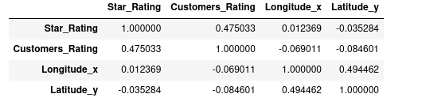

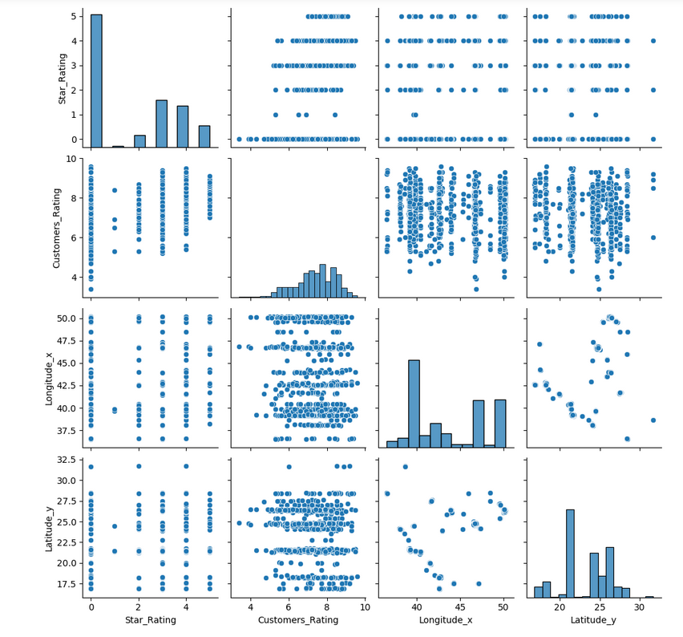
Data Preparation
Drop unnecessary columns
I remove columns that contain only unique values("Property_id", "Unnamed: 0", "Link", "Name" columns), constant value("reservations_Payment", "Canelation", "Credit_card", "Breakfst_included" columns) or just simple text("Property_Demand", "Tax", "Type_of_room" columns). Because, they do not provide any useful data for our analysis.
Identify duplicate values in a dataset
It is very important to remove duplicate values from the dataset. Because, it makes it difficult to maintain accuracy and to avoid misleading statistics. According to the output, there is no any duplicate row in the dataset.
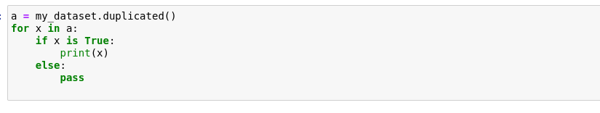
Missing Values
The handling of missing data is very important during the preprocessing of the dataset as many machine learning algorithms do not support missing values.
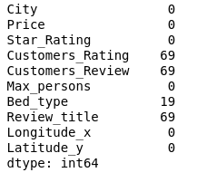

As we can see from the output above, there are some missing values in the dataset. We will delete all rows with missing values. For that, we use dropna() function.
Correcting errors
As we discussed in Exploratory Data Analysis stage, "Price", "Customers_Review" columns must be converted from object data type to float64 data type. Because, these columns contain numerical data and they can provide useful data in our analysis. However, "Price" column values include not only hotel price but also Arabic currency("SAR"). So, before converting the column data type, we need to remove the word "SAR'.
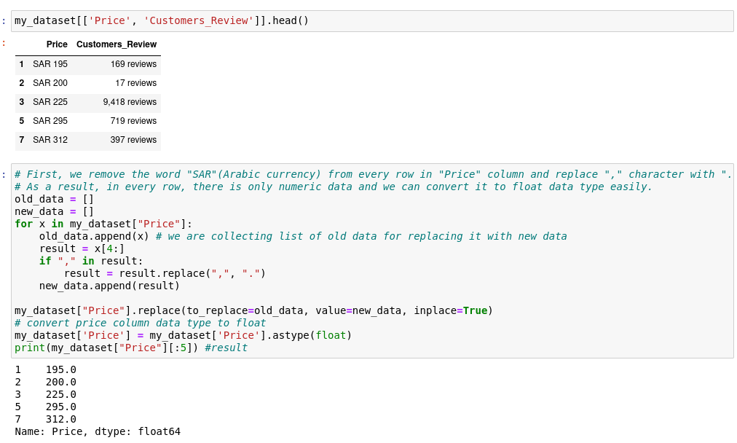
The same goes for the "Customers_Review" column. First, we remove the word "reviews" from every row in the column and replace character "," with character "." .
As a result, in every row, there is only numeric data and we can convert it to float data type easily.
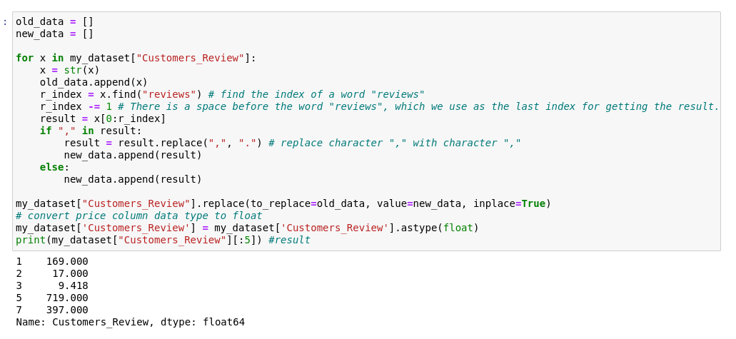
As I mentioned in Exploratory Data Analysis stage, categorical columns contain a lot of unique values that their frequency is equal to 1. As a result, it can be difficult to analyze data. So, we should drop non-duplicate unique values in categorical columns. Because, non-duplicate values(their frequency is equal to 1) in categorical columns do not significantly affect our data analysis. But it makes it difficult for us to analyze the data
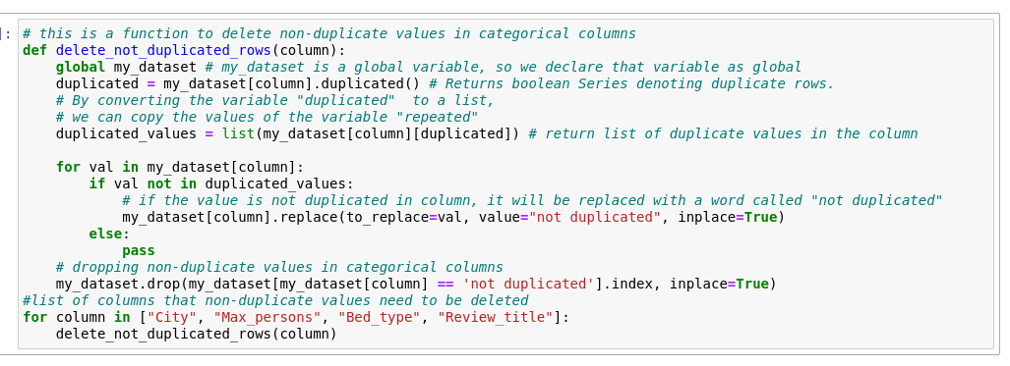
As you can see from the output below, in categorical columns, we've manged to decrease unique values that does not significantly affect our analysis. You can see it in the output below. For example, we’ve decreased unique values of Column “Max_persons” from 12 values to 5 values by removing the values that their frequency is equal to 1.
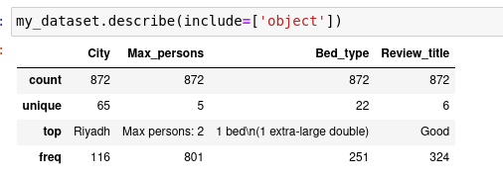

Most machine learning models only accept numerical variables. Preprocessing the categorical columns becomes a necessary step. We need to convert these categorical variables to numbers such that the model is able to understand and extract valuable information. We use Ordinal Encoding technique for converting categorical columns.
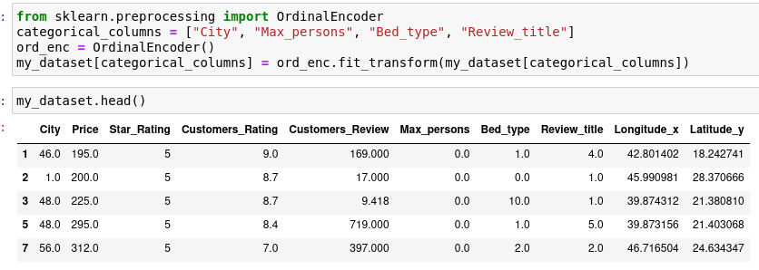
Data Conversions
It can be necessary and aids memory efficiency to use the right data types. In our analysis, it is important to make all column values numeric. So, we convert column data types to float data type.

As you can see from the output below, all column data types has been successfully converted to float data type.
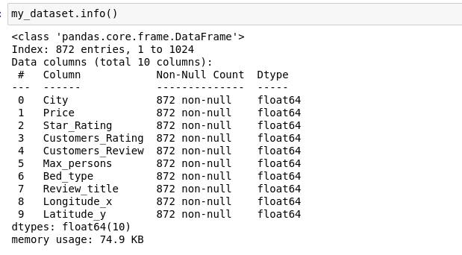

Training and Evaluation sets
Our target column in the dataset is "Price". Because, we try to predict the price of hotels in Saudi Arabia.
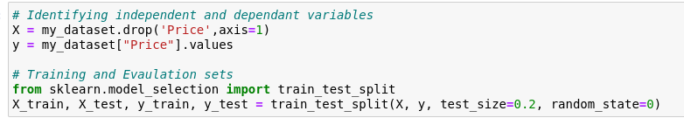
Model Selection
For my predictive analysis, I selected Decision Tree algorithm. A decision tree is a supervised learning algorithm used for classification and regression modeling. Similar to flowcharts, decision trees have a root node with a specific query and branches with possible responses. Branches eventually lead to decision (internal) nodes that pose additional queries and produce additional results. This keeps on until the data finishes at the terminal (or "leaf") node. Comparing the decision tree approach to KNN and other classification algorithms, it is much faster and more effective. Decision trees take less work to prepare the data during pre-processing than other algorithms do. With other algorithms like Support Vector Machine and Linear Regression, it can be challenging to capture non-linear relationships. Decision trees, however, are effective at doing so. KNN does not allow for automatic feature interaction, whereas decision trees do. The results of the decision tree method can be easily understood without the need for statistical expertise or difficult ideas. Decision trees are more adaptable than other classifiers due to a number of qualities. It may work with a variety of data formats, such as discrete or continuous values, and it can employ thresholds to turn continuous values into categorical values. It also has the ability to handle missing values, which can be difficult for other classifiers like Naive Bayes. So, I selected this algorithm for my analysis.
To build Decision Tree, Classification and Regression models are used.
Classification model is used to determine the class that a target variable would most likely belong to. Determining who will or won't subscribe to a digital platform or who will or won't graduate from high school are examples of classification-type problems.
An procedure used to predict the value of the target variable is referred to as a regression model. Predicting the selling prices of a residential house, which is a continuous dependent variable, would be an example of a regression-type problem. This will be influenced by both constant parameters, like square footage, and categorical factors, like the type of house, the neighborhood where the property is situated, etc.
In our analysis, we are going to predict the hotel prices in Kingdom of Saudi Arabia.
If we consider that we want to predict hotel prices, we will see that the regression model is suitable for our analysis. You can see the data we provided about the regression model above as proof of our decision.
Below, you can see how we used the Decision Tree Regression model for our analysis. As you can see, First, we defined the regression model by using the DecisionTreeRegressor class. Then, we fitted the model on train data and checked the model accuracy score.
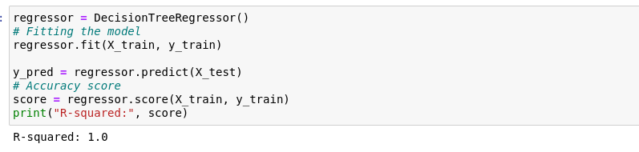
Evaluation Metrics
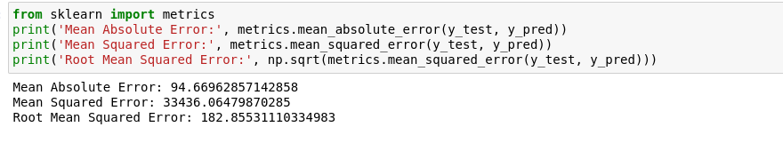
The mean amount of the errors in a collection of predictions is known as the mean absolute error (MAE). Every sample in a dataset is averaged to produce the result by the MAE algorithm. In our case, Mean absolute Error is equal to 94.669.
The difference between the actual values and the predicted values, squared, is what is known as the Mean Squared Error. In our case, it is equal to 33436.064. Root Mean Squared Error is equal to 182.855.

Visualizing the difference between actual and predicted Price values
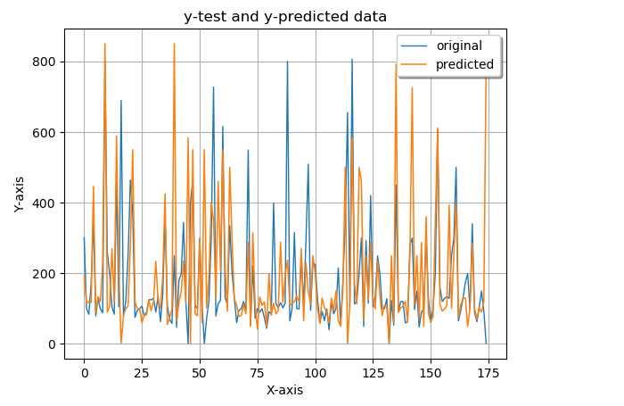
It can be seen from the chart above that our model has almost predicted accurate data.
Conclusion
In conclusion, I can say that we managed to predict hotel prices almost accurately. Our use of the Decision Tree Algorithm came in very handy. The fact that we deleted unnecessary columns, corrected errors, identified duplicate values and removed them in the data preparation stage also led to a good result.

