DATABASE DESIGN DOCUMENTATION
Part 1: Conceptual Design
Case Study: Reliable Rentals

Prepared by:
Fabrisio Ponte Vela
Salome Collante Ramirez
Martineulr Marasigan

April 2026

1. Introduction
This document presents the conceptual data model for the Reliable Rentals vehicle rental management system. Reliable Rentals operates a fleet of vehicles rented to clients through multiple outlet locations. The purpose of this report is to systematically document all steps in the conceptual database design process, from entity identification through the generation of a complete Entity-Relationship (E-R) diagram.

The conceptual design phase establishes the foundation for the relational database that will manage outlets, vehicles, hire agreements, clients, and staff. Each step follows standard database design methodology and all assumptions are clearly stated.

2. Case Study Overview
Reliable Rentals is a vehicle rental company that operates across multiple outlet locations. The system must track:

- Outlet locations and their contact details
- Vehicles allocated to each outlet
- Clients who register with and hire vehicles from the company
- Hire agreements made between clients and the company for specific vehicles
- Staff members assigned to each outlet

Each vehicle is uniquely identified by its registration number. Hire agreements link a specific client to a specific vehicle for a defined period, with mileage recorded at both the start and end of the hire period.

Step 1: Identify the Main Entities
An entity represents a distinct, identifiable object or concept about which data is stored. The following five main entities were identified from the case study description:

Entity 1: Outlet
Represents a physical location or site from which Reliable Rentals operates and rents out vehicles.
Field | Description
Definition | A branch or rental site operated by Reliable Rentals
Justification | Outlets are the operational centers of the business. Multiple outlets exist and vehicles are allocated to them.

Entity 2: Vehicle
Represents each vehicle available for hire within the company's fleet.
Field | Description
Definition | A rentable vehicle uniquely identified by its registration number
Justification | Vehicles are the core asset tracked by the system, each with unique attributes and a current outlet assignment.

Entity 3: Client
Represents an individual who registers with Reliable Rentals and may hire vehicles.
Field | Description
Definition | A registered customer who is eligible to hire vehicles from Reliable Rentals
Justification | Clients are distinct from hire agreements — a client may exist in the system without an active or prior hire.

Entity 4: Hire Agreement
Represents a formal contractual arrangement between a client and the company for the hire of a specific vehicle.
Field | Description
Definition | A unique rental contract specifying the client, vehicle, hire period, and mileage data
Justification | Each hire transaction is recorded individually. A single client may have multiple agreements over time.

Entity 5: Staff
Represents employees of Reliable Rentals who are assigned to a specific outlet.
Field | Description
Definition | An employee of Reliable Rentals associated with one outlet location
Justification | Staff are tracked for HR and operational purposes. Each staff member works at exactly one outlet.

Step 2: Identify the Main Relationships
Relationships describe meaningful associations between entities. Four key relationships were identified:

Relationship 1: Allocates (Outlet – Vehicle)
- Each outlet is allocated one or more vehicles from the company's fleet.
- A vehicle must be allocated to exactly one outlet at any given time.

Relationship 2: Included In (Vehicle – Hire Agreement)
- A vehicle can appear in zero or more hire agreements over its lifetime.
- Each hire agreement includes exactly one vehicle.

Relationship 3: Signed By (Hire Agreement – Client)
- Each hire agreement is signed by exactly one client.
- A client may sign zero or more hire agreements over time.

Relationship 4: Associated With (Staff – Outlet)
- Each staff member is associated with exactly one outlet.
- An outlet must have one or more staff members assigned to it.

Step 3: Multiplicity Constraints
Multiplicity constraints define the minimum and maximum number of times an entity participates in a relationship. The table below presents all constraints using standard UML notation (min..max).

Entity 1 | Multiplicity 1 | Relationship | Multiplicity 2 | Entity 2 | TOR
Vehicle | 1..* | Allocates | 1..1 | Outlet | 1..*
Vehicle | 1..1 | Included In | 0..* | Hire Agreement | 1..*
Hire Agreement | 0..* | Signed By | 1..1 | Client | 1..*
Staff | 1..* | Associated With | 1..1 | Outlet | 1..*

Explanation of Multiplicity Notation
Notation | Meaning
1..1 | Exactly one — the entity participates exactly once in the relationship (mandatory, singular)
1..* | One or more — the entity must participate at least once (mandatory, multiple allowed)
0..* | Zero or more — the entity may or may not participate (optional, multiple allowed)

TOR (Total or Range) Column
The TOR column indicates the minimum participation cardinality on the 'many' side of the relationship, confirming whether participation is mandatory (total) or optional (partial).

Step 4: Identify Attributes
Attributes are properties that describe each entity. The following attributes were identified directly from the case study description and are associated with their respective entities.

Outlet
Attribute | Description | Data Type (Logical)
outletNo | Unique identifier for the outlet (PK) | Integer / String
address | Full postal address of the outlet | String
phoneNumber | Contact telephone number | String
faxNumber | Fax number for the outlet | String

Vehicle
Attribute | Description | Data Type (Logical)
registrationNo | Unique vehicle registration number (PK) | String
model | Vehicle model (e.g., Civic, Corolla) | String
make | Vehicle manufacturer (e.g., Toyota, Ford) | String
engineSize | Engine displacement in litres or cc | Decimal
capacity | Passenger seating capacity | Integer
currentMileage | Current odometer reading | Integer
dailyHireRate | Cost per day to hire the vehicle | Decimal (Currency)

Client
Attribute | Description | Data Type (Logical)
clientNo | Unique client identifier (PK) | Integer / String
firstName | Client's given name | String
lastName | Client's family name | String
homeAddress | Full residential address | String
phoneNumber | Contact phone number | String
dateOfBirth | Client's date of birth | Date
drivingLicenseNo | Client's driving license number (Candidate Key) | String

Hire Agreement
Attribute | Description | Data Type (Logical)
hireNo | Unique hire agreement number (PK) | Integer / String
startDate | Date the hire period begins | Date
endDate | Date the client wishes to terminate the hire | Date
mileageBefore | Vehicle odometer reading at start of hire | Integer
mileageAfter | Vehicle odometer reading at end of hire | Integer
Note: clientNo (FK) and registrationNo (FK) are relationships, not attributes, in the conceptual model and are therefore excluded from the E-R diagram per requirements.

Staff
Attribute | Description | Data Type (Logical)
staffNo | Unique staff identifier (PK) | Integer / String
firstName | Staff member's given name | String
lastName | Staff member's family name | String
homeAddress | Residential address | String
homePhoneNo | Home contact number | String
dateOfBirth | Staff member's date of birth | Date
sex | Gender of the staff member | Char / String
dateJoined | Date the staff member joined the company | Date
jobTitle | Role/position within the company | String
salary | Annual or monthly salary | Decimal (Currency)

Step 5: Candidate and Primary Key Attributes
A candidate key is a minimal set of attributes that uniquely identifies each entity instance. The primary key (PK) is the chosen candidate key used as the main identifier. The following analysis identifies candidate and primary keys for each strong entity.

Entity | Candidate Keys | Primary Key (PK) | Justification
Outlet | outletNo | outletNo | Assigned outlet number is unique per location
Vehicle | registrationNo | registrationNo | Vehicle registration is a legally unique identifier
Client | clientNo, drivingLicenseNo | clientNo | clientNo is system-assigned; license no. is an additional candidate key
Hire Agreement | hireNo | hireNo | Hire number uniquely identifies each agreement
Staff | staffNo | staffNo | System-assigned staff number is unique per employee

Note: For the Client entity, both clientNo and drivingLicenseNo are candidate keys. The clientNo is selected as the primary key as it is a system-controlled, stable identifier. The driving license number serves as an alternate/secondary candidate key and may be used as a unique constraint in the physical database.

Step 6: Entity-Relationship (E-R) Diagram
The E-R diagram below represents the conceptual data model for the Reliable Rentals system. The diagram follows standard E-R notation with no foreign keys represented as attributes (as required for the conceptual level). Relationships are shown as connecting lines with UML-style multiplicity annotations.

Diagram Key
- Rectangles — Entities
- Ellipses — Attributes
- Diamonds — Relationships
- Underlined attribute — Primary Key
- Multiplicity shown at each end of relationship lines (e.g., 1..1, 1..*, 0..*)

The E-R diagram was created using Lucidchart and is embedded below. The diagram shows all five entities (Outlet, Vehicle, Client, Hire Agreement, Staff) with their respective attributes and four relationships (Allocates, Included In, Signed By, Associated With).

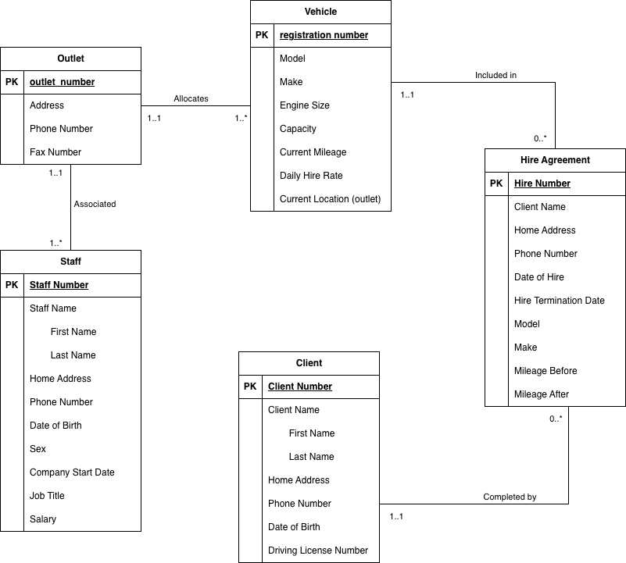

Figure 1: Conceptual E-R Diagram for Reliable Rentals Database (generated in Lucidchart)
Note: Please insert the exported Lucidchart E-R diagram image above by replacing the placeholder box. The diagram must show entities as rectangles, attributes as ellipses, relationships as diamonds, and primary keys as underlined attributes, with no foreign keys included as attributes.

Assumptions
All design decisions are based on the case study text. Where the specification was ambiguous or silent, the following assumptions were made:

# | Assumption | Rationale
1 | One outlet per vehicle at a time | A vehicle cannot be in two places at once. The case study states vehicles have a 'current location (outlet)', implying singular allocation.
2 | Clients exist without active hire agreements | A client registers with the company independently of any hire. This supports a 0..* participation from Client to Hire Agreement.
3 | A vehicle may not always be hired | The vehicle's hire status changes over time. Between agreements, a vehicle is idle but still in the system.
4 | Each agreement is per one vehicle and one client | The hire agreement is a binary relationship. One agreement cannot span multiple clients or multiple vehicles.
5 | Mileage before/after refers to hire period | 'Mileage before' = odometer at start of hire; 'Mileage after' = odometer at end of hire. These are attributes of the hire agreement, not the vehicle.
6 | Staff are permanently assigned to one outlet | The case study states 'each staff member is associated with a single outlet', implying no concurrent multi-outlet assignment.
7 | Driving license is a candidate key for Client | License numbers are legally unique per driver, making them a valid candidate key, though clientNo is chosen as PK for system stability.

Summary
This document has presented a complete conceptual data model for the Reliable Rentals vehicle rental system, addressing all six required design steps:

- Step 1 — Five main entities identified: Outlet, Vehicle, Client, Hire Agreement, and Staff.
- Step 2 — Four key relationships identified: Allocates, Included In, Signed By, and Associated With.
- Step 3 — Multiplicity constraints determined and documented in a structured table using UML notation.
- Step 4 — All attributes identified and associated with their respective entities.
- Step 5 — Candidate and primary keys determined for each entity, with justification.
- Step 6 — Conceptual E-R diagram generated (via Lucidchart) showing entities, attributes, and relationships without foreign keys.

All assumptions made during the design process are explicitly documented in the Assumptions section. This conceptual model serves as the foundation for the subsequent logical and physical database design phases.

