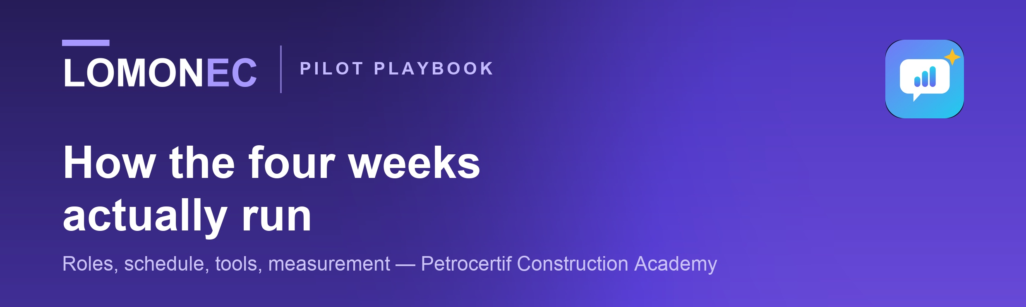
This is the operating manual for the pilot, not the proposal. It exists so that four weeks from now nobody is inventing a form, chasing a name, or arguing about what was supposed to be measured. Everything in it is agreed before week one starts.
01
Named roles — fill these in before day one
A pilot fails when a task belongs to an organisation rather than to a person. Four names, agreed in writing:
ROLE | WHO | WHAT THEY ARE ON THE HOOK FOR
Academy sponsor | ____________________ | Says yes, unblocks things, approves the final report before anyone sees it
Cohort instructor | ____________________ | Knows the learners, gives 10 minutes in week 2 and week 4 for observations
Pilot lead (Lomonec) | ____________________ | Onboarding, weekly figures, the closing report, all learner support
Learner contact | ____________________ | One learner who will tell the truth about what is confusing

Before day one — six things that must be true
Cohort list agreed  20–30 names from the boilermaking, piping or welding supervision programmes. |  | Four roles named  Written down, with an email for each. A role without a name does not get done.
Induction slot booked  20 minutes, with the learners in one place if possible. Everyone installs together. |  | Course-page wording checked  The English promise on the site matches what the app actually does.
Learner guide sent  In French and English, with the induction invitation, not after it. |  | Report approval agreed  Who signs off the closing report, and how long they need.

02
The four weeks
WHEN | WHO | WHAT HAPPENS
Week 0 · setup | Both | Cohort list agreed. Roles named. Course-page wording checked. Learner guide sent.
Week 1 · day 1 | Lomonec | 20-minute induction, in person or on a call. Everyone installs and signs in together.
Week 1 · days 2–5 | Learners | Each learner records ONE workplace answer before practising. This is the baseline.
Weeks 2–3 | Learners | Daily practice in their own time. A weekly figure goes to the sponsor every Monday.
Week 2 · midpoint | Instructor | Ten minutes: what have you noticed, and who has gone quiet?
Week 4 · days 1–3 | Learners | Interview simulations, then the closing measurement — the same task as the baseline.
Week 4 · day 5 | Both | Learner survey and instructor observations collected.
Week 5 | Lomonec | Draft report to the sponsor. Nothing is published without written approval.
THE ONE THING THAT CANNOT SLIP
The week-1 baseline. Without a recorded answer from before any practice, there is no before-and-after and the pilot proves nothing. If a learner joins late, they still record a baseline first.

03
What a learner does
Twenty-five minutes a day, in their own time, on their own phone. No classroom, no timetable, nothing for the academy to schedule.
TIME | ACTIVITY | WHAT IT BUILDS
5 min | Shadowing | Loop a short clip of a real speaker and copy the rhythm out loud
10 min | The day's session | The prepared daily session — pronunciation, a speaking drill, or a meeting simulation
7 min | One workplace conversation | Speak with the supervisor, the QA inspector or HR, and answer out loud
3 min | Read the report | What was covered, what was missed, and the sentence that would have carried it
About ten hours across the four weeks. Once a week they should also run one interview coach — that is the activity closest to what they are actually preparing for.
04
Tools and documents — who gets what, and when
DOCUMENT OR TOOL | GOES TO | WHEN
Pilot proposal | Sponsor and partners | Before the decision
This playbook | Sponsor and instructor | Week 0, once they say yes
Learner guide (EN / FR) | Every learner | Week 0, with the induction invite
The app — app.lomonec.com | Every learner | Week 1 induction, installed together
Instructor observation sheet | Cohort instructor | Week 2 and week 4
Learner feedback survey | Every learner | Week 4, day 5
Weekly figure (one short email) | Sponsor | Every Monday, weeks 2–5
Closing report | Sponsor first, then anyone they allow | Week 5

05
What we measure, and how
MEASURE | HOW IT IS CAPTURED
Activation | Learners who complete setup and record at least one answer
Participation | Learners active in each of the four weeks
Speaking activities | Count of workplace scenarios and interview coaches completed
Recurring usage | Learners returning in week 2, 3 and 4 — the honest retention number
Coverage change | Baseline answer versus closing answer on the same task
Learner feedback | The week-4 survey in Appendix B
Instructor observations | The sheet in Appendix A, at midpoint and at the end
READ BEFORE THE NUMBERS ARRIVE
Some learners will not finish, and the report will say so. A pilot that reports honest attrition is worth more to both sides than one that quietly counts only the people who stayed — and it is the only kind either of us can show to a third party without being caught out.
06
Ground rules
Privacy  Recordings stay on the learner's own device. Only the clip being scored is sent for transcription. No learner personal data is shared with any third party, and no recording is ever sent to the academy. |  | Publication  Nothing is published, quoted or shown to another organisation without the sponsor's written approval — including the academy's name.
Support  All learner support runs through the Lomonec pilot lead, not through academy staff. Instructors are asked for observations, not for help-desk duty. |  | Ending early  Either side can stop the pilot at any point, for any reason, with no cost and no obligation. Learners keep their access for 30 days afterwards regardless.

A
Appendix A · Instructor observation sheet
Ten minutes, twice: once at the midpoint of week 2, once at the end of week 4. Written by the cohort instructor, in whichever language they prefer.
Cohort / programme, and date of this observation
Have you heard any learner mention the app unprompted? What did they say?
Has anyone's spoken English noticeably changed in class? Who, and how?
Who has gone quiet, and do you know why?
What is confusing learners, or what are they complaining about?
Anything a learner asked for that does not exist yet?
Would you keep this in the programme? What would have to change first?

B
Appendix B · Learner feedback survey
Week 4, day 5. Six questions, answered anonymously. English or French.
QUESTION | SCALE
I used the app in a normal week | Never · 1–2 days · 3–4 days · 5+ days
Speaking English at work feels easier than four weeks ago | 1 to 5
The feedback told me something I did not already know | 1 to 5
I would keep using it after the pilot | Yes · No · Not sure
I would recommend it to a colleague | 1 to 5

What stopped you using it more often?
What would you change first?

C
Appendix C · Baseline and closing measurement
The same task, twice, four weeks apart — this is the only comparison in the pilot that shows movement in an individual learner rather than usage of an app.
STEP | WHAT HAPPENS
1 · Same scenario | Every learner runs the same workplace scenario in week 1 and again in week 4
2 · Before practice | The week-1 attempt is recorded before any other activity, on induction day if possible
3 · Recorded by the app | Coverage, the points covered and missed, and the words used are captured automatically
4 · Compared per learner | First attempt against last, learner by learner — not a cohort average hiding the spread
5 · Reported with attrition | Learners who did not complete both attempts are reported as such, never dropped
WHAT THIS MEASUREMENT IS AND IS NOT
It measures how completely someone explained themselves in English against a model answer. It is not a language proficiency test, not a CEFR level, and not evidence of trade competence.

