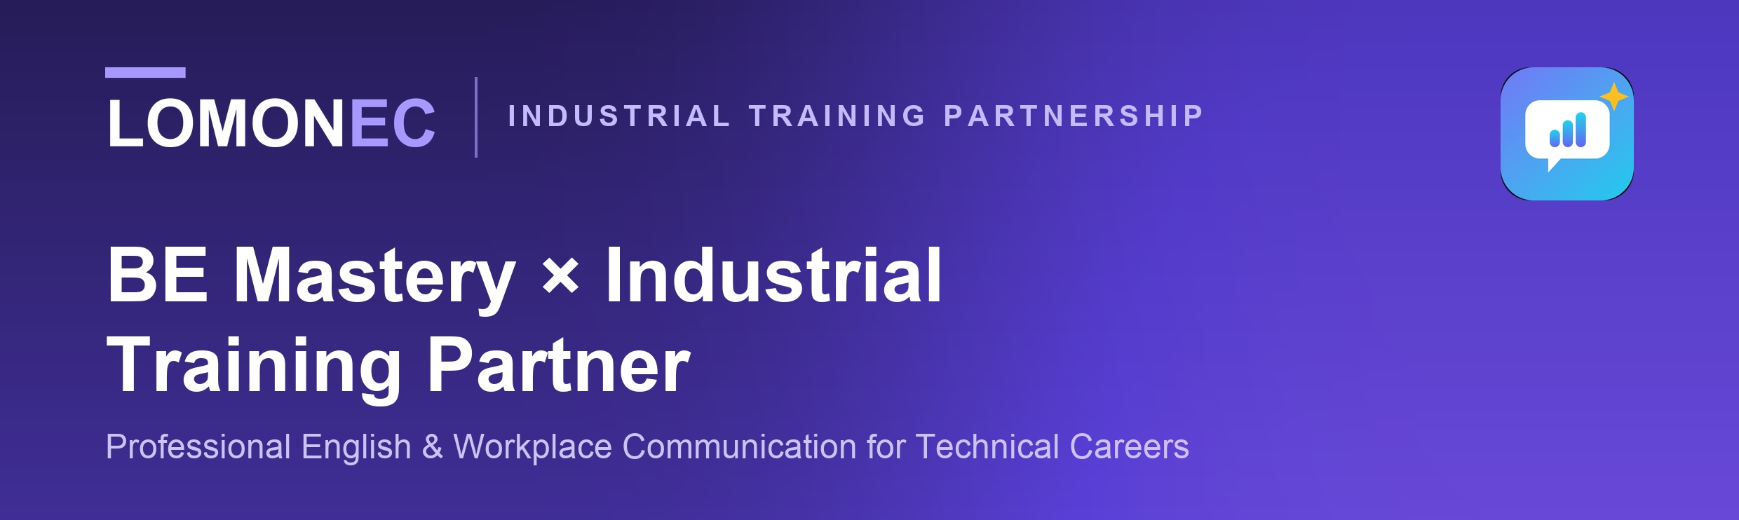
Industrial professionals need more than technical knowledge. They must also explain their work, understand instructions, report problems, discuss safety, communicate with supervisors and inspectors, and perform confidently in professional interviews.
BE Mastery complements an Industrial Training Partner’s technical programs with profession-specific English communication practice.
THE OPPORTUNITY  Technical competence gets the work done. Professional communication helps that competence travel. |  | OUR ROLE  Training Partner  Develops technical capability.  BE Mastery  Helps learners communicate that capability in professional English.

01
What BE Mastery Adds
A voice-first professional communication environment built around realistic industrial situations rather than generic English lessons — safety briefings, shift handovers, equipment checks, drawing clarification, procedure discussions, QA/QC issue reporting, supervisor communication, site coordination and professional interviews.
AI voice simulations  12 workplace scenarios with a five-person cast — HR, supervisor, coworker, safety officer and QA inspector — in one conversation. |  | Technical English & vocabulary  Terminology from welding, fabrication, drawings, procedures, safety and quality, drawn from what the learner actually says.
Personalised coaching  Every spoken answer is measured against what a competent answer needs: what was covered, what was missed, and the sentence that would have carried it. |  | Communication evidence  A record of answers spoken, coverage, best take and the trade words used — every figure from speech, never from opening a screen.
Career preparation  12 interview coaches, each on one part of the professional story, plus destination guidance and a CV & LinkedIn coach. |  | Reaches the learner where they are  Instructions in 15 languages, works offline after first load, installs from the browser on Android and iPhone.

02
Example: International Welder Pathway
The communication layer is aligned to the learner’s technical journey, so practice feels directly connected to the work.
TECHNICAL TRAINING | BE MASTERY COMMUNICATION PRACTICE
Welding procedures / WPS | Explain a procedure and clarify requirements
Safety & HSE | Take part in a safety briefing and a stop-work conversation
Drawings & isometrics | Request and provide technical clarification
Fabrication & equipment | Report equipment or material problems
QA/QC & inspection | Discuss a weld-quality concern with an inspector
Workplace operations | Conduct shift handovers and supervisor briefings
Career preparation | Complete professional welding interview simulations
The same model can later support construction supervisors, piping professionals, QA/QC personnel, maintenance technicians, instrumentation professionals and other industrial occupations.
03
Proposed Pilot Partnership
20–30  LEARNERS |  | 4  WEEKS |  | 1  TECHNICAL PATHWAY

The Industrial Training Partner identifies a learner cohort and continues delivering its normal technical curriculum. BE Mastery provides complementary professional-English missions and workplace simulations aligned with that training.
Success is agreed before the pilot starts, not argued about afterwards. Seven things are measured together:
✓ Activation — learners who start and complete setup  ✓ Participation — learners active across the four weeks  ✓ Speaking activities — workplace simulations completed  ✓ Recurring usage — learners returning week on week |  | ✓ Learner feedback — confidence and perceived usefulness  ✓ Communication evidence — coverage and answer quality over repeated attempts  ✓ Instructor observations — what teaching staff notice in class

THE PILOT QUESTION
Does combining technical education with profession-specific communication practice better prepare learners to operate confidently in professional environments?

04
Partnership Opportunities
Following a successful pilot, the model can grow in whichever direction suits the partner’s programmes.
Student access  Individual learner licences attached to technical programmes. |  | Cohort / institutional  Access for classes, academies and training centres.
Bundled programmes  BE Mastery included as the communication layer of a technical course. |  | Custom pathways  Profession-specific scenarios aligned to partner curricula and learner needs.

05
Why This Partnership Matters
01  Technical training stays technical  The partner keeps ownership of technical instruction, assessment and professional qualification. |  | 02  Communication becomes practice  Learners rehearse the conversations they are likely to face around the workshop, the site and the interview table. |  | 03  Progress becomes visible  Speaking activity, practice history and coaching evidence let learners show how their communication has developed.

06
Scope, Integrity & Expansion
BE Mastery does not replace technical training, professional licensing, trade certification, immigration requirements or employer qualification processes. Its role is deliberately focused: professional English, workplace communication practice, and evidence of communication development.
EXPANSION POTENTIAL
International Welder → Piping → Construction Supervision → QA/QC → Maintenance → Instrumentation → Energy & Industrial Operations

Preparing technical professionals to communicate across workplaces, teams and borders.
