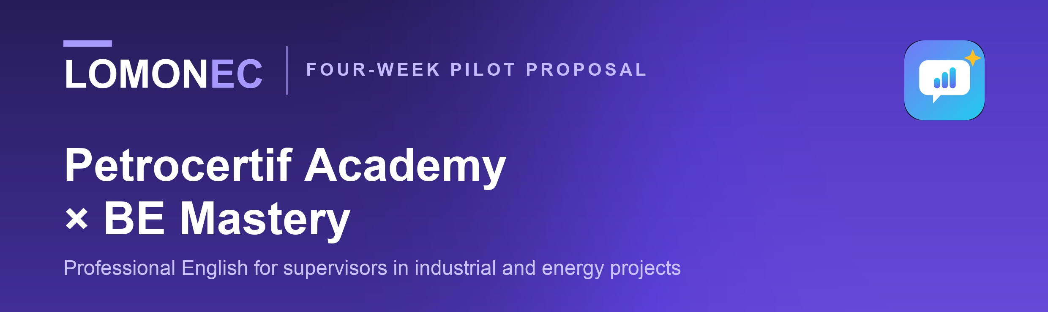
Petrocertif Construction Academy already tells its learners they will strengthen their professional English through the LomoneC app. This proposal is about making that line true, visible and measured — starting with one cohort, at no cost, over four weeks.
ALREADY IN YOUR PUBLISHED OFFER
“Enhance your professional English skills … and a shadowing approach via our LomoneC App: app.lomonec.com” — Petrocertif Construction Academy course offer. The app is live, free and already carries the welding, pipefitting and boilermaking trades. What is missing is evidence of what it does for your learners.

01
Why this matters for supervisors specifically
Your programmes train people to read the plan. On an international site, the supervisor is then the person who has to say it out loud: brief the crew from that drawing, raise a fit-up problem with the fabricator, discuss a weld-quality concern with an inspector, hand over a shift, and sit the interview that got them there in the first place.
Reading is taught. Saying it is not. That gap is what BE Mastery is built for.
Voice-first, not lessons  12 workplace scenarios with a five-person cast — HR, supervisor, coworker, safety officer and QA inspector — talking in one conversation. |  | Measured against a real answer  Every spoken answer is scored on what a competent answer needed: what was covered, what was missed, and the sentence that would have carried it.
Interview rehearsal  12 interview coaches, each on one part of the professional story, plus destination guidance and a CV & LinkedIn coach. |  | Evidence, not attendance  Answers spoken, coverage, best take, trade words actually used. Every figure comes from speech — nothing is scored from opening a screen.
Reaches your learners  Instructions in 15 languages including French, works offline after first load, installs from the browser on Android and iPhone. |  | Free during the pilot  No licence, no per-seat cost, no commitment beyond the four weeks. You supply the cohort; we supply the measurement.

02
Where it fits your catalogue today
BE Mastery currently carries three trades: welder, pipefitter and boilermaker. Those map exactly onto three of your programmes, which is why the pilot is scoped to them rather than spread across the catalogue.
YOUR PROGRAMME | WHAT THE LEARNER PRACTISES SAYING
Reading & Interpretation of Plans in Boiler Making | Brief a crew from the drawing; clarify a detail with the fabricator
Industrial Piping Supervisor | Walk a contractor through an isometric and confirm the line is right
Welding Production Supervision | Discuss a weld-quality concern with a QA inspector; run a stop-work conversation
Boiler & Pressure Vessel Equipment Supervisor | Conduct a shift handover and a supervisor briefing
Storage Tank Supervisor | Run a toolbox talk; report a material or equipment problem
All of the above | Sit the supervisory interview before it counts, as often as they like
THE EXPANSION, IF THE PILOT WORKS
Electrical, civil, instrumentation, renewable energy and metal structures are not yet built as BE Mastery tracks. The pilot decides which one is built next, and Petrocertif chooses it.

03
The pilot — 20 to 30 learners, four weeks, free
PETROCERTIF PROVIDES  ✓ One cohort of 20–30 learners from the three programmes above  ✓ One induction slot of 20 minutes, to introduce the app  ✓ Instructor observations — what teaching staff notice in class  ✓ Permission to write up the result as a joint case study |  | BE MASTERY PROVIDES  ✓ Full access for every learner, free, for the pilot and 30 days after  ✓ Onboarding and a short guide in French and English  ✓ A weekly figure sent to you — no chasing required  ✓ A closing report you may show to anyone, and its underlying data

WEEK | WHAT HAPPENS
Week 1 | Induction, accounts created, first recorded answer captured as the baseline
Weeks 2–3 | Learners practise in their own time — 25 minutes a day is the design target
Week 4 | Interview simulations, closing measurement, learner and instructor feedback
After | Joint report. Nothing is published without Petrocertif's written approval

04
What we agree to measure
Success is agreed before the pilot starts, not argued about afterwards. Seven things, reported together:
✓ Activation — learners who start and finish setup  ✓ Participation — learners active across the four weeks  ✓ Speaking activities — workplace scenarios completed  ✓ Recurring usage — learners returning week on week |  | ✓ Learner feedback — confidence, and whether it felt useful  ✓ Coverage change — first recorded answer against last  ✓ Instructor observations — what your staff notice in class

THE ONE QUESTION THE PILOT ANSWERS
Does adding profession-specific spoken-English practice to a Petrocertif programme measurably improve how confidently a supervisor explains their work in English?

05
What each side gets out of it
Petrocertif Construction Academy  The English line in your course offer stops being a promise and becomes an evidenced benefit, with a report you can show learners, employers and partners. First choice of which discipline is built next. No cost and no commitment. |  | Lomonec / BE Mastery  The first measured cohort, and the evidence needed before approaching any other training organisation. Honest product feedback from instructors who know the trade.

06
Scope, integrity and data
BE Mastery does not replace technical training, professional licensing, trade certification, immigration requirements or employer qualification processes. Its role is deliberately narrow: professional English, workplace communication practice, and evidence of communication development.
TWO THINGS TO STATE PLAINLY
The certificate BE Mastery issues is a completion certificate for its 84-session programme. It is not a recognised English proficiency qualification, and the app does not assess written English. Recordings stay on the learner's own device; only the clip being scored is sent for transcription, and no learner personal data is shared with any third party. Both points are worth reflecting in the course page wording before the cohort starts.

One cohort. Four weeks. No cost, no licence discussion, and nothing published without your approval.


