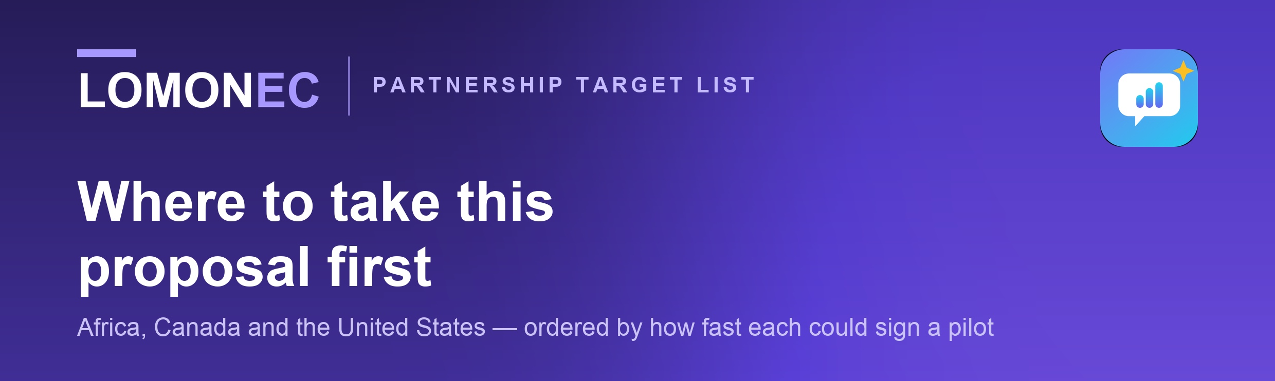
INTERNAL — NOT FOR CIRCULATION
This is the working list, not the pitch. It contains the order of attack and the reasons behind it. The document to send a partner is the partnership proposal; send that one.

01
How this list is ordered
Speed to a signed pilot comes from three things: the organisation’s stated mission already depends on English, there is one decision-maker rather than a procurement process, and you can name a peer they respect. That points away from large employers and government ministries, and toward welding certification bodies and newcomer-bridging charities.
THE FRAMING THAT MAKES THIS EASY
There are no pilot results yet, so nothing here is a product sale. Every approach offers a free, four-week, measured cohort. That is a far easier yes, and it is the thing that produces Case Study #1.

02
Tier A · Africa — weeks, not months
These are IIW and AWS certification bodies. Their purpose is certifying welders to international standards for international work, so their graduates meet the English wall the moment they apply abroad. They already know it.
A1 The Welding Federation Africa (WeldFA)
Highest leverage on this page. A continental umbrella of 14 national welding societies — Nigeria, Egypt, South Africa, Ethiopia, Uganda, Namibia, Morocco, Libya, Cameroon, Kenya, Ghana, Senegal, Tunisia. One conversation can introduce a dozen national bodies.
info@weldfa.org · +27 79 714 9277 · weldfa.org/contacts-weldfa/
SAIW, 52 Western Boulevard, City West, Johannesburg 2092

A2 Cameroon Welding Association (CamWeldAs)
Home ground and the fastest possible yes. IIW-accredited since 2012, running IIW International Welder through Welding Engineer diplomas. You can meet them in person, which is worth more than ten emails.
training@cmrweldas.com · cmrweldas.com/contact/ · Douala and Yaoundé

A3 Nigerian Institute of Welding (NIW-ANB)
IIW Authorized National Body, accredited 2012, issues International Welder diplomas. Largest anglophone industrial market in West Africa, and it publishes a named contact — rare, and it means less bouncing between inboxes.
Ayorinde A. Adeniyi · management@niganb.com · +234 803 223 1653 · Benin City

A4 East African Institute of Welding (Kenya)
The bridge organisation. Trains to IIW standards and is accredited by the Canadian Welding Bureau as well as Kenya’s TVETA. If the pilot works here, the same story sells in Canada — and they can make that introduction.
welding-institute.com

A5 Design and Technology Institute, Accra
Commissioned Africa’s first AWS-certified welder training and testing centre — 40 booths, digital simulators, metallurgical lab — explicitly to place Ghanaian welders globally. Founder-led, so one decision-maker.
dtiafrica.com · founder Constance Elizabeth Swaniker · Accra

Africa first is not only convenience: the users are already francophone African, the app already runs in French, and the welding track already exists. Nothing new has to be built to serve these five.
03
Tier B · Canada — one to three months
Slower, but the mandate fit is sharper and there is a specific opening.
B1 Skills for Change / WeldUp — Toronto
The single best-argued pitch anywhere on this list. WeldUp is a bridging programme for internationally trained welders, run with the CWB Group and funded by Ontario’s Ministry of Labour, Immigration, Training and Skills Development. It requires Canadian Language Benchmark 6 or higher to enrol. That gate is the pitch: every internationally trained welder turned away at CLB 5 is someone BE Mastery is built for. You are not competing — you are their on-ramp, and retention support for the ones who scrape in. Ask for one sentence in the rejection email.
+1 416 658 3101 · 1655 Dupont St, Toronto, Ontario M6P 3S9 · skillsforchange.org/weldup/

B2 CWB Group  Runs the Milton training site behind WeldUp and accredits the East African Institute in Kenya. Use that accreditation link as a warm introduction from Africa into Canada — in that direction. |  | B3 Ontario OSLT colleges  George Brown, Conestoga, Centennial, Niagara, Georgian and Fanshawe run free IRCC-funded Occupation-Specific Language Training, including Construction Skilled Trades streams. This is your product, delivered by people.

VERIFY BEFORE BUILDING A PITCH ON THIS
Search results indicate IRCC funding for OSLT delivery ends around September 2026. I could not confirm it — one college page returned 404 and another blocked automated access. If it is true, six colleges are about to lose funded occupational language training and would need a cheap replacement: a strong and time-limited hook. Phone one college and ask before you lead with it.

04
Tier C · United States — three to six months, grant-bound
The model here is VESL / I-BEST: vocational English fused with trade training. It already exists, so BE Mastery is an enhancement rather than a new idea. These move on grant cycles and will want evidence you do not yet have — approach them after Tier A produces numbers.
Grand Rapids Community College  Runs a One Workforce welding programme specifically for English language learners, with the Hispanic Center of West Michigan. The closest US match to what you built. |  | LaGuardia CC — Center for Immigrant Education and Training  National leader in the I-BEST model: integrated ESOL plus an occupational certificate, in one course.
Mt. Hood Community College, Oregon  Integrated language-and-workforce courses, welding among them. |  | Upwardly Global  18,000+ immigrant professionals supported, 150+ employer partners, and a curriculum already covering professional communication and interview preparation. Embeds its resources inside IRC local offices, so one yes propagates.

05
Two segments deliberately left unnamed
Overseas recruitment agencies  On paper the sharpest pain — their placements fail on interviews, not welds. But searches returned mostly SEO-driven operators that cannot be vouched for, and parts of that industry exploit migrant workers. Reach them through WeldFA members’ own referrals, where someone credible is staking their name. |  | Large EPC contractors and TVET ministries  Real budgets, wrong timing. Procurement, security review and data-protection assessment will consume the months that should go into getting a first cohort measured.

06
How to make the approach
STEP 1 Send five sentences, not the proposal in the body.
Who you are; that BE Mastery is the professional-English layer for technical training; that you are running a free four-week pilot with 20–30 learners; the one question the pilot answers; a request for 20 minutes. Attach the proposal as PDF.

STEP 2 Change four things per recipient — nothing else.
“Industrial Training Partner” becomes their name throughout; the International Welder pathway table becomes their flagship programme; the cohort size fits one of their classes. The document was built to be edited for exactly this.

STEP 3 Lead with their gate, not your features.
Skills for Change: CLB 6. CamWeldAs: IIW graduates failing overseas interviews. DTI: AWS-certified and globally placeable — in English. Section 03’s pilot question does the closing; the feature cards are there to be scanned, not read.

STEP 4 Ask for the smallest possible yes.
One cohort, four weeks, free, you supply the measurement. No licence discussion until Case Study #1 exists.

TWO CAUTIONS
Do not cite JFN / Petrocertif as a reference until you have their written permission and actual numbers — a named reference that evaporates costs you the second meeting. And keep the scope paragraph in Section 06 of the proposal exactly as written: certification bodies read it first, and it is the sentence that makes you a partner rather than a threat.

Sources — every organisation, email and phone number above was taken from that organisation’s own published pages in September 2026: weldfa.org · cmrweldas.com · niganb.com · welding-institute.com · dtiafrica.com · skillsforchange.org/weldup · georgebrown.ca · grcc.edu · laguardia.edu · upwardlyglobal.org

