Project Title:
AI Data Analyst Assistant (Copilot)

1. Introduction
In the modern digital era, data plays a crucial role in decision-making across industries such as finance, healthcare, e-commerce, and marketing. Organizations collect vast amounts of data daily, but extracting meaningful insights from this data requires technical expertise in SQL, data processing, and visualization tools.
Traditional data analysis methods are time-consuming and require skilled professionals. Many non-technical users, such as managers and business executives, find it difficult to interact with databases directly.
This project introduces an AI-powered Data Analyst Assistant (Copilot) that simplifies data analysis by allowing users to interact with data using natural language. The system automates SQL query generation, data retrieval, visualization, and insight generation, making data analysis accessible to everyone.

2. Problem Statement
Data analysts spend approximately 60–70% of their time performing repetitive tasks such as:
- Writing SQL queries
- Extracting and cleaning data
- Generating reports and dashboards
This leads to:
- Reduced productivity
- Delayed decision-making
- Increased dependency on technical experts
There is a need for an intelligent system that can automate these tasks and allow users to interact with data in a simple and intuitive way.

3. Objectives
The main objectives of this project are:
- To develop an AI system that understands natural language queries
- To automatically convert user queries into SQL statements
- To retrieve data from a structured database
- To generate meaningful visualizations such as charts and graphs
- To provide textual insights and summaries based on the data

4. Features
The proposed system will include the following features:
- Natural Language Processing: Users can ask questions in plain English
- Automatic SQL Generation: Converts queries into SQL without manual coding
- Database Integration: Works with structured databases like SQLite or DuckDB
- Data Visualization: Generates charts such as bar graphs, line charts, etc.
- Insight Generation: Provides summaries and trends from the data
- Interactive User Interface: Built using Streamlit for ease of use
- Error Handling: Detects and corrects SQL errors automatically

5. System Architecture
Architecture Diagram:
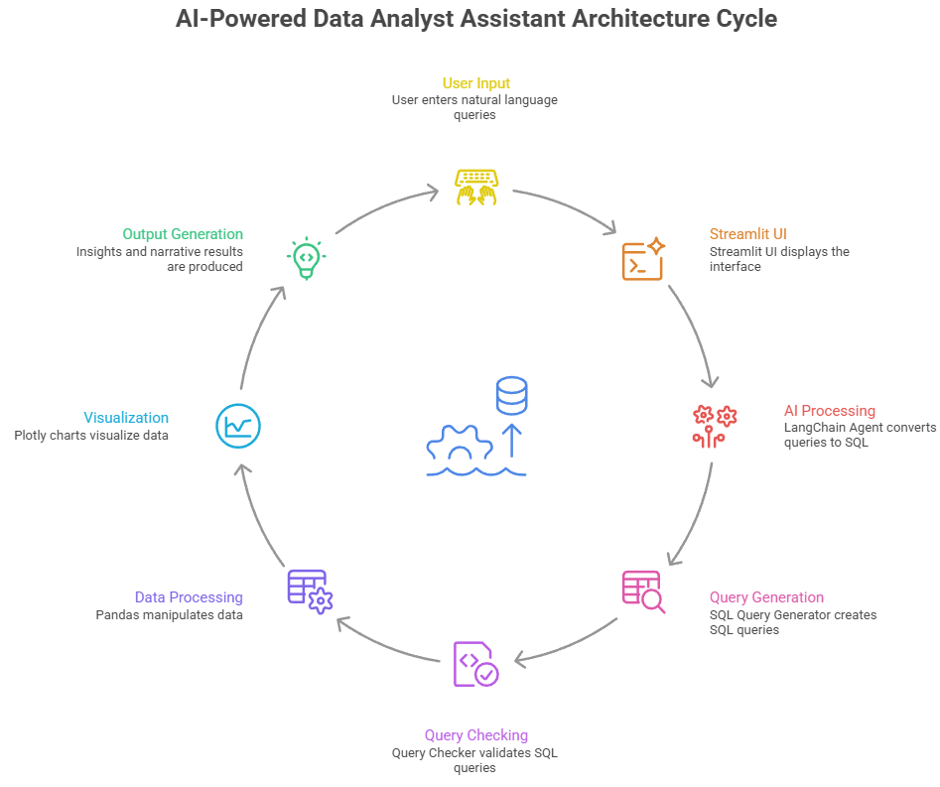
Architecture Explanation:
- The user enters a query in natural language
- The AI model processes the query using LangChain
- The system generates an appropriate SQL query
- The query is executed on the database
- Data is retrieved and processed using Pandas
- Visualization is created using Plotly
- Final results, including charts and insights, are displayed to the user

6. Tools and Technologies Used
Component | Technology
Programming Language | Python
Frontend | Streamlit
AI Framework | LangChain
Database | SQLite / DuckDB
Data Processing | Pandas
Visualization | Plotly

7. Scope of the Project
This project focuses on building a Minimum Viable Product (MVP) with the following scope:
- Use of a local database with sample data
- Read-only database access for safety
- Handling of basic to intermediate analytical queries
- Generation of simple visualizations
Future improvements may include:
- Real-time database integration
- Advanced analytics
- Multi-user support
- Cloud deployment

8. Team Roles
- Backend Developer: Handles database setup and data processing
- AI Engineer: Develops LangChain agent and SQL generation logic
- Frontend Developer: Designs Streamlit interface and visualizations

9. Expected Outcomes
The expected outcome of this project is a functional AI assistant that can:
- Understand user queries in natural language
- Generate SQL queries automatically
- Retrieve and process data efficiently
- Display interactive charts and graphs
- Provide meaningful insights for decision-making

10. Conclusion
The AI Data Analyst Assistant aims to revolutionize the way users interact with data by removing the need for technical expertise in SQL and data visualization. By automating repetitive tasks and simplifying data access, this system improves efficiency, reduces workload, and enables faster and smarter decision-making.
This project demonstrates the potential of combining AI with data analytics to create intelligent and user-friendly systems.

