Full stack Engineering

Project Report
Semester-VII (Batch-2022)

“TOMATO-A Food Delivery Website”



Supervised By: Submitted By:
Mr. Sudeep Saloni,2210992231(G-19)
Saloni Kumari,2210992232(G-19)
Samreen Kaur,2210992240(G-19)
Samridhi Sachdeva,2210992243(G-19)

Department of Computer Science and Engineering
Chitkara University Institute of Engineering & Technology,
Chitkara University, Punjab


Index

Sr. no Topic Page No
1 Title of project 03
- Objective & Key Learning’s 03
3 Problem Statement 03
4 Software Requirements 04
5 Proposed Design / Methodology 05
6 Core Features & Functionality 06
7 Code Snippets 07

8 Project Snippets 09

9 References 12



1.Title of Project :
"Tomato: Revolutionizing Convenient and Efficient Dining Experiences"

2. Objective & Key Learning’s :
Objective:
The primary objective of this project is to design and develop a food delivery application that provides users with a seamless experience for ordering meals. The system aims to:
- Support a diverse range of restaurant options.
- Offer real-time order tracking for enhanced transparency.
- Store and manage order history for easy reference.
- Display personalized recommendations based on user preferences.

Key Learning’s:
- Database Management: Storing user profiles, chat history, and real-time updates.
- Scalability: Designing a scalable system architecture for handling concurrent users.
- User Interface (UI) Design: Building an intuitive and user-friendly interface.
- Security: Implementing secure messaging features like end-to-end encryption, authentication, and data protection.


3.Problem Statement:
In today's fast-paced world, quick and reliable access to food is a critical necessity for individuals with busy lifestyles. Existing food delivery platforms often fall short in providing an intuitive, seamless experience. Common challenges include inefficient navigation, lack of real-time order tracking, limited restaurant options, and absence of personalized features that cater to individual preferences.
- There is a growing demand for a modern food delivery application that overcomes these
limitations by offering a user-friendly interface, a wide selection of restaurants, personalized recommendations, and instant updates on order status. By addressing these needs, the application can enhance the overall dining experience, providing convenience and efficiency to users.

4. Software Requirements:
To develop the food delivery website using MERN Stack, the following software tools and technologies are required:
a. Frontend Technologies:
- React.js: A widely used JavaScript library for building user interfaces with reactive
- HTML/CSS: For basic structure and styling.
b. Backend Technologies:
- Express.js: A lightweight and fast Node.js framework for building robust APIs and handling server-side logic.
- APIs: Used for facilitating communication between the frontend and backend, enabling seamless data exchange.
- Axios: A popular library for making HTTP requests to APIs, ensuring efficient communication between the client and server.
- Middleware: Implemented to handle tasks like authentication, request parsing, and error handling efficiently.


- MongoDB: A NoSQL database for storing and managing user profiles, order history, and menu data.

5. Proposed Design / Methodology
Project Planning & Research
- Define Target Audience: Understand who the website is for (e.g., urban professionals, students, families) and their needs (convenience, variety, speed, cost).
- Market Research: Analyze competitors (UberEats, DoorDash, Grubhub) to identify features, design trends, and functionality.
- Establish Business Requirements: Determine key features like restaurant listings, delivery tracking, payment systems, etc.
- Set Milestones & Timeline: Break the project into phases: Discovery, Design, Development, Testing, Launch.

UX/UI Design
- Wireframing & Prototyping:
  - Tools: Figma, Adobe XD, or Sketch.
  - Design wireframes for key pages: homepage, restaurant page, menu, cart, checkout, user profile, etc.
- Information Architecture: Organize content for intuitive navigation. Structure the content for easy browsing of restaurants, menus, and categories (cuisine type, ratings, prices).
- User Flow Design:
  - Homepage → browse restaurants → select items → add to cart → checkout → payment → delivery tracking → confirmation.
- Visual Design:
  - Branding: Choose color schemes, typography, logo design, and imagery .


6. Core Features & Functionality:
- Homepage & Search Bar:
  - Search by restaurant, cuisine, location, or dish.
  - Filters for ratings, price range, and dietary preferences.
- Restaurant Listings:
  - Display a list of restaurants with thumbnails, ratings, cuisine type, and distance.
  - Option to sort/filter by popularity, delivery time, or price.
- Restaurant Menu:
  - Display menus with prices, images, and descriptions.
  - Allow customization options (e.g., add toppings, size, etc.).
- Cart & Checkout:
  - Users can view selected items, edit quantity, or remove items.
  - Option for promo codes, gift cards, and user rewards.
  - Integration with secure payment gateways (PayPal, Stripe, credit card options).
- User Account:
  - Sign up/login (using email or social accounts).
  - Order history, saved addresses, payment methods, and preferences.
  - Ability to track orders in real-time with delivery ETA.
- Order Tracking:
  - Real-time order status (placed, preparing, dispatched, delivered).
  - Map view of delivery progress.
- Ratings & Reviews:
  - Allow customers to rate and review restaurants and dishes.
  - Use reviews to enhance credibility and guide future customers.
- Admin Panel:
  - Dashboard to manage restaurant listings, menus, orders, payments, and customer feedback.


- Notifications:
  - Email or push notifications for order updates, delivery statuses, and promotional offers.

7.Code Snippets:
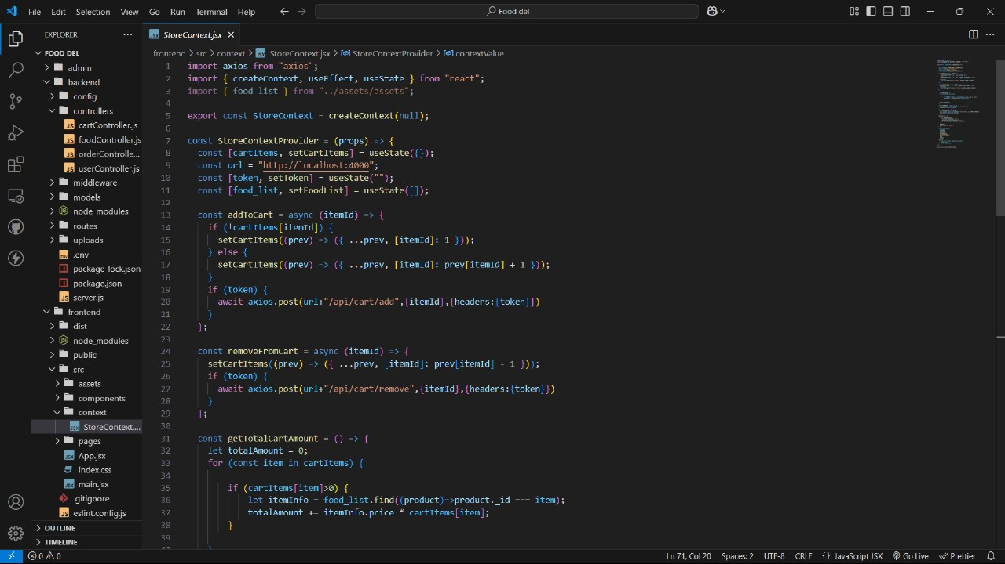


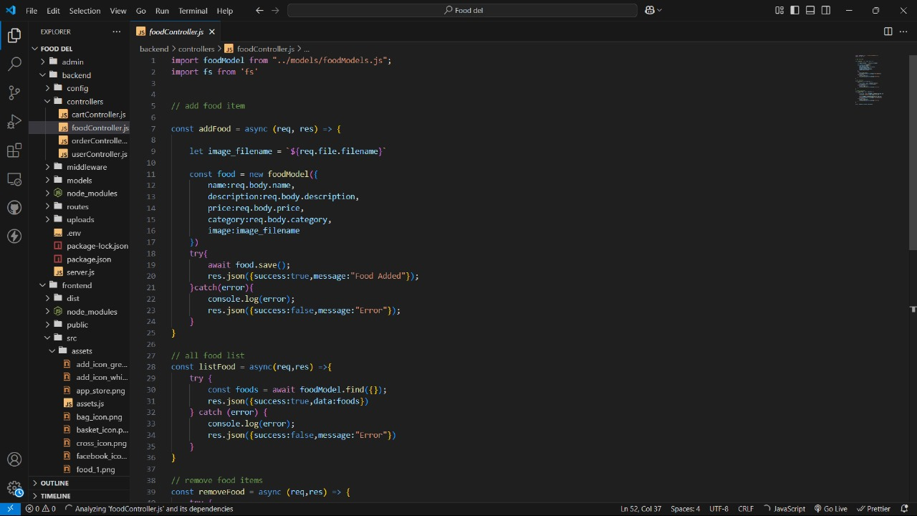

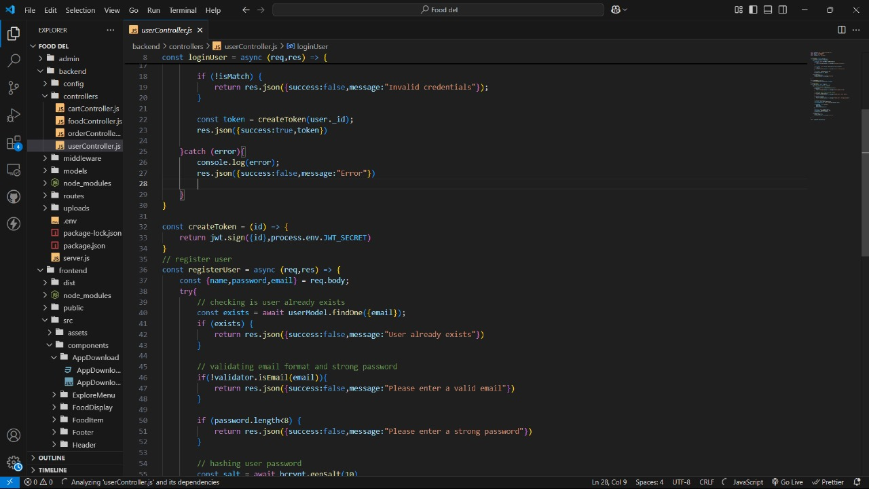


8. Project Snippets:
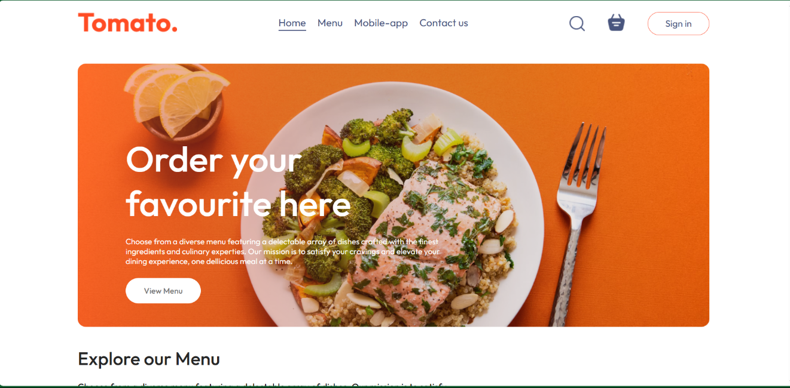
Figure 1 Home page

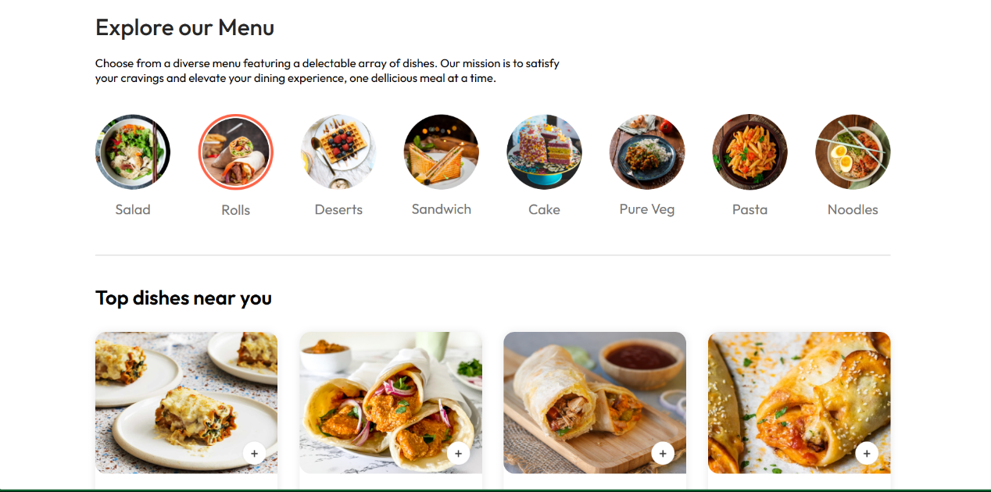
Figure 2 Menu page



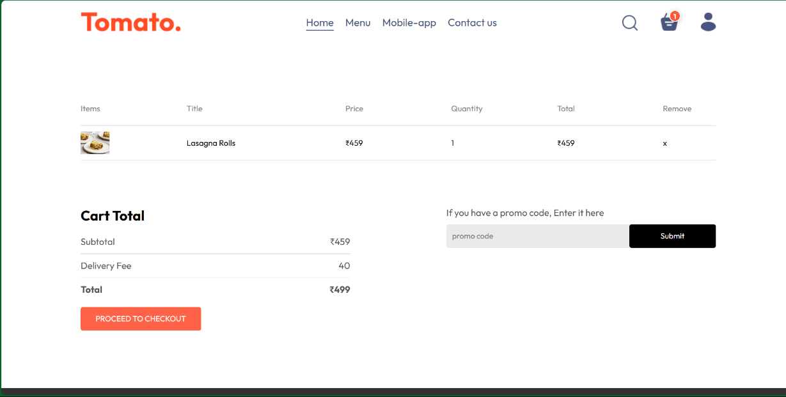
Figure 3 Cart page

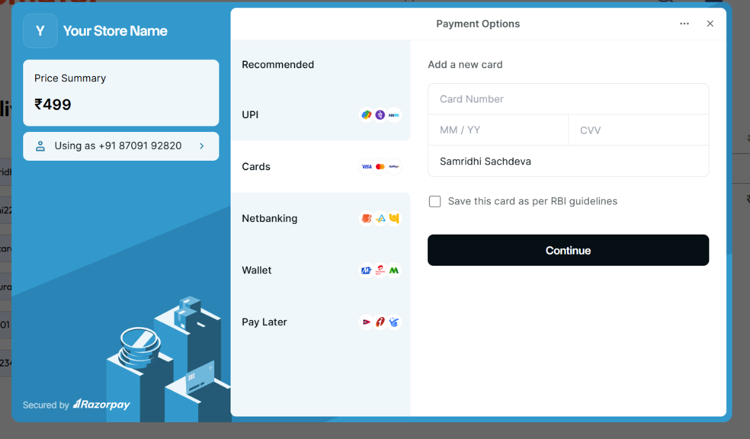
Figure 4 Payment


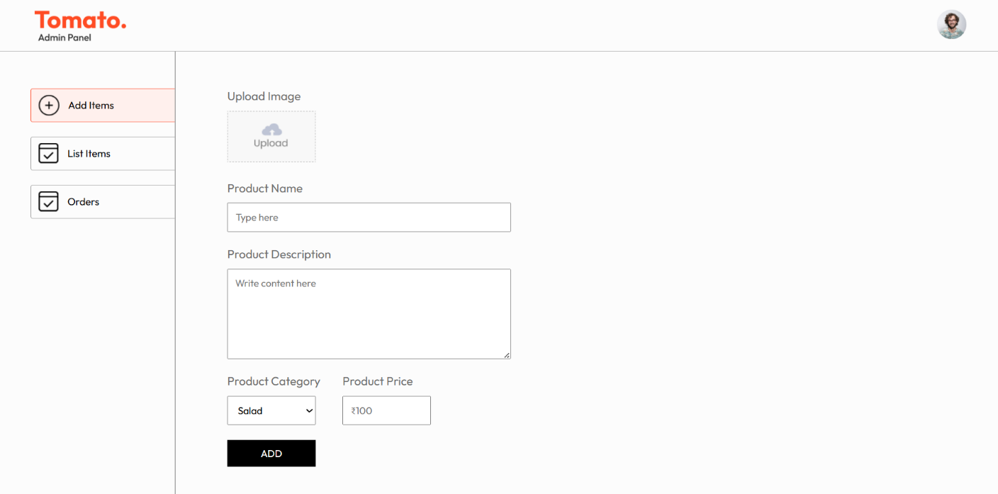
Figure 5 Admin Pannel



9. References
- Node.js Official Site: Comprehensive documentation and guides for backend development using Node.js. (nodejs.org)
- Express.js Documentation: Official reference for using Express.js to build server-side logic and APIs. (expressjs.com)
- MongoDB Documentation: Resources for database integration and data management. (mongodb.com/docs)
- Axios GitHub Repository: Details on Axios library for API requests. (github.com/axios/axios)
- React Documentation: Guides and tutorials for building user interfaces. (react.dev)
- W3Schools HTML/CSS Tutorials: For foundational web development knowledge. (w3schools.com)

