MEDISCOPE
Hospital Intelligence & Performance Analytics
BUSINESS ANALYSIS REPORT
Project review • Power BI dashboard • Data analysis & findings
Prepared by Saloni Patel
updated on 28 October 2026
Portfolio case study based on the supplied Power BI dashboard and Excel source files

Table of Contents
Section | Contents | Page
1 | Executive Summary | 3
2 | Project Overview & Dashboard Pages | 3
3 | Project Phases — Work Completed | 4
4 | Data Analysis & Key Findings | 5–6
5 | Recommendations & Business Value | 7
6 | Conclusion | 7
Appendix | Source Files & Interpretation Notes | 7–8

Report focus: what was reviewed, what was analyzed, what the data showed, and what actions the findings suggest. This report is written as a completed project summary—not a project initiation or requirements-planning document.

1. Executive Summary
MediScope is a hospital operations and finance analytics case study using a Power BI dashboard and seven Excel workbooks. The dashboard brings together patient information, billing, doctor-related indicators, appointments, diagnostic tests, medicine usage, inventory, and bed status. The analysis focused on understanding what the dashboard communicates, checking key figures against the supplied workbooks, and identifying the business meaning and data-quality limitations behind the reported metrics.
Headline metric | Observed result | Business interpretation
Patient records | 30 | Small sample; useful for demonstrating dashboard analysis, not for hospital-wide generalization.
Bill-line value | 727,105 | Largest value categories are Surgery and Room; currency and accounting meaning are not confirmed.
Average patient age | 45.57 years | Descriptive profile of the sample only.
Bed snapshot | 16 Available; 9 Occupied | 64% available and 36% occupied in this supplied snapshot; not a historical utilization rate.
Appointments | 30 Completed; 5 Scheduled | Status distribution in the 35 appointment records.
Medicine usage | 3,928 total quantity across 517 rows | Usage quantity is not the same as staff count or revenue.

Overall takeaway
The dashboard offers a useful consolidated view across hospital functions. The strongest evidence-led finding is that Surgery and Room charges dominate the bill-line values. The most important caution is that some headline metrics need reconciliation: the two patient-status columns disagree, doctor salary can be double-counted when repeated across patient rows, and inventory expiry dates are historical relative to October 2026. These issues should be clearly addressed before the dashboard is used for real operational decisions.

2. Project Overview & Dashboard Pages
The supplied Power BI file and repository README describe a multi-page dashboard with a navigation/cover page and pages focused on overview, patients, doctors, hospital operations, and finance. The source files cover the operational domains below.
Dashboard area | What was reviewed / analyzed | Business use
Overview | Patient profile, status/discharge indicators, charge breakdown, and medicine patterns | Quick management snapshot and identification of major activity/value drivers.
Patients | Patient-level details, charges, medicine quantities, and feedback fields | Understand sample patient characteristics and cost/experience patterns.
Doctors | Doctor-linked activity, commission, and compensation fields | Review doctor-related activity while checking aggregation grain.
Hospital operations | Beds, appointments, tests, and inventory fields | Capacity, scheduling, diagnostic workflow, and stock visibility.
Finance | Bill charge categories, payment status, doctor compensation, and stock/supplier information | Charge mix and financial interpretation, subject to reconciliation.

3. Project Phases — Work Completed
The work is presented in the order a Business Analyst would typically carry out and document the project. These are phases of the completed review, not a proposal for future project delivery.

Phase 1 — Business understanding
- Identified the dashboard’s business purpose: provide a combined view of patient flow, billing, doctor-related indicators, appointments, diagnostic tests, beds, medicine usage, and medical inventory.
- Mapped the dashboard areas to the decisions they could support: service and capacity monitoring, charge-mix review, appointment visibility, and stock follow-up.

Phase 2 — Data familiarization and source review
- Reviewed seven Excel workbooks: patient_info, bills, medicine_patient, patient_tests, appointments, medical_stock_info, and Beds.
- Checked record counts, key fields, status categories, bill values, bed statuses, appointment/test statuses, medicine quantities, and stock expiry fields.
- Noted that patient_info contains direct identifiers and sensitive fields; such data should not be exposed in a public portfolio version.

Phase 3 — Dashboard review and analytical checks
- Reviewed the documented dashboard sections and compared selected dashboard headline figures with calculations from the source workbooks.
- Summarized bill-line values by charge type, compared the two patient-status fields, reviewed the bed-status snapshot, and checked how repeated doctor salary values affect aggregation.

Phase 4 — Findings and interpretation
- Separated what the source data directly shows from interpretations that need confirmation, such as whether bill-line values represent recognized revenue or collected cash.
- Identified reconciliation and freshness issues that can materially change how stakeholders interpret KPIs.

Phase 5 — Recommendations and reporting
- Converted findings into practical actions: standardize status definitions, validate financial semantics, aggregate salaries at the correct grain, label data periods, and protect patient information.
- Documented the findings and recommendations in this report with visual summaries for a portfolio-ready business narrative.

Deliverables from the analysis
Deliverable | Result
Dashboard review | Business purpose and the key analytical areas documented.
Source data profile | Seven workbooks reviewed and important fields/counts summarized.
Finding visuals | Charge mix, patient-status discrepancy, and bed-status snapshot charts.
Data-quality observations | Conflicting status values, salary aggregation risk, old stock expiry dates, and privacy concern recorded.
Action-oriented conclusion | Recommended next steps linked directly to observed findings.

4. Data Analysis & Key Findings

Finding 1 — Surgery and Room are the largest bill-line categories
The 210 rows in bills.xlsx sum to 727,105 across seven charge categories. Surgery contributes 430,000 (about 59.1% of the total) and Room contributes 174,000 (about 23.9%). Together they represent about 83.0% of the recorded bill-line value. This suggests that surgery-related and room-related charges are the largest categories to examine when explaining the value mix.
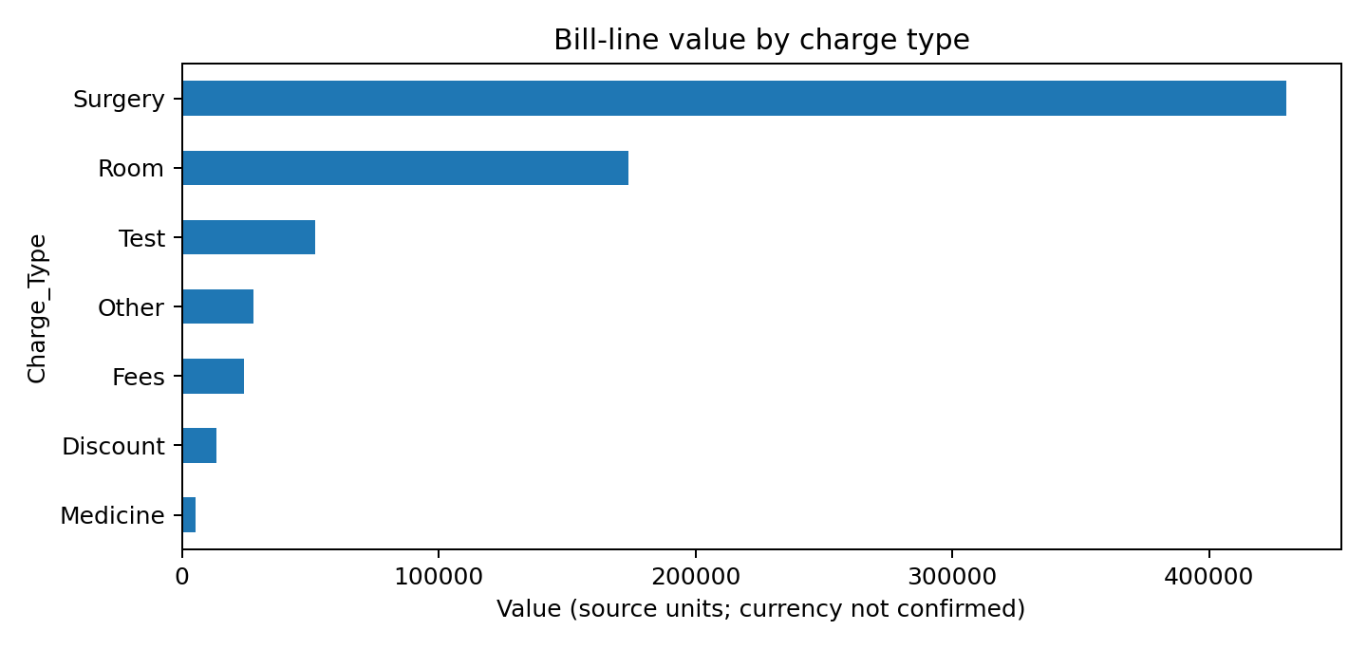
Interpretation caution: the workbook labels every row “Paid,” but charge lines include discounts and zero values. The 727,105 total should therefore be described as summed bill-line value—not automatically as net revenue or cash collected. Currency is not specified in the supplied workbook.

Finding 2 — Patient status is inconsistent across two fields
The patient_status field records 22 Discharged and 8 Admitted patients (73.3% discharged). The separate patient_admission_status field records 21 Discharge and 9 Admitted. The one-record difference is enough to make the discharge KPI ambiguous until the intended field and definitions are confirmed.
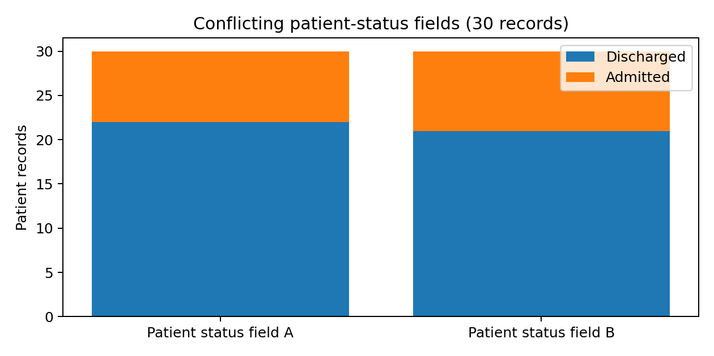

4. Data Analysis & Key Findings (continued)

Finding 3 — Bed snapshot shows 16 available and 9 occupied beds
The Beds workbook contains 25 records: 16 marked Available and 9 marked Occupied. In this snapshot, 64% are available and 36% occupied. This is a point-in-time status distribution only; it does not establish average occupancy, bed turnover, or utilization over time.
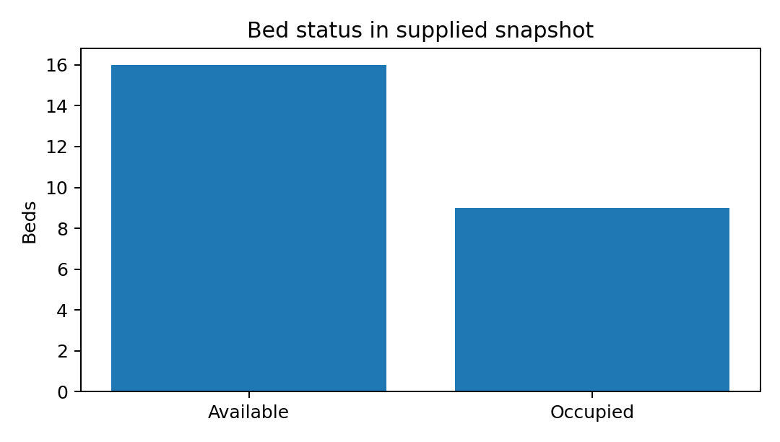

Finding 4 — Doctor salary total depends on aggregation level
Summing doctor_salary across all patient rows gives 4,135,000. Summing distinct doctor ID/salary combinations gives 2,075,000 across 15 doctor IDs. The difference indicates that salary values repeat across patient-level rows. Compensation should be aggregated from a doctor/pay-period-level source, not summed directly from a patient-grain table. The correct amount and salary period still require confirmation.

Finding 5 — Other operational observations
Area | Observed result | What it means
Appointments | 35 records: 30 Completed, 5 Scheduled | The supplied sample has no other appointment statuses. Confirm whether cancellations/no-shows are absent or simply not captured.
Diagnostic tests | 30 records; all marked Completed | This extract cannot show a pending-test backlog; confirm completeness before using it for turnaround monitoring.
Medicine usage | 517 rows; total quantity 3,928 across 15 medicine IDs | Useful for consumption profiling, but quantities need units and period context.
Inventory | 15 stock records; all 15 expiry dates are before 28 Oct 2026 | Treat the inventory as historical/sample data unless refreshed and confirmed. Expired stock must not be counted as usable stock.
Patient feedback | 19 non-null ratings; average 4.16/5 | Descriptive only; the rating response count is smaller than the 30 patient records, so the denominator should be shown.

5. Recommendations & Business Value
Priority | Recommendation | Why it matters
1 | Standardize the patient/admission status definition and use one approved field for discharge reporting. | Prevents inconsistent discharge-rate reporting.
2 | Separate gross charges, discounts, net billed amount, payments received, and outstanding balance. Confirm currency and billing grain. | Avoids presenting a charge total as verified revenue or cash collection.
3 | Calculate doctor compensation from a unique doctor and pay-period table; document the salary period. | Prevents duplicate aggregation and misleading cost totals.
4 | Display bed counts with an as-of timestamp; use occupancy-rate trends only when valid time-based data exists. | Distinguishes snapshot status from utilization performance.
5 | Refresh inventory data and separate expired stock from available/usable stock. | Supports safer procurement and stock decisions.
6 | Use synthetic or safely anonymized data in public screenshots and repository files. | Protects patient privacy and makes the portfolio suitable for public review.
7 | Add metric definitions, source period, and data-quality notes to the dashboard/report. | Helps stakeholders interpret KPIs consistently.

Business value demonstrated
This analysis demonstrates how a Business Analyst can go beyond presenting visuals: understand the business questions, inspect source data, check whether headline metrics reconcile, interpret patterns in business terms, and turn issues into specific actions. The clearest actionable result is the charge-mix concentration; the most important reliability improvement is to reconcile definitions and aggregation logic before using the KPIs for decisions.

6. Conclusion
MediScope consolidates several hospital-related analytical areas into one Power BI dashboard experience. The source-data review found meaningful patterns in billing and useful operational snapshots, while also exposing data-quality issues that affect interpretation. The project’s outcome is a documented business analysis of the dashboard, supported by calculated findings and recommendations. It should be presented as a portfolio case study based on the supplied project files—not as proof of live hospital performance or verified financial outcomes.

Appendix — Source Files & Interpretation Notes
Source workbook | Rows reviewed | Main analytical use
patient_info.xlsx | 30 | Patient profile, status, doctor and satisfaction fields.
bills.xlsx | 210 | Bill-line values by charge type and payment status.
appointments.xlsx | 35 | Appointment status distribution.
patient_tests.xlsx | 30 | Diagnostic test status and amount fields.
medicine_patient.xlsx | 517 | Medicine quantity and usage rows.
medical_stock_info.xlsx | 15 | Stock quantity, supplier, reorder level, expiry.
Beds.xlsx | 25 | Bed status and occupancy fields.

Calculation notes: figures in this report were recalculated from the supplied Excel workbooks. Values are shown in source units where the currency is not specified. The report does not independently certify the Power BI DAX measures, relationships, or Power Query transformations. The source README and project files should be attributed appropriately in any public portfolio release, and any identifiable patient data should be removed or replaced with synthetic data. Dashboard page descriptions are based on the supplied README and workbook fields; the underlying PBIX measures and Power Query logic were not independently audited.

