AURASWEEP
Database Table Structure & Relationships
1. Database Overview
Database Name: aurasweep_db
Database Type: MySQL
Purpose: Stores inspections, inventories, maintenance_requests, notifications, reports, roles, rooms, staff, system_settings, tasks, users.

2. Database Tables
Number | Table_name | Purpose
1 | inspections | Stores inspection records and inspection results for completed work.
2 | inventories | Stores hotel and housekeeping inventory items, quantities, and stock information.
3 | maintenance_requests | Stores maintenance issues, technician assignments, status, and resolution information.
4 | notifications | Stores notifications generated for users during system workflows.
5 | reports | Stores or supports operational report information used by the system.
6 | roles | Stores the roles available in the system, such as Admin, Manager, Supervisor, Housekeeping Staff, and Maintenance Staff.
7 | rooms | Stores hotel room information, room details, and operational room status.
8 | staff | Stores employee/staff information used for operational assignments, attendance, and workload.
9 | system_settings | Stores system-level configuration and settings.
10 | tasks | Stores housekeeping/cleaning tasks, assignments, status, priority, and task information.
11 | users | Stores user login accounts, authentication information, and role association.

1. Database Table Structure

1.1 users
Column | Data Type | Key | Null | Default | Description
id | int(10) unsigned | PK | No | — | Unique ID for each user account.
name | varchar(150) | — | No | — | Stores the user's name.
email | varchar(150) | Unique | No | — | Stores the user's login email address.
password | varchar(255) | — | No | — | Stores the password hash used for authentication.
role_id | int(10) unsigned | FK | No | — | Connects the user to a role in the roles table.
status | enum('active','inactive') | — | No | active | Determines whether the account is active.
created_at | timestamp | — | No | current_timestamp() | Stores when the user account was created.
updated_at | timestamp | — | No | current_timestamp() | Stores when the user account was last updated.

1.2 roles
Column | Data Type | Key | Null | Default | Description
id | int(10) unsigned | PK | No | — | Unique identifier for a system role.
role_name | varchar(100) | Unique | No | — | Name of the system role.
created_at | timestamp | — | No | current_timestamp() | Stores when the role was created.
updated_at | timestamp | — | No | current_timestamp() | Stores when the role was last updated.

1.3 staff
Column | Data Type | Key | Null | Default | Description
id | int(10) unsigned | PK | No | — | Unique identifier for a staff member.
user_id | int(10) unsigned | FK | Yes | NULL | Links the staff record to its login user account.
employee_name | varchar(150) | — | No | — | Name of the employee.
shift | varchar(50) | — | Yes | NULL | Assigned work shift.
attendance_status | varchar(50) | — | Yes | NULL | Attendance status.
workload | int(10) unsigned | — | Yes | 0 | Staff workload value.
created_at | timestamp | — | No | current_timestamp() | Stores when the staff record was created.
updated_at | timestamp | — | No | current_timestamp() | Stores when the staff record was updated.

1.4 rooms
Column | Data Type | Key | Null | Default | Description
id | int(10) unsigned | PK | No | — | Unique identifier for a room.
room_number | varchar(20) | Unique | No | — | Unique room number.
floor | varchar(50) | — | No | — | Floor where the room is located.
category | varchar(100) | — | No | — | Room category/type.
status | varchar(50) | — | No | — | Current operational room status.
availability | varchar(50) | — | No | — | Indicates whether the room is available.
created_at | timestamp | — | No | current_timestamp() | Stores when the room was created.
updated_at | timestamp | — | No | current_timestamp() | Stores when the room was updated.

1.5 tasks
Column | Data Type | Key | Null | Default | Description
id | int(10) unsigned | PK | No | — | Unique identifier for a housekeeping task.
room_id | int(10) unsigned | FK | No | — | Identifies the room for the task.
assigned_to | int(10) unsigned | FK | Yes | NULL | Identifies the assigned Housekeeping Staff member.
created_by | int(10) unsigned | FK | Yes | NULL | Identifies the user who created the task.
title | varchar(150) | — | No | — | Task title.
description | text | — | Yes | NULL | Cleaning instructions/task description.
priority | varchar(50) | — | No | normal | Task priority.
status | varchar(50) | — | No | — | Current housekeeping task status.
completed_at | timestamp | — | Yes | NULL | When the task was completed.
created_at | timestamp | — | No | current_timestamp() | When the task was created.
updated_at | timestamp | — | No | current_timestamp() | When the task was last updated.

1.6 inspections
Column | Data Type | Key | Null | Default | Description
id | int(10) unsigned | PK | No | — | Unique identifier for an inspection.
room_id | int(10) unsigned | FK | No | — | Room being inspected.
task_id | int(10) unsigned | FK | Yes | NULL | Related housekeeping task when applicable.
inspector_id | int(10) unsigned | FK | Yes | NULL | User who performs the inspection.
inspection_date | datetime | — | No | current_timestamp() | Date and time of inspection.
checklist | text | — | Yes | NULL | Inspection checklist information.
score | decimal(5,2) | — | Yes | NULL | Inspection score when applicable.
approval_status | varchar(50) | — | No | — | Inspection result/status.
evidence | text | — | Yes | NULL | Inspection evidence/details when applicable.
comments | text | — | Yes | NULL | Additional inspection comments.
created_at | timestamp | — | No | current_timestamp() | When the inspection record was created.
updated_at | timestamp | — | No | current_timestamp() | When the inspection record was updated.

1.7 maintenance_requests
Column | Data Type | Key | Null | Default | Description
id | int(10) unsigned | PK | No | — | Unique maintenance request ID.
room_id | int(10) unsigned | FK | No | — | Room where the issue exists.
reported_by | int(10) unsigned | FK | Yes | NULL | User who reported the issue.
assigned_to | int(10) unsigned | FK | Yes | NULL | Assigned Maintenance Staff member.
issue_title | varchar(150) | — | No | — | Short issue title.
description | text | — | Yes | NULL | Detailed issue description.
priority | varchar(50) | — | No | normal | Maintenance priority.
status | varchar(50) | — | No | — | Current maintenance workflow status.
started_at | timestamp | — | Yes | NULL | When maintenance work started.
resolution | text | — | Yes | NULL | Technician resolution/work notes.
verified_by | int(10) unsigned | FK | Yes | NULL | User who verifies the repair.
verified_at | timestamp | — | Yes | NULL | When the repair was verified.
rejection_reason | text | — | Yes | NULL | Reason for rejecting/failing the repair.
resolved_at | timestamp | — | Yes | NULL | When the request was resolved.
created_at | timestamp | — | No | current_timestamp() | When the request was created.
updated_at | timestamp | — | No | current_timestamp() | When the request was updated.

1.8 inventories
Column | Data Type | Key | Null | Default | Description
id | int(10) unsigned | PK | No | — | Unique inventory item ID.
item_name | varchar(150) | — | No | — | Inventory item name.
category | varchar(100) | — | No | — | Inventory category.
quantity | int(11) | — | No | 0 | Current stock quantity.
unit | varchar(50) | — | Yes | NULL | Unit such as bottles, pieces, bags or rolls.
minimum_quantity | int(11) | — | No | 0 | Minimum stock threshold.
location | varchar(150) | — | Yes | NULL | Storage/location information.
status | varchar(50) | — | No | available | Current inventory status.
created_at | timestamp | — | No | current_timestamp() | When the item was created.
updated_at | timestamp | — | No | current_timestamp() | When the item was updated.

1.9 notifications
Column | Data Type | Key | Null | Default | Description
id | int(10) unsigned | PK | No | — | Unique notification ID.
user_id | int(10) unsigned | FK | No | — | User receiving the notification.
role_id | int(10) unsigned | FK | Yes | NULL | Role targeted by the notification when applicable.
title | varchar(150) | — | No | — | Notification title.
message | text | — | No | — | Notification message.
type | varchar(50) | — | No | — | Notification type/category.
channel | varchar(50) | — | No | — | Notification channel/type.
status | varchar(50) | — | No | unread | Notification status.
created_at | timestamp | — | No | current_timestamp() | When the notification was created.
read_at | timestamp | — | Yes | NULL | When the notification was read.

1.10 reports
Column | Data Type | Key | Null | Default | Description
id | int(10) unsigned | PK | No | — | Unique report ID.
report_type | varchar(100) | — | No | — | Type of report.
generated_by | int(10) unsigned | FK | Yes | NULL | User who generated the report.
report_data | longtext | — | Yes | NULL | Generated report data.
generated_at | timestamp | — | No | current_timestamp() | When the report was generated.

1.11 system_settings
Column | Data Type | Key | Null | Default | Description
id | int(10) unsigned | PK | No | — | Unique setting ID.
setting_key | varchar(100) | Unique | No | — | Unique setting key/name.
setting_value | text | — | Yes | NULL | Stored setting value.
setting_type | enum('text','number','boolean','time') | — | No | text | Type of the stored setting.
description | varchar(255) | — | Yes | NULL | Description of the setting.
created_at | timestamp | — | No | current_timestamp() | When the setting was created.
updated_at | timestamp | — | No | current_timestamp() | When the setting was updated.

2. Primary Key Summary
Table | Primary Key
users | id
roles | id
staff | id
rooms | id
tasks | id
inspections | id
maintenance_requests | id
inventories | id
notifications | id
reports | id
system_settings | id

3. Foreign Key Relationships
Child Table | Foreign Key | Parent Table | Parent Key | Purpose
users | role_id | roles | id | Connects a user account to its system role.
staff | user_id | users | id | Connects operational staff to a login account.
tasks | room_id | rooms | id | Connects a housekeeping task to a room.
tasks | assigned_to | staff | id | Connects a cleaning task to the assigned Housekeeper.
tasks | created_by | users | id | Records which user created the task.
inspections | room_id | rooms | id | Connects an inspection to a room.
inspections | task_id | tasks | id | Connects an inspection to a housekeeping task.
inspections | inspector_id | users | id | Identifies the user performing the inspection.
maintenance_requests | room_id | rooms | id | Connects a maintenance request to a room.
maintenance_requests | reported_by | users | id | Identifies the user who reported the issue.
maintenance_requests | assigned_to | staff | id | Connects the request to Maintenance Staff.
maintenance_requests | verified_by | users | id | Identifies the user who verified the repair.
notifications | user_id | users | id | Identifies the notification recipient.
notifications | role_id | roles | id | Allows notification targeting by role.
reports | generated_by | users | id | Identifies who generated the report.

4. Key User–Staff Relationship
Layer | Column | Purpose
Login identity | users.id | Identifies the authenticated user account.
Staff link | staff.user_id | Connects the operational staff record to the login account.
Operational identity | staff.id | Identifies the staff member used for task assignments.
Housekeeping assignment | tasks.assigned_to | Stores the assigned Housekeeping Staff ID.
Maintenance assignment | maintenance_requests.assigned_to | Stores the assigned Maintenance Staff ID.

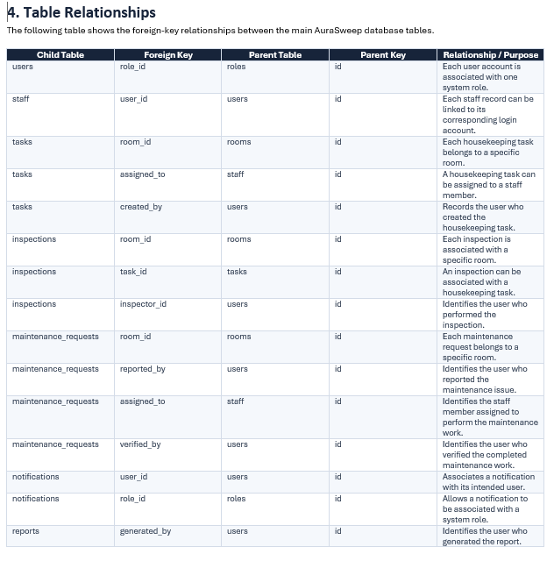
The AuraSweep database uses primary and foreign keys to connect user accounts, staff records, rooms, housekeeping tasks, inspections, maintenance requests, notifications, and reports. These relationships allow operational data to move between modules while maintaining consistent references to users, staff members, and rooms.

ER Diagram
