INDIAN CYBER CLUB • SOC ANALYST HANDS-ON PROJECT

DNS LOG ANALYSIS
SOC Investigation Report
DNS Security Investigation with Splunk SIEM

Student name | [Your full name]
Batch | [Your batch]
Project level | SOC Analyst / L1
Primary tool | Splunk Enterprise 10.6.0.5
Dataset | Zeek dns.log, 427,935 DNS events, 16 to 17 March 2012
Report date | 4 October 2026
Final assessment | Suspicious and requires validation (host 192.168.202.79)

Learn • Search • Investigate • Correlate • Report
Authorised training dataset analysed in an isolated lab environment.

Contents
1. Executive Summary
2. Environment and Investigation Data Source
3. Methodology
4. DNS Baseline (Phase 1 and Tasks 01 to 10)
5. Investigation Findings (Phase 3 and notable observations)
6. Threat Intelligence Validation
7. Evidence Screenshots
8. Answers to Investigation Questions
9. Final Investigation: SOC Analyst Assessment
10. Conclusion and Limitations
11. Recommended Next Steps
Appendix A: SPL Searches Used
Appendix B: Field-Extraction Macro and Time Conversion
Conventions: all times are UTC unless marked IST (Splunk displays IST, UTC + 5:30). "Figure N" refers to the screenshots in this report; "SPL N" refers to the searches listed in Appendix A.

1. Executive Summary
This report documents a DNS threat-hunting investigation performed in Splunk Enterprise on a Zeek dns.log containing 427,935 DNS events captured between 16 March 2012 12:30 UTC and 17 March 2012 20:59 UTC. The investigation followed the four phases of the project brief: data validation, baseline analysis, advanced threat hunting and threat-intelligence validation.
The baseline is dominated by normal background activity: Windows IPv6 (Teredo) tunnelling, Google, Apple and Symantec services, software-update checks and NetBIOS name resolution. The busiest client, 10.10.117.210 (75,943 queries), repeats only about 250 domains and is assessed as expected behaviour pending asset confirmation.
The most significant finding is internal host 192.168.202.79, which shows a combination of behaviours that no other host shows:
- 437 of the 440 zone-transfer (AXFR) requests in the dataset, covering 7 hec.net zones across 10 DNS servers. 415 requests received NOERROR responses whose answers contained internal hostnames and IP addresses.
- 3,703 reverse (PTR) lookups spread evenly across nine subnets (192.168.21.0 to 28.0 and 192.168.229.0), 2,620 unique domains queried and 2,557 unique failed names.
- DNS blocklist (DNSBL) lookups from 192.168.202.79 and 192.168.202.108, and version.bind software-fingerprinting queries from 192.168.202.102 and 192.168.202.115.
- The domain rootshell-security.net was requested 770 times by seven clients, all answered NXDOMAIN. Threat intelligence is mixed (VirusTotal 4 of 91 vendors; URLhaus no entry) and is treated as inconclusive.
Overall assessment: SUSPICIOUS AND REQUIRES VALIDATION
The behaviour of 192.168.202.79 matches network reconnaissance of the hec.net environment. DNS logs cannot show intent, the tool used, or how much data was transferred, and an approved vulnerability scan or penetration test would produce the same pattern. The activity is therefore not classified as malicious.
Priority actions: (1) confirm whether the activity was authorised and identify the owner of 192.168.202.79; (2) confirm what was transferred using firewall/conn.log and DNS-server logs; (3) restrict AXFR on the DNS servers to approved secondary servers only.

2. Environment and Investigation Data Source

2.1 Environment summary
Item | Detail
Tool | Splunk Enterprise 10.6.0.5 (local lab instance)
Data source | Zeek dns.log (tab-separated, no header row, about 62 MB). The original file was kept unchanged.
Index / sourcetype | dns_lab / dns_sample
Events | 427,935
Time range (UTC) | 16 Mar 2012 12:30:05 to 17 Mar 2012 20:59:51
Time display | Splunk displays times in the user time zone (IST, UTC + 5:30). This report states UTC unless a value is marked IST. Subtract 5 h 30 min from Splunk's displayed time to obtain UTC.
Field extraction | Search-time rex macro named dnsf (see Appendix B). Fields follow the Zeek DNS log layout.
Authorisation | Authorised training dataset analysed inside the lab environment only.

2.2 Data ingestion and validation
The file was uploaded with Settings → Add Data → Upload. Zeek records begin with an epoch timestamp, and the events are from 2012, which is older than Splunk's default acceptance window. Splunk therefore stamped the first preview with the upload time. The sourcetype dns_sample was saved with the settings below so that Splunk reads the real event time:
Setting | Value | Purpose
TIME_PREFIX | ^ | Timestamp is at the start of each line
TIME_FORMAT | %s.%6N | Epoch seconds with microseconds
MAX_TIMESTAMP_LOOKAHEAD | 17 | Length of the epoch timestamp
TZ | UTC | Zeek logs epoch time (UTC)
MAX_DAYS_AGO | 10951 | Accept timestamps older than the default limit (2012 data)
DATETIME_CONFIG | /etc/datetime.xml | Enable timestamp detection
SHOULD_LINEMERGE | false | One event per line

Validation. Figure 1 shows that events are searchable, the raw records are visible, host, source and sourcetype are correct, and the timestamps are in March 2012 (Splunk lists the newest events first; 3/18/12 2:29 AM IST equals 17 Mar 20:59 UTC). The total event count and time range are confirmed in Figure 4.
SPL 1: Validation search
index=dns_lab sourcetype=dns_sample | head 20
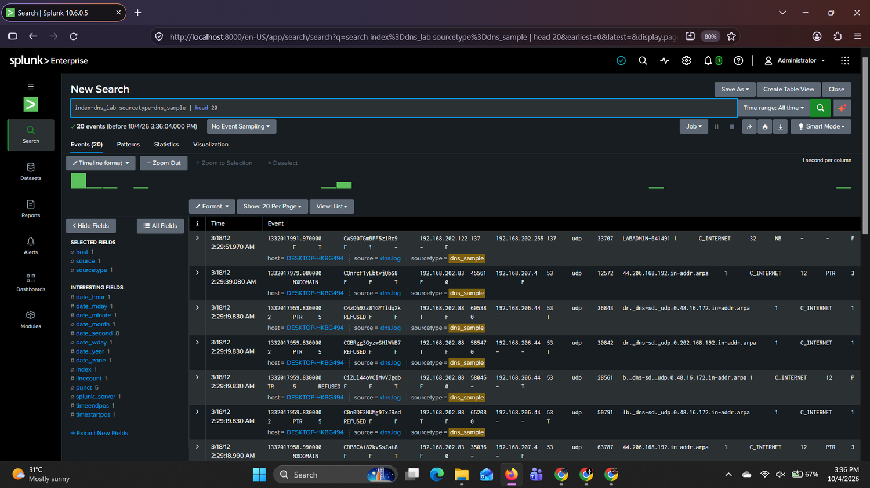
Figure 1: Validation search showing 2012 timestamps and raw DNS records

3. Methodology
The investigation followed the project phases and the SOC rules of engagement (evidence first, reproducibility, context matters):
- Phase 1: Understand the data. Validated ingestion and discovered the fields present (Section 4.1).
- Phase 2: Baseline. Completed Tasks 01 to 10: totals, top domains and clients, query types, response codes, activity over time, client/domain pairs, rare domains, NXDOMAIN and keyword searches (Section 4.2).
- Phase 3: Advanced hunting. Compared query volume with unique domains, domains with many clients, repeated NXDOMAIN by client, query bursts and a domain pivot (Section 5).
- Phase 4: Threat intelligence. Checked a domain of interest against VirusTotal and URLhaus and documented the limitations (Section 6).
- Case development. The strongest lead (192.168.202.79) was pivoted by query type, response code, frequency and related clients (Sections 5.6 to 5.9 and 9).
Facts and assumptions. Throughout this report, *facts* are values returned by Splunk and are tied to a figure and an SPL search. *Assessments* are interpretations and are labelled as such. Popularity, rarity or a keyword alone is never treated as proof of malicious activity.
Reading the log. A - in response_code means Zeek logged the query but did not record a matching reply. It is not a DNS error code.

4. DNS Baseline

4.1 Phase 1: Field discovery
Field discovery shows which fields exist before any analysis. Figure 2 shows the full summary. It also lists fields that Splunk adds automatically from the timestamp (date_hour, date_mday, date_minute), which are not DNS fields. fieldsummary examines the first 400,000 events only, so it is used here for field discovery and not for totals.
SPL 2: Field summary
index=dns_lab sourcetype=dns_sample | `dnsf` | fieldsummary | sort - count
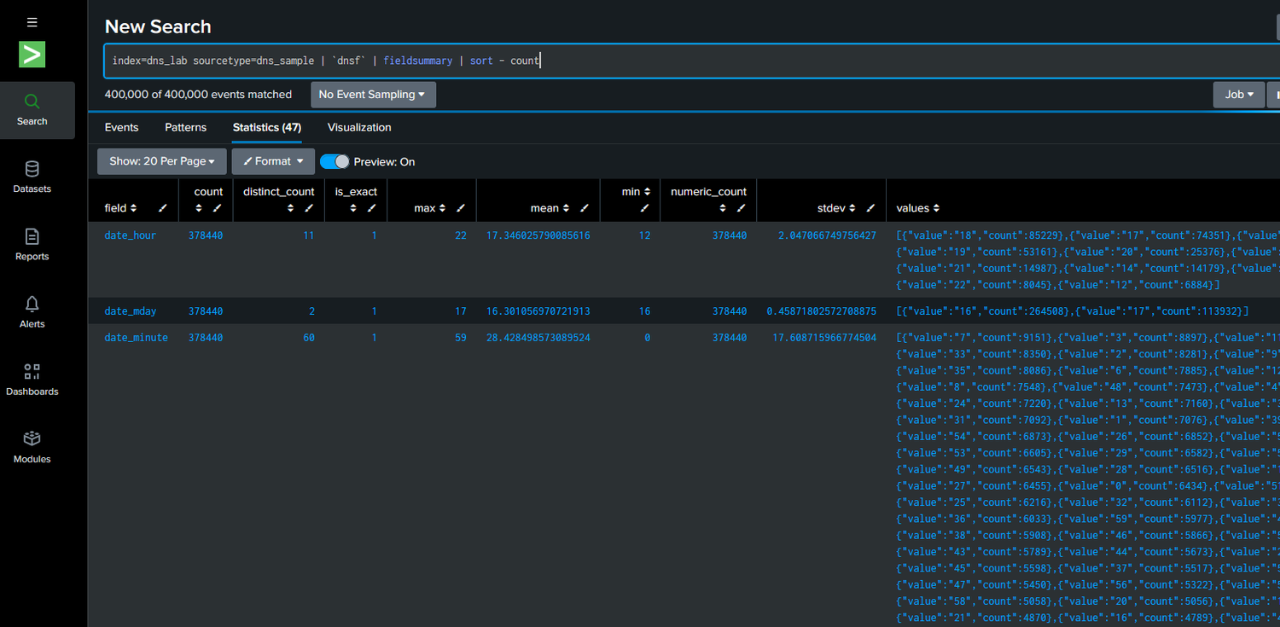
Figure 2: Field summary (first 400,000 events), including Splunk's automatic date fields
Figure 3 narrows the result to the DNS fields used in the investigation. All ten fields are present on all 427,935 events, which confirms that the extraction macro works on every record.
SPL 3: DNS fields only
index=dns_lab sourcetype=dns_sample | `dnsf` | fieldsummary | search field IN ("src_ip","dest_ip","fqdn","query_type","response_code","src_port","dest_port","proto","uid","ts") | table field count distinct_count | sort - count
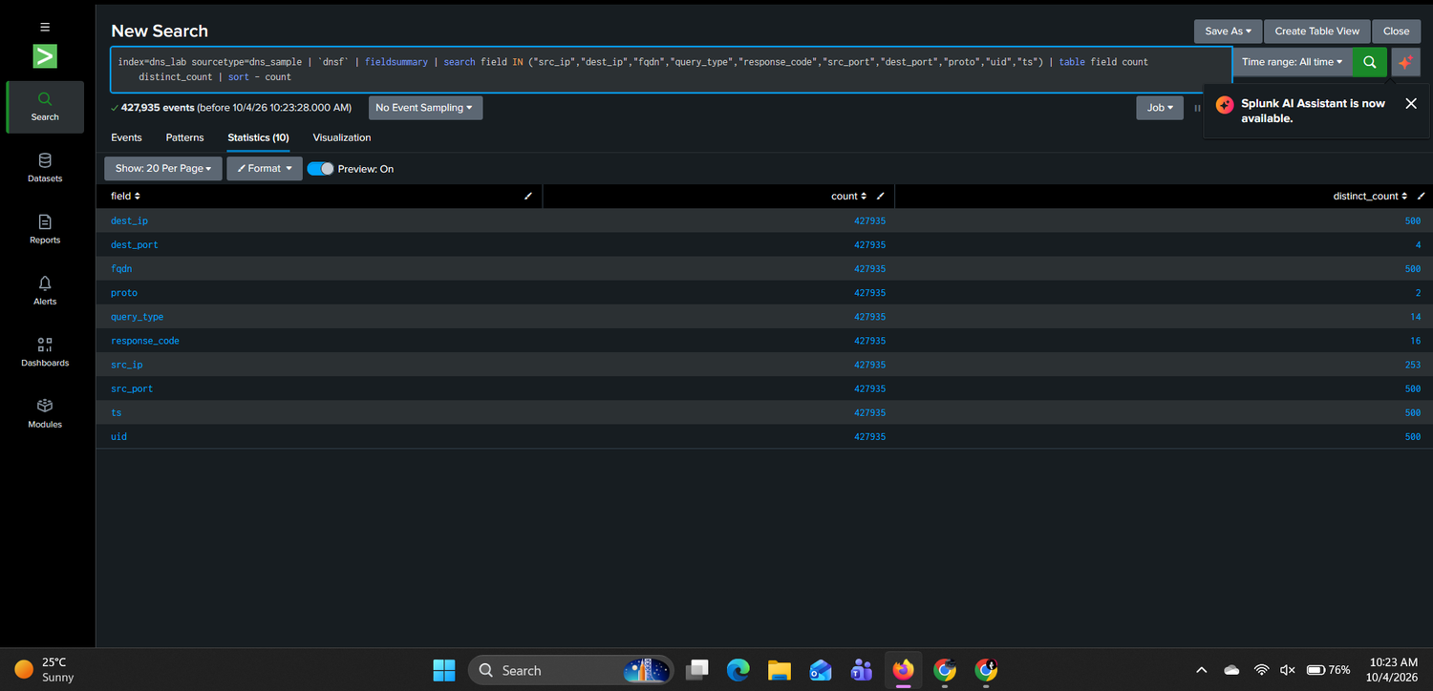
Figure 3: DNS fields extracted on all 427,935 events
Field | Meaning | Investigation use
src_ip | Client making the DNS request (253 distinct clients) | Find the most active or unusual clients
dest_ip | DNS server or destination of the query | Identify resolver infrastructure and targeted servers
fqdn | Domain name requested | Investigate suspicious or rare destinations
query_type | Record type (A, AAAA, PTR, TXT, AXFR, NB ...); 14 types | Detect unusual query patterns
response_code | Result of the query (NOERROR, NXDOMAIN, REFUSED, - ...); 16 values | Find failure-heavy behaviour
dest_port / proto | Service port (53, 137, 5353, 5355) and transport (udp, tcp) | Separate DNS from NetBIOS, mDNS and LLMNR; identify TCP zone transfers
ts, uid, src_port | Event time (epoch), Zeek connection ID, client port | Timelines and correlation

Note: fieldsummary caps distinct-value counts at 500, so dest_ip, fqdn, ts, uid and src_port show 500 in Figure 3. The true numbers are higher (for example, 5,178 unique domains calculated from the same log).

4.2 Phase 2: Core investigation tasks

Task 01: Baseline the data source
SPL 4
index=dns_lab sourcetype=dns_sample | stats count min(_time) as first max(_time) as last | convert ctime(first) ctime(last)
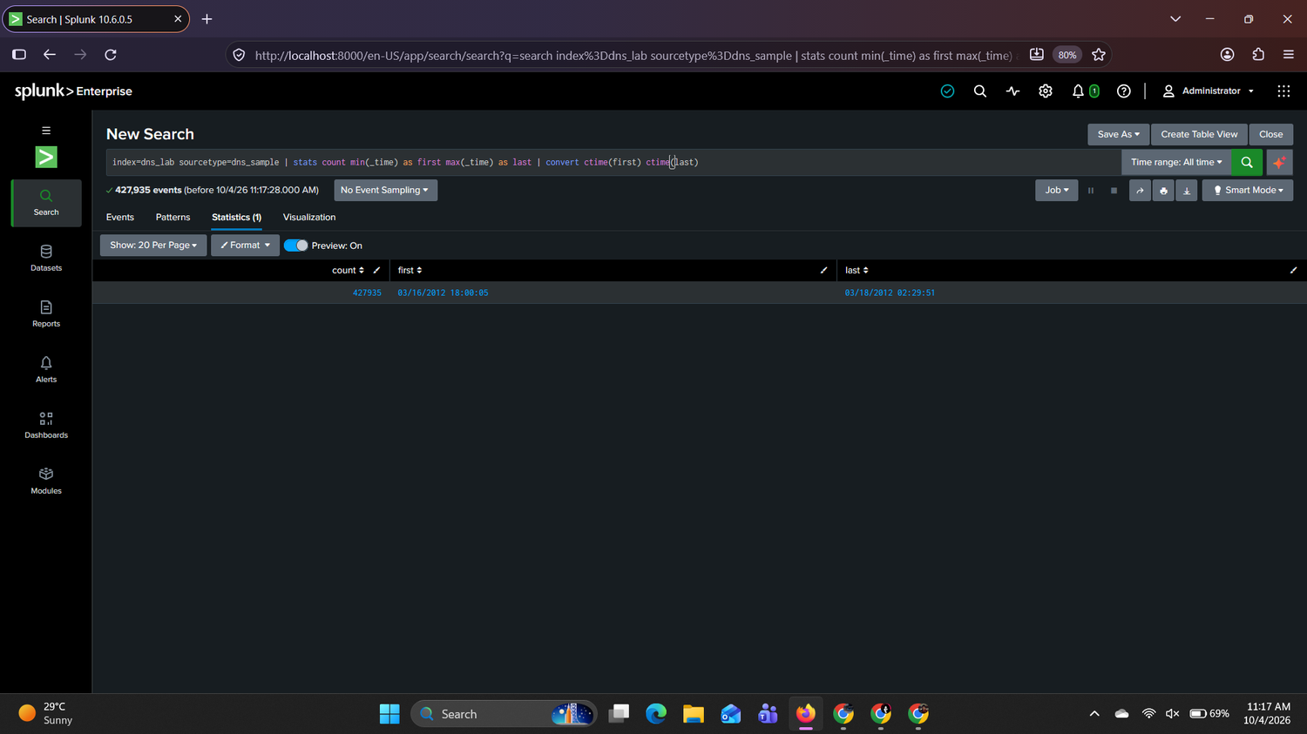
Figure 4: Total events and time range (Splunk displays IST)
Result: 427,935 events from 16 Mar 2012 12:30:05 UTC to 17 Mar 2012 20:59:51 UTC. Splunk displays 03/16/2012 18:00:05 and 03/18/2012 02:29:51 because the user time zone is IST (UTC + 5:30).

Task 02: Top queried domains
SPL 5
index=dns_lab sourcetype=dns_sample | `dnsf` | top limit=20 fqdn
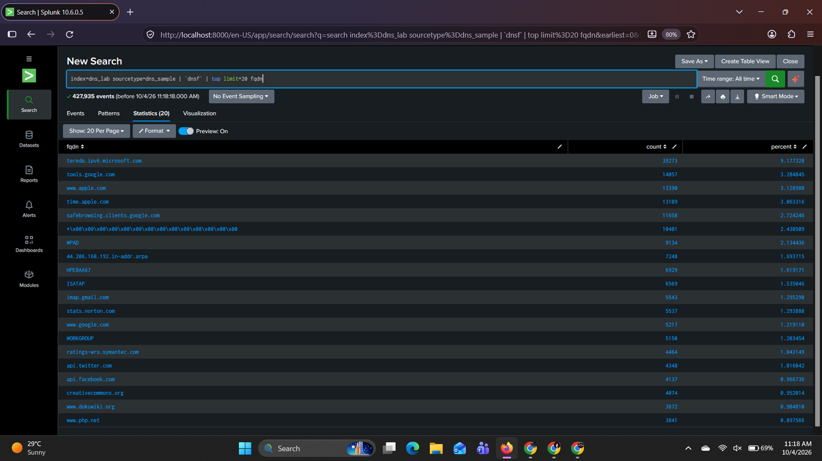
Figure 5: Top 20 queried domains
# | Domain | Queries | Typical purpose
1 | teredo.ipv6.microsoft.com | 39,273 | Windows IPv6 (Teredo) tunnelling
2 | tools.google.com | 14,057 | Google toolbar / update checks
3 | www.apple.com | 13,390 | Apple connectivity and updates
4 | time.apple.com | 13,109 | Time synchronisation
5 | safebrowsing.clients.google.com | 11,658 | Browser safe-browsing checks
6 | NetBIOS wildcard name (*\x00...) | 10,401 | NetBIOS name service
7 | WPAD | 9,134 | Proxy auto-discovery (local name)
8 | 44.206.168.192.in-addr.arpa | 7,248 | Repeated reverse lookup of one internal address
9 | HPE8AA67 | 6,929 | Local NetBIOS name
10 | ISATAP | 6,569 | IPv6 transition (local name)

Interpretation: The most frequent domains are well-known services performing routine background work, plus local NetBIOS names. High frequency alone is not enough to call a domain malicious, because automated software legitimately repeats the same lookups thousands of times. Frequency is only a prompt to check context.

Task 03: Top DNS clients
SPL 6
index=dns_lab sourcetype=dns_sample | `dnsf` | top limit=20 src_ip
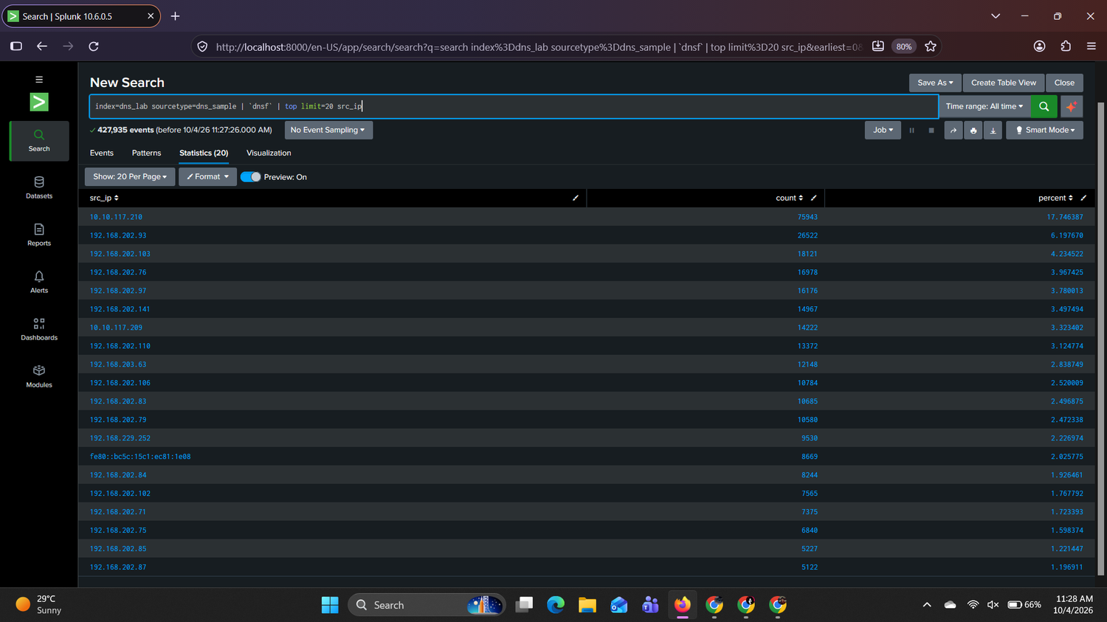
Figure 6: Top 20 source clients
The most active clients are 10.10.117.210 (75,943 queries, 17.7%), 192.168.202.93 (26,522), 192.168.202.103 (18,121), 192.168.202.76 (16,978) and 192.168.202.97 (16,176). The highest-volume client was investigated further:
SPL 7: Profile of 10.10.117.210
index=dns_lab sourcetype=dns_sample | `dnsf` | search src_ip=10.10.117.210 | stats count dc(fqdn) as unique_domains min(_time) as first max(_time) as last | convert ctime(first) ctime(last)
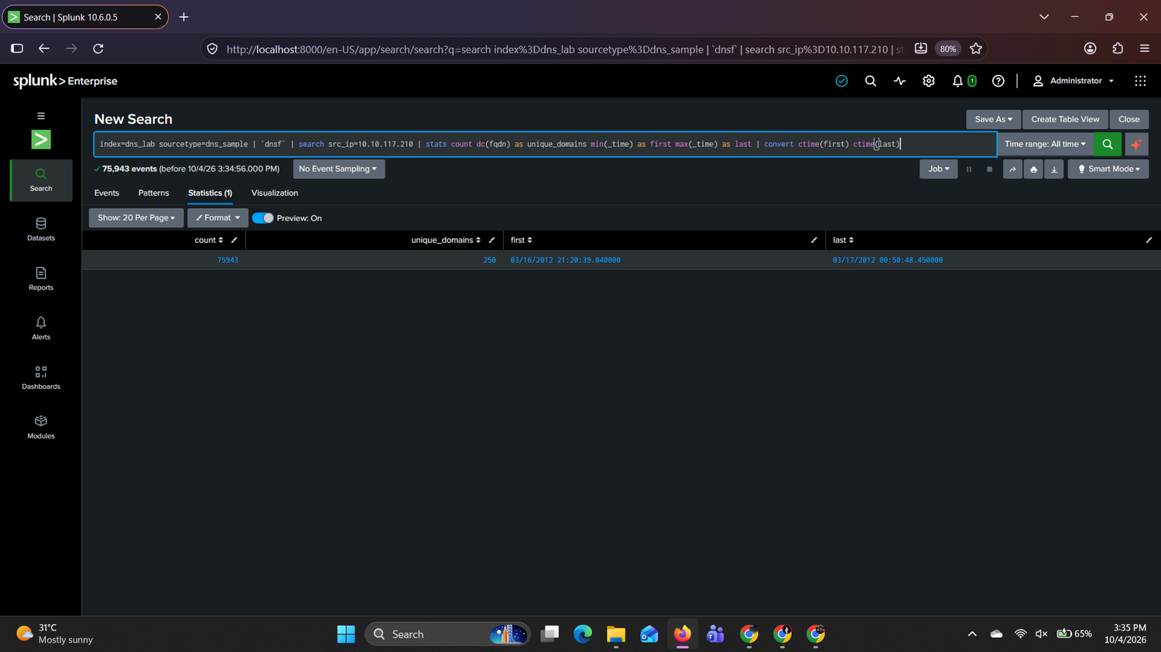
Figure 7: 10.10.117.210: event count, unique domains and active period (IST)
SPL 8: Domains, query types and responses for 10.10.117.210
index=dns_lab sourcetype=dns_sample | `dnsf` | search src_ip=10.10.117.210 | stats count by fqdn query_type response_code | sort - count | head 15
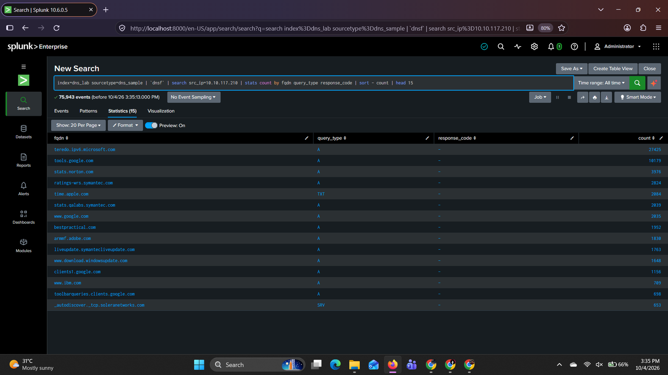
Figure 8: 10.10.117.210: most requested domains, query types and response codes
Observation | Value
Total queries / unique domains | 75,943 / only 250
Active period (UTC) | 16 Mar 15:50:39 to 19:20:48 (Splunk shows 21:20:39 IST to 00:50:48 IST)
Top domains | teredo.ipv6.microsoft.com 27,425; tools.google.com 10,179; stats.norton.com 3,976; ratings-wrs.symantec.com 2,824; time.apple.com (TXT) 2,084
Response codes | All shown as - (no reply recorded)

Assessment: A very high volume against a small set of domains (Teredo, Google, Norton/Symantec, update services), with no NXDOMAIN failures and no scanning-style diversity, points to a gateway, proxy or a host running automated software. This client also produces the 16 March spike (Task 06). The behaviour is assessed as expected, pending confirmation. To confirm, I would check DHCP and asset records and the number of users behind this address.

Task 04: Query-type distribution
SPL 9
index=dns_lab sourcetype=dns_sample | `dnsf` | stats count by query_type | sort - count
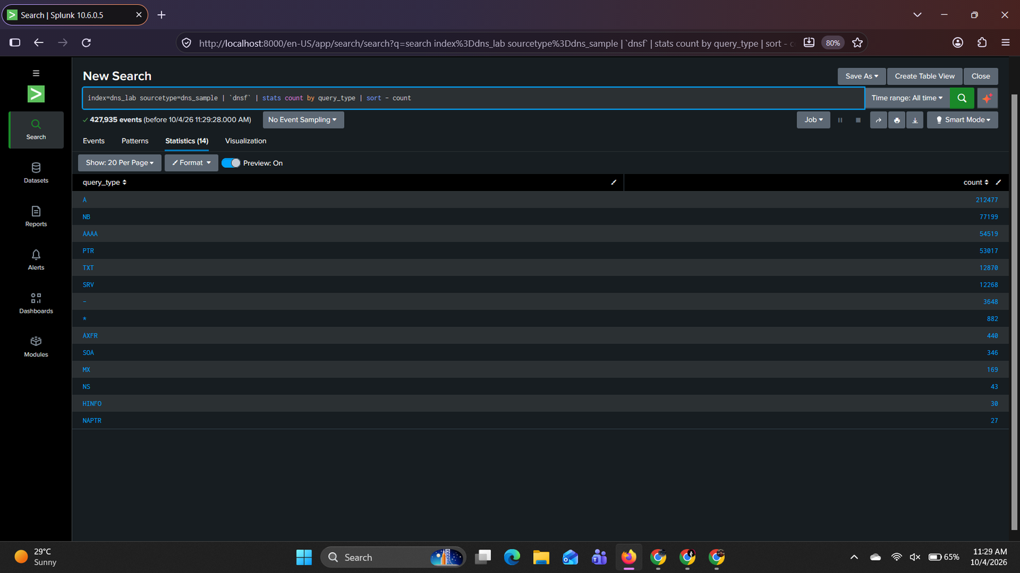
Figure 9: Query-type distribution
Dominant types: A (212,477), NB (77,199), AAAA (54,519), PTR (53,017), TXT (12,870) and SRV (12,268). NB is NetBIOS name lookup; PTR is reverse lookup.
Uncommon types that deserve review: AXFR (440), which is a request for a full zone transfer and is not normal workstation behaviour; the wildcard * type (882); SOA (346), MX (169), NS (43), HINFO (30) and NAPTR (27). AXFR is developed in Section 5.6.

Task 05: Response-code analysis
SPL 10
index=dns_lab sourcetype=dns_sample | `dnsf` | stats count by response_code | sort - count
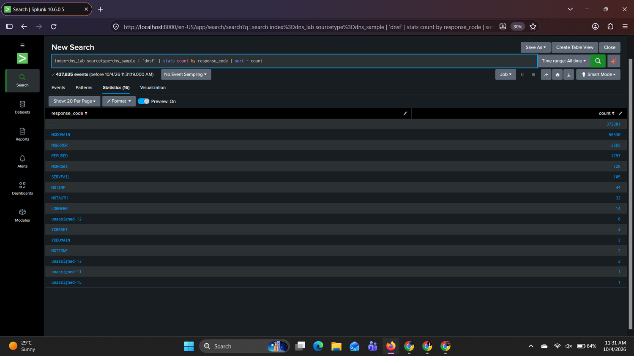
Figure 10: Response-code distribution
Response code | Count | Meaning
- | 372,201 | Query logged, no reply recorded
NXDOMAIN | 50,330 | Name does not exist
NOERROR | 2,665 | Successful answer
REFUSED | 1,797 | Server refused the query
NXRRSet | 728 | Name exists, requested record type does not
SERVFAIL / NOTIMP / NOTAUTH / FORMERR | 105 / 44 / 32 / 14 | Server failure, not implemented, not authoritative, malformed query
Rare codes | 1 to 6 each | unassigned-*, YXRRSET, YXDOMAIN, NOTZONE

Concentration of failures. NXDOMAIN is concentrated in particular clients and is analysed in Section 5.3. REFUSED is also concentrated: 1,666 of the 1,797 REFUSED responses come from one client (192.168.202.88) querying one server (192.168.206.44), and about 71% of REFUSED responses involve _dns-sd (mDNS service-discovery) names. This looks like a misconfigured service-discovery client and not an attack.

Task 06: DNS activity over time
SPL 11
index=dns_lab sourcetype=dns_sample | timechart span=1h count
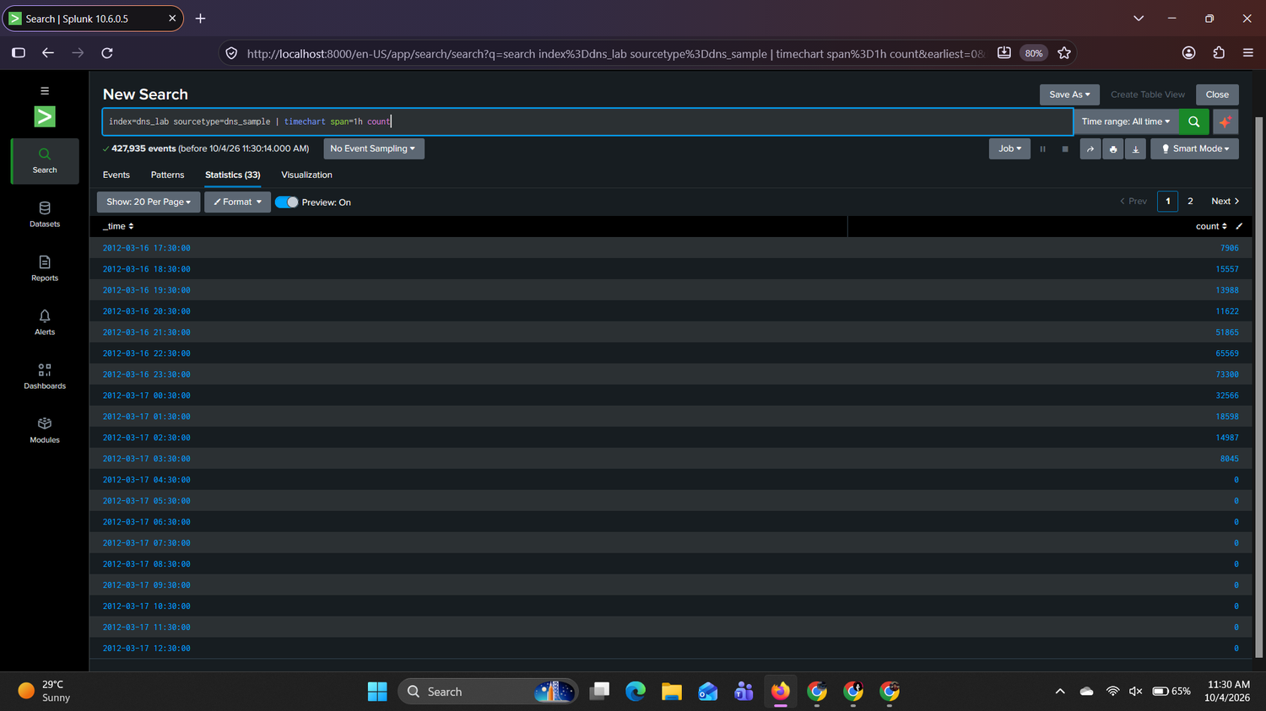
Figure 11: Hourly event counts (Splunk table, IST). Subtract 5 h 30 min for UTC
Figure 12 is a supplementary chart drawn from the same log in UTC, so the whole timeline, including the overnight gap, is visible in one view.
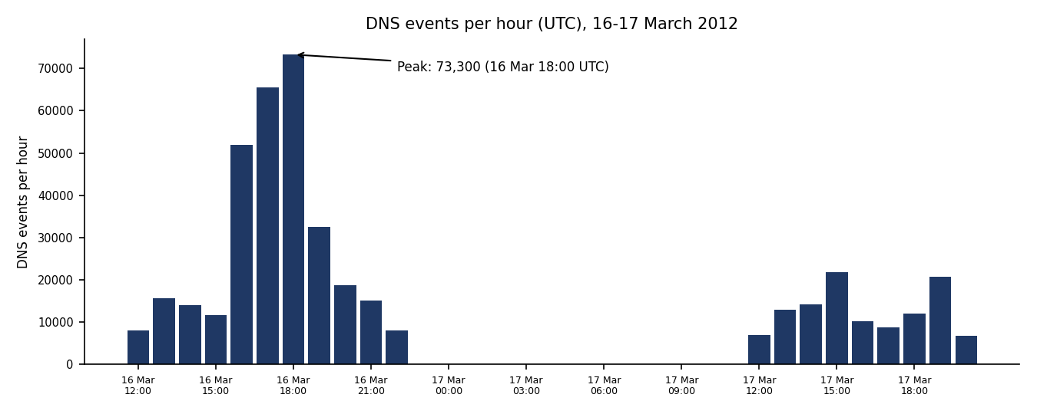
Figure 12: Supplementary chart: DNS events per hour in UTC (generated from dns.log)
Hour (UTC) | Events | Splunk shows (IST)
16 Mar 12:00 | 7,906 | 17:30
16 Mar 16:00 | 51,865 | 21:30
16 Mar 17:00 | 65,569 | 22:30
16 Mar 18:00 (peak) | 73,300 | 23:30
16 Mar 19:00 | 32,566 | 17 Mar 00:30
16 Mar 20:00 | 18,598 | 01:30

Observations: Activity peaks on 16 March between 16:00 and 19:00 UTC, reaching 73,300 events at 18:00 against a normal 8,000 to 20,000 per hour. This spike is driven by 10.10.117.210 (Task 03). There is also no data from about 23:00 UTC on 16 March until about 12:00 UTC on 17 March, which suggests capture stopped or the network was quiet. A smaller second period of activity follows on 17 March.
Additional evidence I would inspect: the clients behind the spike (Section 5.4), query diversity and response codes, and DHCP, proxy and firewall logs for the same window.

Task 07: Top client-to-domain relationships
SPL 12
index=dns_lab sourcetype=dns_sample | `dnsf` | stats count by src_ip fqdn | sort - count | head 30
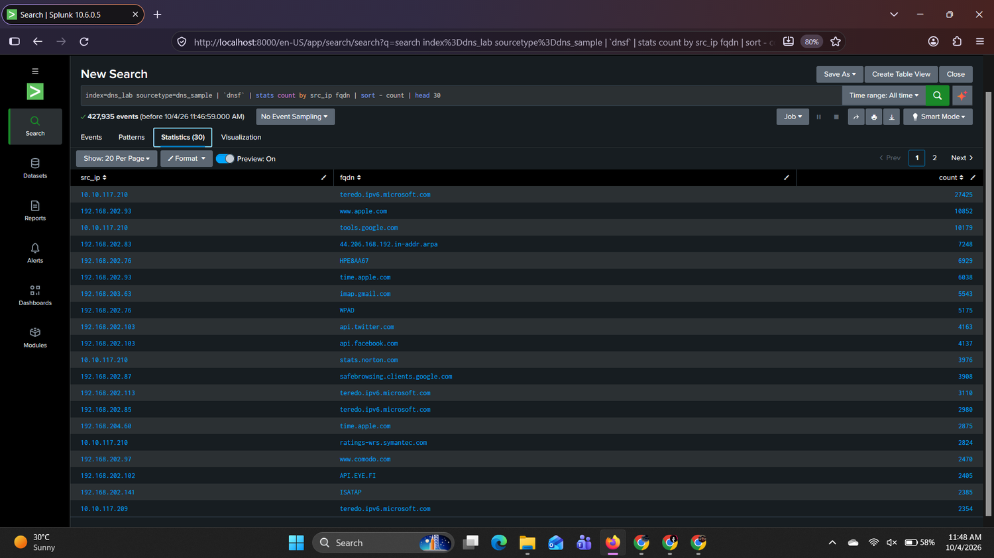
Figure 13: Top 30 client/domain pairs
Client | Domain | Queries | Review note
10.10.117.210 | teredo.ipv6.microsoft.com | 27,425 | Routine tunnelling; see Task 03
192.168.202.93 | www.apple.com | 10,852 | Routine
192.168.202.83 | 44.206.168.192.in-addr.arpa | 7,248 | Review: one reverse lookup repeated thousands of times (retry loop)
192.168.202.103 | api.twitter.com, api.facebook.com | 4,163 / 4,137 | Review: repeated API lookups, many failing (Task 09)
192.168.202.76 | HPE8AA67, WPAD | 6,929 / 5,175 | Local NetBIOS names

Three relationships deserve deeper review: (1) 192.168.202.83 to the single reverse-lookup name, (2) 192.168.202.103 to Twitter/Facebook API names that repeatedly fail, and (3) 192.168.202.79 to the hec.net zones (Section 5.6).

Task 08: Rarely queried domains
SPL 13
index=dns_lab sourcetype=dns_sample | `dnsf` | rare limit=30 fqdn
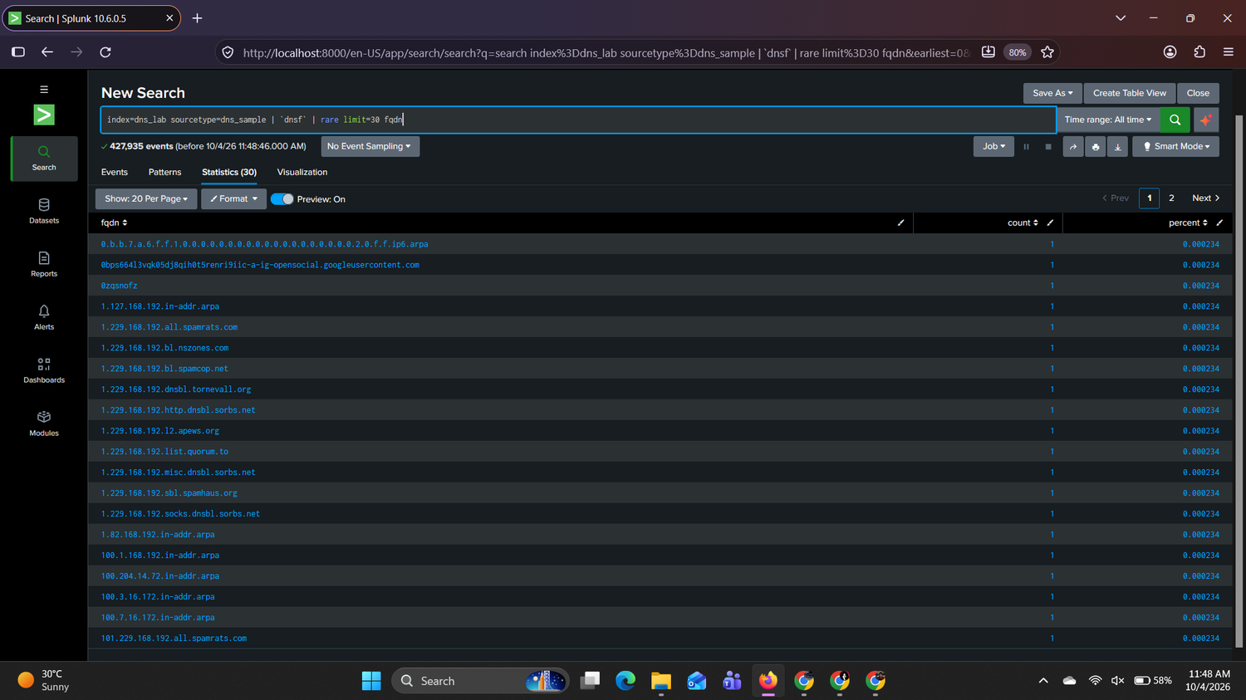
Figure 14: Rare domains (count = 1)
Rare domain | Evidence worth reviewing
1.229.168.192.bl.spamcop.net (and .all.spamrats.com, .list.quorum.to, .dnsbl.sorbs.net ...) | Internal address 192.168.229.1 checked against many public spam blocklists; typical of scanning tools, not normal browsing (Section 5.9)
metasploitable, acme-texmcxhenx | Seen once from 192.168.202.88, NXDOMAIN; look like probe or test names
0zqsnofz | Random single-label name, once, from 192.168.202.140, NXDOMAIN
100.204.14.72.in-addr.arpa | Single reverse lookup of an external address from 192.168.202.115; could be part of an address sweep
0.b.b.7.a.6.f.f.1.0...ip6.arpa | IPv6 reverse lookup; usually benign but rare

Rarity is a signal that prompts a closer look. It is not proof of maliciousness: many one-off names are typos, one-time software lookups or random browser probes.

Task 09: NXDOMAIN investigation
SPL 14
index=dns_lab sourcetype=dns_sample | `dnsf` | search response_code=NXDOMAIN | stats count by src_ip fqdn | sort - count | head 30
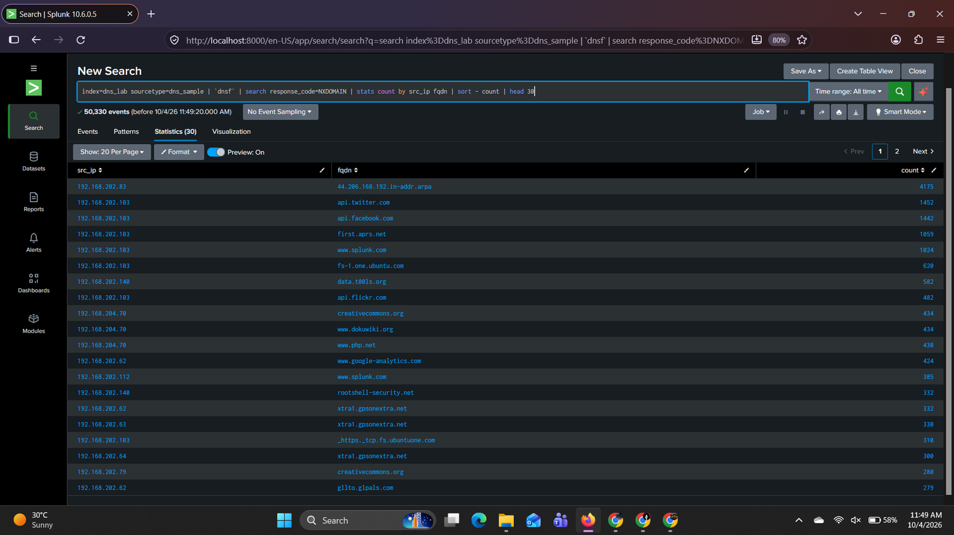
Figure 15: Top client/domain pairs returning NXDOMAIN
Client | Domain | NXDOMAIN
192.168.202.83 | 44.206.168.192.in-addr.arpa | 4,175
192.168.202.103 | api.twitter.com / api.facebook.com / first.aprs.net / www.splunk.com | 1,452 / 1,442 / 1,059 / 1,024
192.168.202.140 | data.t00ls.org / rootshell-security.net | 582 / 332
192.168.204.70 | creativecommons.org / www.dokuwiki.org / www.php.net | 434 / 434 / 430

Repeated failures for the same name (.83, .103) suggest software retrying. Hosts that fail on thousands of different names are a different pattern and are analysed in Section 5.3.

Task 10: Suspicious keyword hunt
SPL 15
index=dns_lab sourcetype=dns_sample | regex _raw="(?i)(login|verify|secure|update|account|password|wallet)" | `dnsf` | stats count by fqdn src_ip | sort - count
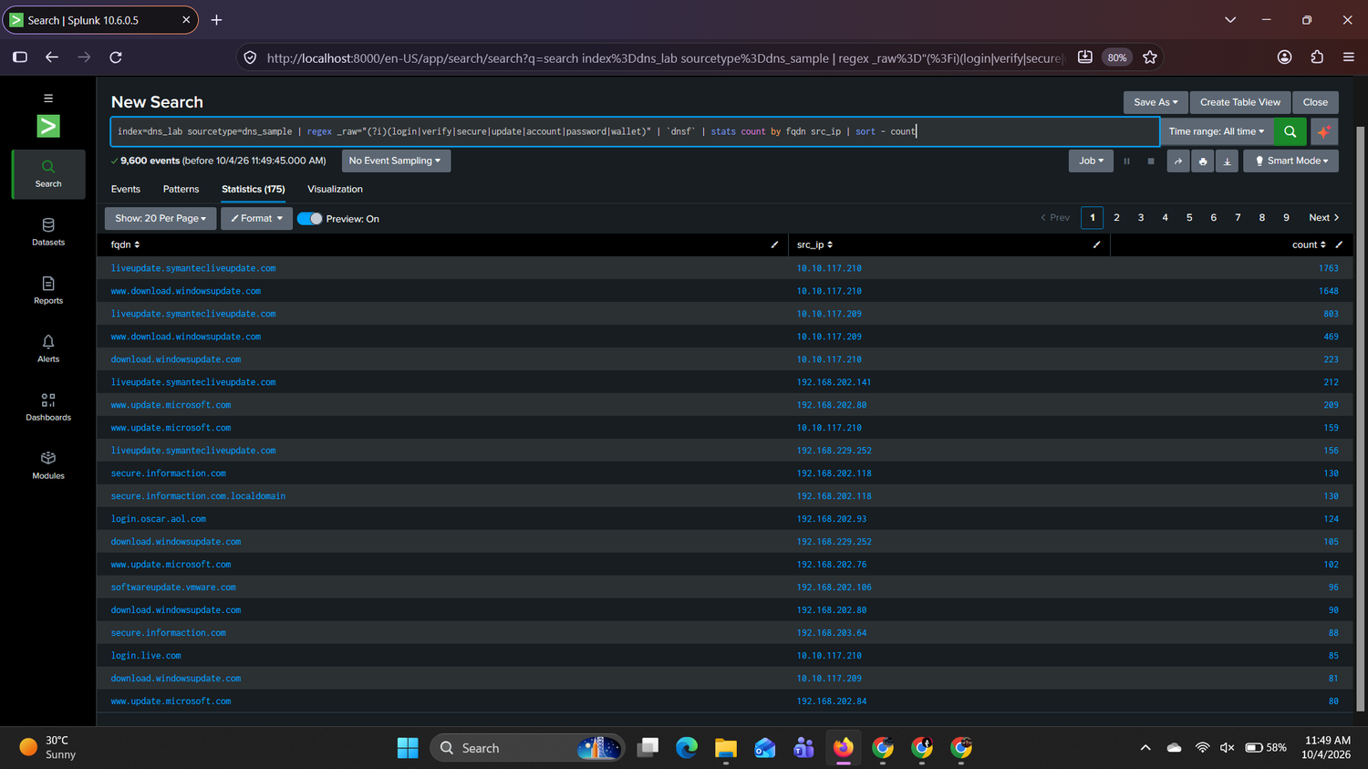
Figure 16: Keyword hunt results (9,600 events matched)
The regular expression matched 9,600 events. Almost all are legitimate update and login services: liveupdate.symantecliveupdate.com (1,763 from 10.10.117.210), www.download.windowsupdate.com (1,648), www.update.microsoft.com, login.live.com, login.oscar.aol.com and softwareupdate.vmware.com.
One name needs validation: `secure.informaction.com` (874 queries from 29 clients, plus a .localdomain variant of 130 queries from 192.168.202.118, which suggests the host's resolver appended its local search domain). Because many clients query it, it is probably shared software or a service, but it should be checked against threat intelligence before closing. No obvious phishing-style names were found. No escalation is required on the keyword results alone.

5. Investigation Findings

5.1 High-volume clients versus unique domains (Phase 3A)
SPL 16
index=dns_lab sourcetype=dns_sample | `dnsf` | stats count as dns_queries dc(fqdn) as unique_domains by src_ip | sort - dns_queries | head 20
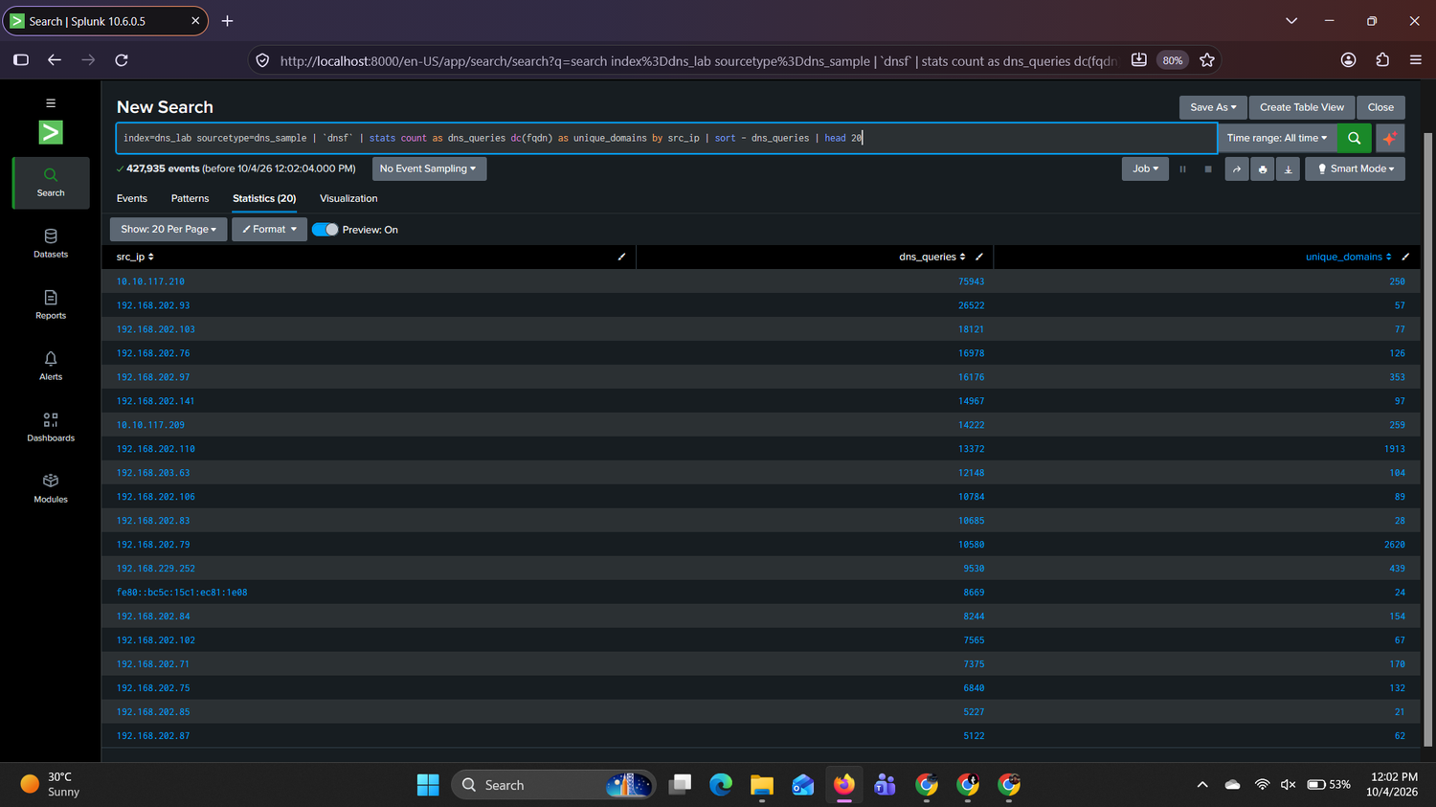
Figure 17: Query volume compared with unique domains per client
Client | Queries | Unique domains | Reading
10.10.117.210 | 75,943 | 250 | High volume, low diversity: repeated names
192.168.202.93 | 26,522 | 57 | Repeated names
192.168.202.103 | 18,121 | 77 | Repeated names
192.168.202.110 | 13,372 | 1,913 | High diversity: review
192.168.202.79 | 10,580 | 2,620 | Highest diversity of any client: strongest lead
192.168.229.252 | 9,530 | 439 | Moderate

A client that contacts thousands of different domains from a modest number of queries behaves differently from a client that repeats a few names. 192.168.202.79 queried 2,620 unique domains from 10,580 events (about one new name for every four queries).

5.2 Domains contacted by many clients (Phase 3B)
SPL 17
index=dns_lab sourcetype=dns_sample | `dnsf` | stats dc(src_ip) as unique_clients count as queries by fqdn | sort - unique_clients | head 30
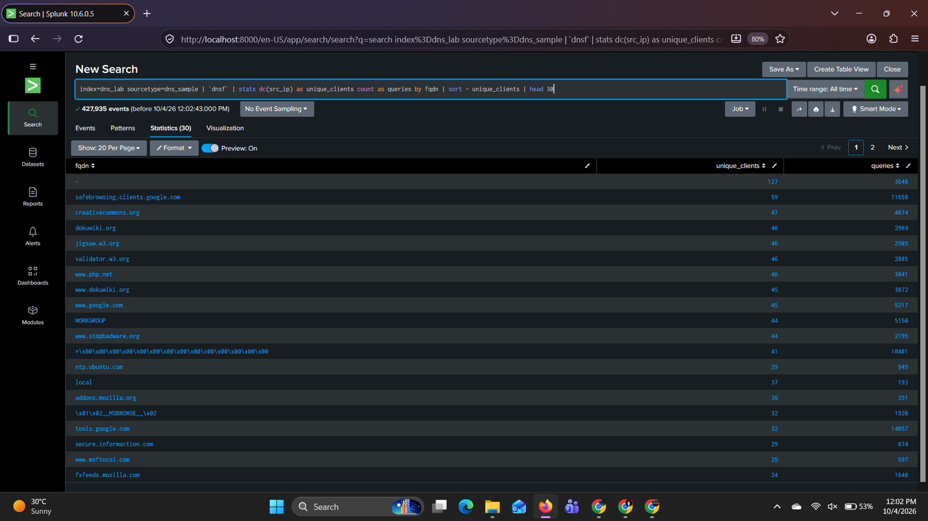
Figure 18: Domains ranked by number of distinct clients
The domains with the most distinct clients are common infrastructure: safebrowsing.clients.google.com (59 clients), creativecommons.org (47), dokuwiki.org, jigsaw.w3.org, validator.w3.org and www.php.net (46 each), www.google.com (45) and ntp.ubuntu.com (39). The - entry (127 clients) is not a domain: it marks records with no query name. secure.informaction.com (29 clients, 874 queries) is shared software or a service and is listed for validation.

5.3 Repeated NXDOMAIN by client (Phase 3C)
SPL 18
index=dns_lab sourcetype=dns_sample | `dnsf` | search response_code=NXDOMAIN | stats count as nxdomain_count dc(fqdn) as unique_failed_domains by src_ip | sort - nxdomain_count
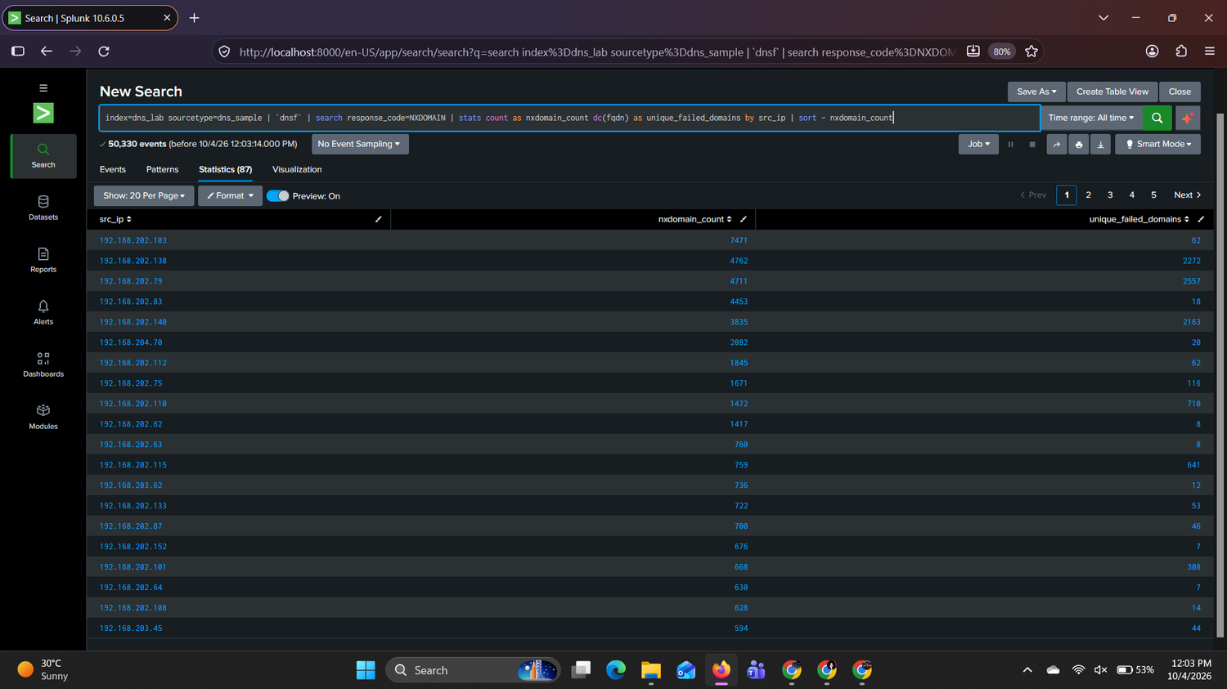
Figure 19: NXDOMAIN count compared with unique failed domains per client
Client | NXDOMAIN | Unique failed domains | Reading
192.168.202.103 | 7,471 | 62 | Retrying a few names: benign pattern
192.168.202.83 | 4,453 | 18 | Retrying one reverse lookup: benign pattern
192.168.202.138 | 4,762 | 2,272 | Many different failed names: scanning pattern
192.168.202.79 | 4,711 | 2,557 | Many different failed names: scanning pattern
192.168.202.140 | 3,835 | 2,163 | Many different failed names: scanning pattern
192.168.202.110 / .115 | 1,472 / 759 | 710 / 641 | Elevated diversity: secondary leads

The key distinction is the ratio of unique failed names to total failures. For .79, .138 and .140, about half of all failures are for a *different* name (48% to 56%). For .103 and .83 it is below 1%. A high NXDOMAIN rate can be benign (software retries, typos), so it is treated as a lead and correlated with other evidence in Section 5.6 onward.

5.4 Query bursts (Phase 3D)
SPL 19
index=dns_lab sourcetype=dns_sample | `dnsf` | bin _time span=5m | stats count as queries by _time src_ip | sort - queries | head 50
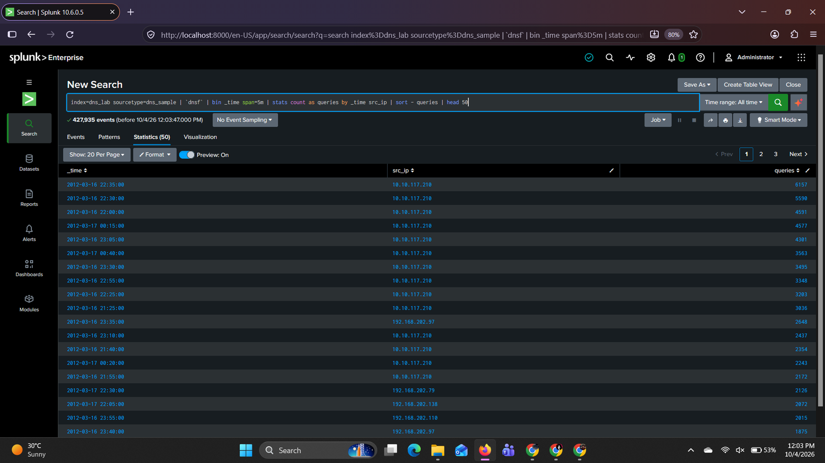
Figure 20: Largest 5-minute query bursts by client (Splunk shows IST)
The largest burst is 10.10.117.210 with 6,157 queries in five minutes (17:05 UTC on 16 March; shown as 22:35 IST). This client sustains bursts from about 16:00 to 19:00 UTC, which explains the spike in Task 06. On 17 March the largest bursts come from 192.168.202.79 (2,126 queries at 17:00 UTC) and 192.168.202.138 (2,072 at 16:35 UTC), the same hosts that show high unique-failure counts. Burst volume is therefore consistent with automated activity on those hosts.

5.5 Domain pivot: rootshell-security.net (Phase 3E)
SPL 20
index=dns_lab sourcetype=dns_sample | `dnsf` | search fqdn="rootshell-security.net" | stats count values(src_ip) as clients values(query_type) as query_types by fqdn
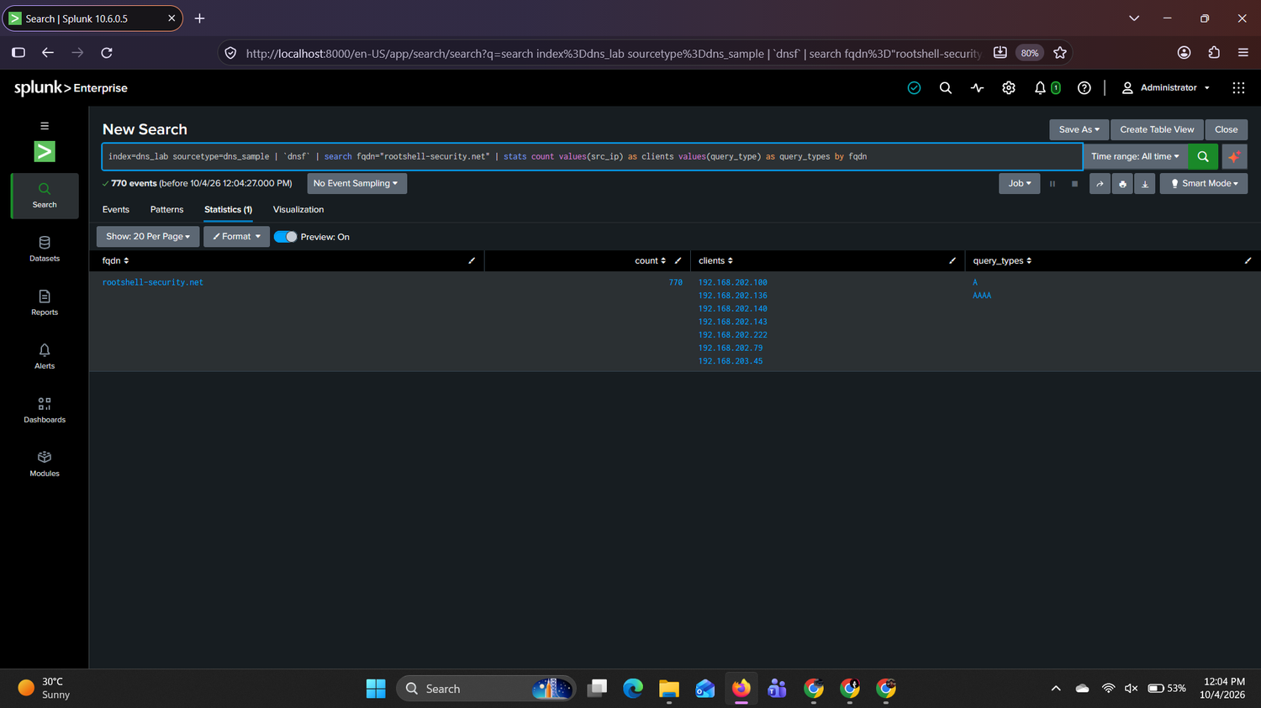
Figure 21: Clients requesting rootshell-security.net
Client | Queries
192.168.202.140 | 332
192.168.202.79 | 228
192.168.202.143 | 106
192.168.202.136 | 72
192.168.202.100 / .222 / 192.168.203.45 | 16 / 8 / 8

The domain was requested 770 times by seven clients, using A and AAAA records. All 770 responses were NXDOMAIN, so the name never resolved. All requests fall within one hour on 17 March (19:24 to 20:23 UTC). The group includes 192.168.202.79 and 192.168.202.140, two hosts flagged for scanning behaviour. Several clients asking for the same unresolved name in the same hour could indicate a shared tool, script or web page, but this alone is not evidence of compromise. The domain is validated in Section 6.

5.6 Notable observation 1: Zone-transfer (AXFR) requests
Finding
Host 192.168.202.79 sent 437 of the 440 AXFR requests. A zone transfer asks a DNS server for its complete list of records and is not normal workstation behaviour. 415 requests received NOERROR responses containing internal hostnames and IP addresses.

SPL 21: AXFR requests by client
index=dns_lab sourcetype=dns_sample | `dnsf` | search query_type=AXFR | stats count dc(fqdn) as zones dc(dest_ip) as dns_servers min(_time) as first max(_time) as last by src_ip | convert ctime(first) ctime(last)
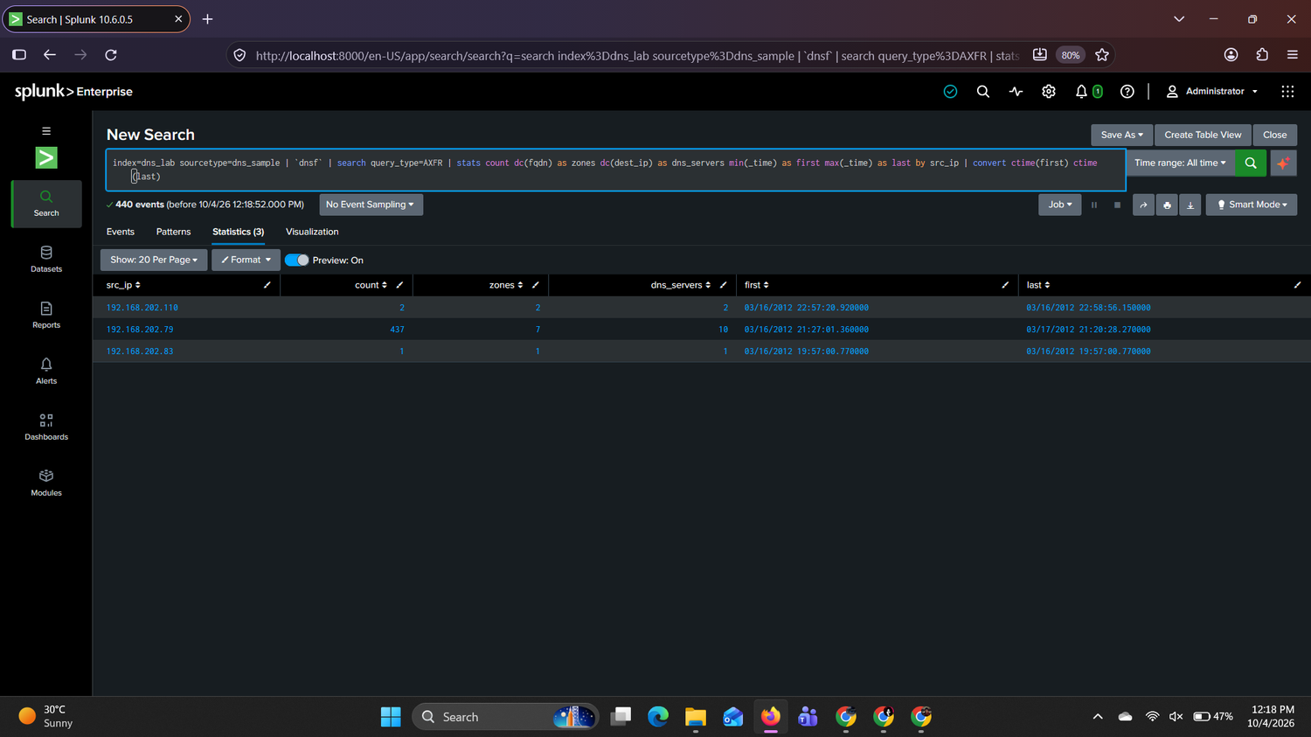
Figure 22: AXFR requests by source host (Splunk shows IST)
Source | AXFR requests | Zones | DNS servers | First / last (UTC)
192.168.202.79 | 437 | 7 | 10 | 16 Mar 15:57:01 to 17 Mar 15:50:28
192.168.202.110 | 2 | 2 | 2 | 16 Mar 17:27 to 17:28
192.168.202.83 | 1 | 1 | 1 | 16 Mar 14:27

SPL 22: Zones and servers targeted
index=dns_lab sourcetype=dns_sample | `dnsf` | search src_ip=192.168.202.79 query_type=AXFR | stats count by fqdn dest_ip | sort - count
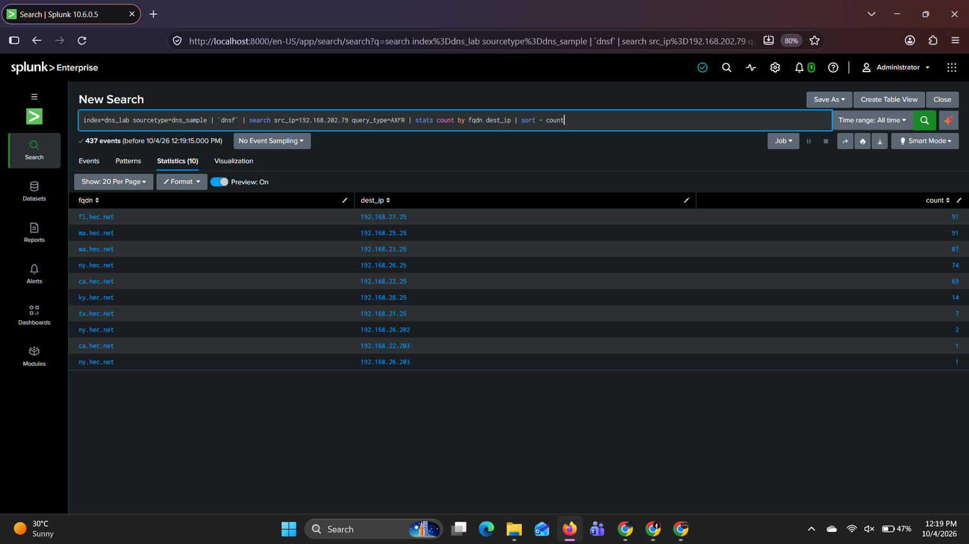
Figure 23: Zones and DNS servers targeted by 192.168.202.79
The host requested seven zones (fl, ma, wa, ny, ca, ky, tx.hec.net). Each zone was requested from its own site DNS server 192.168.2N.25 (N = 21 to 28), for example fl.hec.net from 192.168.27.25 (91 requests), ma.hec.net from 192.168.25.25 (91), wa.hec.net from 192.168.23.25 (87), ny.hec.net from 192.168.26.25 (74) and ca.hec.net from 192.168.22.25 (69). Requesting every site's zone from that site's server is systematic enumeration, not a one-off administrative query. All 437 requests used TCP port 53, the transport zone transfers use.
SPL 23: AXFR responses with answer data
index=dns_lab sourcetype=dns_sample | `dnsf` | search src_ip=192.168.202.79 query_type=AXFR response_code=NOERROR | rex field=_raw "\t(?<answers>[^\t]+)\t(?<TTLs>[^\t]+)\t(?<rejected>[^\t]+)$" | table _time fqdn dest_ip answers | head 10
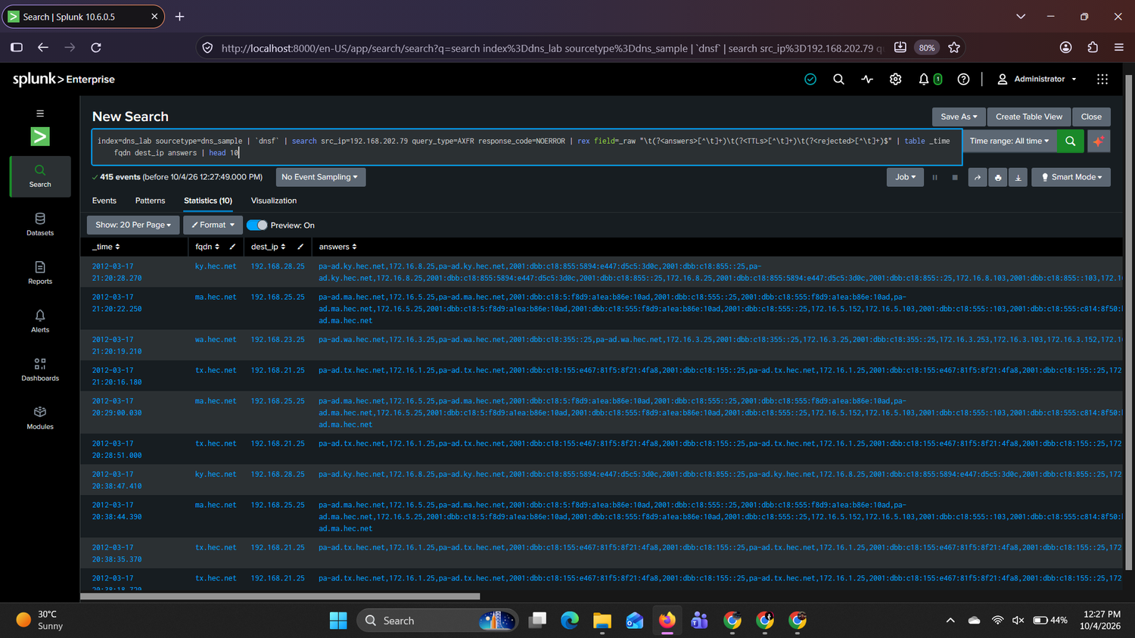
Figure 24: AXFR responses (NOERROR) containing internal hostnames and addresses (Splunk shows IST)
Of the 437 requests, 415 returned NOERROR, 16 had no recorded reply, 4 returned NOTAUTH and 2 returned REFUSED. The answers field of the NOERROR responses holds real records: for example pa-ad.ky.hec.net with 172.16.8.25 and 172.16.8.103 plus IPv6 addresses, and equivalent records for the ma, wa and tx sites. The DNS servers therefore appear to allow zone transfers to an ordinary workstation, which exposes an internal host inventory.

Preserved raw evidence
SPL 24: Raw AXFR events
index=dns_lab sourcetype=dns_sample | `dnsf` | search src_ip=192.168.202.79 query_type=AXFR | head 3 | table _time _raw
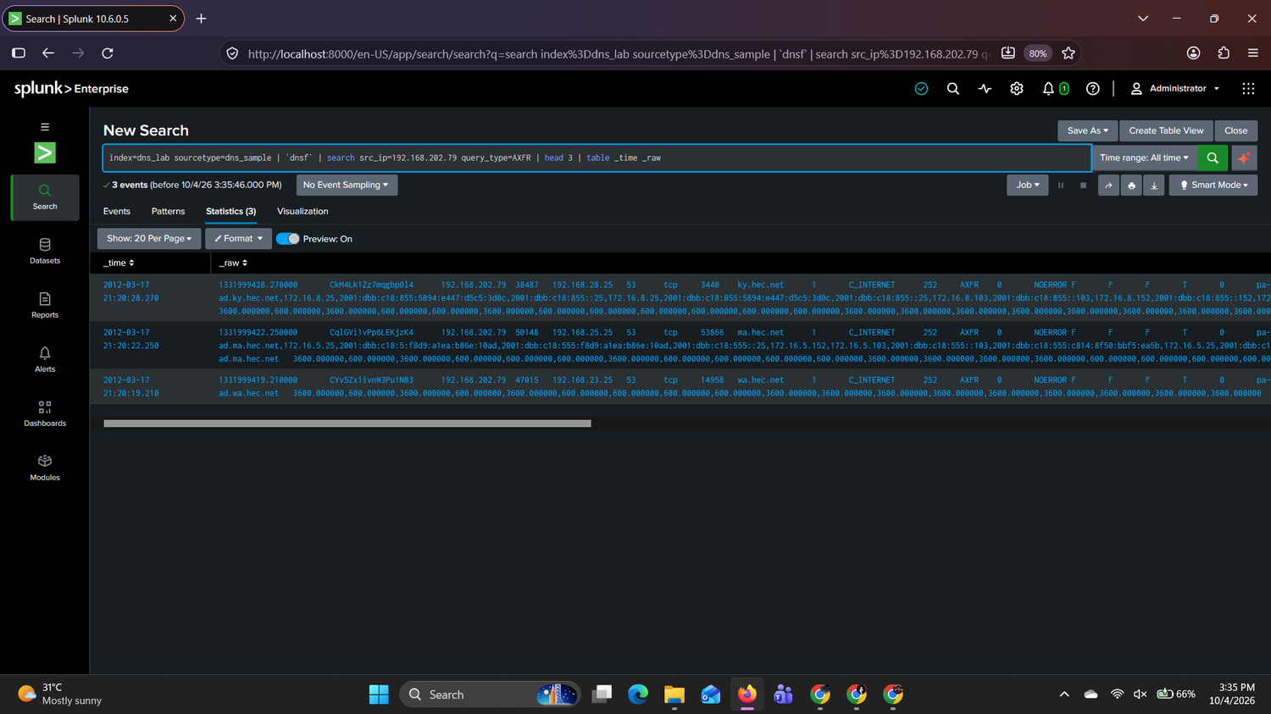
Figure 25: Raw AXFR events preserved with timestamps
Raw field (first event) | Value | Meaning
ts | 1331999428.270000 | 17 Mar 2012 15:50:28.270 UTC
uid | CkM4Lk1Zz7mqgbp0l4 | Zeek connection ID
source | 192.168.202.79 : 38487 | Client and client port
destination | 192.168.28.25 : 53 | DNS server, port 53
proto | tcp | Zone transfers use TCP
query | ky.hec.net, class IN, type 252 (AXFR) | Zone requested
rcode | 0 (NOERROR) | Server answered
flags | AA=F, TC=F, RD=F, RA=T | Authoritative/truncated/recursion flags
answers | pa-ad.ky.hec.net, 172.16.8.25, ... | Records returned by the server

Assessment (not proven): this pattern is consistent with reconnaissance. Limitation: DNS logs cannot prove the complete zone was transferred or how much data moved. Firewall, conn.log or DNS-server logs are needed. Possible benign explanation: an approved vulnerability scan or penetration test.

5.7 Notable observation 2: Reverse-lookup (PTR) sweep
SPL 25: PTR queries by subnet
index=dns_lab sourcetype=dns_sample | `dnsf` | search src_ip=192.168.202.79 query_type=PTR | rex field=fqdn "^\d+\.(?<third_octet>\d+)\.168\.192\.in-addr\.arpa" | stats count by third_octet | sort - count
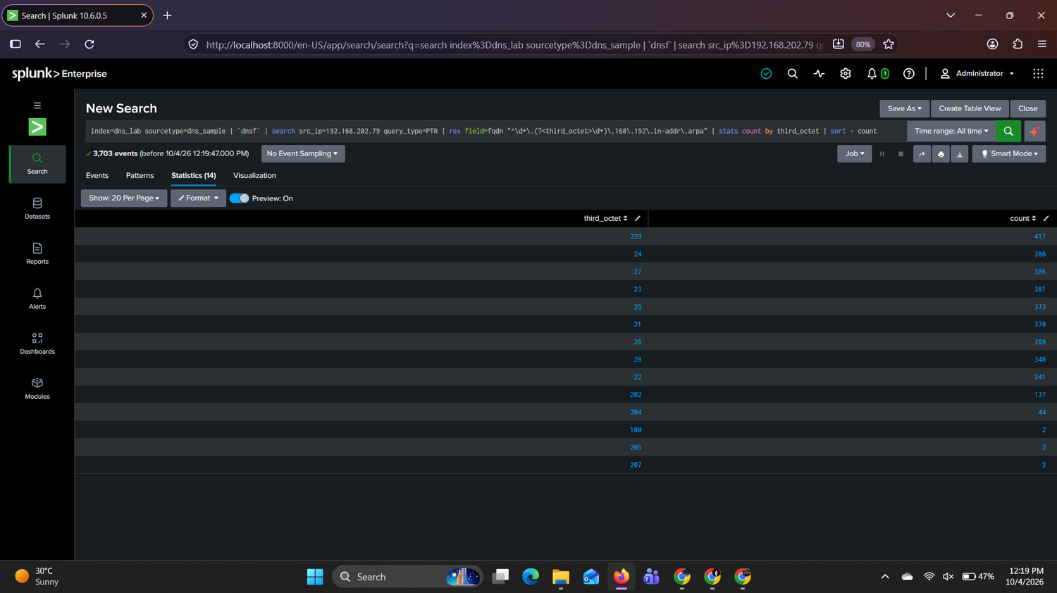
Figure 26: PTR queries from 192.168.202.79 by subnet
Subnet (192.168.x.0) | PTR queries
229 | 417
24 / 27 / 23 | 386 / 386 / 381
25 / 21 / 26 | 373 / 370 / 359
28 / 22 | 348 / 341
202 (own subnet) | 137
204 | 44

192.168.202.79 sent 3,703 PTR queries, spread almost evenly across nine subnets: 21 to 28 (341 to 386 each) and 229 (417), against 137 for its own subnet. Walking through consecutive subnets with similar counts is characteristic of host discovery, meaning mapping which addresses exist.
SPL 26: Query types and responses for 192.168.202.79
index=dns_lab sourcetype=dns_sample | `dnsf` | search src_ip=192.168.202.79 | stats count by query_type response_code | sort - count
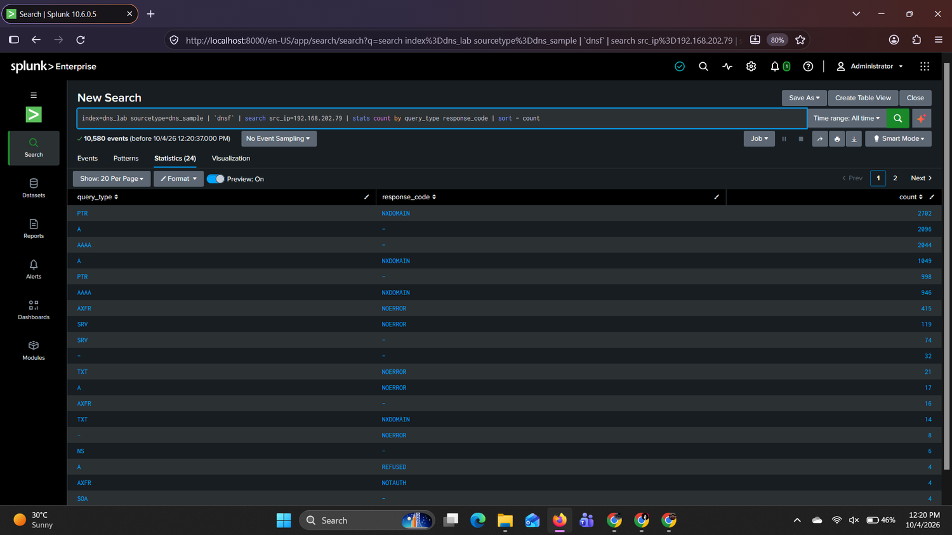
Figure 27: Query types and response codes for 192.168.202.79
Of this host's 10,580 events, 2,702 were PTR queries answered NXDOMAIN, 1,049 were A queries answered NXDOMAIN and 946 were AAAA queries answered NXDOMAIN, alongside the 415 successful AXFR responses. Mostly failing lookups across many names, combined with successful zone transfers, show a host enumerating the network. The host was active from 16 Mar 12:30 UTC to 17 Mar 20:38 UTC.
Possible benign explanation: a network scanner or asset-discovery tool run by IT. Evidence needed: DHCP and asset records, the scan schedule and firewall logs.

5.8 Notable observation 3: DNS fingerprinting (version.bind)
SPL 27
index=dns_lab sourcetype=dns_sample | `dnsf` | search fqdn="version.bind" | stats count dc(dest_ip) as dns_servers by src_ip | sort - count
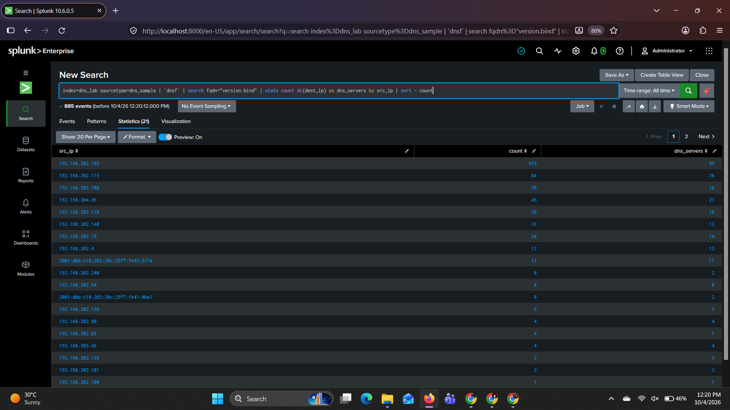
Figure 28: version.bind queries by client
Client | Queries | DNS servers asked
192.168.202.102 | 515 | 95
192.168.202.115 | 84 | 76
192.168.202.108 | 76 | 16
192.168.204.45 | 45 | 21
192.168.202.110 | 38 | 16
192.168.202.140 | 33 | 12
192.168.202.79 | 24 | 14

A version.bind query asks a DNS server which software and version it runs. There were 885 such queries. 192.168.202.102 asked 95 different DNS servers (515 queries) and 192.168.202.115 asked 76. A normal user has no reason to do this. Asking many servers for their version is consistent with fingerprinting. Several of these hosts appear elsewhere in this report (.79, .108, .110, .115, .140), which suggests a shared tool or an approved scan run from several machines. `192.168.202.102` is a new host of interest.

5.9 Notable observation 4: DNS blocklist (DNSBL) lookups
SPL 28
index=dns_lab sourcetype=dns_sample | `dnsf` | search fqdn IN ("*sorbs.net","*spamhaus.org","*spamcop.net","*spamrats.com","*quorum.to","*tornevall.org","*apews.org","*nszones.com") | stats count dc(fqdn) as lookups by src_ip | sort - count
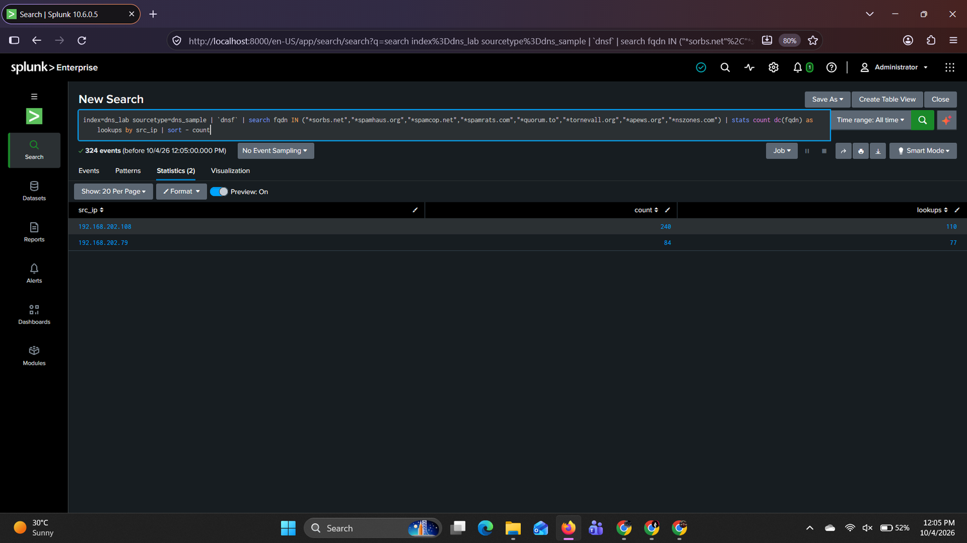
Figure 29: DNSBL lookups by source host
Client | DNSBL events | Distinct lookups
192.168.202.108 | 240 | 110
192.168.202.79 | 84 | 77

324 events came from only two hosts. The lookups follow the DNSBL format of a reversed IP address in front of a blocklist domain, for example 1.229.168.192.bl.spamcop.net (a check of 192.168.229.1 against SpamCop). Normal users do not check addresses against many blocklists. The same host (.79) also sent the zone transfers and the subnet sweep, which strengthens that case. 192.168.202.108 is a second host of interest (it also sent 76 version.bind queries).
Possible benign explanation: mail servers and mail gateways query blocklists routinely, so .108 could be a mail system. This is not confirmed. Evidence needed: asset records, and SMTP (port 25) traffic from .108 in firewall logs.

6. Threat Intelligence Validation
Indicator: rootshell-security.net. Why chosen: requested 770 times by seven internal clients, including 192.168.202.79 and 192.168.202.140; every query returned NXDOMAIN (Section 5.5). Date of checks: 4 October 2026.
Source | Date | Result
VirusTotal | 4 Oct 2026 | 4 of 91 security vendors flagged the domain: ADMINUSLabs, alphaMountain.ai and Chong Lua Dao as malicious, Fortinet as malware. Other vendors shown (for example Abusix, Acronis, AlienVault, BitDefender) reported clean. Registrar: Stichting Registrar of Last Resort Foundation; created about 2 years ago.
URLhaus | 4 Oct 2026 | No malware URLs listed for rootshell-security.net.

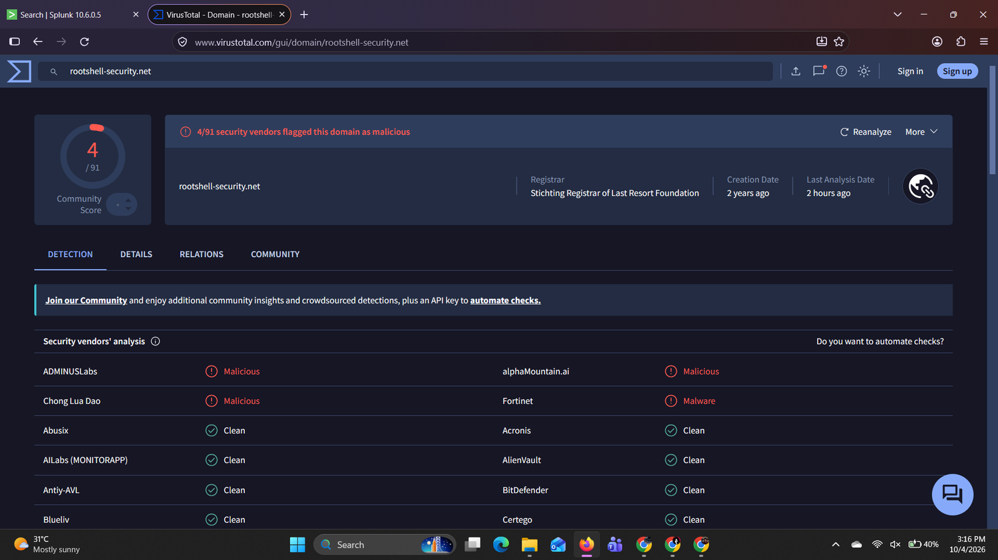
Figure 30: VirusTotal result for rootshell-security.net (checked 4 Oct 2026)
[[Insert URLhaus search-result screenshot here: search box showing rootshell-security.net with no entries]]
Figure 31: URLhaus search result for rootshell-security.net (no entries)
Interpretation: mixed and inconclusive
Four of 91 vendors flag the domain, and URLhaus has no entry. URLhaus only lists URLs used to distribute malware, so absence there does not prove a domain is safe.
Important limitation: the domain was registered about two years before these checks, but the DNS log is from March 2012. Today's reputation therefore describes the domain as it is now and does not show who owned or used the name in 2012. In this dataset every query for it returned NXDOMAIN, so it never resolved.
The domain is not labelled malicious. The case against 192.168.202.79 rests on its internal behaviour (Section 9), not on this domain.

7. Evidence Screenshots
The screenshots are placed beside the finding they support. The key evidence is indexed below.
Figure | Evidence | Supports
Figure 1 | Validation: 2012 timestamps and raw records | Ingestion and validation
Figure 4 | Event count and time range | Baseline
Figure 12 | Hourly activity and 16 Mar spike | Task 06
Figure 8 | Profile of the busiest client | Task 03
Figure 19 | NXDOMAIN versus unique failed names | Scanning pattern
Figure 22 to Figure 25 | AXFR requests, targets, answers and raw events | Main finding
Figure 26 | Reverse-lookup sweep across nine subnets | Enumeration
Figure 28 | version.bind fingerprinting | Related hosts
Figure 29 | Blocklist lookups | Supporting behaviour
Figure 30 | Threat-intelligence check | Phase 4

8. Answers to Investigation Questions
1. How many total DNS events are present?
427,935 events (Figure 4).
2. Earliest and latest event timestamp?
Earliest 16 Mar 2012 12:30:05 UTC; latest 17 Mar 2012 20:59:51 UTC. Splunk displayed 18:00:05 and 02:29:51 (18 Mar) because the user time zone is IST.
3. Which client generated the most queries?
10.10.117.210 with 75,943 queries (17.7%). It repeats only 250 domains and is assessed as expected behaviour pending asset confirmation (Task 03).
4. Which 10 domains were queried most?
teredo.ipv6.microsoft.com (39,273), tools.google.com (14,057), www.apple.com (13,390), time.apple.com (13,109), safebrowsing.clients.google.com (11,658), the NetBIOS wildcard name (10,401), WPAD (9,134), 44.206.168.192.in-addr.arpa (7,248), HPE8AA67 (6,929) and ISATAP (6,569).
5. Which client queried the most unique domains?
192.168.202.79 with 2,620 unique domains.
6. Most common query types?
A (212,477), NB (77,199), AAAA (54,519), PTR (53,017), TXT (12,870), SRV (12,268). Uncommon: AXFR (440), HINFO (30), NAPTR (27).
7. Response codes and frequency?
- 372,201; NXDOMAIN 50,330; NOERROR 2,665; REFUSED 1,797; NXRRSet 728; SERVFAIL 105; NOTIMP 44; NOTAUTH 32; FORMERR 14; plus rare codes (unassigned-*, YXRRSET, YXDOMAIN, NOTZONE).
8. Which clients generated the most NXDOMAIN?
192.168.202.103 (7,471), 192.168.202.138 (4,762), 192.168.202.79 (4,711), 192.168.202.83 (4,453) and 192.168.202.140 (3,835). .79, .138 and .140 failed on more than 2,000 different names (scanning pattern); .103 and .83 failed on 62 and 18 names (retries).
9. Which domains have the most distinct source IPs?
safebrowsing.clients.google.com (59 clients), creativecommons.org (47), and dokuwiki.org, jigsaw.w3.org, validator.w3.org, www.php.net (46 each). The - entry (127) is not a domain.
10. Are there noticeable spikes? When?
Yes. 16 Mar 16:00 to 19:00 UTC, peaking at 73,300 events at 18:00 against a normal 8,000 to 20,000 per hour. It is driven by 10.10.117.210 (up to 6,157 queries in 5 minutes at 17:05 UTC). Smaller bursts on 17 Mar come from 192.168.202.79 and .138.
11. Five rare domains and why each is worth reviewing
(1) 1.229.168.192.bl.spamcop.net and (2) 1.229.168.192.list.quorum.to: blocklist checks of an internal address, typical of scanning tools; (3) metasploitable and (4) acme-texmcxhenx: probe-style names seen once and unresolved; (5) 0zqsnofz: random single-label name from 192.168.202.140. Also 100.204.14.72.in-addr.arpa: a single reverse lookup that could be part of an address sweep. Rarity alone is not proof of malice.
12. Three client/domain relationships to investigate
(1) **192.168.202.79 to *.hec.net: 437 zone-transfer requests to 10 DNS servers, 415 answered with internal host data. (2) 192.168.202.140 / .79 to rootshell-security.net: requested by seven clients, all NXDOMAIN. (3) 192.168.202.108 / .79 to blocklist domains**: 240 and 84 DNSBL events, unusual for normal users.
13. Security-sensitive keywords?
The keyword search matched 9,600 events, almost all legitimate (Symantec LiveUpdate, Windows Update, login.live.com, login.oscar.aol.com). `secure.informaction.com` (874 queries, 29 clients) needs validation. No phishing-style names were found.
14. Domain requiring threat-intelligence validation
rootshell-security.net. VirusTotal (4 Oct 2026): 4 of 91 vendors flagged it. URLhaus (4 Oct 2026): no entry. Result: mixed and inconclusive. The domain is two years old but the log is from 2012, and all queries were NXDOMAIN (Section 6).
15. Anomaly with a benign explanation
10.10.117.210 is the top client (75,943 queries) but queried only 250 domains, mainly teredo.ipv6.microsoft.com (27,425), Google, Norton/Symantec and update services, with no failures. It is probably a gateway/proxy or a host running automated software. Evidence needed: DHCP and asset records, how many users sit behind the address, and DNS-server logs. A second example is 192.168.202.103/.83: thousands of NXDOMAIN for only 62 and 18 names, which indicates software retries.
16. Incident hypothesis (evidence versus assumptions)
Evidence: 192.168.202.79 sent 437 AXFR requests for 7 zones to 10 DNS servers (415 answered NOERROR with internal records), about 3,700 PTR lookups across nine subnets, queried 2,620 unique domains (2,557 unique failures) and made blocklist lookups. Assumptions (not proven): the host performed reconnaissance of hec.net, either unauthorised or as an approved scan, and complete zones were transferred. Conclusion: suspicious and requires validation.
17. Additional logs to request
Firewall/NetFlow/Zeek conn.log (TCP/53 volume between .79 and the DNS servers); DNS-server logs (which zone transfers were allowed); DHCP and asset inventory (owner of .79); EDR/endpoint process logs from that host; the vulnerability-scan and penetration-test schedule; authentication logs.

9. Final Investigation: SOC Analyst Assessment

9.1 Anomaly (one sentence)
Internal host 192.168.202.79 sent 437 zone-transfer (AXFR) requests to the DNS servers, swept many subnets with reverse lookups and caused thousands of failed lookups, which looks like network reconnaissance of the hec.net environment.

9.2 SPL that found it
SPL 21 (see Figure 22)
index=dns_lab sourcetype=dns_sample | `dnsf` | search query_type=AXFR | stats count dc(fqdn) as zones dc(dest_ip) as dns_servers min(_time) as first max(_time) as last by src_ip | convert ctime(first) ctime(last)
The host was first flagged by the unique-domains search (SPL 16), where it queried 2,620 unique domains, the most of any client.

9.3 Affected systems and time period
Item | Detail
Client | 192.168.202.79 (related leads: .102, .108, .115, .138, .140)
Targets | 10 DNS servers, mainly 192.168.2N.25 (N = 21 to 28); 7 zones: ma, fl, wa, ny, ca, ky, tx.hec.net
Domain of interest | rootshell-security.net (7 clients, all NXDOMAIN)
Time period (UTC) | AXFR: 16 Mar 2012 15:57 to 17 Mar 2012 15:50. Host activity: 16 Mar 12:30 to 17 Mar 20:38.

9.4 Pivots
Pivot | Finding
Query type | 437 AXFR; 3,703 PTR
Response code | 415 AXFR answered NOERROR with internal hostnames and IPs; 4 NOTAUTH; 2 REFUSED; 2,702 PTR answered NXDOMAIN
Frequency and diversity | 2,620 unique domains; 2,557 unique failed names; burst of 2,126 queries in 5 minutes on 17 Mar
Related clients | Blocklist lookups from .79 and .108; version.bind from .102 and .115; failed-name diversity on .138 and .140

9.5 Threat-intelligence validation
rootshell-security.net (requested by 192.168.202.79 and six other clients), checked 4 Oct 2026: VirusTotal flags 4 of 91 vendors; URLhaus has no entry. The result is mixed and inconclusive (Section 6). The case rests on the host's internal behaviour.

9.6 Conclusion
Outcome: Suspicious and requires validation
Why: one host requested zone transfers for 7 zones from 10 DNS servers, received answers containing internal host data, swept nine subnets and produced more than 2,500 unique failed lookups. No other host shows this combination.
Not proven: intent, and whether complete zones were copied. An approved security scan would look the same, so the activity is not called malicious.

9.7 Next three actions as an L1 SOC analyst
- Identify the owner and check authorisation. Use DHCP and asset records to find who owns 192.168.202.79, then ask IT or change management whether a scan or penetration test was approved for 16 to 17 March.
- Confirm what was transferred. Review firewall, NetFlow or conn.log data for TCP/53 between 192.168.202.79 and the DNS servers, and DNS-server logs for allowed zone transfers.
- Escalate and contain if unapproved. Raise a ticket to L2, review the host with EDR, and recommend restricting AXFR on the DNS servers to approved secondary servers only. Review 192.168.202.102, .108, .115, .138 and .140 for similar behaviour.

10. Conclusion
Analysis of 427,935 DNS events found that most activity is normal background traffic: Windows IPv6 tunnelling, time synchronisation, browser safe-browsing checks and software updates. The busiest client (10.10.117.210) repeats a small set of domains and is assessed as expected behaviour.
The most significant anomaly is host 192.168.202.79. It sent 437 of the 440 zone-transfer requests across seven zones and ten DNS servers (415 answered with internal host records), swept nine subnets with about 3,700 reverse lookups, queried 2,620 unique domains with 2,557 unique failures and performed blocklist lookups. Supporting observations include version.bind fingerprinting from 192.168.202.102 and .115, blocklist lookups from 192.168.202.108, and a shared unresolved domain, rootshell-security.net, whose threat-intelligence result is mixed.
Outcome: suspicious and requires validation. The behaviour matches reconnaissance, but the dataset cannot show intent, the tool used or the data volume, so the activity is not classified as malicious.

10.1 Limitations
- The dataset contains DNS only: no connection volumes, user identities, process data or DNS-server logs.
- The log dates from March 2012, while threat-intelligence results reflect October 2026.
- Splunk displays times in IST; the data is in UTC (conversion stated throughout).
- 372,201 events show -, meaning no reply was recorded, which limits response analysis.
- A significant gap with no events (about 23:00 UTC 16 Mar to 12:00 UTC 17 Mar) means the capture is not continuous.
- NOERROR on AXFR and the answers returned strongly suggest transfers were allowed, but they do not prove complete zones were copied.

11. Recommended Next Steps
- Identify the owner of 192.168.202.79 from DHCP and asset records and confirm with IT or change management whether a scan or penetration test was approved for 16 to 17 March 2012.
- Confirm what was transferred by reviewing firewall, NetFlow or conn.log data for TCP/53 traffic between 192.168.202.79 and the DNS servers, and the DNS-server logs.
- Escalate to L2 if the activity was not approved, and review the host with EDR or endpoint logs.
- Harden the DNS servers by restricting AXFR to approved secondary servers only.
- Review related hosts (192.168.202.102, .108, .115, .138 and .140) for similar scanning behaviour.
- Monitor `rootshell-security.net` and re-check its reputation, since the current result is mixed.
- Create a detection for AXFR requests from non-DNS hosts and for clients with a high ratio of unique failed names.

Appendix A: SPL Searches Used
All searches use index dns_lab, sourcetype dns_sample and time range All time. The macro dnsf extracts the DNS fields (Appendix B). The type - in the Zeek log stands for "no value".
SPL 1: Validation
index=dns_lab sourcetype=dns_sample | head 20
SPL 2: Field summary
index=dns_lab sourcetype=dns_sample | `dnsf` | fieldsummary | sort - count
SPL 3: DNS fields only
index=dns_lab sourcetype=dns_sample | `dnsf` | fieldsummary | search field IN ("src_ip","dest_ip","fqdn","query_type","response_code","src_port","dest_port","proto","uid","ts") | table field count distinct_count | sort - count
SPL 4: Task 01, event count and time range
index=dns_lab sourcetype=dns_sample | stats count min(_time) as first max(_time) as last | convert ctime(first) ctime(last)
SPL 5: Task 02, top domains
index=dns_lab sourcetype=dns_sample | `dnsf` | top limit=20 fqdn
SPL 6: Task 03, top clients
index=dns_lab sourcetype=dns_sample | `dnsf` | top limit=20 src_ip
SPL 7: Profile of 10.10.117.210
index=dns_lab sourcetype=dns_sample | `dnsf` | search src_ip=10.10.117.210 | stats count dc(fqdn) as unique_domains min(_time) as first max(_time) as last | convert ctime(first) ctime(last)
SPL 8: Domains/types/responses of 10.10.117.210
index=dns_lab sourcetype=dns_sample | `dnsf` | search src_ip=10.10.117.210 | stats count by fqdn query_type response_code | sort - count | head 15
SPL 9: Task 04, query types
index=dns_lab sourcetype=dns_sample | `dnsf` | stats count by query_type | sort - count
SPL 10: Task 05, response codes
index=dns_lab sourcetype=dns_sample | `dnsf` | stats count by response_code | sort - count
SPL 11: Task 06, activity over time
index=dns_lab sourcetype=dns_sample | timechart span=1h count
SPL 12: Task 07, client/domain pairs
index=dns_lab sourcetype=dns_sample | `dnsf` | stats count by src_ip fqdn | sort - count | head 30
SPL 13: Task 08, rare domains
index=dns_lab sourcetype=dns_sample | `dnsf` | rare limit=30 fqdn
SPL 14: Task 09, NXDOMAIN pairs
index=dns_lab sourcetype=dns_sample | `dnsf` | search response_code=NXDOMAIN | stats count by src_ip fqdn | sort - count | head 30
SPL 15: Task 10, keyword hunt
index=dns_lab sourcetype=dns_sample | regex _raw="(?i)(login|verify|secure|update|account|password|wallet)" | `dnsf` | stats count by fqdn src_ip | sort - count
SPL 16: Phase 3A, volume vs unique domains
index=dns_lab sourcetype=dns_sample | `dnsf` | stats count as dns_queries dc(fqdn) as unique_domains by src_ip | sort - dns_queries | head 20
SPL 17: Phase 3B, domains by distinct clients
index=dns_lab sourcetype=dns_sample | `dnsf` | stats dc(src_ip) as unique_clients count as queries by fqdn | sort - unique_clients | head 30
SPL 18: Phase 3C, NXDOMAIN by client
index=dns_lab sourcetype=dns_sample | `dnsf` | search response_code=NXDOMAIN | stats count as nxdomain_count dc(fqdn) as unique_failed_domains by src_ip | sort - nxdomain_count
SPL 19: Phase 3D, query bursts
index=dns_lab sourcetype=dns_sample | `dnsf` | bin _time span=5m | stats count as queries by _time src_ip | sort - queries | head 50
SPL 20: Phase 3E, domain pivot
index=dns_lab sourcetype=dns_sample | `dnsf` | search fqdn="rootshell-security.net" | stats count values(src_ip) as clients values(query_type) as query_types by fqdn
SPL 21: AXFR requests by client
index=dns_lab sourcetype=dns_sample | `dnsf` | search query_type=AXFR | stats count dc(fqdn) as zones dc(dest_ip) as dns_servers min(_time) as first max(_time) as last by src_ip | convert ctime(first) ctime(last)
SPL 22: AXFR zones and servers
index=dns_lab sourcetype=dns_sample | `dnsf` | search src_ip=192.168.202.79 query_type=AXFR | stats count by fqdn dest_ip | sort - count
SPL 23: AXFR responses with answers
index=dns_lab sourcetype=dns_sample | `dnsf` | search src_ip=192.168.202.79 query_type=AXFR response_code=NOERROR | rex field=_raw "\t(?<answers>[^\t]+)\t(?<TTLs>[^\t]+)\t(?<rejected>[^\t]+)$" | table _time fqdn dest_ip answers | head 10
SPL 24: Raw AXFR events
index=dns_lab sourcetype=dns_sample | `dnsf` | search src_ip=192.168.202.79 query_type=AXFR | head 3 | table _time _raw
SPL 25: PTR sweep by subnet
index=dns_lab sourcetype=dns_sample | `dnsf` | search src_ip=192.168.202.79 query_type=PTR | rex field=fqdn "^\d+\.(?<third_octet>\d+)\.168\.192\.in-addr\.arpa" | stats count by third_octet | sort - count
SPL 26: Query types/responses for 192.168.202.79
index=dns_lab sourcetype=dns_sample | `dnsf` | search src_ip=192.168.202.79 | stats count by query_type response_code | sort - count
SPL 27: version.bind queries
index=dns_lab sourcetype=dns_sample | `dnsf` | search fqdn="version.bind" | stats count dc(dest_ip) as dns_servers by src_ip | sort - count
SPL 28: DNSBL lookups
index=dns_lab sourcetype=dns_sample | `dnsf` | search fqdn IN ("*sorbs.net","*spamhaus.org","*spamcop.net","*spamrats.com","*quorum.to","*tornevall.org","*apews.org","*nszones.com") | stats count dc(fqdn) as lookups by src_ip | sort - count

Appendix B: Field-Extraction Macro `dnsf`
Created in Settings → Advanced search → Search macros (name dnsf, no leading pipe). The log has no header row, so the fields are named according to the Zeek DNS log layout. The fields after response_code (AA, TC, RD, RA, Z, answers, TTLs, rejected) are not extracted by the macro; answers is extracted inside SPL 23 where needed.
rex "^(?<ts>[^\t]+)\t(?<uid>[^\t]+)\t(?<src_ip>[^\t]+)\t(?<src_port>[^\t]+)\t(?<dest_ip>[^\t]+)\t(?<dest_port>[^\t]+)\t(?<proto>[^\t]+)\t(?<trans_id>[^\t]+)\t(?<fqdn>[^\t]+)\t(?<qclass>[^\t]+)\t(?<qclass_name>[^\t]+)\t(?<qtype>[^\t]+)\t(?<query_type>[^\t]+)\t(?<rcode>[^\t]+)\t(?<response_code>[^\t]+)"

Time conversion reference
Splunk displays (IST) | UTC | Example
03/16/2012 18:00:05 | 16 Mar 2012 12:30:05 | First event
03/17/2012 21:20:28 | 17 Mar 2012 15:50:28 | Last AXFR request
03/18/2012 02:29:51 | 17 Mar 2012 20:59:51 | Last event

