* Perform branch operation:

git branch test //create branch but don’t switched

git branch –move old-branch new-branch

//rename the branch name in local doesn’t reflect to git repo

For that we need to push branch to the git

git push origin new-branch //new branch is created but not renamed with old-branch (i.e. both branches old and new will be available on git)

now we need to explicitly remove the old-branch

git push origin –delete old-branch

* Switch from one branch to another:

git switch branch-name //Move to the branch-name

git switch –c branch-name //Create branch and move to that branch

* Log commands:

git log –oneline //display logs within one line desc

git log –graph //display logs with graphical representation of branches

* Revise revert command again for practice

git revert -1 f5b335476819957082b34aa966cdea630d439f65

Today I tried to revert the merged commit in main branch.

git revert –continue //continue the revert operation

git revert –abort //abort revert operation

git revert –quit //quit revert operation

* Next I again execute merged commit but using cherry-pick command which is used to pick the commit from a branch and execute in other branch.

git cherry-pick f5b335476819957082b34aa966cdea630d439f65

Now take commit from temp branch and execute in demo branch

git switch temp

git log //to fetch commit hash

git switch demo

git cherry-pick fc07862ae88c8124043549cc60f81fed4bb16b7e

* Visual representation of git log command

gitk

this command will launch gitk gui which look similar to the following:

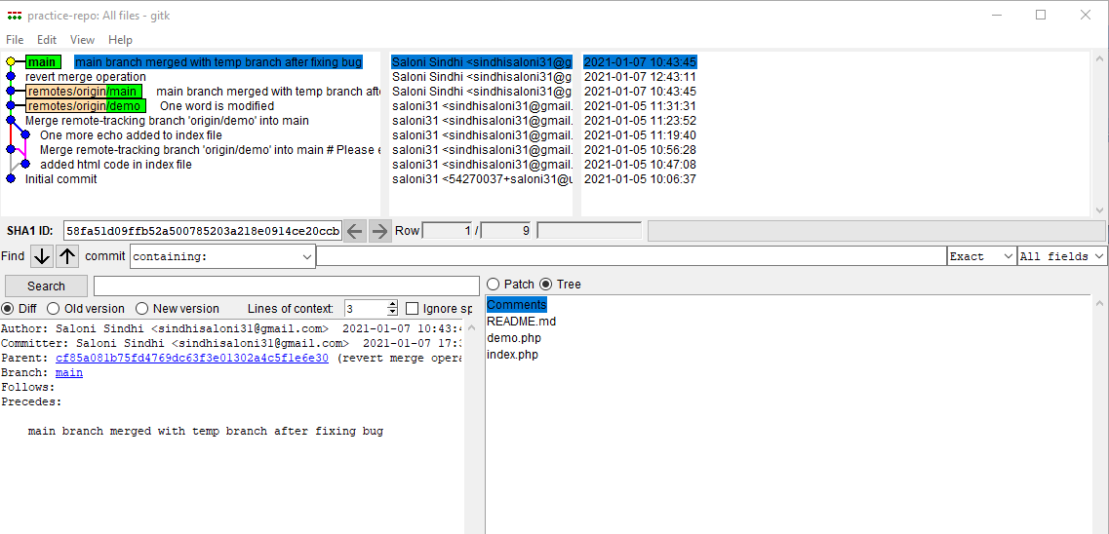

gitk –branches

this commands will display the log of all the associated branches in gitk GUI.

* How to come back to our previous stage of code , if there may be any bad modification code done in previous working code. But this command is useful only when we didn’t commit that file in staged area : git checkout – demo.php
* Reset command: (--mixed is default option work)

git reset 2dc4f08fa16701d35668da08d7f79d517f8ac271

This command just undo the last commit and update staged snapshot (now the last commit does not link to anyone i.e orphaned), but it is displayed in the log.

--soft 🡺 it will not affect or alter staged snapshot and working directory

--mixed🡺Update staged snapshot, but not affect to the working directory

--hard 🡺Update both staged snapshot and working directory

* Rev-parse command which return hash code which point to any branch, tag or any indirect reference

git rev-parse master

* Mirroring git repository

git push origin –mirror [git@github.com:saloni31/practice-repo.git](mailto:git@github.com:saloni31/practice-repo.git)

It will push all of our local code into new repo. It will completely overwrite new repo. In short it is most suitable command to take a backup of our repository.