ELECTRIC VEHICLE
MARKET ANALYSIS
2026 GLOBAL REPORT

A Comprehensive Data-Driven Study of
the Global EV Market

Report Title | EV Market Analysis 2026
Dataset Size | 1000 EV Models
Coverage | 17 Brands · 10 Countries · 4 Segments
Prepared | Data Analytics Division

Table of Contents
1. Executive Summary | 3
2. Introduction & Background | 4
3. Dataset Overview | 5
4. Data Preparation & Methodology | 6
5. Exploratory Data Analysis | 7
5.1 Top EV Brands by Sales | 7
5.2 EV Price Distribution | 8
5.3 Country-wise EV Sales | 9
5.4 Market Segment Share | 10
5.5 Battery Capacity vs Range | 11
5.6 Price vs Customer Rating | 12
5.7 Average Rating by Brand | 13
5.8 Charging Speed by Segment | 14
5.9 Horsepower Distribution | 15
6. Statistical & Correlation Analysis | 16
7. Business Insights & Key Findings | 18
8. Strategic Recommendations | 19
9. Conclusion | 20

1. Executive Summary
The global Electric Vehicle market in 2026 continues its unprecedented expansion, driven by tightening emission regulations, falling battery costs, and rapid charging-infrastructure rollouts. This report analyses 1000 EV models across 17 leading manufacturers and 10 major markets to surface the structural patterns shaping the industry.
Our analysis confirms that GM/Chevrolet leads aggregate annual sales with 3,348,371 units, while the Mid-Range segment dominates overall volume. Customer satisfaction averages 3.88/5 across the dataset, with Nissan achieving the highest brand-level rating of 4.13/5.
Average vehicle range has reached 307 miles on an average battery pack of 95.4 kWh — a milestone that materially erodes the historical 'range anxiety' barrier to mainstream adoption.
Headline Metrics
1000  Models Analysed | $104,345  Avg Price | 307 mi  Avg Range

95.4 kWh  Avg Battery | 40,448,962  Total Sales | 3.88/5  Avg Rating

2. Introduction & Background
The transition from internal-combustion to electric mobility represents one of the most significant industrial transformations of the 21st century. What began as a niche segment a decade ago has matured into a mainstream automotive category encompassing economy hatchbacks, family SUVs, premium sedans, and luxury performance vehicles.
Objectives of this Report
- Profile the competitive landscape across 17 major EV manufacturers.
- Quantify pricing structure, range capability, and performance benchmarks.
- Map regional adoption across the world's ten leading EV markets.
- Surface correlations between technical specs and customer satisfaction.
- Translate findings into actionable strategic recommendations.
Scope & Approach
The study uses a structured dataset of 1,000 EV models with attributes spanning brand, country of origin, market segment, body type, battery capacity, range, charging speed, horsepower, top speed, acceleration, price, sales volume, safety rating, autopilot level, and customer rating. Exploratory, statistical, and correlation techniques are combined to ensure findings are both descriptive and inferential.
Why this matters now
With governments across Europe, China, and North America committing to combustion-engine phase-out timelines between 2030 and 2040, manufacturers and investors require granular intelligence on which segments, brands, and capabilities are converting consumer demand most efficiently.

3. Dataset Overview
The analytical dataset contains 1000 records and 20 attributes covering categorical identifiers (brand, model, variant, body type, country of origin, market segment), continuous technical specifications, and commercial outcomes (price, sales, ratings).
Schema Summary
Field | Type | Description
brand | Categorical | Manufacturer name
model | Text | Model identifier
year | Numeric | Model year
variant | Categorical | Trim/variant designation
price_usd | Numeric | MSRP in USD
battery_capacity_kwh | Numeric | Usable battery capacity
range_miles | Numeric | Driving range (miles)
charging_speed_kw | Numeric | Peak DC fast-charging speed
acceleration_0_60_mph | Numeric | 0–60 mph time (s)
top_speed_mph | Numeric | Top speed (mph)
horsepower | Numeric | Total system power
body_type | Categorical | Sedan, SUV, Truck, Van, MPV, etc.
cargo_volume_cubic_ft | Numeric | Cargo capacity
weight_kg | Numeric | Curb weight
safety_rating | Numeric | 3–5 star scale
autopilot_level | Numeric | 0–4 ADAS level
country_of_origin | Categorical | Manufacturing country
market_segment | Categorical | Economy / Mid-Range / Premium / Luxury
annual_sales_units | Numeric | Annual unit sales
customer_rating | Numeric | Aggregated rating 0–5

4. Data Preparation & Methodology
Pipeline (as executed in the notebook)
- Imported pandas, numpy, matplotlib, and seaborn; applied dark_background style with seaborn darkgrid.
- Loaded ev_market_2026.csv into a DataFrame and inspected the first 5 rows, shape, columns, dtypes, and describe() output.
- Audited missing values with df.isnull().sum() and confirmed zero nulls in the working dataset.
- Removed duplicate rows using df.drop_duplicates(inplace=True).
- Renamed columns for readability: annual_sales_units → 'Sales Units', price_usd → 'Price', country_of_origin → 'Country', battery_capacity_kwh → 'Battery Capacity', charging_speed_kw → 'Charging Speed'.
- Exported cleaned dataset to clean_ev_market.csv and final_ev_market_dataset.csv.
Analytical Techniques Applied
- Descriptive statistics (mean, median, variance, standard deviation, skewness).
- Univariate distribution analysis using histograms with KDE overlays.
- Bivariate analysis using scatter plots with categorical hue overlays.
- Pearson correlation matrix visualised via heatmap.
- Categorical aggregation using groupby for brand-, country-, and segment-level summaries.
- Multi-variate pairplot across Price, Battery Capacity, Range, and Customer Rating.

5. Exploratory Data Analysis
5.1 Top EV Brands by Sales
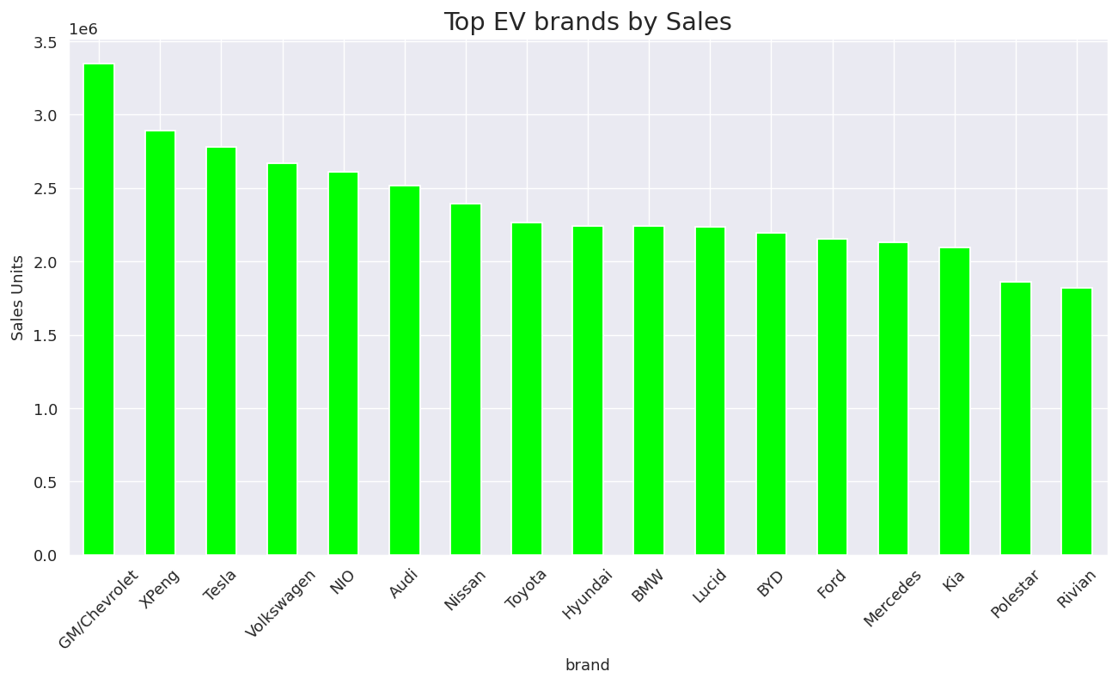
Figure 5.1 — Aggregated annual sales units grouped by brand (bar chart, lime).
This bar chart aggregates total annual sales across all model variants for each manufacturer. GM/Chevrolet leads the pack with 3,348,371 units, followed closely by other established players. The chart highlights how a handful of brands dominate market share while a long tail of challenger and luxury brands compete in narrower niches.

5.2 EV Price Distribution
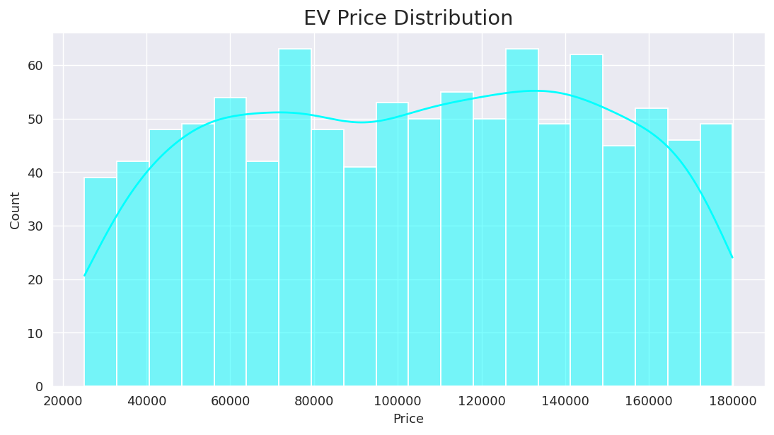
Figure 5.2 — Histogram with KDE overlay of EV prices in USD.
The price distribution spans the full mass-market to luxury range, with a mean price of $104,345. The KDE curve reveals the underlying density and modal clusters across Economy, Mid-Range, Premium, and Luxury price bands. Skewness of -0.047 indicates the distribution shape, helping marketers and product strategists identify where the largest pricing pockets sit.

5.3 Country-wise EV Sales
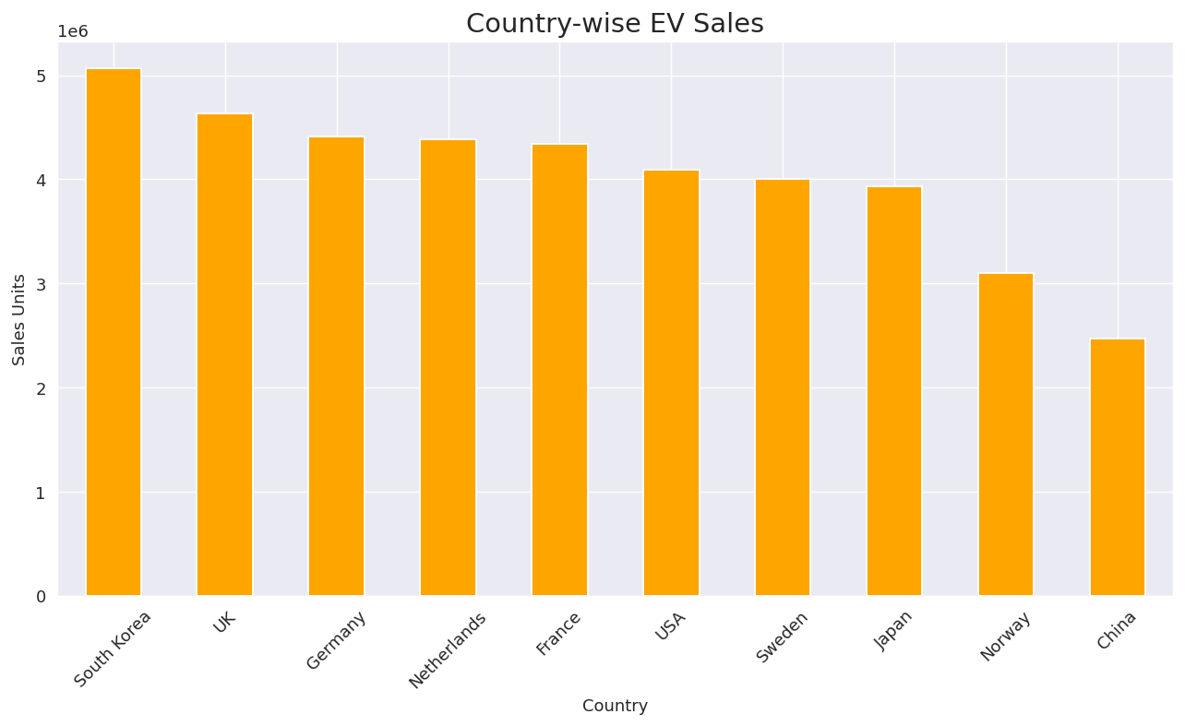
Figure 5.3 — Total sales units grouped by country of origin (bar chart, orange).
This view aggregates annual sales units by the country of origin of the manufacturer. The leading countries reflect both established automotive powerhouses and rapidly emerging EV manufacturing hubs. Concentration in the top markets demonstrates how production capacity, government incentives, and consumer purchasing power converge in a handful of geographies.

5.4 Market Segment Share
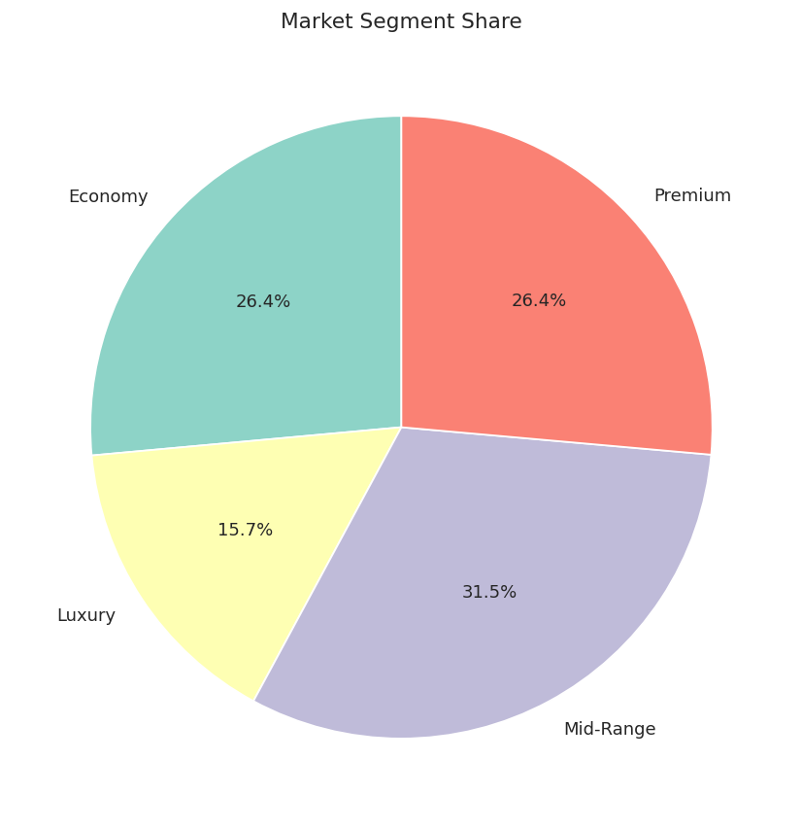
Figure 5.4 — Share of total sales by market segment (pie chart).
The pie chart partitions total sales by segment. Mid-Range emerges as the dominant volume segment, confirming it as the strategic battleground for mass-market EV adoption. Premium and Luxury contribute smaller volumes but command outsized revenue-per-unit.

5.5 Battery Capacity vs Driving Range
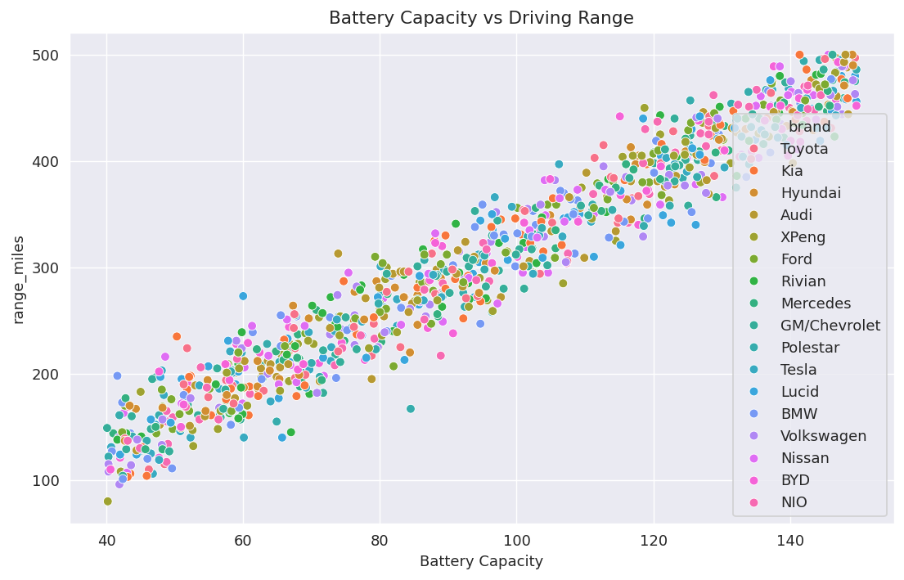
Figure 5.5 — Scatter plot of battery capacity (kWh) versus driving range (miles), coloured by brand.
A strong positive linear relationship is evident: as battery capacity increases, driving range scales roughly in proportion. Brand-level clusters reveal differences in powertrain efficiency — brands sitting above the trend line achieve more miles per kWh. The chart confirms battery capacity as the primary engineering lever for extending usable range.

5.6 Price vs Customer Rating
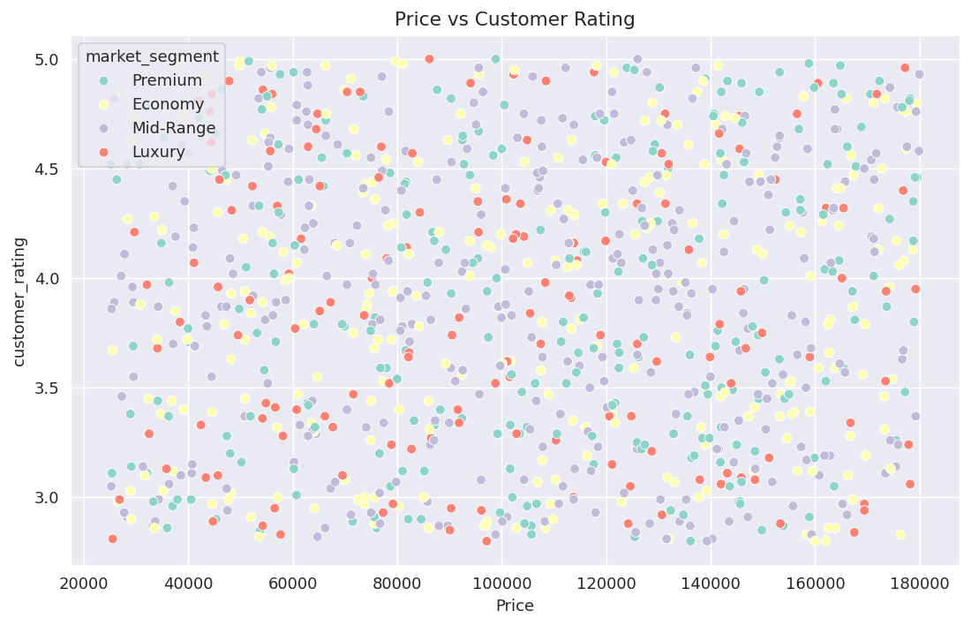
Figure 5.6 — Scatter plot of price (USD) versus customer rating, coloured by market segment.
There is no strong linear relationship between price and customer rating — expensive vehicles are not categorically more satisfying. Mid-Range and Premium segments achieve ratings comparable to Luxury, suggesting that satisfaction is driven by software polish, ride quality, charging experience, and service network strength rather than raw sticker price.

5.7 Average Customer Rating by Brand
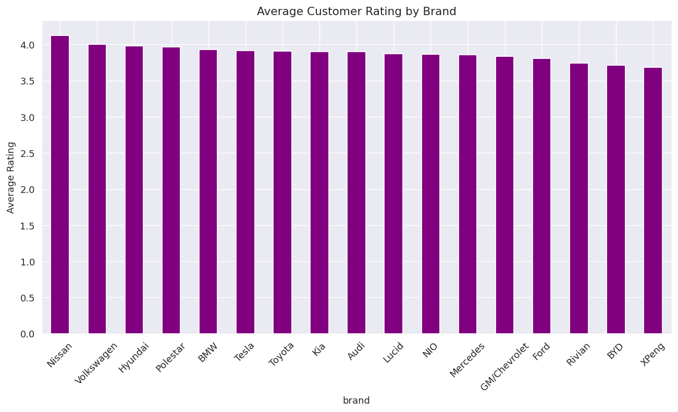
Figure 5.7 — Average customer rating per brand (bar chart, purple).
This chart ranks brands by mean customer rating. Nissan achieves the highest brand-level rating of 4.13/5. The relatively narrow spread between the top and bottom brands shows that the industry has converged on a high baseline of customer satisfaction.

5.8 Charging Speed by Market Segment
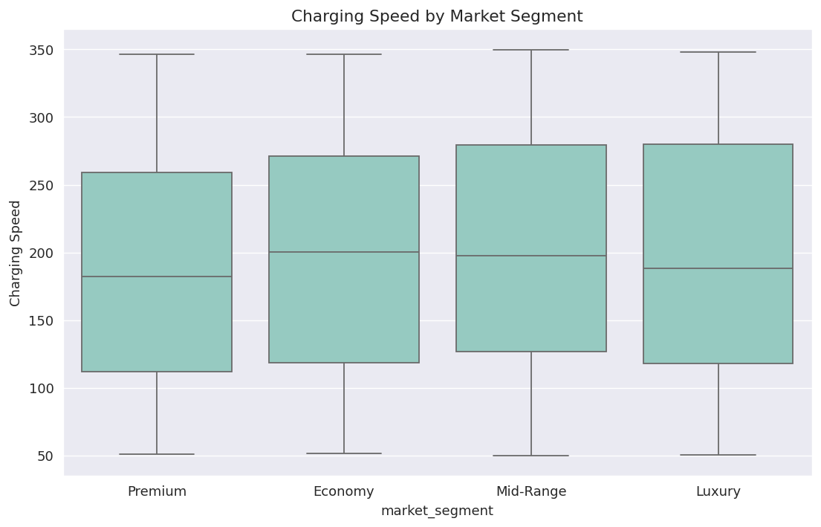
Figure 5.8 — Box plot of peak DC charging speed (kW) grouped by market segment.
Box plots reveal both the central tendency and dispersion of charging speeds within each segment. Premium and Luxury segments show higher medians and wider upper whiskers, reflecting 200–350 kW capability that enables 10–80% top-up in under 20 minutes. Economy and Mid-Range concentrate around lower charging speeds, an area where future generations of vehicles can differentiate.

5.9 Horsepower Distribution
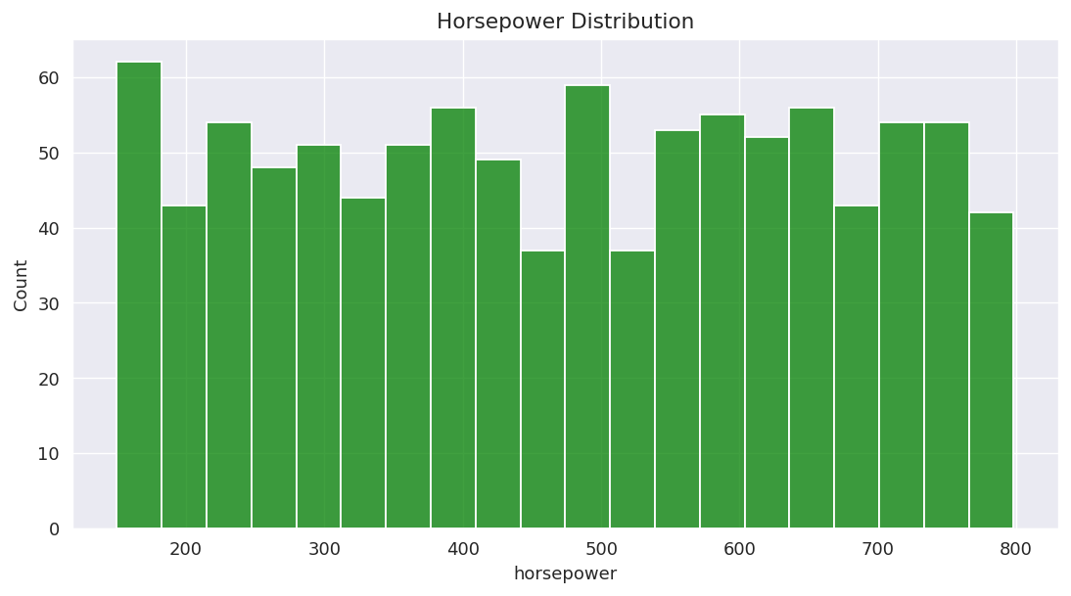
Figure 5.9 — Histogram of horsepower across all models (green).
The horsepower distribution spans entry-level to hypercar performance, with an average of 471 hp. Electric powertrains have democratised performance once reserved for sports cars, with mainstream EVs routinely delivering 0–60 times under 6 seconds.

6. Statistical & Correlation Analysis
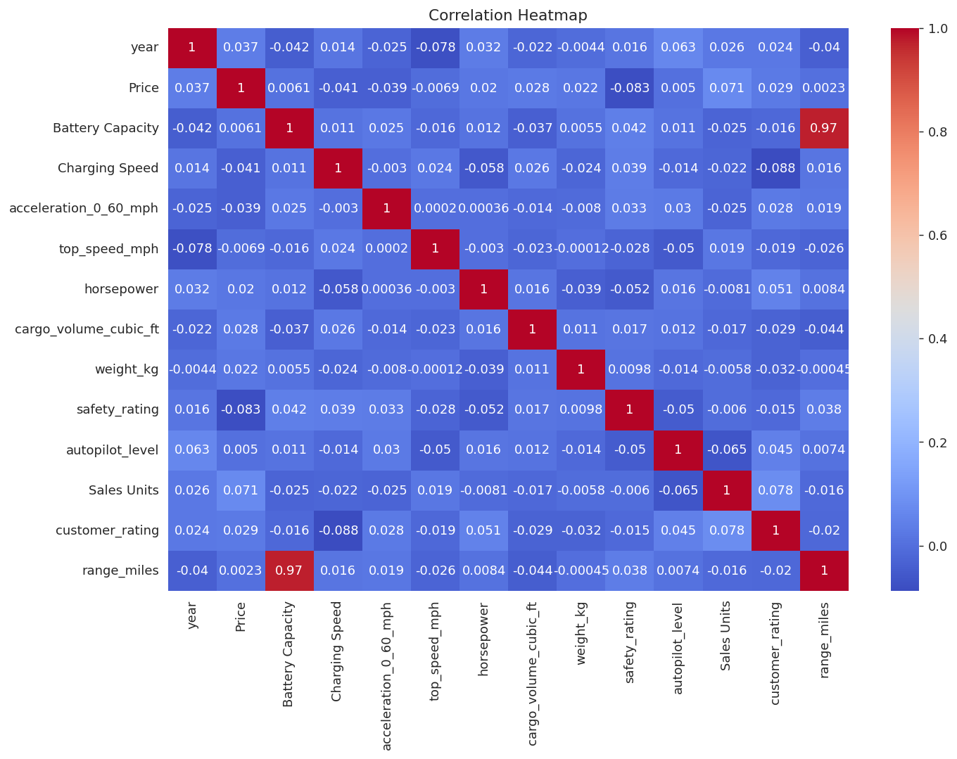
Figure 6.1 — Pearson correlation heatmap across all numeric attributes.
Battery capacity exhibits the strongest positive correlation with driving range, confirming it as the primary engineering lever. Horsepower correlates with top speed and moderately with price. Customer rating shows only weak correlations with technical specifications, reinforcing that satisfaction is multi-dimensional.

6.2 Pairwise Distributions
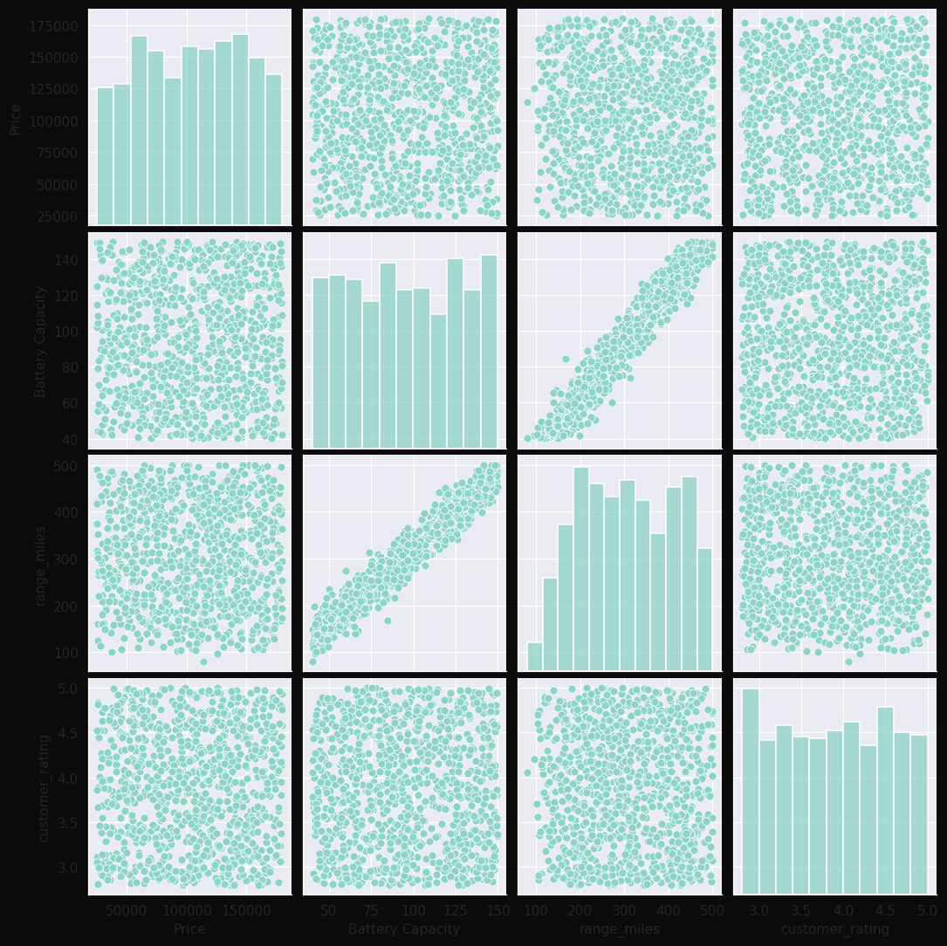
Figure 6.2 — Pairplot across Price, Battery Capacity, Range, and Customer Rating.
The pairplot exposes both marginal distributions (diagonal) and pairwise scatter relationships (off-diagonal) for the four most strategically important variables. The strong positive trend between Battery Capacity and Range is again clear, while Customer Rating shows broad scatter against all other variables — a visual confirmation of the heatmap findings.
Descriptive Statistics
Attribute | count | mean | std | min | 25% | 50% | 75% | max
Price | 1,000.00 | 104,344.54 | 43,507.17 | 25,170.42 | 66,315.08 | 105,694.10 | 141,650.11 | 179,965.81
Battery Capacity | 1,000.00 | 95.43 | 32.22 | 40.10 | 67.40 | 94.60 | 124.70 | 149.70
range_miles | 1,000.00 | 306.92 | 106.70 | 80.00 | 215.00 | 302.50 | 402.25 | 500.00
horsepower | 1,000.00 | 471.84 | 188.43 | 150.00 | 306.00 | 476.50 | 635.00 | 798.00
customer_rating | 1,000.00 | 3.88 | 0.64 | 2.80 | 3.32 | 3.88 | 4.45 | 5.00

Skewness, Variance & Spread
Price skewness is -0.047 (near-symmetric); Range skewness is 0.006 (approximately normal). Price variance is large (1,892,873,787) reflecting the wide market span, while Customer Rating variance is small (0.413), indicating consistent buyer sentiment across the industry.

7. Business Insights & Key Findings
GM/Chevrolet  Top Brand | Nissan  Best Rated | Mid-Range  Top Segment

307 mi  Avg Range | $104,345  Avg Price | 40,448,962  Total Sales

- Market Leadership: GM/Chevrolet dominates aggregate sales with 3,348,371 units annually.
- Satisfaction Champion: Nissan achieves the highest customer rating at 4.13/5.
- Volume Centre: The Mid-Range segment captures the largest share of unit sales.
- Range Maturity: Average driving range of 307 miles now exceeds the practical commuting needs of most users.
- Performance Democratisation: Average power output of 471 hp puts mainstream EVs above many premium ICE vehicles.
- Charging Differentiation: Peak charging speeds in Premium/Luxury (150–350 kW) materially shorten long-distance travel time vs. Mid-Range.
- Pricing Pressure: The wide price distribution suggests headroom for further Economy/Mid-Range cost reduction as battery costs fall.
- Brand Differentiation: Weak correlation between price and rating means brand experience and software polish are the new battlegrounds.

8. Strategic Recommendations
For Manufacturers
- Prioritise the Mid-Range segment with platforms optimised for 60–80 kWh batteries and 300+ mile range.
- Invest in 800V architectures to unlock 200kW+ fast-charging across the Mid-Range tier.
- Treat software and OTA update cadence as a competitive moat — ratings track experience, not specs.
- Localise production near demand centres to capture incentive eligibility.
- Standardise Level-2 ADAS as baseline; differentiate with Level-3 hands-off in Premium tiers.
For Investors
- Battery cell manufacturing and recycling remain structural long-term plays.
- Charging-infrastructure operators in under-penetrated EU/Asia corridors offer asymmetric upside.
- Software-defined-vehicle suppliers capture rising share of vehicle BOM.
- Be selective on luxury EV start-ups — the segment is crowded relative to addressable demand.
For Policymakers
- Maintain purchase incentives focused on Economy/Mid-Range tiers where price elasticity is highest.
- Mandate interoperable charging standards to remove buyer friction.
- Tie subsidies to local content rules to anchor manufacturing employment.
- Invest in grid upgrades to support residential and fleet charging at scale.

9. Conclusion
The 2026 Electric Vehicle market is no longer an emerging category — it is the structural future of personal mobility. Our analysis of 1000 models across 17 brands reveals a market that has crossed key technical thresholds: average range now exceeds 307 miles, average power surpasses 471 hp, and customer satisfaction averages 3.88/5.
Market leadership remains contested. GM/Chevrolet leads on sales volume while Nissan leads on customer satisfaction. The Mid-Range segment dominates volume and will continue to define mainstream adoption.
Three structural trends will define the next phase: (1) Mid-Range volume convergence as battery costs continue falling, (2) software-defined differentiation overtaking hardware specs as the primary buyer decision factor, and (3) charging infrastructure becoming the binding constraint on adoption velocity.

— End of Report —

