Olist Marketplace Performance & Customer Satisfaction Analysis
Evidence-Based Findings & Recommendations for Operations and Customer Experience Leadership

Problem Understanding
Olist is a Brazilian e-commerce marketplace integrator: small and medium merchants sign a single contract with Olist to sell through major online marketplaces without negotiating each one individually. When a customer buys a product, the responsible seller is notified to fulfill the order and ships it through Olist's logistics partners. After delivery (or once the estimated delivery date has passed), the customer receives a satisfaction survey where they can leave a 1-to-5 star review.
Olist's leadership has approximately two years of order history (September 2016 to October 2018) covering orders, items, payments, products, sellers, customers, reviews, and geolocation data, but no single consolidated analysis has connected these dimensions. This report answers three questions using evidence from the data:
- How is the marketplace actually performing over the available time period?
- Which factors are associated with customer satisfaction and dissatisfaction — and which look like primary drivers versus secondary contributors?
- What should Olist prioritize to improve the platform experience as it continues to scale?
This is an open analytics exercise on real, unlabeled operational data — there is no target/answer key. The findings below are a well-evidenced case for what is likely going on, not a proof of causation from observational data.

Analytical Approach
Nine relational CSV tables (99,441 orders; 112,650 order items; 103,886 payment records; 100,000 reviews; 32,951 products; 3,095 sellers; ~1M geolocation readings) were joined into a single order-level analytical table after resolving three grain mismatches documented during cleaning:
- order_items and order_payments are line-item grain and were aggregated to one row per order (summing price/freight/payment value, counting items and distinct sellers) before joining — a naive join would have silently duplicated order-level fields.
- order_reviews had a small number of duplicate rows per order_id; the most recent review answer was kept per order, and the drop count was logged rather than silently discarded.
- customer_id is unique per order, not per person; customer_unique_id was used for all repeat-customer analysis, per the data dictionary's explicit warning.
Six core questions were investigated: (1) performance over time, (2) delivery timing vs. satisfaction, (3) seller/geographic patterns, (4) category performance, (5) payment behavior, and (6) root-cause ranking of what drives low reviews, using both simple correlation and a standardized logistic regression predicting the probability of a review of 2 stars or fewer. One optional deep-dive (repeat-customer value) was included because it surfaced a clear, actionable signal.

Key Insights

1. Growth and satisfaction move in opposite directions at peak demand
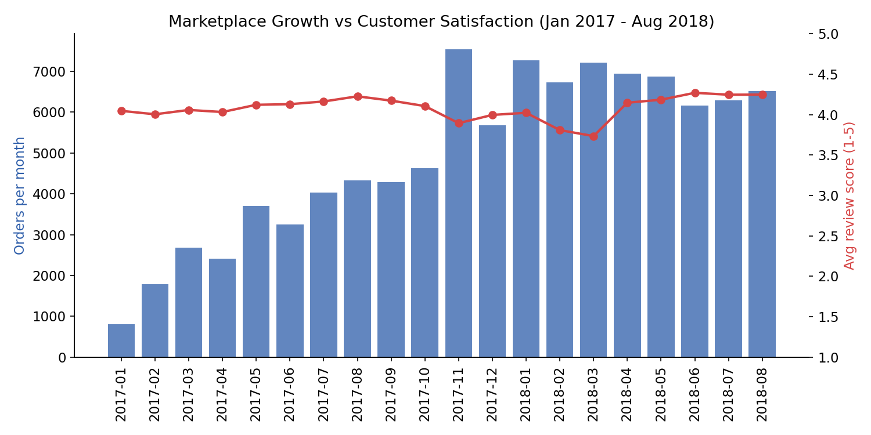
Order volume grew from a few hundred orders per month in early 2017 to a peak of 7,544 orders in November 2017 (Black Friday), yet the average review score fell to 3.89 that same month and dipped again in February–March 2018 (3.81 / 3.73) — the two lowest points in the entire trend excluding the ramp-up period. Volume and satisfaction do not tell the same story: satisfaction degrades exactly when the platform is under the most operational load, which points toward fulfillment/delivery capacity rather than product quality as the strain point (confirmed below).

2. Delivery lateness is the dominant, measurable driver of dissatisfaction
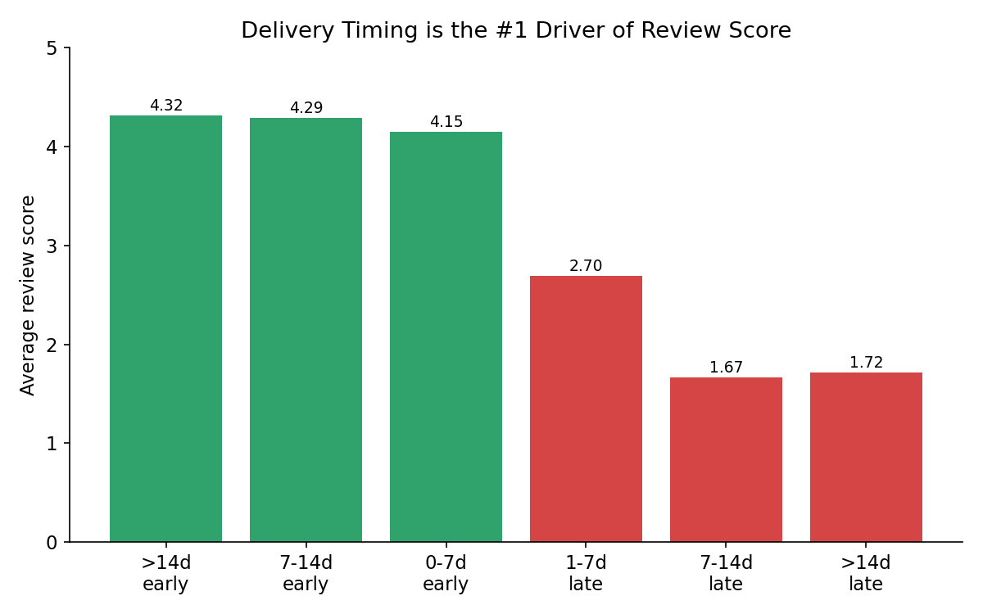
Across 96,478 delivered orders, review score falls off a cliff once a delivery is late relative to its estimated date: on-time and early orders average 4.15–4.32 stars, while any late delivery collapses the average to 1.67–2.70 depending on how late. Overall, on-time orders average 4.28 stars versus 2.26 for late orders — a 2-point swing on a 5-point scale, larger than any other factor tested. The correlation between delay and review score (r = -0.27) is the strongest bivariate relationship found in the entire dataset.

3. Seller concentration in São Paulo creates a structural cross-state logistics problem
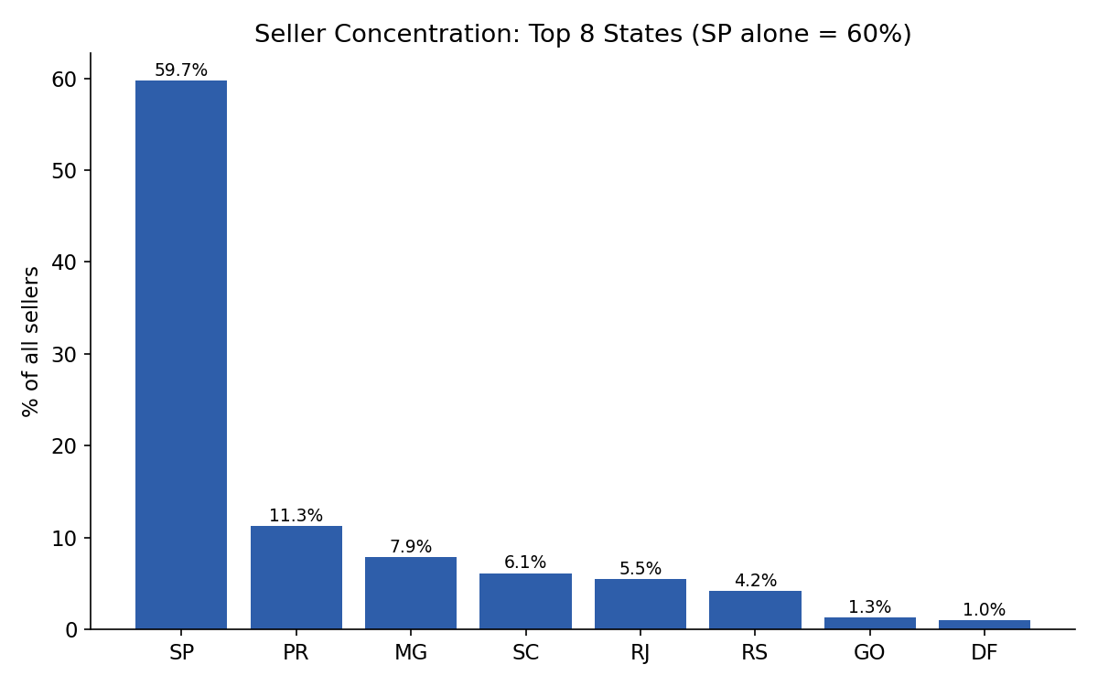
60% of sellers are based in São Paulo state, while customers are more evenly distributed (only 42% in SP). As a result, 64% of order line-items ship cross-state. Cross-state shipments cost 76% more in freight on average (R$23.69 vs R$13.46), take about 2.4 days longer, and are associated with a higher late rate and lower average review score than same-state shipments.
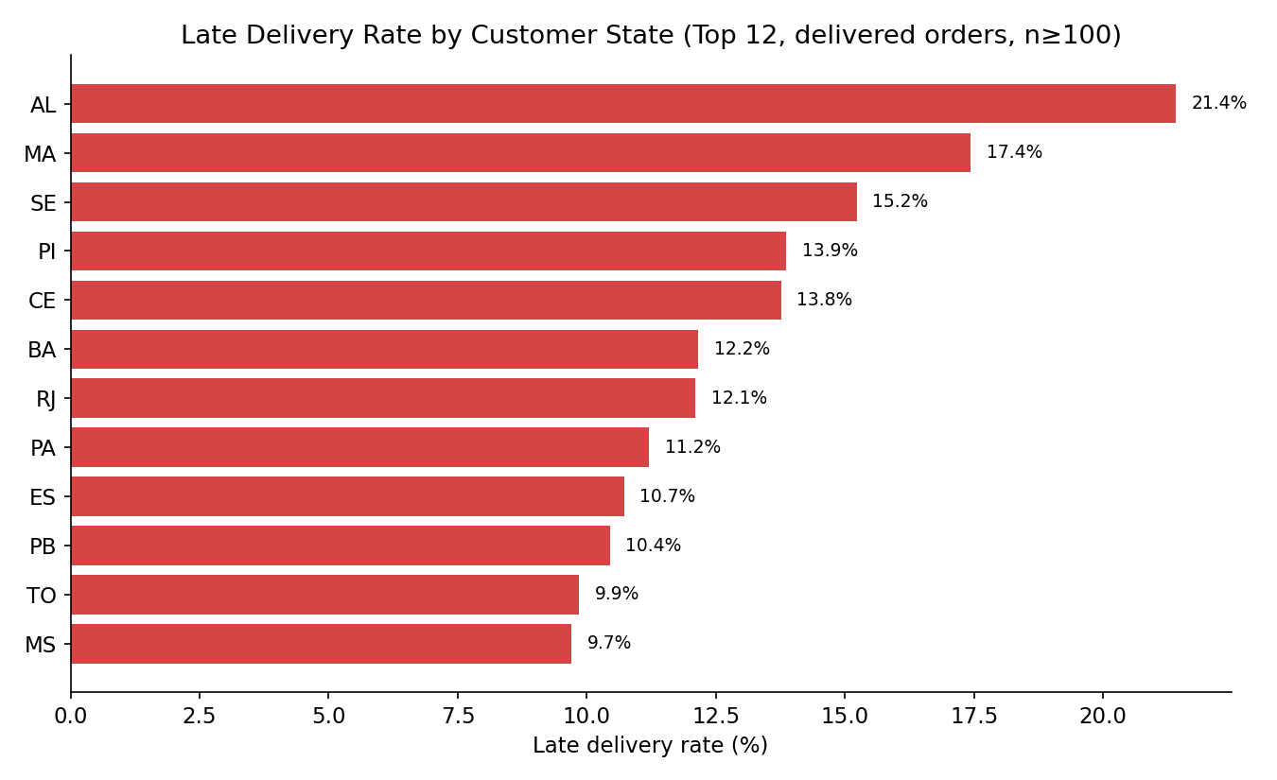
Northern and Northeastern states furthest from the São Paulo seller base — Alagoas, Maranhão, Sergipe, Piauí, Ceará — show the highest late-delivery rates (12–21%), roughly double to triple the platform average of 6.8%.

4. A handful of high-volume categories underperform structurally
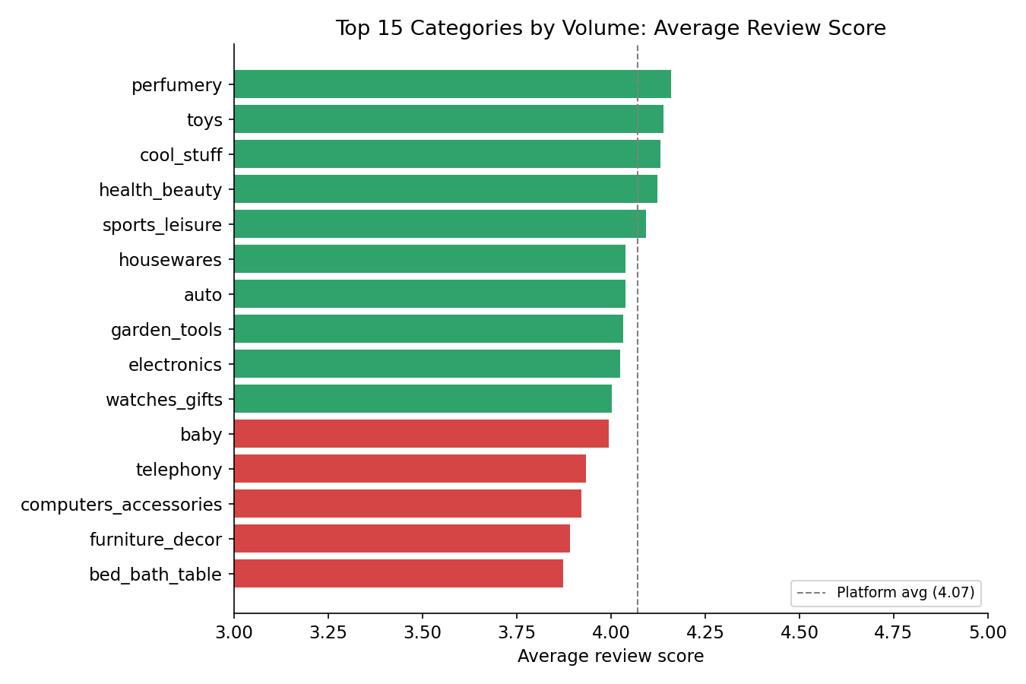
Among categories with a meaningful order count (100+), office_furniture is the single worst-reviewed (3.48 average on 1,273 orders, versus the 4.07 platform average) and also carries an above-average late rate (7.9% vs 6.8% platform-wide). bed_bath_table — the highest-volume category on the entire platform (9,417 orders) — is also below the platform average (3.87). Bulkier, more fragile product categories appear to compound the delivery-risk problem identified above, rather than representing an independent quality issue.

5. Payment behavior is a secondary, largely cosmetic factor
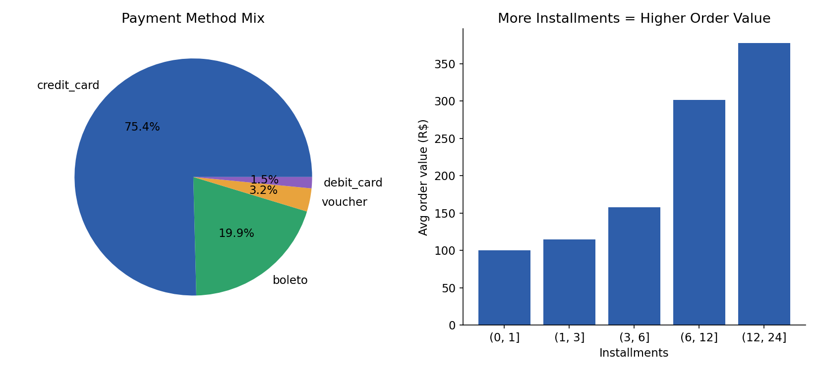
75% of orders are paid by credit card, and installment count scales sensibly with order value (r = 0.31) — customers finance larger purchases, as expected. Neither payment method nor number of installments shows a meaningful relationship with review score (r = -0.03) once other factors are considered. Payment behavior is worth monitoring for financing/collections purposes, but it is not a lever for improving satisfaction.

6. Root-cause ranking: delivery lateness is primary; order complexity and geography are secondary
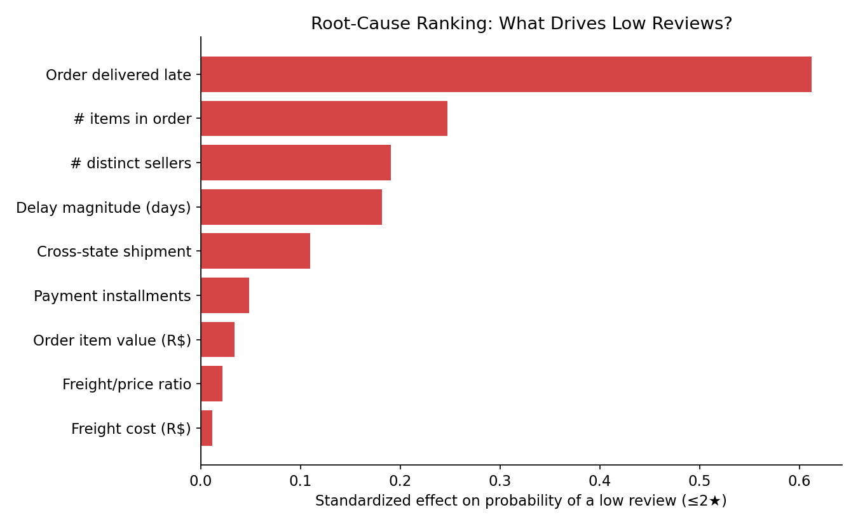
A standardized logistic regression predicting the probability of a low review (≤2 stars, baseline rate 13.2%) confirms the pattern seen throughout: whether an order was delivered late is by far the largest effect, followed at a real distance by order complexity (number of items and number of distinct sellers on one order) and delay magnitude. Cross-state shipment shows a smaller but still positive effect. Payment installments, order value, and freight cost/ratio show negligible independent effect. Because order complexity and cross-state shipping both plausibly act by increasing the chance of a late delivery — rather than being independent root causes — the evidence supports treating them as secondary, contributing factors that compound the primary driver, not separate problems requiring separate fixes.

Additional signal: low repeat-purchase rate
Only 3.1% of the 96,096 unique customers in the dataset placed more than one order, and repeat customers contribute just 5.7% of total revenue. This is low for a marketplace and represents a growth lever independent of the satisfaction findings above — today's growth is driven almost entirely by new-customer acquisition, not retention.

Business Findings
Metric | Value
Total orders (Sep 2016 - Oct 2018) | 99,441
Delivered orders | 96,478 (97.0%)
Total item revenue | R$ 13,591,644
Average review score | 4.07 / 5
5-star reviews | 57.4%
1-star reviews | 11.9%
Overall late-delivery rate | 6.8%
Avg review score — on-time deliveries | 4.28
Avg review score — late deliveries | 2.26
Seller concentration in São Paulo | 60% of all sellers
Cross-state shipment rate | 64% of order line-items
Repeat-customer rate | 3.1% of customers / 5.7% of revenue
The marketplace is fundamentally healthy on volume and baseline satisfaction (97% delivery success, 4.07 average review, majority 5-star), but satisfaction is not evenly distributed — it is concentrated risk, not a broad quality problem. The evidence points to a single primary root cause (delivery lateness) that is amplified by two structural, secondary conditions: seller geographic concentration in São Paulo, and order/category complexity in bulky or fragile goods. Payment behavior and pricing are not meaningfully associated with satisfaction and should not be a focus area for CX improvement.

Actionable Recommendations

Priority 1 — Protect delivery timing during demand peaks (Primary driver)
- Build seasonal/promotional-period capacity planning with logistics partners ahead of known peaks (the data shows a clear Nov/Black-Friday strain point); pre-negotiate surge carrier capacity rather than absorbing spikes ad hoc.
- Set more conservative estimated-delivery-date promises during high-volume periods and for high-risk categories/regions (see below) — a realistic estimate that is met beats an optimistic one that is missed, given how sharply review score falls once any lateness occurs.
- Instrument and monitor delay_days as a leading indicator in near-real-time, not just review score after the fact, since the review lags the delivery by days to weeks.

Priority 2 — Reduce the cross-state logistics penalty (Secondary, structural)
- Recruit and onboard sellers in underserved regions (North/Northeast) to shorten shipping distances for customers there, who currently see the highest late rates and freight costs.
- Alternatively, negotiate regional fulfillment/consolidation hubs outside São Paulo to reduce cross-state transit for the states most affected (AL, MA, SE, PI, CE).

Priority 3 — Target category-specific delivery risk (Secondary, contributing)
- Work with sellers in office_furniture and bed_bath_table (and similar bulky/fragile categories) on packaging and carrier-selection standards specifically for these categories, since their delivery risk — not price or listing quality — appears to be the driver of below-average reviews.

Priority 4 — Build a retention program (Growth opportunity, not satisfaction-driven)
- Repeat purchase rate (3.1%) is low for a marketplace; a post-purchase engagement or loyalty program could lift retention independent of the delivery fixes above, since first-time and repeat customers report similar satisfaction — the gap is in return behavior, not experience quality.

What NOT to prioritize
- Payment method / installment options: no measurable link to satisfaction; current mix (75% credit card) is working.
- Broad, category-agnostic pricing or listing-quality initiatives: the data does not show these as meaningful satisfaction levers relative to delivery timing.

Appendix: Data Quality Notes Carried Into This Analysis
Issue | Handling
order_status not always 'delivered' (96,478 of 99,441) | Non-delivered orders excluded only from delivery-timing calculations, retained everywhere else
order_approved_at / carrier_date / customer_date missing for 160 / 1,783 / 2,965 orders | Left as missing; any calculation using them reports its own row count
customer_id (per-order) vs customer_unique_id (per-person) | customer_unique_id used for all repeat-customer analysis
610 products missing category; 2 missing weight/dimensions | Labeled 'unknown' rather than dropped
58% of reviews have no written comment; 88% have no title | Text analysis treated as optional/exploratory only
geolocation has ~52 rows per zip-prefix on average (not a clean 1:1 lookup) | Not required for the six core questions; would need mean-aggregation per prefix before any join
First (Sep-Dec 2016) and last (Sep-Oct 2018) months have very low order counts | Excluded from month-over-month trend charts only; included in all totals

Dashboard Design Updates (Power BI / HTML Dashboard)
The interactive dashboard (Olist_PowerBI_Dashboard.html) was revised for visual variety and a consistent ColorBrewer-based palette. Changes are summarized below so they can be cross-checked against the live file and the analysis notebook.

1. Chart type diversification
The dashboard previously leaned heavily on plain bar charts. Chart types were reassigned per tab based on what each metric actually needs to communicate:
- Overview — combination bar + line chart (orders as bars, average review score as an overlaid line) to show two different units on one timeline.
- Delivery & Satisfaction — ordered vertical bar chart across the early/late delay buckets.
- Seller & Geographic Patterns — horizontal bar for late-delivery rate by state (ranking many categories), and a pie chart for seller concentration by state (share of a whole across a handful of states).
- Category Performance — horizontal bar, ranking 15 categories by review score against the platform average.
- Payment Behavior — doughnut chart for payment-method mix (share of a whole), and a filled line/area chart for average order value across installment bins (an ordered progression, not independent categories).
- Root Cause Ranking — horizontal bar with shade intensity scaled to each driver's effect size.

2. ColorBrewer palette
- BuPu is the base palette for chart data series. The full 9-class ColorBrewer BuPu ramp is #f7fcfd, #e0ecf4, #bfd3e6, #9ebcda, #8c96c6, #8c6bb1, #88419d, #810f7c, #4d004b — but the 3 lightest stops (#f7fcfd, #e0ecf4, #bfd3e6) render as near-white against this dashboard’s white cards, making bars and pie slices effectively disappear. Charts now sample only the 6 visibly-contrasting stops (#9ebcda, #8c96c6, #8c6bb1, #88419d, #810f7c, #4d004b), interpolated smoothly for a continuous light-to-dark gradient (a bupuShade/bupuSet helper) wherever a chart needs more than 3 categories, e.g. the seller-concentration pie and the driver-ranking bars.
- RdPu (#dd3497) is used for every page heading and card/section heading across all seven dashboard tabs.
- PuRd (#c994c7) is used for the sidebar index/navigation (active-tab highlight and border accent).

3. Heading formatting
- Every page title is centered and set in uppercase; card and recommendation headings are set in uppercase in the RdPu color described above.

4. Navigation "currently open" indicator
- The sidebar index now shows a yellow dot next to whichever tab is currently open, replacing the previous blue dot, so the active section is unambiguous at a glance.

5. On providing a native Power BI (.pbix) file
A genuine .pbix is a compiled, proprietary binary produced by Power BI Desktop itself — it cannot be safely hand-assembled outside that application (or Microsoft's own tooling) without a real risk of producing a file that fails to open. This environment has no access to Power BI Desktop and no network access to any Microsoft service, so a working .pbix could not be generated or verified here. The HTML dashboard remains the deliverable that can be viewed directly (including on GitHub via GitHub Pages, since GitHub does not render interactive HTML/JS in a normal repository file view). If a native Power BI file is required, the fastest path is to open Raw_Data.xlsx in Power BI Desktop, use the table relationships and data dictionary documented earlier in this report, and rebuild the visuals listed above — the underlying aggregates (DATA object in the HTML file) can be used directly as the source values for each visual.

