A MINI-PROJECT SYNOPSIS ON
Machine Learning–Based Sales Intelligence System
(SalesIntel-ML)

School of Computer Science & Applications Department of Computer Science and Applications
2025-2026

DR. VISHWANATH KARAD MIT WORLD PEACE UNIVERSITY, PUNE-411038

TYBCA

Submitted by :  Ms.Saloni Jamdade(1132230740)  Mr.Shivam Thombare(1132230700) | Faculty: Mr. Kaustubh Keer  Mr.Rajesh Kanzade

Machine Learning–Based Sales Intelligence System
(SalesIntel-ML)

- Introduction:
In modern sales-driven organizations, large volumes of sales interaction data are generated through emails, chats, follow-ups, and deal records. While businesses track basic metrics such as revenue and deal closures, they often lack deeper analytical insight into why deals succeed or fail, which opportunities are at risk, and what actions should be taken to improve sales outcomes.
This project presents a Machine Learning–Based Sales Intelligence System that analyzes historical sales interaction data to generate decision-oriented intelligence and audit-style reports. The system applies supervised machine learning techniques to classify customer intent, predict deal success probability, and identify recurring loss patterns across the sales pipeline. Instead of focusing on user interfaces or dashboards, the system produces structured analytical outputs suitable for management review and internal sales audits.
The project emphasizes statistical machine learning, explainability, and business relevance, making it suitable for real-world sales analytics scenarios

- Objectives:

- Analyze historical sales interaction and deal data.
- Classify customer intent using machine learning techniques
- Predict deal success or failure probability
- Identify high-risk deals and sales bottlenecks
- Detect recurring patterns leading to deal loss
- Generate structured sales intelligence and audit reports
- Support data-driven sales decision-making

- Tools & Technologies:

Category | Tools / Technologies
Programming Language | Python
Data Handling | Pandas, NumPy
Machine Learning | Scikit-learn, XGBoost
Text Feature Extraction | TF-IDF / Numerical Encoding
Data Storage | CSV Files
Development Platform | Jupyter Notebook / VS Code
Output Format | Text / PDF / CSV Reports

- Actors in the Project:

- Sales Manager / Business Analyst
  - Primary actor
  - Reviews sales intelligence and audit reports for decision-making

- Sales intelligence ML engine
  - Processes sales data and generates predictions and insights

- Intent Classification Module
  - Identifies customer intent from sales interactions

- Deal Outcome Prediction Module
  - Predicts probability of deal success or failure

- Sales Audit Report Generator
  - Compiles analytical findings into structured reports

- Scope of the Project:

  - Applicable to B2B and B2C sales organizations
  - Helps identify high-risk deals and weak pipeline stages
  - Assists in improving sales conversion rates
  - Supports internal sales audits and performance reviews
  - Can be extended to integrate CRM systems and real-time data

- Modules of the Project:

- Sales Data Ingestion Module
  - Loads historical sales interaction and deal data

- Feature Engineering Module
  - Processes text interactions, deal stages, response times, and deal values

- Intent Classification Module
  - Classifies customer intent using supervised ML models

- Deal Success Prediction Module
  - Predicts deal outcome probability based on engineered features

- Sales Intelligence & Audit Report Module
  - Generates structured reports with findings and recommendations

- Use Cases:

Use Case 1: Customer Intent Classification
- Actor: Intent Classification Module
- Description: System classifies customer intent from sales interactions

Use Case 2: Deal Risk Prediction
- Actor: Deal Outcome Prediction Module
- Description: Predicts deal success probability and flags high-risk deals

Use Case 3: Sales Loss Pattern Analysis
- Actor: Sales Intelligence Engine
- Description: Identifies common reasons and stages where deals fail

Use Case 4: Sales Intelligence Report Generation
- Actor: Audit Report Generator
- Description: Generates a comprehensive sales intelligence report

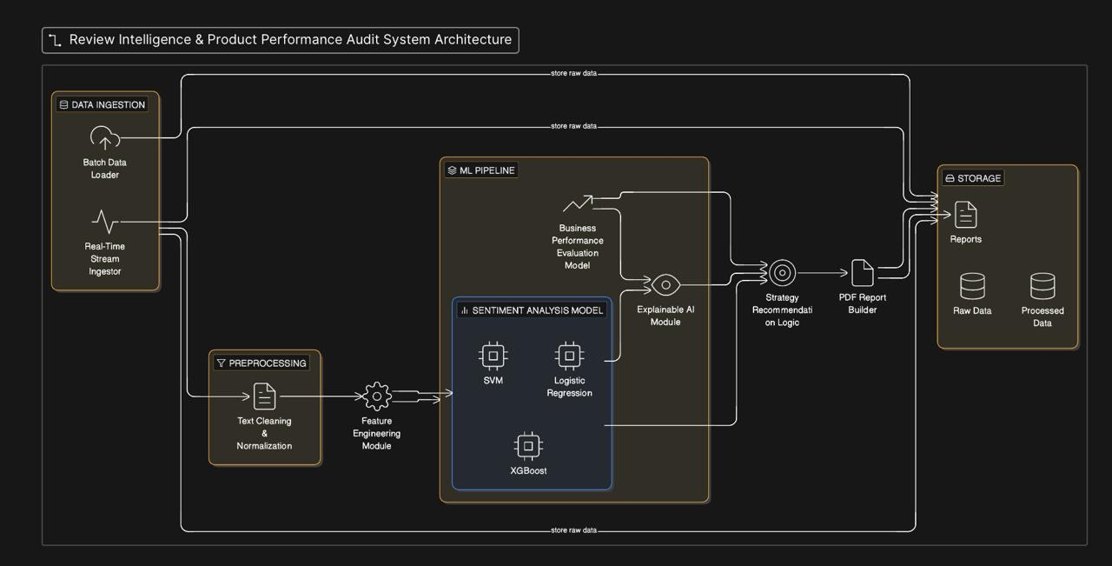
System Architecture

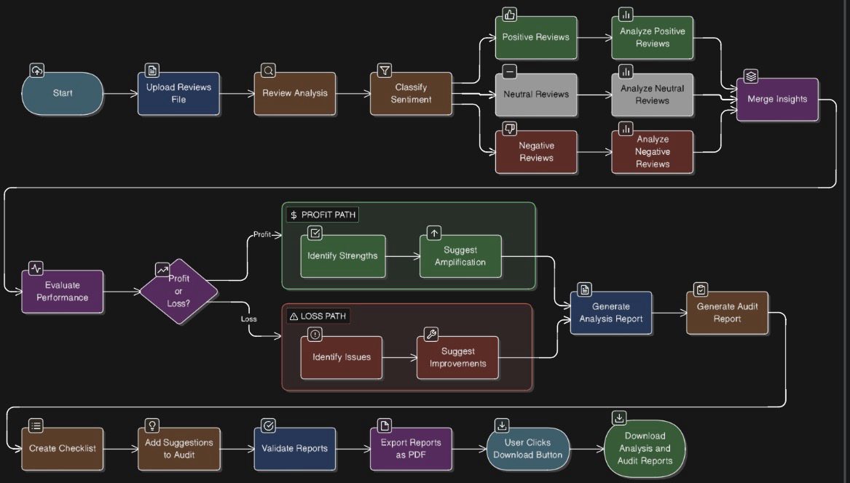

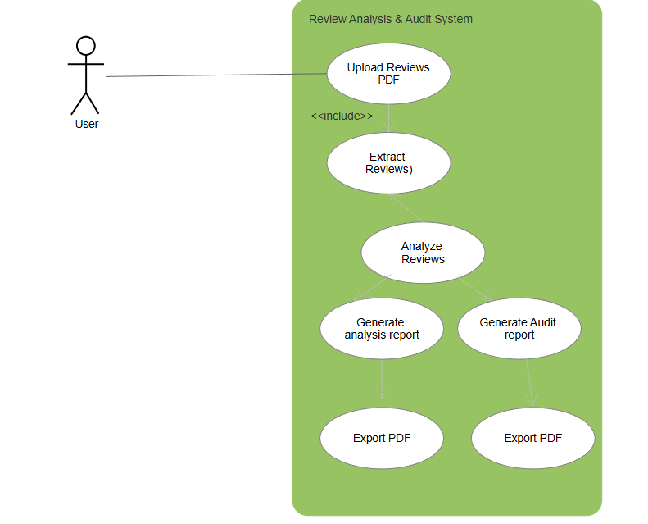

Use Case Diagram

- Expected Outcomes:

  - ML-based classification of customer intent
  - Accurate prediction of deal success probability
  - Identification of high-risk sales opportunities
  - Clear insights into sales pipeline inefficiencies
  - Structured sales intelligence and audit reports
  - Improved data-driven sales decision-making

- References

