**.NET LAB 3**

Saloni Kapoor

2141067

4BCA A

**__________________________________________________________________________________**

**PORTAL 1:**

using System;

using System.Collections.Generic;

using System.ComponentModel;

using System.Data;

using System.Drawing;

using System.Linq;

using System.Text;

using System.Text.RegularExpressions;

using System.Threading;

using System.Threading.Tasks;

using System.Windows.Forms;

using static System.Windows.Forms.VisualStyles.VisualStyleElement;

namespace WindowsFormsApp3

{

public partial class Form1 : Form

{

public Form1()

{

InitializeComponent();

}

private void button2_Click(object sender, EventArgs e)

{

textBox1.Text = " ";

textBox2.Text = " ";

comboBox1.Text = " ";

comboBox2.Text = " ";

richTextBox1.Text = " ";

}

private void comboBox1_SelectedIndexChanged(object sender, EventArgs e)

{

}

private void comboBox2_SelectedIndexChanged(object sender, EventArgs e)

{

}

private void linkLabel1_LinkClicked(object sender, LinkLabelLinkClickedEventArgs e)

{

System.Diagnostics.Process.Start("http://www.christuniversity.in");

}

private void richTextBox1_TextChanged(object sender, EventArgs e)

{

}

private void textBox2_TextChanged(object sender, EventArgs e)

{

}

private void button1_Click(object sender, EventArgs e)

{

if (string.IsNullOrWhiteSpace(textBox1.Text))

{

MessageBox.Show("Invalid form. Check the message box for more","Warning",MessageBoxButtons.OK, MessageBoxIcon.Exclamation);

richTextBox1.Text = "Enter the name";

}

else if ((new Regex(@"^[A-Za-z]+$")).IsMatch(textBox1.Text) == false)

{

MessageBox.Show("Invalid form. Check the message box for more", "Warning", MessageBoxButtons.OK, MessageBoxIcon.Error);

richTextBox1.Text = "Enter a valid name";

}

else if (string.IsNullOrWhiteSpace(textBox2.Text))

{

MessageBox.Show("Invalid form. Check the message box for more", "Warning", MessageBoxButtons.OK, MessageBoxIcon.Exclamation);

richTextBox1.Text = "Enter the phone number";

}

else if ((new Regex(@"^(0|[1-9][0-9]*)$")).IsMatch(textBox2.Text) == false)

{

MessageBox.Show("Invalid form. Check the message box for more", "Warning", MessageBoxButtons.OK, MessageBoxIcon.Error);

richTextBox1.Text = "Enter a valid phone number";

}

else if ((new Regex(@"^((\+){0,1}91(\s){0,1}(\-){0,1}(\s){0,1}){0,1}9[0-9](\s){0,1}(\-){0,1}(\s){0,1}[1-9]{1}[0-9]{7}$")).IsMatch(textBox2.Text) == false)

{

MessageBox.Show("Invalid form. Check the message box for more", "Warning", MessageBoxButtons.OK, MessageBoxIcon.Information);

richTextBox1.Text = "Enter 10 digit phone number";

}

else if (comboBox1.SelectedIndex == -1)

{

MessageBox.Show("Invalid form. Check the message box for more", "Warning", MessageBoxButtons.OK, MessageBoxIcon.Exclamation);

richTextBox1.Text = "Select a calamity region";

}

else if (comboBox2.SelectedIndex == -1)

{

MessageBox.Show("Invalid form. Check the message box for more", "Warning", MessageBoxButtons.OK, MessageBoxIcon.Exclamation);

richTextBox1.Text = "Select a calamity type";

}

else if (!checkBox1.Checked && !checkBox2.Checked)

{

MessageBox.Show("Invalid form. Check the message box for more", "Warning", MessageBoxButtons.OK, MessageBoxIcon.Exclamation);

richTextBox1.Text = "Please select yes or no";

}

else

{

richTextBox1.Text = "Submission Successful";

var myForm = new Form2();

myForm.Show();

}

}

}

}

**PORTAL 2:**

using System;

using System.Collections.Generic;

using System.ComponentModel;

using System.Data;

using System.Drawing;

using System.Linq;

using System.Text;

using System.Threading.Tasks;

using System.Windows.Forms;

namespace WindowsFormsApp3

{

public partial class Form2 : Form

{

public Form2()

{

InitializeComponent();

}

private void button1_Click(object sender, EventArgs e)

{

var myForm = new Form3();

myForm.Show();

}

private void button2_Click(object sender, EventArgs e)

{

var myForm = new Form4();

myForm.Show();

}

private void button3_Click(object sender, EventArgs e)

{

var myForm = new Form5();

myForm.Show();

}

private void button3_Click_1(object sender, EventArgs e)

{

var myForm = new Form5();

myForm.Show();

}

}

}

**PORTAL 3:**

using System;

using System.Collections.Generic;

using System.ComponentModel;

using System.Data;

using System.Drawing;

using System.Linq;

using System.Text;

using System.Threading.Tasks;

using System.Windows.Forms;

namespace WindowsFormsApp3

{

public partial class Form3 : Form

{

public Form3()

{

InitializeComponent();

}

private void button1_Click(object sender, EventArgs e)

{

if (!checkBox1.Checked && !checkBox2.Checked &&!checkBox3.Checked)

{

MessageBox.Show("Invalid input. Check the message box for more", "Warning", MessageBoxButtons.OK, MessageBoxIcon.Exclamation);

textBox1.Text = "Please select atleast any one option";

}

else

{

textBox1.Text = "Farishte Members will contact you soon";

}

}

private void textBox1_TextChanged(object sender, EventArgs e)

{

}

}

}

**PORTAL 4:**

using System;

using System.Collections.Generic;

using System.ComponentModel;

using System.Data;

using System.Drawing;

using System.Linq;

using System.Text;

using System.Text.RegularExpressions;

using System.Threading.Tasks;

using System.Windows.Forms;

namespace WindowsFormsApp3

{

public partial class Form4 : Form

{

public Form4()

{

InitializeComponent();

}

private void textBox4_TextChanged(object sender, EventArgs e)

{

}

private void button1_Click(object sender, EventArgs e)

{

if (string.IsNullOrWhiteSpace(textBox1.Text))

{

MessageBox.Show("Invalid form. Check the message box for more", "Warning", MessageBoxButtons.OK, MessageBoxIcon.Exclamation);

textBox4.Text = "Enter the name";

}

else if((new Regex(@"^[A-Za-z]+$")).IsMatch(textBox1.Text)==false)

{

MessageBox.Show("Invalid form. Check the message box for more", "Warning", MessageBoxButtons.OK, MessageBoxIcon.Error);

textBox4.Text = "Enter a valid name";

}

else if (string.IsNullOrWhiteSpace(textBox2.Text))

{

MessageBox.Show("Invalid form. Check the message box for more", "Warning", MessageBoxButtons.OK, MessageBoxIcon.Exclamation);

textBox4.Text = "Enter the phone number";

}

else if ((new Regex(@"^(0|[1-9][0-9]*)$")).IsMatch(textBox2.Text) == false)

{

MessageBox.Show("Invalid form. Check the message box for more", "Warning", MessageBoxButtons.OK, MessageBoxIcon.Error);

textBox4.Text = "Enter a valid phone number";

}

else if((new Regex(@"^((\+){0,1}91(\s){0,1}(\-){0,1}(\s){0,1}){0,1}9[0-9](\s){0,1}(\-){0,1}(\s){0,1}[1-9]{1}[0-9]{7}$")).IsMatch(textBox2.Text) == false)

{

MessageBox.Show("Invalid form. Check the message box for more", "Warning", MessageBoxButtons.OK, MessageBoxIcon.Information);

textBox4.Text = "Enter 10 digit phone number";

}

else if (string.IsNullOrWhiteSpace(textBox3.Text))

{

MessageBox.Show("Invalid form. Check the message box for more", "Warning", MessageBoxButtons.OK, MessageBoxIcon.Exclamation);

textBox4.Text = "Enter the email id";

}

else if((new Regex(@"^[a-zA-Z][\w\.-]{2,28}[a-zA-Z0-9]@[a-zA-Z0-9][\w\.-]*[a-zA-Z0-9]\.[a-zA-Z][a-zA-Z\.]*[a-zA-Z]$")).IsMatch(textBox3.Text) == false)

{

MessageBox.Show("Invalid form. Check the message box for more", "Warning", MessageBoxButtons.OK, MessageBoxIcon.Error);

textBox4.Text = "Enter the valid email id";

}

else if (string.IsNullOrWhiteSpace(textBox5.Text))

{

MessageBox.Show("Invalid form. Check the message box for more", "Warning", MessageBoxButtons.OK, MessageBoxIcon.Exclamation);

textBox4.Text = "Enter the amount";

}

else if ((new Regex(@"^(0|[1-9][0-9]*)$")).IsMatch(textBox5.Text) == false)

{

MessageBox.Show("Invalid form. Check the message box for more", "Warning", MessageBoxButtons.OK, MessageBoxIcon.Error);

textBox4.Text = "Enter a valid donation amount";

}

else

{

System.Media.SoundPlayer player = new System.Media.SoundPlayer(Properties.Resources.thank_you);//Use your own filename in place of _15035

player.Play();

textBox4.Text = "Refer email for payment portal";

}

}

}

}

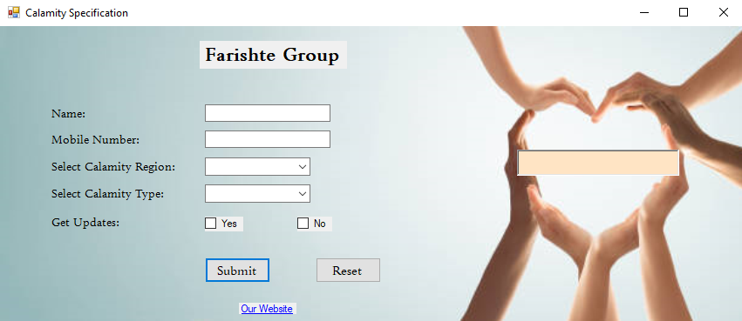This is a screenshot of the working space.

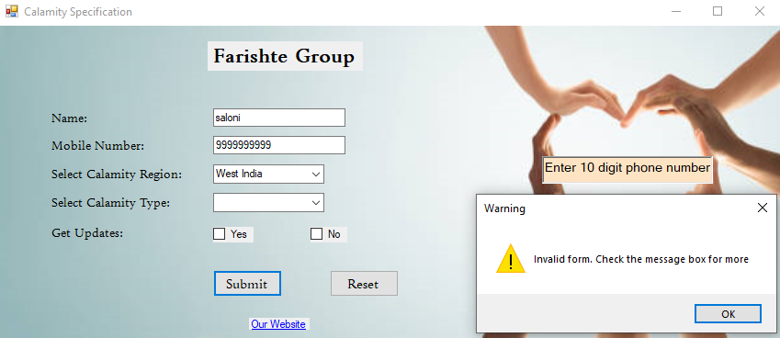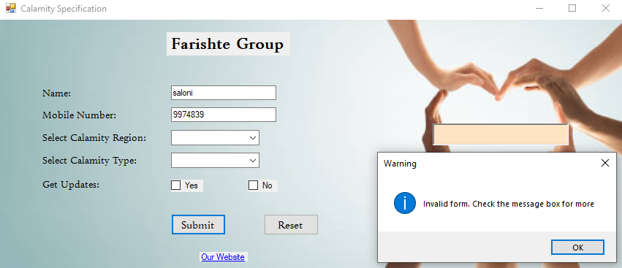  
  
Snippet of the application Window:  
  
  
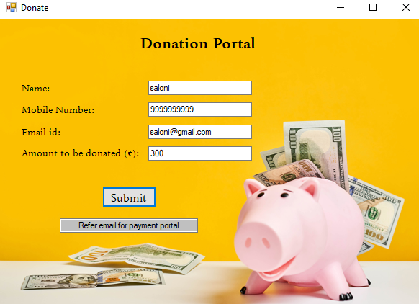Snippet of the executed application: