.NET LAB

Saloni Kapoor

4BCA A

2141067

**CODE:**

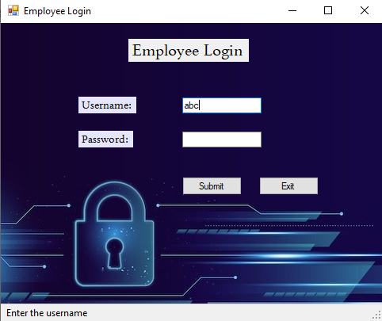**Form -1**using System;

using System.Collections.Generic;

using System.ComponentModel;

using System.Data;

using System.Drawing;

using System.Linq;

using System.Text;

using System.Text.RegularExpressions;

using System.Threading.Tasks;

using System.Windows.Forms;

using static System.Windows.Forms.VisualStyles.VisualStyleElement.StartPanel;

namespace WindowsFormsApp11

{

public partial class Form1 : Form

{

public Form1()

{

InitializeComponent();

}

private void Form1_Load(object sender, EventArgs e)

{

}

private void button1_Click(object sender, EventArgs e)

{

if (string.IsNullOrWhiteSpace(textBox1.Text))

{

MessageBox.Show("Invalid Login. Enter the username ", "Warning ", MessageBoxButtons.OK,

MessageBoxIcon.Exclamation);

}

else if (string.IsNullOrWhiteSpace(textBox2.Text))

{

MessageBox.Show("Invalid Login. Enter the username ", "Warning ", MessageBoxButtons.OK,

MessageBoxIcon.Exclamation);

}

else if ((new Regex(@"^[A-Za-z]+$")).IsMatch(textBox1.Text) == false)

{

MessageBox.Show("Invalid Login. Enter a valid username", "Warning ", MessageBoxButtons.OK,

MessageBoxIcon.Error);

}

else if ((new Regex(@"^(0|[1-9][0-9]*)$")).IsMatch(textBox2.Text) == false)

{

MessageBox.Show("Invalid Login. Enter a valid password", "Warning ", MessageBoxButtons.OK,

MessageBoxIcon.Error);

}

else if ((textBox1.Text != "abc")|| (textBox2.Text != "123"))

{

MessageBox.Show("Invalid Login. Login Failed", "Warning ", MessageBoxButtons.OK,

MessageBoxIcon.Error);

}

else

{

var myForm = new Form2();

myForm.Show();

toolStripStatusLabel1.Text = "Submitted";

this.Hide();

}

}

private void textBox1_TextChanged(object sender, EventArgs e)

{

toolStripStatusLabel1.Text = " Enter the username";

}

private void textBox2_TextChanged(object sender, EventArgs e)

{

toolStripStatusLabel1.Text = " Enter the password";

}

private void button2_Click(object sender, EventArgs e)

{

this.Close();

}

}

}

**Form -2**

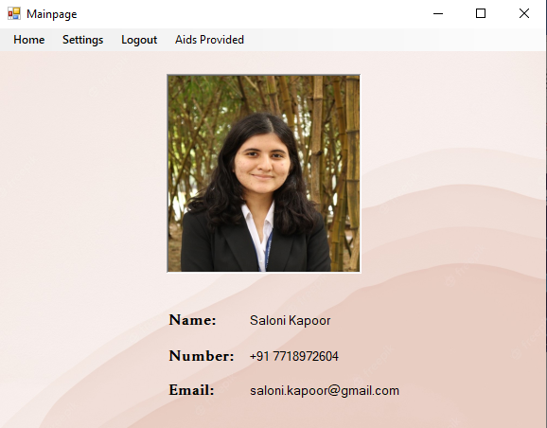

using System;

using System.Collections.Generic;

using System.ComponentModel;

using System.Data;

using System.Drawing;

using System.Linq;

using System.Text;

using System.Threading.Tasks;

using System.Windows.Forms;

namespace WindowsFormsApp11

{

public partial class Form2 : Form

{

public Form2()

{

InitializeComponent();

}

private void Form2_Load(object sender, EventArgs e)

{

}

private void closeToolStripMenuItem_Click(object sender, EventArgs e)

{

this.Close();

}

private void helpToolStripMenuItem_Click(object sender, EventArgs e)

{

MessageBox.Show("We will contact you soon", "Help", MessageBoxButtons.OK,

MessageBoxIcon.Error);

}

private void logoutToolStripMenuItem_Click(object sender, EventArgs e)

{

var myForm = new Form1();

myForm.Show();

this.Hide();

}

private void aidsProvidedToolStripMenuItem_Click(object sender, EventArgs e)

{

var myForm = new Form3();

myForm.Show();

this.Hide();

}

}

}

**Form -3**

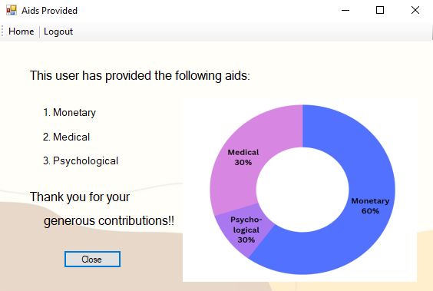

using System;

using System.Collections.Generic;

using System.ComponentModel;

using System.Data;

using System.Drawing;

using System.Linq;

using System.Text;

using System.Threading.Tasks;

using System.Windows.Forms;

namespace WindowsFormsApp11

{

public partial class Form3 : Form

{

public Form3()

{

InitializeComponent();

}

private void toolStripLabel4_Click(object sender, EventArgs e)

{

var myForm = new Form1();

myForm.Show();

this.Hide();

}

private void toolStripLabel2_Click(object sender, EventArgs e)

{

var myForm = new Form2();

myForm.Show();

this.Hide();

}

private void pictureBox1_Click(object sender, EventArgs e)

{

}

private void button1_Click(object sender, EventArgs e)

{

this.Close();

}

}

}