.NET LAB

Saloni Kapoor

4BCA A

2141067

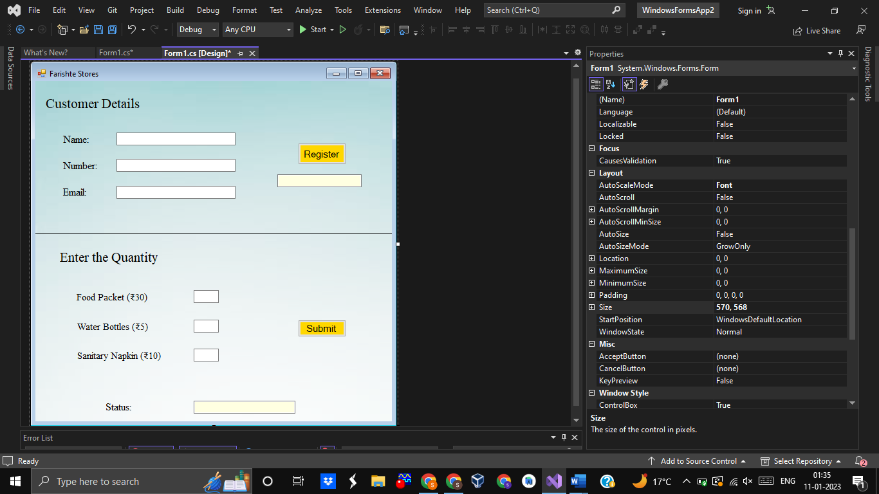This is a screenshot of the working space.

Snippet of the application Window:

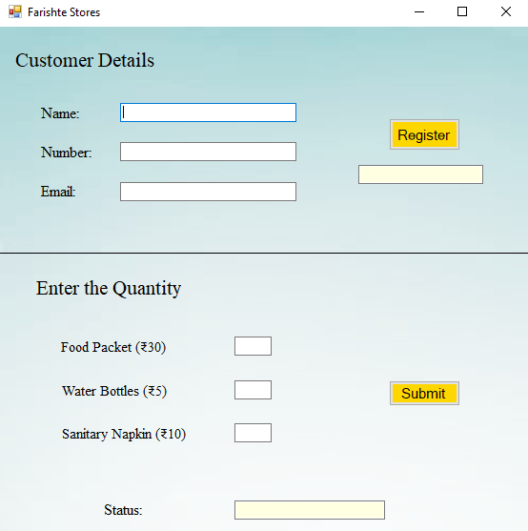Here, the user is supposed to enter the personal details for registration. Then, they should enter the quantity of the given products and click ‘submit’, to donate the required number of products.

Snippet of the executed application:

