.NET LAB

Saloni Kapoor

4BCA A

2141067

This is a screenshot of the working space.  
  
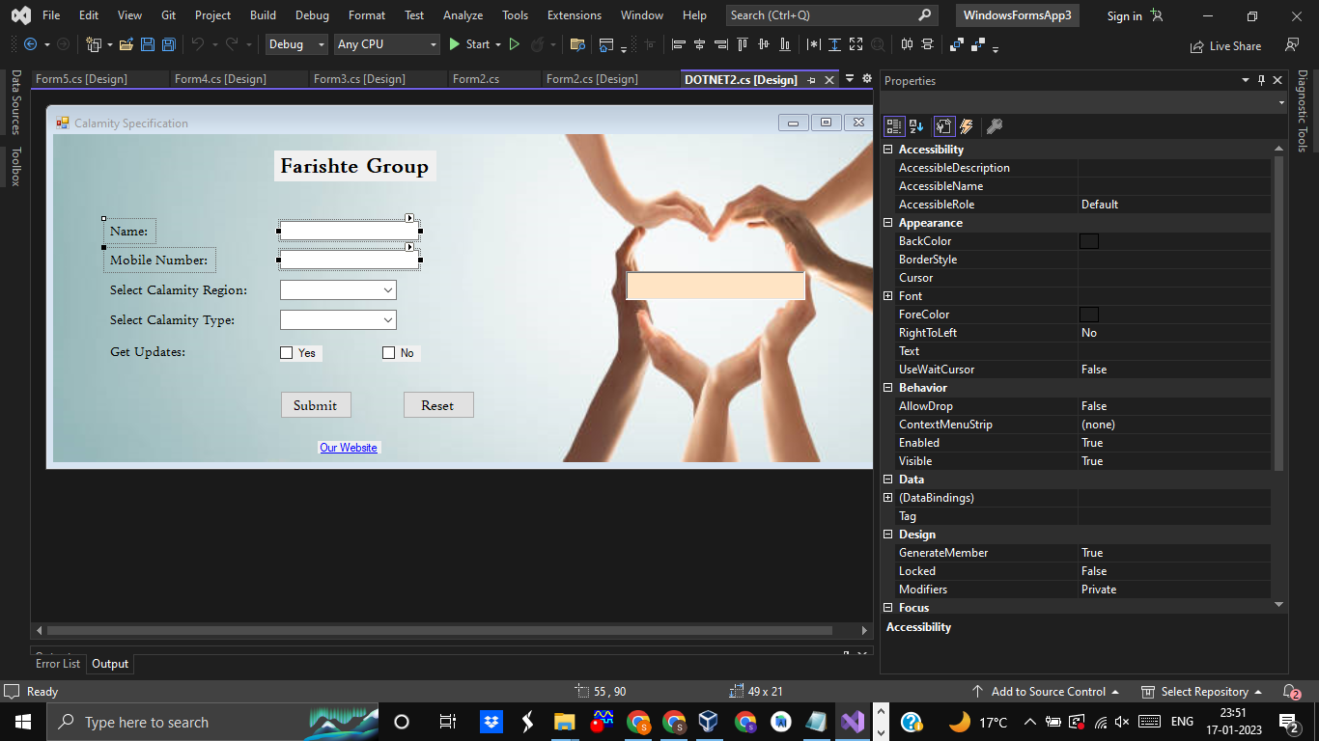

Snippet of the application Window:

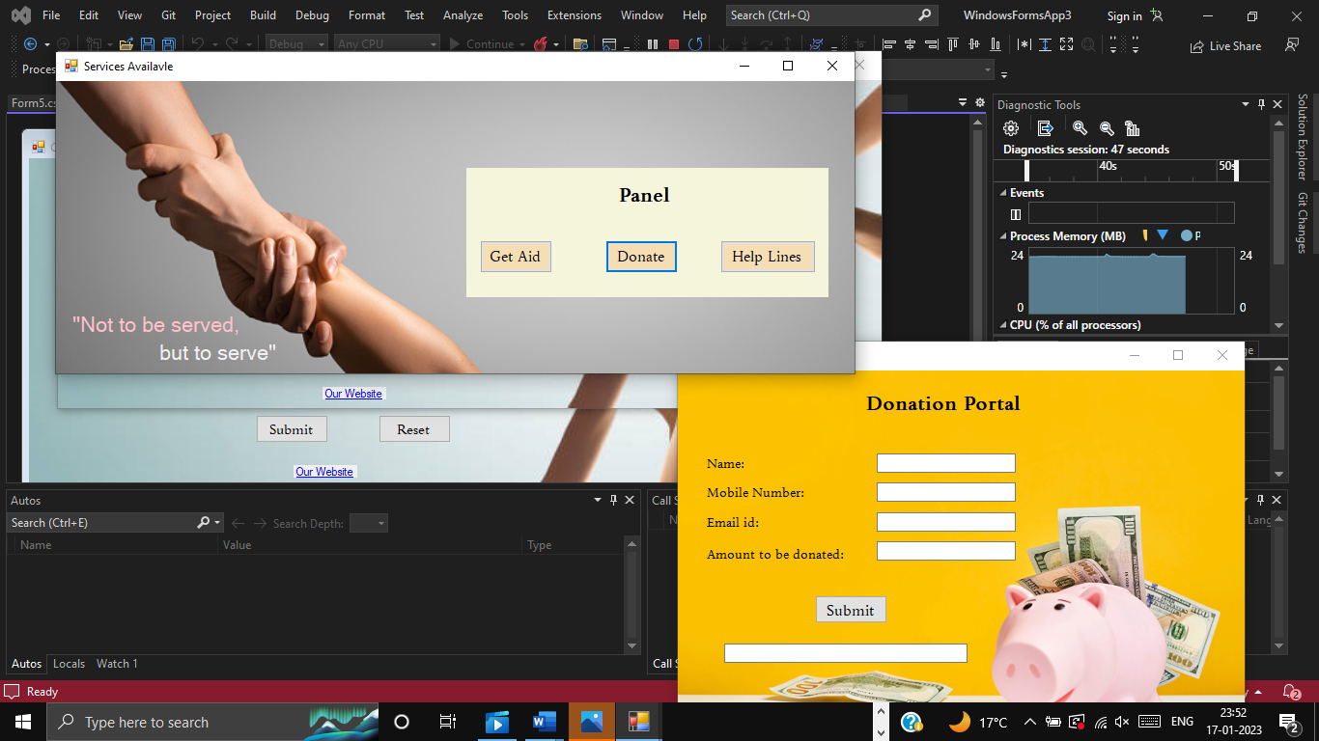

Snippet of the executed application:

