WORK-BASED LEARNING (WBL) PROGRAMME
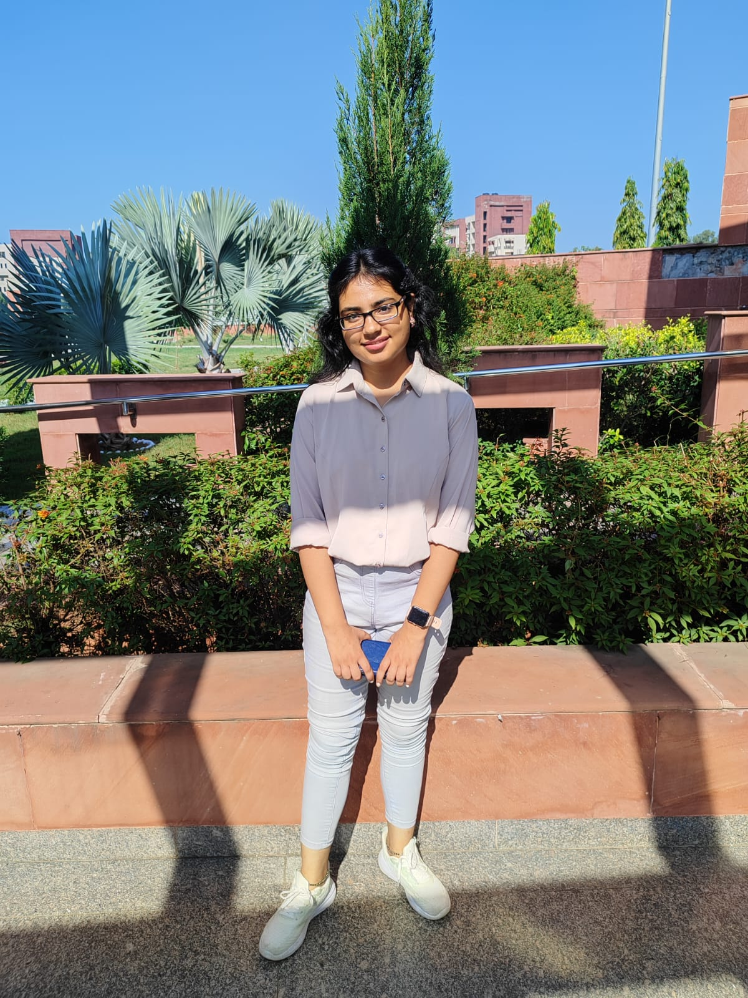
1. Candidate Information
Particulars | Candidate Information
Name | Saloni
Educational Qualification | Master of Technology (M.Tech) in Computer Science & Engineering
Institution / University | Indraprastha Institute of Information Technology, Delhi (IIIT Delhi)
Specialization / Branch | Computer Science & Engineering
WBL Programme Centre | ERNET India, Delhi
Department | Research & Development (R&D)
Duration of WBL Programme | 12th March 2025 – 11th July 2025
Hometown | Delhi, India
2. Background
My name is Saloni, and I am currently pursuing my Master of Technology (M.Tech) in Computer Science & Engineering from the Indraprastha Institute of Information Technology, Delhi (IIIT Delhi). I have just completed my first year of the M.Tech programme. Prior to this, I completed my undergraduate studies in Computer Science, which laid a strong foundation in core computing concepts, programming, and problem-solving.
My passion for software development and technology drove me to seek practical, industry-level experience alongside my academic studies. The Work-Based Learning (WBL) Programme at ERNET India offered me a unique opportunity to bridge the gap between theoretical knowledge and real-world application. ERNET India, as an autonomous scientific society under the Ministry of Electronics & Information Technology (MeitY), Government of India, provided an ideal environment to work on meaningful technology projects.
Before joining the WBL Programme, I was eager to apply my academic learnings to real software development challenges. The programme gave me the platform to contribute to actual government-level software systems, helping me develop both technical depth and professional maturity.
3. Experience and Learnings from WBL Programme
During the WBL Programme at ERNET India from 12th March 2025 to 11th July 2025, I worked on the development and functional testing of the Visitor Management System (VMS) software — a critical internal software solution used within ERNET India's operations. This hands-on experience gave me deep exposure to the full software development lifecycle in a professional government R&D environment.
My primary responsibilities included developing key features of the VMS software and conducting comprehensive functional testing to ensure the system met operational requirements. I gained practical experience in software engineering practices such as requirements analysis, module development, integration, and quality assurance. Working on the VMS gave me exposure to building robust, user-centric software systems designed for real organisational use.
Throughout the programme, I developed skills in software development, system testing methodologies, debugging, and documentation. I also learned how to collaborate within a professional team, manage project tasks, and communicate technical progress effectively. The experience enhanced my understanding of how large-scale software projects are managed in government institutions and the importance of systematic, structured development approaches.
One of the most rewarding aspects of this experience was the invaluable mentorship I received from Sh. Kishor Lala and Sh. Naveen Choudhary, my reporting officers at ERNET India. Their patience, encouragement, and constant guidance were the backbone of my growth throughout this programme. I genuinely believe that I am nothing without their support — every task I completed, every skill I developed, and every challenge I overcame was possible only because of the direction and confidence they gave me. They did not just supervise my work; they invested their time in shaping me as a professional. Their feedback each week pushed me to think deeper, work harder, and strive for quality in everything I did.
4. Key Contributions / Achievements
During the WBL Programme, I made significant contributions to the Visitor Management System (VMS) project at ERNET India. My work spanned both development and quality assurance phases, allowing me to contribute meaningfully to the software's overall functionality and reliability.
On the development side, I implemented functional modules of the VMS, contributing to the codebase and improving the system's features. On the testing side, I designed and executed functional test cases, identified and reported defects, and verified fixes to ensure the system performed as intended. My GitHub contributions to the project (https://github.com/saloninarang27/Ernet-Techlog) reflect my active involvement throughout the internship period.
This dual exposure to development and testing gave me a well-rounded understanding of software engineering in practice and strengthened my ability to deliver quality software in a professional setting.
5. Current Status
I have successfully completed the WBL Programme at ERNET India as of 11th July 2025 and received an internship completion certificate from Dr. A. Paventhan, Senior Director (R&D), ERNET India. I am currently continuing my M.Tech studies (2nd year) at IIIT Delhi, applying the industry knowledge and professional skills gained during the WBL Programme to my academic research and coursework.
6. Acknowledgements
I would like to express my deepest gratitude to Sh. Kishor Lala and Sh. Naveen Choudhary, my mentors and reporting officers at ERNET India, for their unwavering support and guidance throughout my WBL internship. Words fall short when I try to describe how much their mentorship has meant to me. They were always approachable, always encouraging, and always ready to help — whether it was a technical doubt, a professional challenge, or simply the need for direction when I felt uncertain.
Sh. Kishor Lala's deep technical knowledge and calm, structured approach to problem-solving taught me how to think critically and tackle complex tasks with confidence. Sh. Naveen Choudhary's enthusiasm, practical insights, and genuine interest in my growth as an intern made me feel valued and motivated every single day. Together, they created an environment where learning felt natural and meaningful.
I truly believe that the person I am becoming as a technology professional is shaped in large part by the lessons, values, and work ethic instilled by both of them. Their guidance has not just made me a better intern — it has made me a better learner and a more responsible individual. I am nothing without the support and direction they so generously gave me. I am forever grateful for the opportunity to have worked under such remarkable mentors.
7. Future Goals and Aspirations
My primary goal is to build a strong career in software engineering and technology research, leveraging both my academic foundation from IIIT Delhi and the industry experience gained through the WBL Programme. I aspire to contribute to impactful technology projects — particularly those that serve public interest, similar to the government-level work I experienced at ERNET India.
I am passionate about software development, system design, and exploring emerging areas in computer science. I plan to pursue advanced research during my M.Tech and aim to work on innovative, real-world software solutions upon graduation. I am also interested in contributing to open-source technology ecosystems and building software products that create a meaningful difference.
Through continuous learning, perseverance, and the professional discipline instilled by the WBL Programme — and inspired by the example set by Sh. Kishor Lala and Sh. Naveen Choudhary — I am committed to growing as a skilled technology professional and making a positive impact in the IT sector.

