Software Requirements Specification

For

Visitor Management System

April 11, 2025

By

Saloni
Ajay Chand
Anchal Sharma

Table of Contents

Table of Contents i
List of Figures ii
1.0. Introduction 2
1.1. Purpose 2
1.2. Scope of Project 2
1.3. Overview of Document 2
2.0. Overall Description 3
2.1 System Environment 3
2.2 Functional Requirements Specification 3
2.2.1 Visitor Use Case 4
2.2.2 Register Visitor with Team Use Case 5
2.2.3 Receptionist/Security Use Case 5
2.2.4 Administrator Use Case 7
2.2.5 Receptionist/Security Use Case 8
2.2.6 Administrator Use Case 9
Figure 1 - Use Case Summary Diagram 11
2.3 User Characteristics 12
Role-Based Access Control (RBAC) 12
Visitor 14
Receptionist/Security 14
Administrator 15
2.4 Non-Functional Requirements 16
3.0. Requirements Specification 16
3.1 External Interface Requirements 16
3.2 Employee Directory Integration 17
3.3 Functional Requirements 17
3.4 Detailed Non-Functional Requirements 21

List of Figures

Figure 1 - System Environment 3
Figure 2 - Use Cases 11.

1.0. Introduction

1.1. Purpose
The purpose of this document is to provide a detailed description of the Visitor Management System (VMS). This system will be designed to streamline the visitor check-in process at the organization’s premises by capturing visitor profiles using a webcam and scanning visitor details from their visitor cards using a dedicated scanner. The document aims to outline the purpose and key features of the system, the interfaces it will provide, the expected functionalities, system constraints, and the interaction between the system and external inputs. It is intended for both the stakeholders (to provide insight and approval) and developers (to guide the development of the system).

1.2. Scope of Project
This application will support scanning of Visitor- ID cards using a scanner, extracting relevant information such as name, address, and ID number using Optical Character Recognition (OCR), and allowing this information to be used for automatic or manual Copy n Paste form filling. In addition, the system will capture a live image of the visitor using a webcam, log their check-in and check-out times, store all information in a secure and searchable database, and allow administrators to generate reports. Future updates may include face recognition and cloud storage integration.

1.3. Overview of Document
The following sections of this document will provide a detailed description of the Visitor Management System (VMS), outlining its features, functionality, and technical requirements.
The second chapter, Overall Description, provides an overview of the system’s functionality. This section describes the general objectives and key features of the Visitor Management System, offering a high-level view of how the system will function and meet the needs of the organization. It includes an informal outline of the system’s major components, including the webcam integration for capturing visitor profiles, the scanner for reading visitor cards, and the user interfaces. This chapter is intended for a general audience, including stakeholders and managers, to give them a contextual understanding of the system’s purpose and capabilities.
The third chapter, Requirements Specification, is written specifically for the development team and provides a more in-depth, technical breakdown of the system’s functionality. This section outlines the detailed specifications required for building the system, including hardware, software, and system integration details. It also defines the system’s expected behaviors, constraints, and performance requirements. The information provided here is critical for developers and engineers to ensure the system is implemented correctly and meets all required technical standards.
Together, these two sections describe the Visitor Management System in its entirety, catering to different audiences through distinct language and levels of detail. While the first chapter establishes a broad understanding of the system's goals, the second chapter dives into the technical specifications necessary for its development and implementation.

2.0. Overall Description

2.1 System Environment

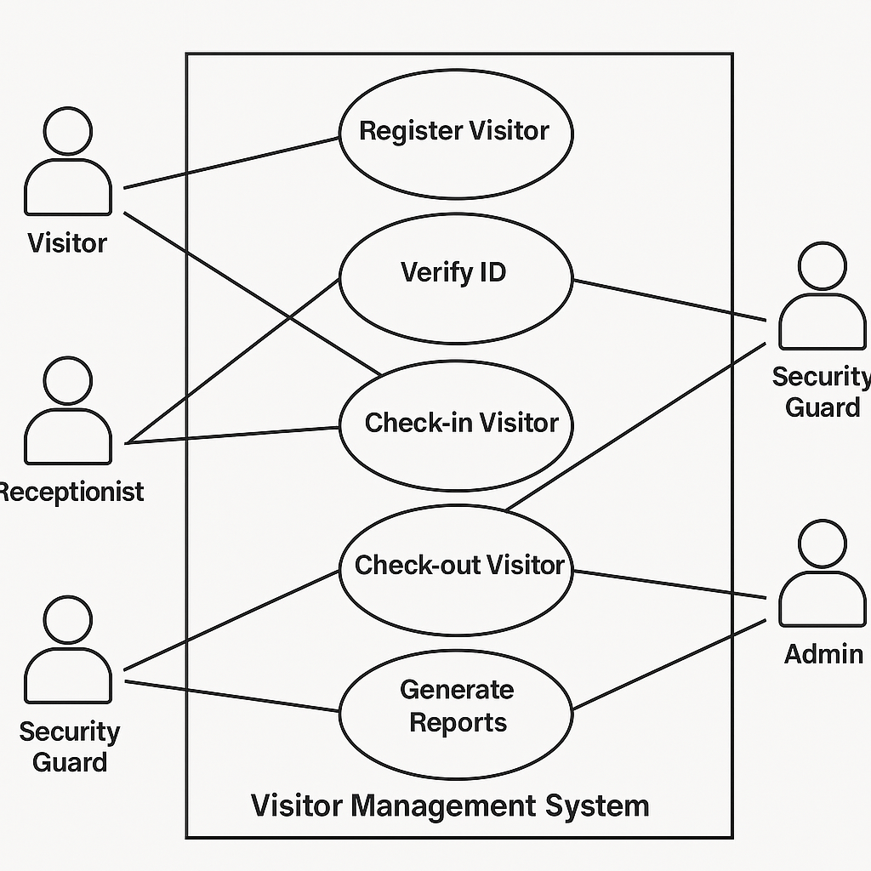
Figure 1 - System Environment

2.2 Functional Requirements Specification
This section outlines the use cases for each of the active roles in the Visitor Management System (VMS). The Visitor, Receptionist/Security, and Administrator each have distinct use cases. The Administrator is the main actor in this system, responsible for managing the system's configuration and overseeing the operation.

2.2.1 Visitor Use Case
Brief Description
The Visitor arrives at the premises, registers their arrival by scanning their visitor card or entering their details manually, has their photo taken by the webcam, and receives a visitor Pass.

Initial Step-By-Step Description
Before this use case can be initiated, the Visitor has already arrived at the entrance of the facility.
- The Visitor approaches the Reception desk.
- The system prompts the Visitor to scan their visitor card or enter their details manually (e.g., name, purpose of visit).
- The system captures the Visitor's profile image using the webcam.
- The Visitor verifies the details and confirms their registration.
- The system generates a visitor pass with the Visitor's name and access details.
- The system prints the Pass or displays it digitally (if applicable).
- The Visitor proceeds to the relevant area of the premises, showing the Pass for access verification if needed.

2.2.2 Register Visitor with Team Use Case
Use Case: Register Visitor with Team

Brief Description: A visitor arrives with a team and registers all team members under a single entry by using the “Add Team” option.
Preconditions:
- Visitor is on the registration interface (kiosk or receptionist-assisted).
- Visitor has details of their team members (name, purpose, ID).
Flow of Events:
- Visitor initiates check-in on the system.
- System prompts for visitor details and displays an “Add Team Member” button.
- Visitor clicks “Add Team Member” and enters basic details (name, ID, etc.) for each team member.
- System captures optional images and ID scans for each team member (if needed).
- All entries are grouped under the primary visitor's record.
- System generates group visitor passes.
- System logs check-in time for all team members.
- Notification is sent to the host indicating a team has arrived.
Postconditions:
- All team members are registered and linked to the main visitor.
- Their status is marked as "Checked In" under the same appointment or visitor group.
Exceptions:
- Incomplete data for a team member — the system prompts for missing required fields.
- Team member already checked in separately — the system warns about duplicates.

2.2.3 Receptionist/Security Use Case
Use case: Verify Visitor
Brief Description
The Receptionist/Security verifies the identity of a visitor, approves their access, and monitors their visit in real-time.

Initial Step-By-Step Description
Before this use case can be initiated, the Receptionist/Security has already logged into the system.
- The Receptionist/Security accesses the Visitor Management System on their terminal.
- The system displays a list of all visitors who have checked in or are waiting to check in.
- The Receptionist/Security selects a Visitor from the list or manually searches for the visitor by name or other identifiers.
- The system displays the Visitor's profile, including their photo, check-in time, and host details.
- The Receptionist/Security verifies the visitor's identity by comparing the information with their visitor card or any additional documentation provided.
- If the Visitor’s details are correct, the Receptionist/Security confirms the visitor’s access by approving the request.
- The system logs the approval and updates the visitor's status to “granted access.”
- The Receptionist/Security monitors the visitor's departure and updates the system when the visitor leaves.

2.2.4 Administrator Use Case
Use case: Manage System Configuration
Brief Description
The Administrator configures and maintains the Visitor Management System settings, including user management, visitor data retention, and security settings.

Initial Step-By-Step Description
Before this use case can be initiated, the Administrator has already logged into the system with administrative privileges.
- The Administrator accesses the system’s configuration page.
- The system presents various configuration options, such as:
  - Managing user roles (Receptionist/Security, Administrator).
  - Setting up security permissions (e.g., allowed areas for visitors).
  - Configuring data retention policies.
- The Administrator selects the configuration option they wish to modify (e.g., update permissions, change data retention policy).
- The system prompts the Administrator to enter or update the relevant information.
- The Administrator updates the configuration settings and submits the changes.
- The system validates the changes and applies them across the system.
- The Administrator receives confirmation that the system has been updated successfully.

2.2.5 Receptionist/Security Use Case
Use case: Track Visitor
Brief Description
The Receptionist/Security monitors the movement of visitors in real-time, ensuring that they stay within permitted areas and track their check-in and check-out times.

Initial Step-By-Step Description
Before this use case can be initiated, the Receptionist/Security is logged into the system.
- The Receptionist/Security accesses the visitor tracking page on the system.
- The system displays a list of all active visitors on-site, including their check-in time, host details, and assigned access areas.
- The Receptionist/Security selects a visitor from the list to view detailed information, including access logs.
- The Receptionist/Security monitors the visitor’s movement based on the visitor’s access badge (if integrated with physical security systems).
- If the visitor exceeds the permitted access areas, the system sends an alert to the Receptionist/Security.
- The Receptionist/Security can update the visitor’s access permissions or alert security personnel if needed.
- The Receptionist/Security logs the visitor’s departure when they check out, and the system updates the visitor’s status to “left” in the database.

2.2.6 Administrator Use Case
Use case: Generate Visitor Reports
Brief Description
The Administrator generates reports based on visitor data for security audits, operational review, or compliance purposes.

Initial Step-By-Step Description
Before this use case can be initiated, the Administrator has logged into the system.
- The Administrator accesses the reports section of the system.
- The system prompts the Administrator to choose the type of report they wish to generate (e.g., daily, weekly, or monthly visitor logs).
- The Administrator selects the date range and any additional filters (e.g., specific departments or areas visited).
- The system compiles and generates the requested report.
- The Administrator reviews the generated report on-screen or exports it to a file format (PDF, CSV, etc.) for further analysis.
- The Administrator can save or print the report for record-keeping.

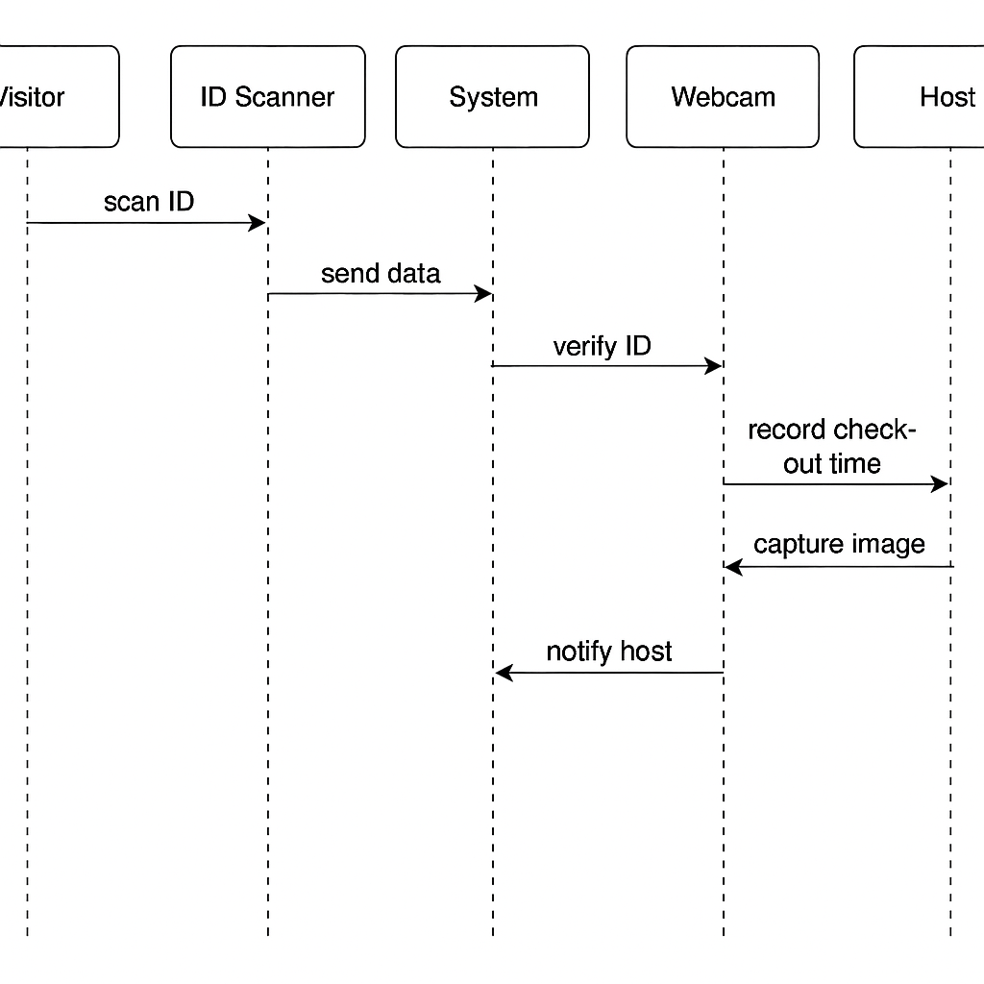

Figure 2 - Use Case Summary Diagram
The summary diagram below illustrates the primary use
cases for the Visitor Management System (VMS):
- Visitor Use Case: Check-In Visitor
- Receptionist/Security Use Cases: Verify Visitor, Track Visitor
- Administrator Use Cases: Manage System Configuration, Generate Visitor Reports

This functional requirements section presents the key use cases for each role in the Visitor Management System (VMS). The Visitor primarily interacts with the system during the check-in process, while the Receptionist/Security is responsible for verifying and tracking visitors' movements. The Administrator plays a critical role in system configuration and generating reports. Each use case defines the expected steps to complete tasks within the system.

2.3 User Characteristics
The Visitor Management System (VMS) is designed for a variety of users, each with different levels of technical expertise. Below are the expected characteristics for each role interacting with the system:

Role-Based Access Control (RBAC)
The Visitor Management System (VMS) implements Role-Based Access Control (RBAC) to ensure that each user has access only to the features and data relevant to their responsibilities. This enhances security, prevents unauthorized access, and simplifies the user experience.
- Visitor
Visitors have limited access restricted to their own registration and check-in processes.
They can:
• Register themselves or their team using the "Add Team" option.
• Enter personal information and scan ID cards.
• Capture a live image using the webcam.
• View confirmation and access their digital or printed visitor pass.
They cannot access visitor logs, system settings, or employee data.
- Receptionist/Security
Receptionist/Security personnel have moderate access focused on real-time visitor handling and monitoring.
They can:
• View and verify current visitor records.
• Approve or deny visitor access.
• Track check-in and check-out statuses.
• Respond to alerts related to unauthorized access or overstays.
They cannot access system configuration, manage user roles, or alter administrative settings.

- Administrator
Administrators have full system access to manage configurations, users, and data.
They can:
• Add, remove, and assign roles to users.
• Configure system behavior, access permissions, and data retention policies.
• Generate reports and audit logs.
• Manage the employee directory and visitor database.
They have complete authority over all components of the system.

- Employee (Host)
Employees (hosts) have limited access relevant to visitor scheduling and coordination.
They can:
• Pre-register visitors and manage their own appointments.
• Receive notifications about visitor check-in or cancellations.
• View history of visits associated with their name.
They cannot access other users’ data, manage the system, or verify visitor identity.

Visitor
The Visitor is expected to have basic computer literacy and should be familiar with using touchscreens, especially for scanning visitor cards or entering personal information. Visitors are not required to have advanced technical skills but should be able to:
- Use a touch interface or keyboard to enter their details (name, purpose of visit).
- Scan their visitor card (if applicable).
- Follow simple on-screen prompts to take a photo using the webcam.
- Read and understand basic instructions or prompts displayed on the system.

Receptionist/Security
The Receptionist/Security personnel are expected to be comfortable using computer systems, with a moderate level of technical literacy. They should be familiar with:
- Using the VMS interface to track and verify visitor information.
- Navigating the system to look up visitor records, approve access, and issue badges.
- Using the security tools integrated with the VMS to monitor visitor movement.
- Handling basic troubleshooting in case of issues with the system (e.g., webcam or scanner errors).
Receptionists and security personnel should be able to handle multiple tasks concurrently in a busy environment and respond quickly to system prompts.

Administrator
The Administrator is expected to have advanced technical literacy and should be comfortable with system management tasks. The Administrator should be proficient in:
- Using complex software tools to configure the system, such as adding and modifying user roles, setting permissions, and managing security features.
- Generating reports and analyzing visitor data to ensure compliance and operational efficiency.
- Handling the system’s backend settings, including data retention, visitor database management, and user management.
- Troubleshooting system issues and overseeing regular system maintenance.
The Administrator should also be able to navigate through various system settings, perform updates, and ensure the system’s security protocols are up to date.

2.4 Non-Functional Requirements
The Visitor Management System will be hosted on a server with high-speed internet connectivity to ensure optimal performance during peak usage. The specific physical machine to be used will be determined by the organization, taking into account factors such as the expected number of visitors, data processing requirements, and system uptime. The system will be designed to work with web servers like Apache or Nginx for connecting the front-end user interface to the backend database. The visitor’s connection speed will depend on their local internet service rather than any limitation in the system architecture.
The Admin Panel for managing visitor data will be hosted on the system administrator's workstation, which will be running a modern Windows or Linux operating system. The Admin Panel will interact with a NoSQL database for storing visitor information. The database will be configured to handle high concurrency and large volumes of data efficiently.

3.0. Requirements Specification

3.1 External Interface Requirements
The only link to an external system is the link to the Historical Society (HS) Database to verify the membership of a Reviewer. The Editor believes that a society member is much more likely to be an effective reviewer and has imposed a membership requirement for a Reviewer. The HS Database fields of interest to the Web Publishing Systems are member’s name, membership (ID) number, and email address (an optional field for the HS Database).
The Assign Reviewer use case sends the Reviewer ID to the HS Database and a Boolean is returned denoting membership status. The Update Reviewer use case requests a list of member names, membership numbers and (optional) email addresses when adding a new Reviewer. It returns a Boolean for membership status when updating a Reviewer.

3.2 Employee Directory Integration
Purpose:
The Employee Directory will serve as a centralized database of all employees within the organization. This directory will be used to:
- Associate visitors with their respective hosts.
- Enable automatic appointment matching.
- Notify hosts of visitor arrivals.
- Enhance security and access control by validating host identities.
Functional Requirements:
- The system must maintain a database of employees, including the following information:
  - Employee ID
  - Full Name
  - Department
  - Designation
  - Email Address
  - Phone Number
  - Office Location or Extension Number
- The employee directory must be editable by the Administrator.
- Receptionists/Security must be able to search for employees when assigning a visitor to a host.
- Upon visitor check-in, the system must automatically notify the selected host via email/SMS.
- The system should allow employees to pre-register visitors and schedule appointments through a web interface.
Integration Points:
- The employee data may be imported from an existing HR or ERP system using APIs or CSV upload.
- The system must ensure data synchronization with HR updates to reflect new hires or employee departures.
Security & Access Control:
- Only users with Admin roles can modify employee records.
- All employee data must be stored securely, with access logs and change histories maintained.
Non-Functional Requirements:
- The directory must support search and filter functionality with real-time results.
- The directory should be responsive and accessible on both desktop and mobile platforms.

3.3 Functional Requirements
- Visitor Registration:
  - The system must allow both registered and first-time visitors to input personal information (name, contact number, email, purpose of visit, etc.).
  - The system must validate the visitor's details against a database to check if they are a returning visitor.
  - If it is the visitor’s first time, the system should create a new record in the Visitor Database.
- Check-in and Check-out Process:
  - The system must allow visitors to check in using multiple methods: scanning a QR code, entering a PIN, or using facial recognition (if available).
  - The system must log the time of check-in and check-out for tracking purposes.
  - Upon check-out, the system will send an automatic notification to the host and update the visitor's status to "Checked Out" in the system.
- Appointment and Scheduling Integration:
  - The system should automatically check the visitor's appointment against the host's calendar to verify their visit time and ensure room availability.
  - In the case of a scheduled visit, the system must send reminders to both the visitor and host in advance.
- Visitor Notifications:
  - The system must notify visitors with confirmation emails or SMS messages when their appointment is confirmed, canceled, or rescheduled.
  - Visitors will also receive notifications upon successful check-in and check-out.

- Visitor Tracking and Reporting:
  - The system should generate reports on visitor statistics such as visit frequency, duration of stay, host interaction, etc.
  - Hosts should have access to a visitor history to see past visit details and make better decisions regarding security or access permissions.
- Security and Privacy:
  - The system must ensure data privacy by encrypting personal information, following GDPR or relevant local laws.
  - Access control should be implemented to restrict system access based on user roles (admin, host, security officer, etc.).

- Visitor ID Validation:
  - The system must validate visitor IDs against the external database of registered visitors, checking against valid identification methods (e.g., membership ID, government-issued ID).
- Emergency Alerts:
  - In case of emergencies (e.g., fire alarm, security threats), the system should be able to send real-time alerts to all visitors, staff, and security teams to guide evacuation or lockdown procedures.

3.4 Detailed Non-Functional Requirements

• Performance:
- The system must support concurrent user sessions, allowing multiple visitors to check in or out simultaneously without delay.
- The system should process visitor check-in and check-out operations within 5 seconds to minimize wait times.
- Real-time notifications (SMS, email) should be delivered within 1 minute of an event trigger.

• Scalability:
- The system should be scalable to handle a high volume of visitors during peak hours, such as conferences or large events.
- The system should be able to accommodate the addition of new buildings, departments, or campuses without significant reconfiguration.
• Availability:
- The system should be available 99.9% of the time, with planned downtime limited to non-peak hours and communicated in advance to users.
- Critical functionalities (e.g., check-in, check-out) must be operational even during maintenance windows.

• Usability:
- The system should feature a user-friendly interface for both visitors and hosts, with minimal training required for users to get started.
- The system must be accessible via desktop and mobile devices, ensuring ease of use across various platforms.
- A kiosk-style interface should be provided at entry points for visitors to self-check in.

• Security:
- All sensitive data (e.g., visitor personal information, appointment details) should be encrypted both in transit and at rest.
- The system must support multi-factor authentication for administrative users and integrate with existing access control systems.
- Detailed audit logs should be maintained to track all user actions for security and compliance purposes.
• Interoperability:
- The system must support integration with existing enterprise systems, including email, calendar, and security systems (e.g., access control, surveillance).
- The system should be able to exchange data with the external visitor database in real-time.
• Compliance:
- The system should adhere to relevant regulatory standards, such as GDPR (General Data Protection Regulation) or HIPAA (Health Insurance Portability and Accountability Act), depending on the organization's location and sector.
- Visitor data should be retained for a predefined period, after which it should be archived or deleted in compliance with data retention policies.
• Maintainability:
- The system should be modular and easy to update, with minimal downtime required for software updates.
- Detailed documentation should be provided for system administrators, outlining how to manage user accounts, configure external interfaces, and troubleshoot common issues.
• Backup and Recovery:
- Regular backups of visitor data should be performed to avoid data loss, and the system should support automatic backup processes.
- In the event of a system failure, the system must have a recovery plan in place to restore services with minimal disruption, targeting recovery time within 2 hours.

