A
Project Report
Compressive Strength of Concrete with partial replacement of cement with silica
SUBMITTED BY:
Name: Saloni Samotra
Registration No: 0863CE231014
B.Tech : 3rd Yr. V Sem

GUIDED BY: Prof Dr.Rewa Bochare

Department of Civil Engineering



PRESTIGE INSTITUTE OF ENGINEERING MANAGEMENT AND RESEARCH

Date Of Submission:
Department of Civil Engineering / Material Testing Lab
CERTIFICATE
This is to certify that the Project Report titled “Compressive Strength of Concrete with partial replacement of cement with silica’’ submitted by Saloni Samotra, Registration no. 0863CE231014 of Civil Engineering has been prepared under my supervision and guidance.
I hereby confirm that the work presented in this report/manual is original and has been carried out by the student in accordance with the rules and regulations of PIEMR Indore.
It is also certified that the report/manual is suitable for the partial fulfilment of the requirements of the course Material Testing Laboratoty (V sem)
Submitted by:
Name: Saloni Samotra
Signature:
Date:
Guided by/Supervisor:
Name: Prof Dr. Rewa Bochare
Designation: Professor
Signature:
Date:
Head of Department:
Name: Prof Dr.Raksha Parolkar
Signature:
Date:
C0NTENTS

- ABSTRACT
- KEYWORDS
- INTRODUCTION
- METHODOLOGY
- RESULT AND DISCUSSION
- CONCLUSION

Abstract: This experimental study examines the effect of replacing 10% of ordinary Portland cement (OPC) with silica fume on the compressive strength of M20 grade concrete. Three standards 150×150×150 mm concrete cubes were cast using a nominal M20 mix (1:1.5:3) with a water–cement ratio of 0.50. No chemical admixtures or superplasticizers were used. Total batch mass was 30 kg (lab-scale). After mixing and standard curing, one cube was tested at 7 days and two cubes at 28 days. Peak loads were recorded using a compression testing machine and converted to compressive stress (MPa).
Results show that the 7-day cube achieved 26.28 MPa, while the 28-day cubes achieved 45.10 MPa and 44.20 MPa, indicating a substantial strength gain at 28 days due to silica fume replacement and normal strength development.
The findings confirm silica fume’s effectiveness in improving long-term compressive strength at 10% replacement in an M20 nominal mix under proper curing.

Keywords: Silica fume, M20 concrete, compressive strength, cement replacement, cube test.

INTRODUCTION:

Concrete is one of the most widely used construction materials in the world due to its high compressive strength, durability, and ease of availability. The strength and performance of concrete mainly depend on the quality of ingredients such as cement, fine aggregate, coarse aggregate, and water. However, ordinary concrete sometimes does not fully meet modern construction demands for higher strength and durability.

In recent years, the use of supplementary cementitious materials (SCMs) has increased in concrete technology to improve its mechanical properties and sustainability. Silica fume is a very fine by-product of the silicon and ferrosilicon industry and is highly rich in amorphous silica. Due to its very small particle size and high pozzolanic reactivity, silica fume can fill micro-voids in concrete and react with calcium hydroxide to form additional calcium silicate hydrate (C–S–H) gel, which increases strength and reduces permeability.

This project focuses on studying the effect of partial replacement of cement with 10% silica fume on the compressive strength of M20 grade concrete. Standard concrete cubes were cast and tested after 7 days and 28 days of water curing. The objective of this study is to evaluate the improvement in strength performance and to understand the suitability of silica fume as a partial cement replacement material in conventional concrete.
METHODOLOGY:
Material used:
- Cement: Ordinary Portland Cement (OPC)
- Silica fume: 10% replacement by weight of cement
- Fine aggregate: Natural sand (well-graded)
- Coarse aggregate: Crushed stone
- Water: Potable water
- Admixtures: None used
- Cube size: 150×150×150 mm

Mix Design (Lab-scale, 30 kg batch)
- Nominal M20 mix ratio: 1:1.5:3 (C: F.A: C. A)
- Total parts = 1 + 1.5 + 3 = 5.5
- Binder (cement + silica fume) = 5.45 kg
- Cement = 4.90 kg
- Silica fume = 0.55 kg
- Fine aggregate = 8.18 kg
- Coarse aggregate = 16.36 kg
- Water (w/c = 0.50 w.r.t cement) = 2.45 L

Procedure
- Weigh all materials accurately.
- Dry mix cement, silica fume, and sand for 2 minutes.
- Add coarse aggregate and mix for 1 minute.
- Gradually add water (80% first, remaining later) and mix to uniform consistency.
- Fill cube moulds in three layers, tamping each layer (25 strokes) to remove air.
- Cover and demould after 24 hours; cure cubes in water at 20±5°C until testing.
- Cube 1: 7 days
- Cube 2 & 3: 28 days

Images:

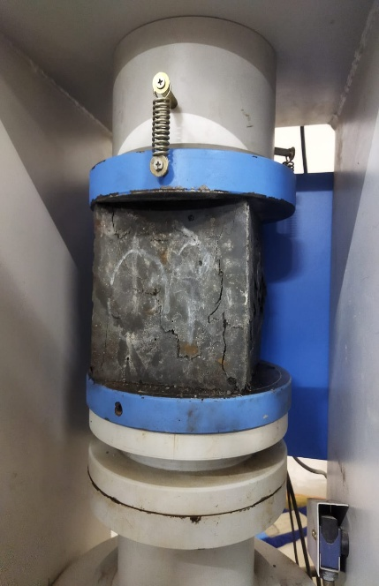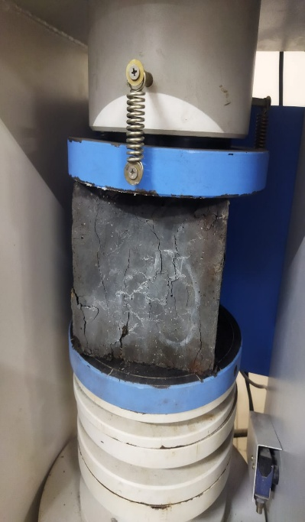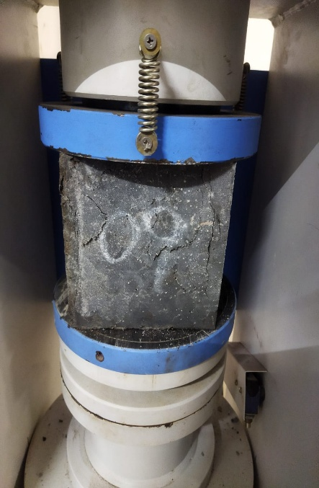
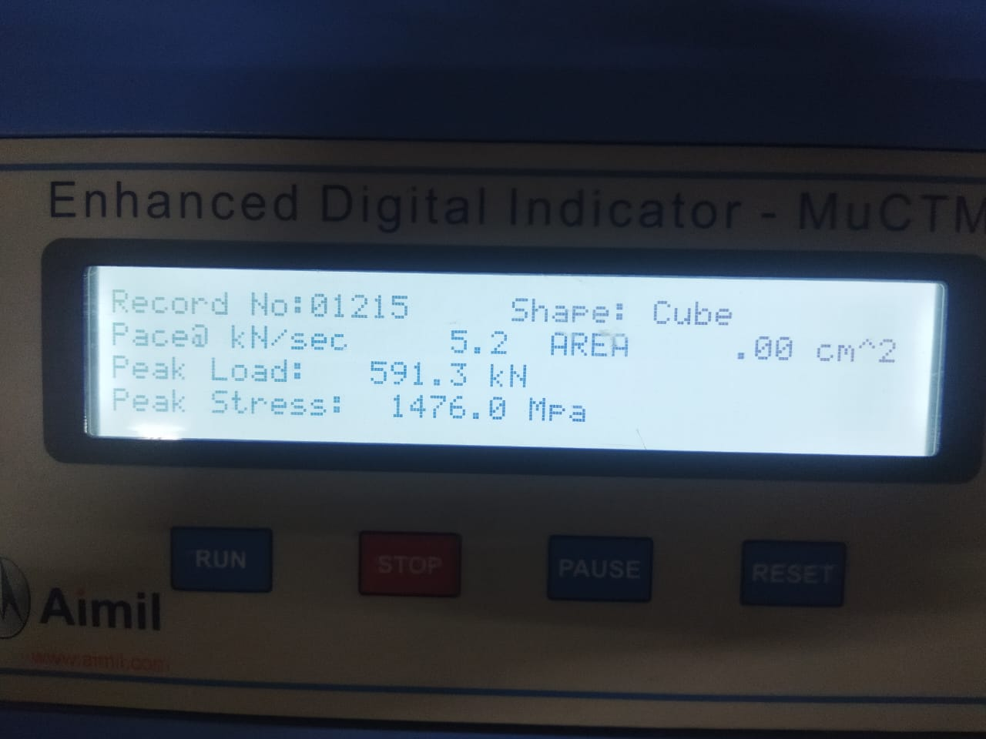
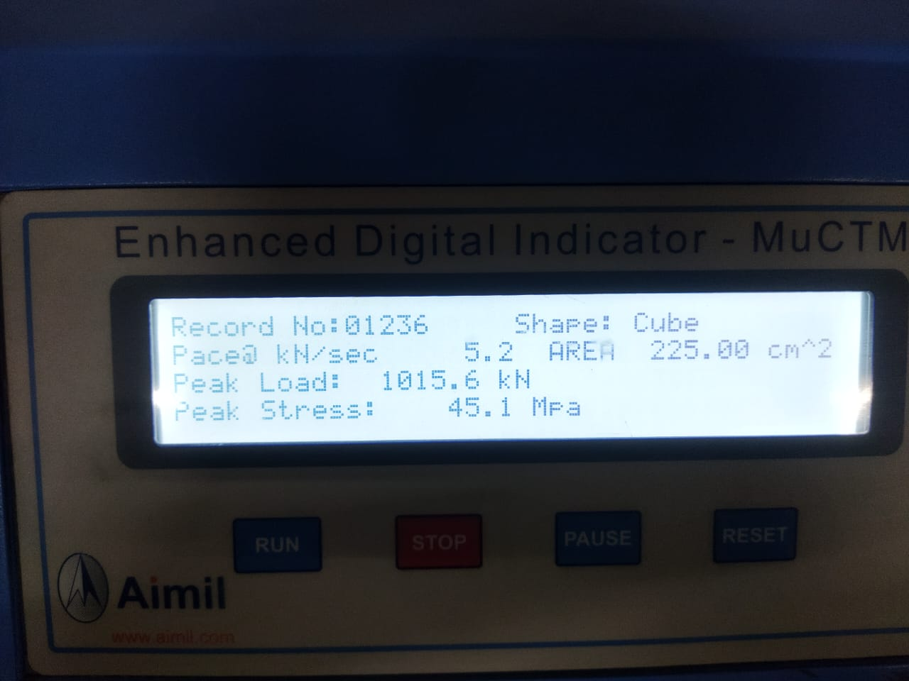
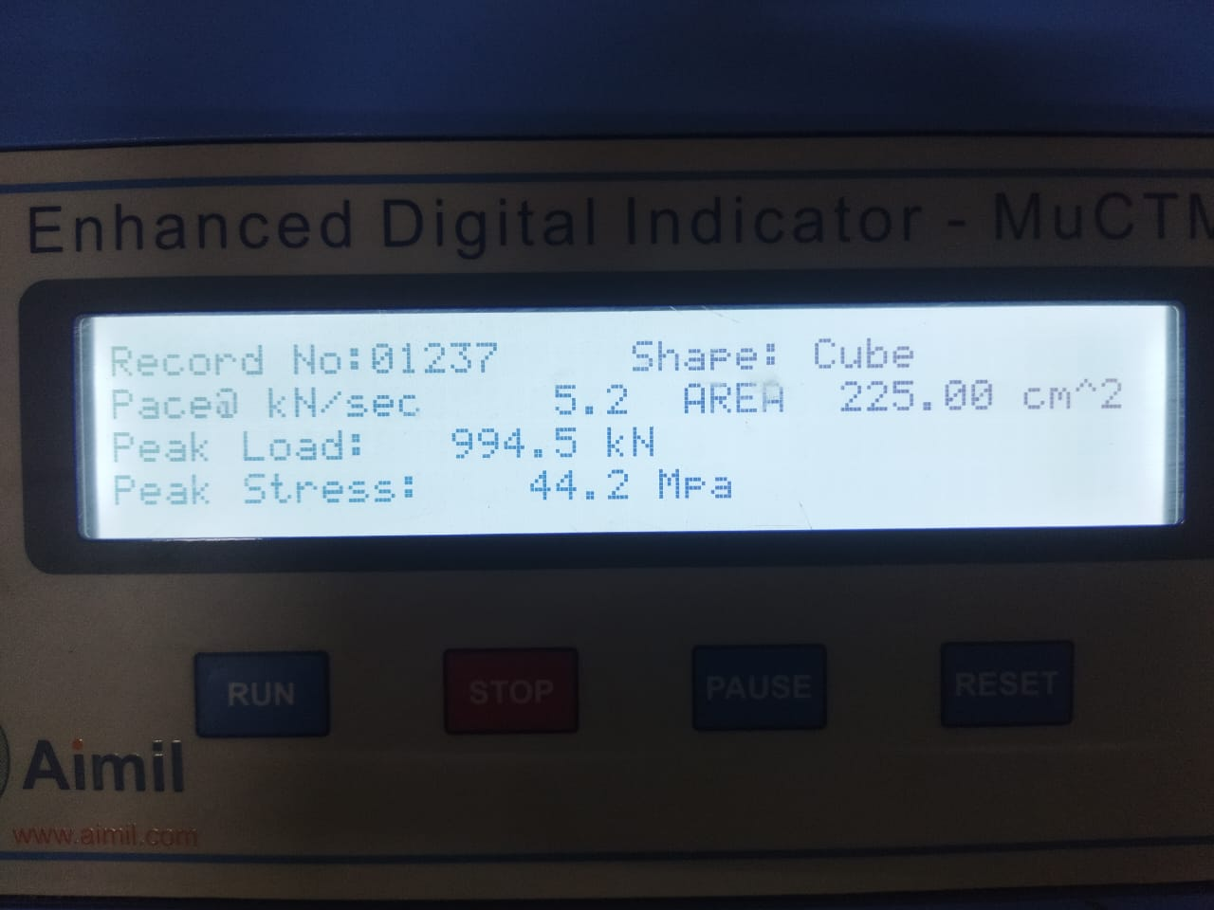

Result and Discussion
Compressive Strength Test Results
Cube | Time(days) | Peak load | Cross-sectional Area (m²) | Compressive Strength (MPa)
1. | 7 | 591.3 | 0.0225 | 26.28
2. | 28 | 1015.6 | 0.0225 | 45.10
3. | 28 | 994.5 | 0.0225 | 44.20

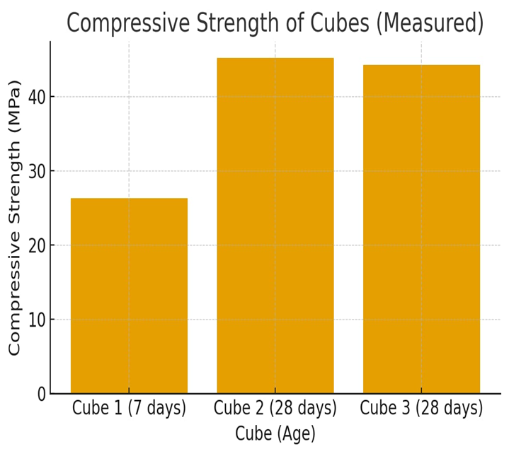

Observations:
- The 7-day cube achieved 26.28 MPa, showing typical early-age M20 concrete strength.
- The 28-day cubes reached 44–45 MPa, significantly higher than nominal M20 strength (~26.6 MPa).
- The increase in strength indicates the effectiveness of 10% silica fume replacement, due to pozzolanic reaction and densification of the cement matrix.
- Minimal variation between the two 28-day cubes (0.9 MPa) demonstrates good repeatability and uniform mixing.
Interpretation:
The results confirm that silica fume improves the long-term compressive strength of M20 concrete. Early-age strength gain is moderate, while later-age strength is significantly enhanced, showing the pozzolanic activity over time.

CONCLUSIONS:

Partial replacement of cement by silica fume at 10% in a nominal M20 mix (1:1.5:3) produced a notable increase in 28-day compressive strength (≈44–45 MPa) in this lab trial.
Proper dispersion of silica fume, good curing, and controlled mixing contributed to the observed strength.
For reliable design adjustments, perform more repetitions, trial mixes at larger scale, consider measuring workability (slump), density, and water absorption of aggregates. Also check durability parameters as silica fume may increase shrinkage and require control.

REFERENCE:
- IS 456:2000 — Code of Practice for Plain and Reinforced Concrete.
- IS 10262 — Guidelines for concrete mix design (use as reference for mix proportions).
- Research papers on silica fume effects (e.g., various MDPI and IJERT articles cited earlier).

