***ASSIGNMENT ON***

***CANNY EDGE DETECTION***

* CVG LAB 2020-21
* Saloni Shah
* 01FE18BCS183

Edges in images are areas with strong intensity contrasts – a jump in intensity from one pixel to the next.

Canny edge detection is a technique to extract useful structural information from different vision objects and dramatically reduce the amount of data to be processed.

The general criteria for edge detection include:

1. Detection of edge with low error rate, which means that the detection should accurately catch as many edges shown in the image as possible
2. The edge point detected from the operator should accurately localize on the center of the edge.
3. A given edge in the image should only be marked once, and where possible, image noise should not create false edges.

The Process of Canny edge detection algorithm can be broken down to 5 different steps:

1. Compute image derivatives, Gx and Gy.

Smoothing with a Gaussian Filter.

Use derivative kernels [1 -1]

1. Compute edge detection: tan(alpha) = Gy/Gx.
2. Edge point is the local maxima in edge detection.

Eg: Zero crossing. (To get an edge with width 1)

1. Use only edge points with gradient above the threshold.
2. Hysteresis: Edge linking with two thresholds.

Approach used in the solution:

**Step 1: Gaussian filtering-**

Convolve the image with the following Gaussian Kernel.

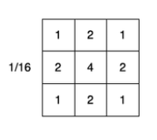

 

Original Image Gaussian Averaged Image

**Step 2: Sobel Filtering**

To calculate edges in X-direction the convolve the output of step 1 with [ 1

-1 ].

 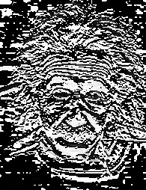

Previous Output Horizontal Edges

Convolve with [1 -1] to detect edges in Y-direction.

 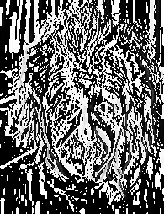

Horizontal Edges Vertical Edges

**Step 3: Calculate Laplacian(2nd derivative)**

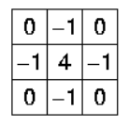

Convolve the previous output with Laplacian kernel to find 2nd derivative.

 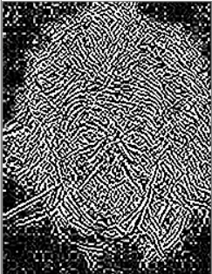

Previous output 2nd Derivation – Laplacian Output

**Step 4: Hysteresis**

Define a lower threshold and higher threshold.

The values below lower threshold is not considered to be an edge point. The values above higher threshold are considered to be an edge point. The values in between the lower threshold and higher threshold are then check for the 8-neighbourhood, if any one value in the 8-neighbourhood is in the higher threshold then the corresponding value is set to 255.

 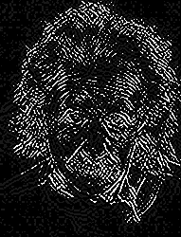

Original Image Output of Canny Edge detection