- Display the list of employees who have joined the company before 30th June 80 or after 31st Dec 81.

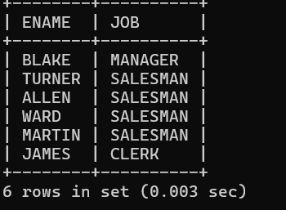

- Display the names of employees whose names have second alphabet A in their names.

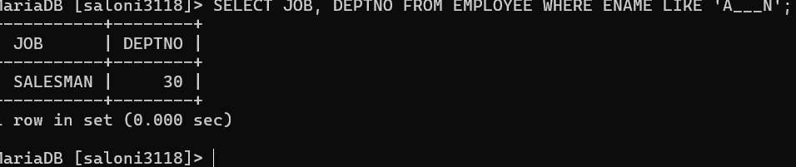

- Display the names of employees whose name is exactly five characters in length
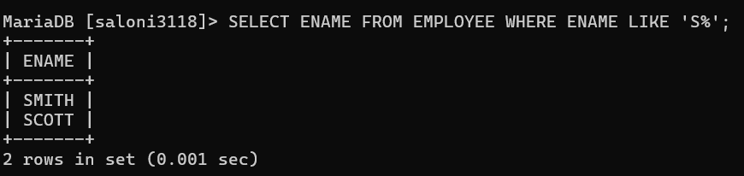

- Display the names of employees whose names have second alphabet A in their names.

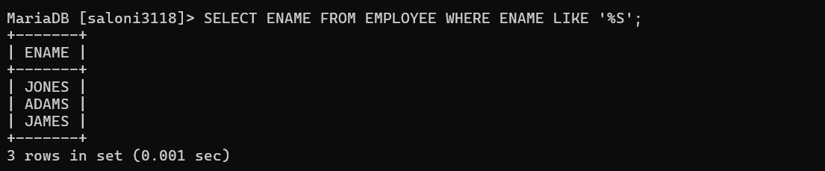

- Display the names of employees who are not working as salesman or clerk or analyst.

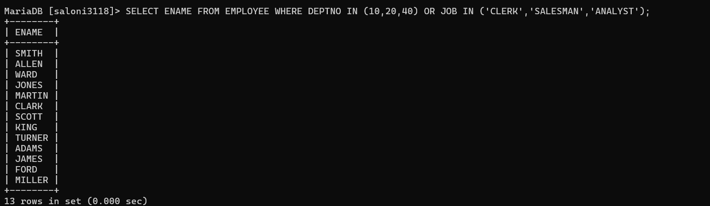

- Display the name of the employee along with their annual salary (sal*12). The name of the employee earning highest salary should appear first.

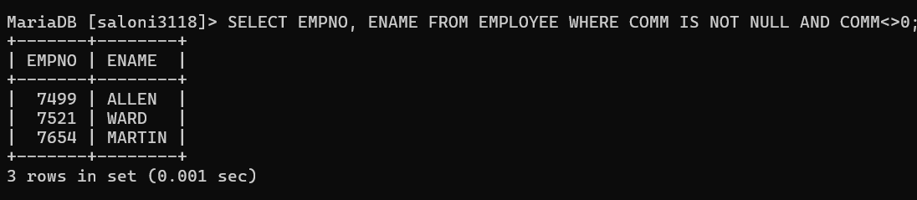

- Display name, sal, hra, pf, da, totalsal for each employee. The output should be in the order of total sal, hra 15% of sal, da 10% of sal, pf 5% of sal. Total salary will be (sal*hra*da)-pf.

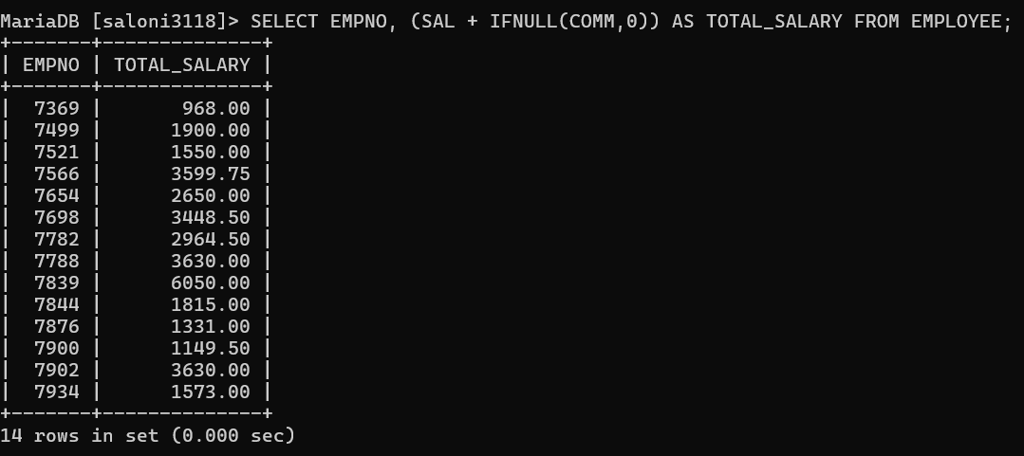

- Update the salary of each employee by 10% increment who are not eligible for commission.

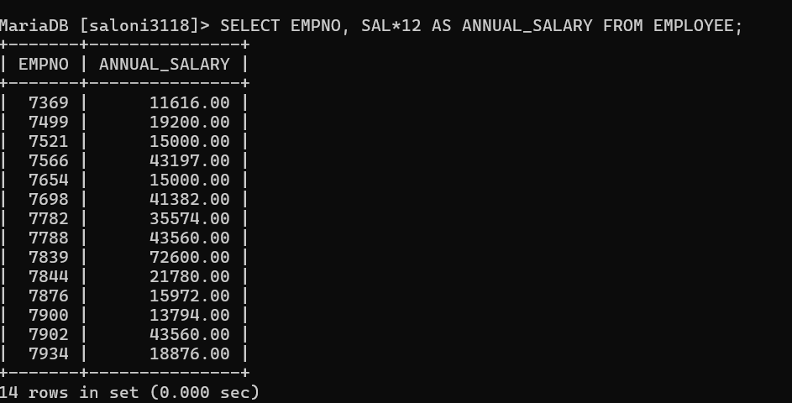

- Display those employees whose salary is more than 3000 after giving 20% increment.

- Display those employees whose salary contains atleast 3 digits.

