

Project Interim Report

On

File Compression Simulator (Using Core Java & OOP Concepts)
RU-100-01-00012
Object Oriented Programming with Java

SESSION: 2025-26

Submitted By Student name – Saloni Singh
Reg No.-
RU-25-11265

Bachelor of Technology in Computer Science & Engineering

Under the Guidance of Mr. Ashish Shivhare

SCHOOL OF COMPUTER SCIENCE AND ENGINEERING RUNGTA INTERNATIONAL SKILLS UNIVERSITY
BHILAI, CG

(April 2026)

Acknowledgement

I would like to express my sincere gratitude to my faculty members and Head of Department for their valuable guidance and support throughout the completion of this project.

I am also thankful to my college for providing the necessary resources and environment to successfully complete this work. I would like to extend my thanks to my mentors and classmates who helped me with their suggestions and encouragement.

Finally, I would like to thank everyone who directly or indirectly contributed to the successful completion of this project.

Abstract
The Contact Directory Management System is a Java-based application developed using Object-Oriented Programming (OOP) concepts to manage personal and professional contacts efficiently. In today’s digital world, maintaining organized contact information is essential for communication and productivity. This project provides a simple and effective solution to store, search, and delete contact details such as name and phone number.
The system uses a Contact class to represent individual contact entries and a Directory class to manage multiple contacts using arrays. It allows users to add new contacts, perform case-insensitive searches using .equalsIgnoreCase(), and delete contacts while maintaining data consistency through array element shifting.
This project is needed to reduce manual effort in managing contact lists and to demonstrate practical implementation of OOP concepts like encapsulation, class design, and data handling. Overall, the system provides a structured and efficient way to manage contacts while enhancing programming skills in Java.

Introduction
The Contact Directory Management System is designed to simplify the process of storing and managing contact information. Traditionally, contact management is done manually or through basic applications, which can be inefficient and difficult to maintain. This project provides a structured approach using Java and Object-Oriented Programming.
The system allows users to:
- Add new contacts
- Search contacts easily
- Delete unwanted contacts
- Display all stored contacts
The application is built using classes and arrays, making it efficient and easy to understand. It demonstrates key OOP concepts such as encapsulation, class interaction, and data abstraction. The use of case-insensitive search improves usability, while array manipulation ensures efficient deletion operations.

Scope
This project is suitable for managing small-scale contact lists such as personal directories. It can be extended in the future by:
- Adding database integration
- Creating a graphical user interface (GUI)
- Supporting additional fields like email and address
- Implementing sorting and filtering features

System Requirements
Hardware: Computer with 4GB RAM
Software: Java JDK, IDE (VS Code/Eclipse/Edit Plus)

Methodology
The system works in a step-by-step manner:
- User starts the program
- Menu is displayed with options (Add, Search, Delete, Display)
- User selects an operation
- Based on choice:
  - Add Contact: Stores contact in array
  - Search Contact: Compares names using .equalsIgnoreCase()
  - Delete Contact: Finds and removes contact, shifts array elements
  - Display Contacts: Shows all stored contacts
- Process repeats until user exits

Flowchart

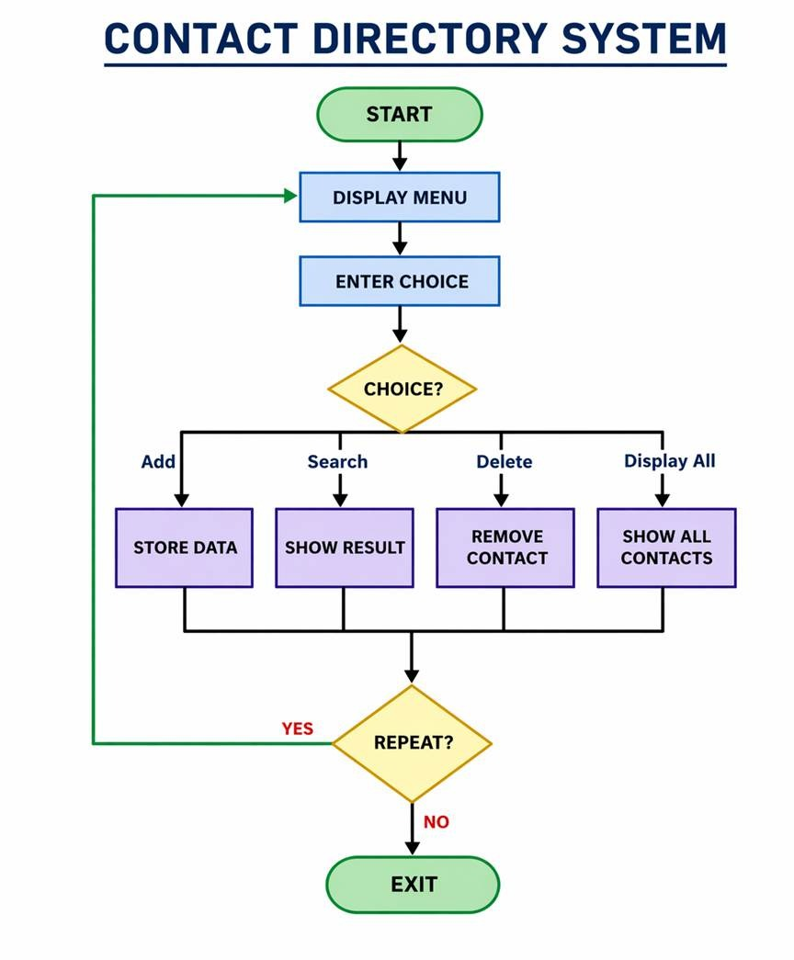

Class: Contact

Variables inside class:

name

phoneNumber

Methods inside class:

Contact(name, phoneNumber) → Constructor to initialize values

getName() → Returns name

getPhoneNumber() → Returns phone number

Class: Directory

Variables inside class:

Contact[] contacts (array to store multiple contacts)

int count (to track number of contacts)

Methods inside class:

addContact(name, phone) → Adds new contact

searchContact(name) → Searches contact using .equalsIgnoreCase()

deleteContact(name) → Deletes contact and shifts array

displayContacts() → Displays all contacts

Implementation
Contact Class
Stores individual contact details like name and phone number. Constructor initializes values and getter methods return them.
Directory Class
Manages multiple contacts using an array.
- addContact():
Adds new contact at next available position using contacts[count++].
- searchContact():
Loops through array and compares names using .equalsIgnoreCase().
- deleteContact():
Finds contact and shifts remaining elements to maintain continuity.
- displayContacts():
Prints all stored contacts using loop.

Gantt Chart
Task | Duration
Planning & Design | Day 1
Class Structure Design | Day 2
Coding | Day 3–4
Testing | Day 5
Documentation | Day 6

Conclusion
The Contact Directory Management System successfully demonstrates the use of Object-Oriented Programming in Java. It provides a simple and efficient way to manage contacts while implementing important concepts such as encapsulation, arrays, searching, and deletion logic. The project enhances programming skills and offers a base for further improvements.

References
[1] H. Schildt, Java: The Complete Reference, 11th ed. New York: McGraw-Hill, 2018.
[2] Oracle, "Java Documentation," Oracle. [Online]. Available: https://docs.oracle.com
[3] S. Kumar, "AI in Education," in Proc. IEEE Conf. on AI, 2021, pp. 120-125.
[4] A. Sharma and R. Gupta, "Machine Learning Techniques," International Journal of AI, vol. 5, no. 2, pp. 45-50, 2020.

