**SVKM’s NMIMS**

**School of Technology Management & Engineering, Chandigarh**

A.Y. 2023 - 24

**Course: Database Management Systems**

**Project Report**

|  |  |  |
| --- | --- | --- |
| Program | Btech. Computer Science and Business Systems (CSBS) | |
| Semester | 4 | |
| Name of the Project: | Movie Tracking System using Python and SQL | |
|  | | |
| Details of Project Members |  |  |
| Batch | Roll No. | Name |
| E2 | E044 | Saloni Sivakumar |
| E2 | E053 | Mansa Mohanty |
| E2 | E075 | Prarthana Subudhi |
| Date of Submission: | | |

**Contribution of each project Members:**

|  |  |  |
| --- | --- | --- |
| Roll No. | Name: | Contribution |
| 44 | Saloni Sivakumar | Tables creation,ER diagram,python code,writing report |
| 53 | Mansa Mohanty | SQL queries,python code, writing report |
| 75 | Prarthana Subudhi | SQL queries,python code,writing report |

**Github link :**

**https://github.com/saloniskumar/Movie_tracker**

**Project Report**

**Movie Tracking System using Python and SQL**

**by**

**Saloni Sivakumar, Roll number:44**

**Mansa Mohanty Roll number: 53**

**Prarthana Subudhi, Roll number: 75**

**Course: DBMS**

**AY: 2023-24**

**Table of Contents**

|  |  |  |
| --- | --- | --- |
| **Sr no.** | **Topic** | **Page no.** |
| **1** | Storyline | 4 |
| **2** | Components of Database Design | 5 |
| **3** | Entity Relationship Diagram | 6 |
| **4** | Relational Model | 6 |
| **5** | Normalization | 7 |
| **6** | SQL Queries | 8 |
| **7** | Learning from the Project | 17 |
| **8** | Project Demonstration | 16 |
| **9** | Self-learning beyond classroom | 17 |
| **10** | Challenges faced | 18 |
| **10** | Conclusion | 18 |

**I. Storyline**

**FUNCTIONAL REQUIREMENTS: -**

1. Movie tracking: As a user, I would like to be able to maintain a record of all my movies in my database and when I have added them.
2. Reviewing: As a user, I would want to give movies a rating of 1 to 10.
3. Classify Movies:-As a user, I would like to be able to sort my movies based on -Currently watching, to watch and already watched.
4. Sort and search movies: As a user,I wish to sort my list based on rating and search movies using movie title, actors, etc
5. View Movie Description: As a user, I wish to automatically see a movie’s description by just searching it’s title
6. Privacy: As a user,I would want my database to be accessible only by me

**NON-FUNCTIONAL REQUIREMENTS:**

**AS A USER: -**

1. Loading time: As a user, I want the application to load as fast as possible
2. Privacy: As a user, I want to control what information about me is accessible to other people..
3. Compatibility: As a user, I would want to run the application in both IOS and Android devices
4. Space: As a user, I would want the application to take less amount of storage on my device

**AS A DEVELOPER: -**

1. Cost and Security: As a developer, I would want every user's data to be safe and secure
2. Performance: As a developer, I want my application to load in less than two seconds and have a quick response time.
3. Scalability: In my capacity as a developer, I want my application to support millions of people worldwide.

**SYSTEM REQUIREMENTS-**

1. Hardware: 64-bit operating system,8 GB RAM,12th Gen Intel(R) Core(TM) i5-12500T
2. Software: uninterrupted access to IMDB APIs,MySQL workbench(DBMS)

**II. Components of Database Design**

|  |  |  |  |
| --- | --- | --- | --- |
| Name of entity | List of Attributes | Primary Key | Cardinality & Participation |
| User_account | User_id,User_name,User_password,User_bio | User_id | 1-1 with Already_watched  To_watch  Currently_watching  1-M with Explore_movies,Rating_review |
| Already_watched | Movie_ID,Movie_title,Movie_genre,  Movie_release date, Movie_rating | Movie_ID | 1-1 with User_account |
| To_watch | Movie_ID,Movie_title,Movie_genre,  Movie_release date, Movie_rating | Movie_ID | 1-1 with User_account |
| Currently_watching | Movie_ID,Movie_title,Movie_genre,  Movie_release date, Movie_rating | Movie_ID | 1-1 with User_account |
| Explore_movies | Movie_ID, Movie_title,Movie_Genre,  Movie_release_date , Movie_director,  Movie_earning,Movie_actor | Movie_ID | M-1 with User_account  1-1 with Rating_review |
| Rating_review | Movie_ID,Movie_user_rating,  Movie_imdb_rating | Movie_ID | M-1 with User_account  1-1 with Explore_movies |

**III. Entity Relationship Diagram**

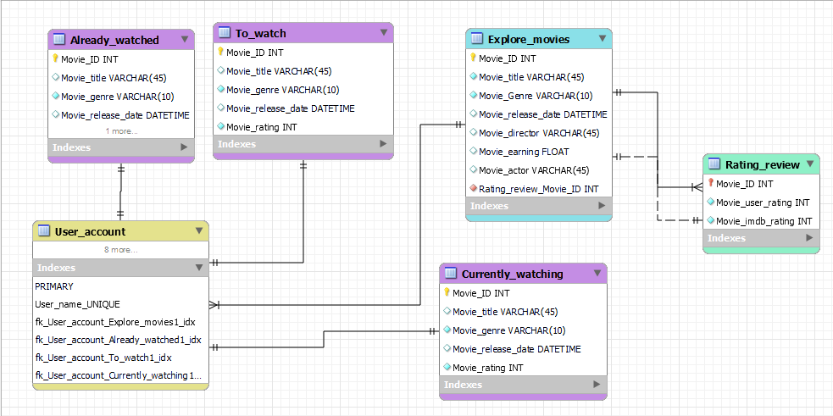

**IV. Relational Model**

CREATE DATABASE project;

use project;

CREATE TABLE Explore_movies (

Movie_ID INT NOT NULL,

Movie_title VARCHAR(45) NOT NULL,

Movie_Genre VARCHAR(10) NOT NULL,

Movie_release_date DATETIME NOT NULL,

Movie_director VARCHAR(45) NOT NULL,

Movie_earning FLOAT NULL,

Movie_actor VARCHAR(45)NOT NULL,

Rating_review_Movie_ID INT NOT NULL,

PRIMARY KEY ( Movie_ID )

);

CREATE TABLE Rating_review (

Movie_ID INT NOT NULL,

Movie_user_rating INT NOT NULL,

Movie_imdb_rating INT NOT NULL,

PRIMARY KEY (Movie_ID),

FOREIGN KEY (Movie_ID)

REFERENCES Explore_movies(Movie_ID)

);

CREATE TABLE Already_watched (

Movie_ID INT NOT NULL,

Movie_title VARCHAR(45) UNIQUE,

Movie_genre VARCHAR(10) NOT NULL,

Movie_release_date DATETIME NOT NULL,

Movie_rating INT NOT NULL,

PRIMARY KEY ( Movie_ID )

);

CREATE TABLE To_watch (

Movie_ID INT NOT NULL,

Movie_title VARCHAR(45) UNIQUE,

Movie_genre VARCHAR(10) NOT NULL,

Movie_release_date DATETIME NOT NULL,

Movie_rating INT NOT NULL,

PRIMARY KEY ( Movie_ID )

);

CREATE TABLE Currently_watching (

Movie_ID INT NOT NULL,

Movie_title VARCHAR(45) NOT NULL,

Movie_genre VARCHAR(10) NOT NULL,

Movie_release_date DATETIME NOT NULL,

Movie_rating INT NOT NULL,

PRIMARY KEY ( Movie_ID )

);

CREATE TABLE User_account (

User_id INT NOT NULL,

User_name VARCHAR(45) UNIQUE,

User_password VARCHAR(45) NOT NULL,

User_bio VARCHAR(100) NOT NULL,

PRIMARY KEY ( User_id)

);

**V. Normalization**

Not applicable as already in 3NF

**VI. SQL Queries**

use project;  
insert into to_watch (Movie_ID,movie_title,Movie_genre,Movie_release_date,Movie_rating) values ('2','3 idiots','comedy','1999-03-11','8.1');  
insert into to_watch (Movie_ID,movie_title,Movie_genre,Movie_release_date,Movie_rating) values ('3','knives out','mystery','2019-11-21','8.7');  
  
update to_watch set movie_rating=7 where movie_genre='Sci-fi';  
  
delete from to_watch where movie_rating='8';  
  
start transaction;  
update to_watch set Movie_title='knives out 2' where Movie_ID='3';  
rollback;  
  
select count(*)as number_of_movies from to_watch;  
select * from to_watch order by Movie_title desc;  
alter table to_watch modify column Movie_rating float(10);  
insert into to_watch (Movie_ID,movie_title,Movie_genre,Movie_release_date,Movie_rating) values ('4','searching','mystery','2018-06-21','7.6'),  
('5','rush hour','action','1998-09-17','6.7'),  
( '6','hera pheri','comedy','2000-03-31','8.2'),  
('7','interstellar','Sci-fi','2014-11-07','8.7');  
select * from to_watch;  
select * from to_watch where Movie_rating <9 and  Movie_title like "%r";  
select Movie_genre,count(movie_title) from to_watch group by Movie_genre;  
  
alter table already_watched modify column Movie_rating float(10);  
insert into already_watched (Movie_ID,movie_title,Movie_genre,Movie_release_date,Movie_rating) values ('1','3 Idiots','comedy','1999-03-11','8.1');  
insert into already_watched (Movie_ID,movie_title,Movie_genre,Movie_release_date,Movie_rating) values ('2','Knives out','mystery','2019-11-21','8.7');  
insert into already_watched (Movie_ID,movie_title,Movie_genre,Movie_release_date,Movie_rating) values ('3','Interstellar','Sci-fi','2014-11-07','8.7');  
insert into already_watched (Movie_ID,movie_title,Movie_genre,Movie_release_date,Movie_rating) values ('4','Dune','Sci-fi','2024-03-15','8.0');  
insert into already_watched (Movie_ID,movie_title,Movie_genre,Movie_release_date,Movie_rating) values ('5','Your name','Romance','2017-04-07','8.8');  
insert into already_watched (Movie_ID,movie_title,Movie_genre,Movie_release_date,Movie_rating) values ('6','How to Train Your Dragon','Fantasy','2010-04-16','8.1');  
  
select * from already_watched;  
update already_watched set Movie_rating=8.1 where Movie_ID=1;  
update already_watched set Movie_rating=8.7 where Movie_ID=2;  
update already_watched set Movie_rating=8.7 where Movie_ID=3;  
update already_watched set Movie_rating=8.0 where Movie_ID=4;  
update already_watched set Movie_rating=8.8 where Movie_ID=5;  
update already_watched set Movie_rating=8.1 where Movie_ID=6;  
select * from already_watched;  
  
select * from already_watched inner join to_watch on already_watched.Movie_title=to_watch.Movie_title;  
select * from already_watched left join to_watch on already_watched.Movie_title=to_watch.Movie_title;  
select * from already_watched right join to_watch on already_watched.Movie_genre=to_watch.Movie_genre;  
select * from already_watched union select * from to_watch;  
select * from already_watched intersect select * from to_watch;  
select * from already_watched except select * from to_watch;  
  
alter table currently_watching modify column Movie_rating float(10);  
insert into currently_watching (Movie_ID,movie_title,Movie_genre,Movie_release_date,Movie_rating) values ('1','Bullet train','Action','2022-08-05','7.3');  
insert into currently_watching (Movie_ID,movie_title,Movie_genre,Movie_release_date,Movie_rating) values ('2','Fight club','Thriller','1999-10-15','8.8');  
insert into currently_watching (Movie_ID,movie_title,Movie_genre,Movie_release_date,Movie_rating) values ('3','The conjuring','Horror','2013-08-02','7.5');  
insert into currently_watching (Movie_ID,movie_title,Movie_genre,Movie_release_date,Movie_rating) values ('4','Scary Movie','Comedy','2013-08-02','6.3');  
insert into currently_watching (Movie_ID,movie_title,Movie_genre,Movie_release_date,Movie_rating) values ('5','The karate kid','Teen drama','2010-07-11','6.2');  
insert into currently_watching (Movie_ID,movie_title,Movie_genre,Movie_release_date,Movie_rating) values ('6','Kabhi khushi kabhi gham','Musical','2001-12-14','7.4');  
  
select max(Movie_rating)  
from currently_watching;  
  
select min(Movie_rating)  
from currently_watching;  
  
select avg(Movie_rating) from currently_watching;  
  
select * from to_watch;  
  
 select mid(Movie_title,2,3) from currently_watching;  
 select round(Movie_rating,2) from to_watch;  
   
 select Movie_genre from to_watch group by Movie_genre having avg(Movie_rating)>7.2;  
   
select sum(Movie_rating) from currently_watching;  
  
select movie_id,now() as date_and_time from already_watched;  
  
select Movie_title,length(Movie_title) from currently_watching;

**Outputs:**

1. **Display to_watch:**

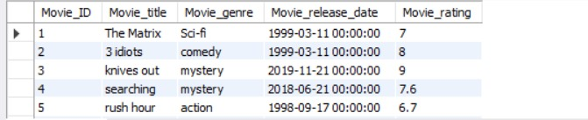

1. **Display already_watched:**

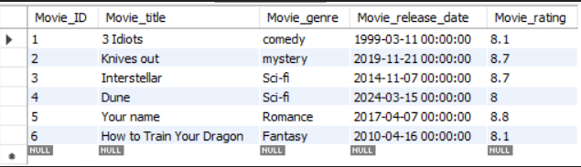

1. **Display currently_watching:**

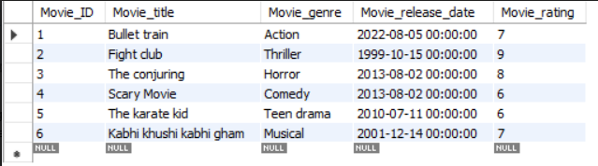

1. **Change movie rating to 7 where genre="Sci-fi":**

update to_watch set movie_rating=7 where movie_genre='Sci-fi';  
**select * from to_watch;**

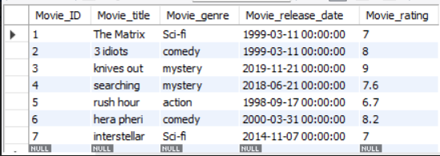

1. **Delete movie where movie_rating="8":** delete from to_watch where movie_rating='8';

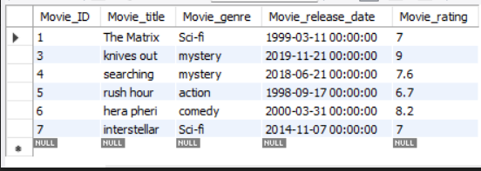

1. **Undo the changes using rollback:**

start transaction;  
update to_watch set Movie_title='knives out 2' where Movie_ID='3';

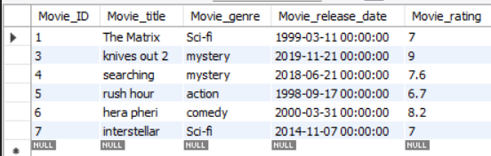

rollback;  
select * from to_watch;

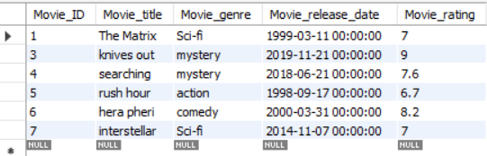

1. **Count the number of movies in to_watch:**

select count(*)as number_of_movies from to_watch;



1. **Sort Movie title in descending  order:** select * from to_watch order by Movie_title desc;

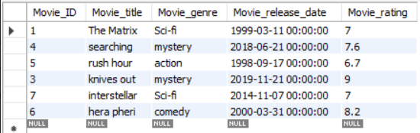

1. **Select movies from to_watch where movie rating is greater than 9 and movie name ends with "r":**

select * from to_watch where Movie_rating <9 and  Movie_title like "%r";

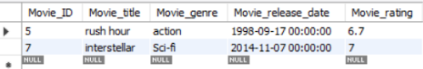

1. **Count movie_title according to genre:** select Movie_genre,count(movie_title) from to_watch group by Movie_genre;

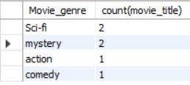

1. **Perform natural join:**

select * from already_watched inner join to_watch on already_watched.Movie_title=to_watch.Movie_title;



1. **Perform left join:**

select * from already_watched left join to_watch on already_watched.Movie_title=to_watch.Movie_title;

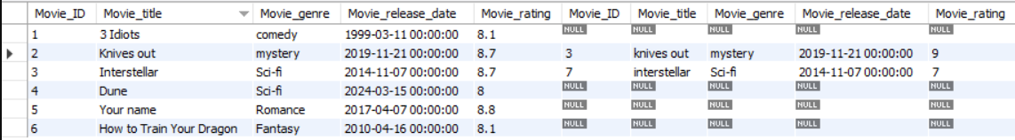

1. **Perform right join:**

select * from already_watched right join to_watch on already_watched.Movie_genre=to_watch.Movie_genre;

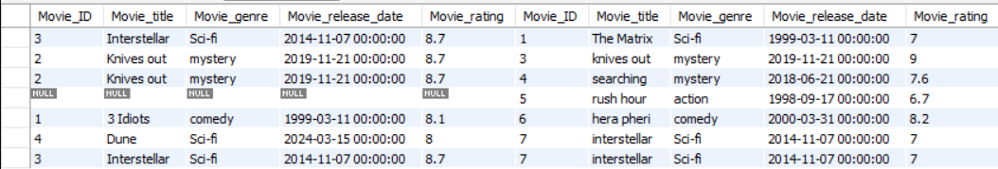

1. **Perform union operation:**

select * from already_watched union select * from to_watch;

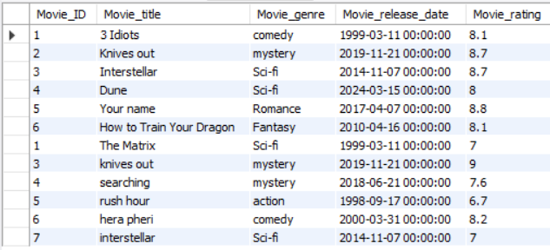

1. **Perform intersection operation:**

select * from already_watched intersect select * from to_watch;



1. **Perform set difference operation:**

select * from already_watched except  select * from to_watch;

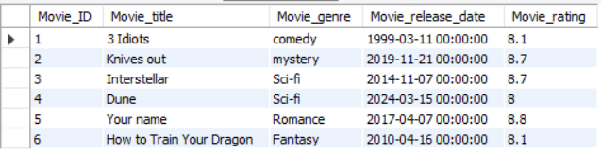

1. **Select maximum rating from table:**

select max(Movie_rating)  
from currently_watching;



1. **Select minimum rating from table:**

select min(Movie_rating)  
from currently_watching;



1. **Select a substring starting from 2nd position with a length of 3:**

select mid(Movie_title,2,3) from currently_watching;

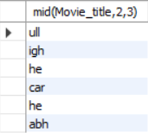

1. **Round Movie_rating till 2 decimals:**

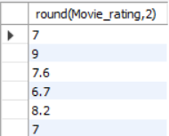

1. **Select genre from table where average rating is more than 7.2:**

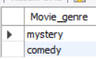

1. **Show the sum of movie_ratings :**



1. **Perform Now() function**

select movie_id,now() as date_and_time from already_watched;

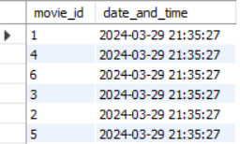

1. **Show length of movie titles:**

select Movie_title,length(Movie_title) from currently_watching;

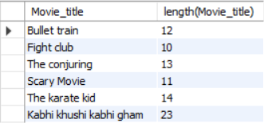

**VI. Project demonstration**

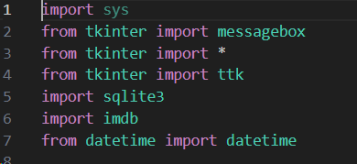 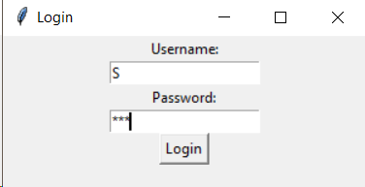

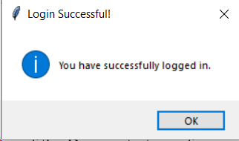 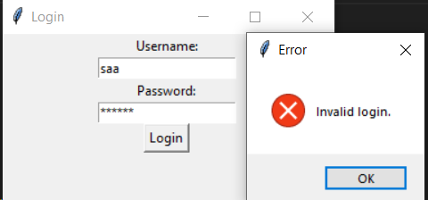

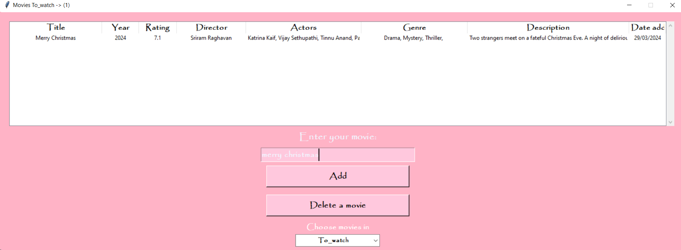

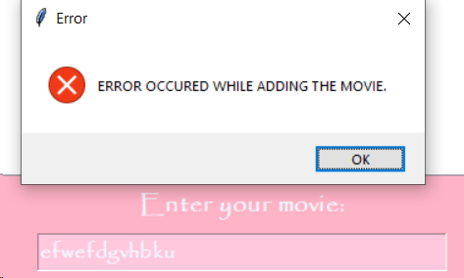

The project was made using Python(tkiner) and SQL.

Only after user’s username and password are correct login is successful and the movie tracker application will open. User can select from 3 lists-To_watch,Already_watched and currently_watching using the drop down list. User can enter the title of a movie of their choice and click ‘Add’. If the movie exists in the IMDB database then it’s successfully added in the respective list along with it’s description. If the movie doesn’t exist in the IMDB database or if the system doesn’t have uninterrupted access to the IMDB database then an error is shown to the user. User can only add a movie once to a list. The user can select any movie from the list and click on the ‘Delete a movie’ button to delete that particular movie.

**VII. Self -Learning beyond classroom**

In working on the DBMS project and engaging with MySQL, I explored several new aspects beyond classroom teachings.

* Real-world Constraints: Working on a project outside of the controlled environment of a classroom exposed me to the complexities of the real-world scenarios.
* Transaction Management: Understanding how to ensure data consistency and integrity through proper transaction management was a valuable skill that I honed through hands-on experience.
* Advanced SQL Queries: While I was familiar with basic SQL queries, I expanded my knowledge by exploring more advanced query functionalities such as subqueries, joins, and aggregate functions,etc.
* Error Handling and Debugging: I learned to identify common errors, diagnose issues effectively which provided valuable insights into troubleshooting techniques.

Overall, working on the movie tracker project allowed me to apply and expand upon the theoretical knowledge gained in the classroom

**VIII. Learning from the Project**

* Working on the movie tracker project in MySQL has been a valuable learning experience that has significantly enhanced my database management skills.
* By creating the database schema, ER diagram, and implementing various SQL queries including, DDL commands, DML commands, transactions, aggregate functions, etc I gained hands-on experience in database design and manipulation.
* Solving real-world queries improved my problem-solving abilities and deepened my understanding of data retrieval and manipulation techniques. I learned to analyze requirements, identify potential issues, and devise effective solutions to ensure the efficiency and integrity of the database.
* Collaborating with team members on the project enhanced my communication and teamwork skills. We discussed database schema designs, resolved conflicts, and coordinated tasks to ensure the successful completion of the project.

**IX. Challenges Faced**

* Database Performance: Ensuring optimal database performance while handling a large volume of movie data, queries, and user interactions to maintain responsiveness and efficiency.
* Database Management: Handling database operations such as storing, retrieving, and updating movie data efficiently in MySQL while ensuring data integrity and performance.
* Safe Mode Limitations: Overcoming challenges related to safe mode restrictions that initially prevented updating or deleting movies, requiring adjustments to database configurations for full functionality.
* Compatibility Issues: Ensuring compatibility between the database management system (MySQL) and the chosen GUI framework or tool (Tkinter) was crucial. Ensuring seamless interaction and data exchange between the database and GUI components required careful consideration of compatibility issues.

**X. Conclusion**

* Practical application of database concepts.
* Enhanced problem-solving skills.
* Understanding of query optimization techniques.
* Improved collaboration and communication abilities.
* Proficiency in error handling and debugging.
* Development of project management skills.
* Emphasis on continuous learning and adaptation.

Overall, the project provided valuable hands-on experience and prepared me for challenges in database management and software engineering.