Q1.

Sol:
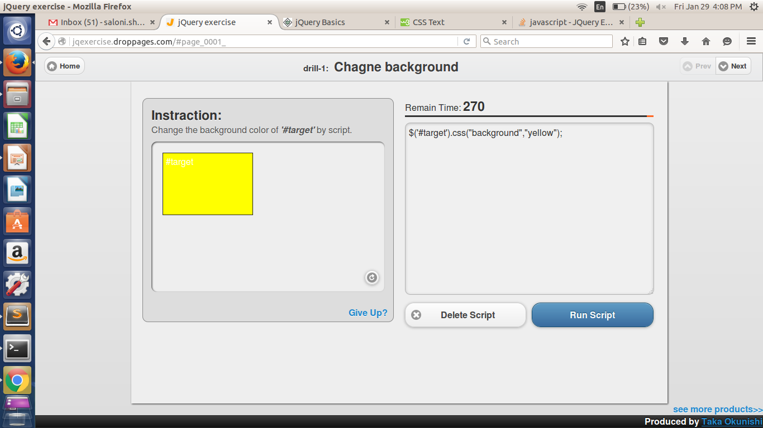

Q2.

Sol:

Q3.

Sol : var el=$('div#target span').clone();
$('div').prepend(el);

Q4.

Sol: $('div.target:eq(1)').css("background","red");

Q5.

Sol: $(':button').attr("disabled","true");

Q6.

Sol: $(':checkbox').attr("checked",false);

Q7.

Sol: $('#child').prependTo('#parent2');

Q8.

Sol: $(':text').attr("readonly",true);

Sol:

Q10.

Sol: var w=parseInt($("#target").css('width'));
var h=parseInt($("#target").css('height'));
var w1=2*w;
var h1=2*h;
$('#target').css({"width":w1+"px","height":h1+"px"});

