Solution to Optimal Power flow by Differential Evolution
RMS Danaraj
salorajan@gmail.com
1. Introduction
.
Optimal Power flow (OPF) is allocating loads to plants for minimum cost while meeting the network constraints. It is formulated as an optimization problem of minimizing the total fuel cost of all committed plant while meeting the network(power flow ) constraints. The variants of the problems are numerous which model the objective and the constraints in different ways.
The basic OPF problem can described mathematically as a minimization of problem of
Minimizing the total fuel cost of all committed plants subject to the constraints.
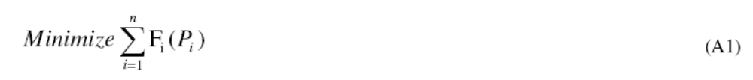
F( P_{i}) is the fuel cost equation of the ‘i’th plant. It is the variation of fuel cost ($ or Rs) with generated power (MW).Normally it is expressed as continuous quadratic equation.

The total generation should meet the total demand and transmission loss. The transmission loss can be determined from power flow.
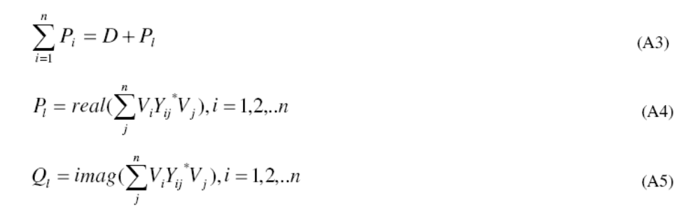

2. Solution to Optimal Power flow by Differential Evolution
1. Collect the busdata,line data and cost coefficients and their limits.
2. Convert the constrained optimization problem as an unconstrained problem by penalty
function method.
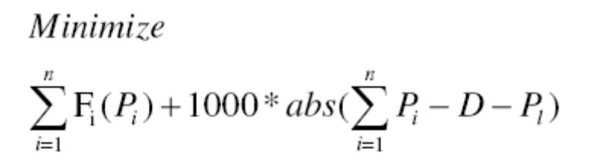= =
3. This software contain two case studies. The first one is the ieee 30 bus system This can be simulated by running the file deopf30.m. The other case study is the ieee 26 bus system.It is the example from Hadi sadaat example 7.11.This can be solved by running the file deopf26.m

4.The file .opf2.m is a function file which returns the fuel cost, voltage ,Generation, and transmission loss. Pflow.m is the power flow routine
5. I am using the differential evolution toolbox developed by Mr. Dipl.-Ing. Markus Buehren Stuttgart, Germany(mb_matlab@gmx.de, http://www.markusbuehren.de )My sincere thanks to him for this efficient toolbox.

6. Change your default folder as deopf. Just run deopf26 or deopf30 to simulate the opf. The results will be displayed on the command window. This is the simulation result of ieee 30 bu system.
Iteration: 180, Best: 801.843596, F: 0.800000, CR: 0.800000, NP: 20
best(1) = 48.830058
best(2) = 21.473815
best(3) = 21.648141
best(4) = -12.093687
best(5) = 2.783315
Iteration: 190, Best: 801.843596, F: 0.800000, CR: 0.800000, NP: 20
best(1) = 48.830058
best(2) = 21.473815
best(3) = 21.648141
best(4) = -12.093687
best(5) = 2.783315
Elapsed time is 52.556025 seconds.
F1 = 801.8436
PP = 176.7303 48.8301 21.4738 21.6481 12.0937 12.0000
vv = Columns 1 through 12
1.0600 1.0430 1.0254 1.0171 1.0100 1.0148 1.0050 1.0100 1.0530 1.0467 1.0820 1.0599
Columns 13 through 24
1.0710 1.0450 1.0402 1.0471 1.0415 1.0304 1.0277 1.0317 1.0345 1.0350 1.0296 1.0237
Columns 25 through 30
1.0203 1.0027 1.0269 1.0128 1.0071 0.9957

ALL THE BEST

