Test0

Technical Mathematics Test Document
This document demonstrates and tests mathematical equations spanning both Algebra and Calculus, rendered using three distinct dialects: LaTeX, Typst typeset, and SymPy.

Skip to H3: Algebra Equations
Below are five algebra-themed equations.
- LaTeX (Algebra 1): The expansion of a binomial squared.
$$(a+b)^{2}=a^{2}+2ab+b^{2}$$
- LaTeX (Algebra 2): The quadratic formula to solve $ax^{2}+bx+c=0$ in fraction format.
$$x=\frac{−b±\sqrt{b^{2}−4ac}}{2a}$$
- SymPy (Algebra 3): Factoring the difference of two squares.
$$a^{2}−b^{2}=\left(a−b\right)\left(a+b\right)$$
- Typst (Algebra 4): The logarithmic product rule.
$$\log_{b(xy)}=\log_{b(x)}+\log_{b(y)}$$
- SymPy (Algebra 5): The determinant of a $2×2$ matrix.
$$ad−bc=ad−bc$$

Skip to H3: Calculus Equations
Below are five calculus-themed equations.
- LaTeX (Calculus 1): The fundamental trigonometric limit.
$$\lim_{x→0}\frac{sinx}{x}=1$$
- Typst (Calculus 2): The Fundamental Theorem of Calculus.
$$\int_{a}^{b}{f}(x)dx=F(b)−F(a)$$
- LaTeX (Calculus 3): The derivative of the natural exponential function.
$$\frac{d}{dx}(e^{x})=e^{x}$$
- Typst (Calculus 4): The solution to the Basel problem.
$$\sum_{n=1}^{∞}{\frac{1}{n^{2}}}=\frac{π^{2}}{6}$$
- SymPy (Calculus 5): Derivative of the sine function.
$$cos\left(x\right)=cos\left(x\right)$$

Visual Representation
Here is a graph visualising some of the functions:
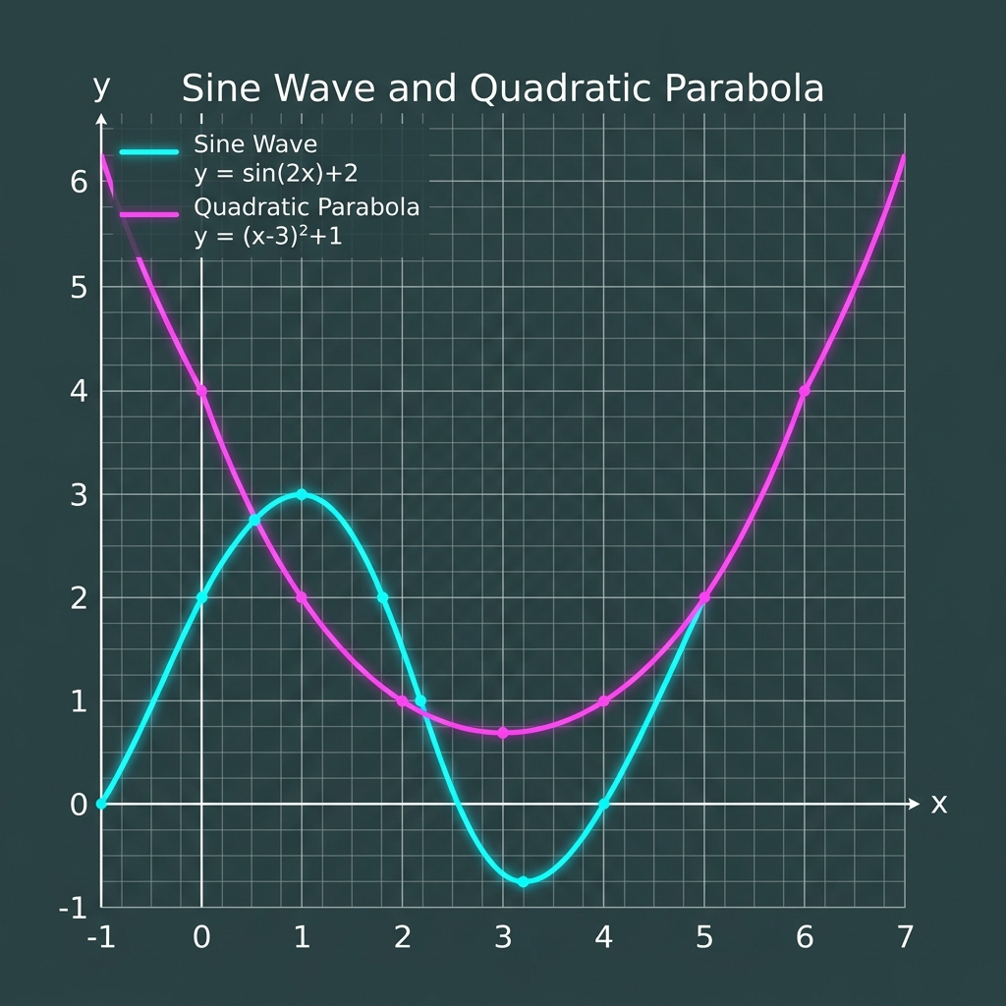
this image in this 49 is not alt text . put it

Tabular Data (Inaccessible Layout)
 | Value A | Value B
Row 1 | 12.5 | 14.2 | 19.1
Row 2 | 10.1 | 9.8
Row 3 | 22.0

