Customer Churn Prediction System
A Scientific Reproducibility Study Based on a Machine Learning Approach

Methodology : CRISP-DM

Prepared by: Yorna Salouej
Rayen Samaali
Yassin Raihi

Academic Year
2025 – 2026

Table of Contents
General Introduction 5
Chapter 1: General context of the project 6
1. Introduction*** 6
1.1 Customer Churn in the Telecom Industry 6
1.2 Problem Statement 6
1.3 Objectives of the Study 7
1.4 Scientific Reproducibility Perspective 7
1.5 Report Organization 8
Chapter 2 : Business Understanding 9
2. Business Understanding (CRISP-DM – Phase 1) 9
2.1 Business Objectives 9
2.2 Data Mining Objectives 9
2.3 Success Criteria 9

List of Figures

List of Tables

List of Acronyms

GSA
AUC

General Introduction

Chapter 1: General context of the project

Introduction*

Customer Churn in the Telecom Industry
Customer churn refers to the phenomenon where customers discontinue their subscription or switch from one service provider to another. In the telecommunications industry, churn has become a major concern due to the rapid growth of competition and the increasing number of service providers in the market. As highlighted in the reference article, customer retention is significantly less costly than acquiring new customers, making churn management a strategic priority for telecom companies.
The business impact of customer churn is substantial, as it directly affects revenue, market share, and long-term profitability. Customer dissatisfaction, particularly related to service quality and customer support, is identified as one of the primary drivers of churn. Consequently, the ability to accurately identify customers who are at risk of leaving allows companies to design effective retention strategies and improve customer loyalty. With the availability of large volumes of customer data, data-driven approaches have become essential for understanding customer behavior and predicting churn patterns.

Problem Statement
Customer churn prediction is formulated as a binary classification problem, where customers are categorized as either churners or non-churners. The main challenge lies in accurately modeling customer behavior using historical data in order to detect early signals of churn. Traditional churn management approaches can be classified into two categories: reactive and proactive.
In a reactive approach, companies wait until a customer submits a cancellation request before taking action, often by offering incentives or promotional plans to retain the customer. In contrast, a proactive approach aims to predict the likelihood of churn in advance and take preventive measures accordingly. As emphasized in the article, proactive churn prediction is more effective, as it enables companies to intervene before customers decide to leave. Machine learning techniques have proven to be particularly suitable for this task due to their ability to learn complex patterns from historical data and provide accurate predictive insights.

Objectives of the Study
This figure summarizes the main objectives of the study, highlighting the scientific reproducibility analysis, the replication of the experimental pipeline, and the proposed methodological improvements, including customer segmentation and the integration of explainable AI techniques.

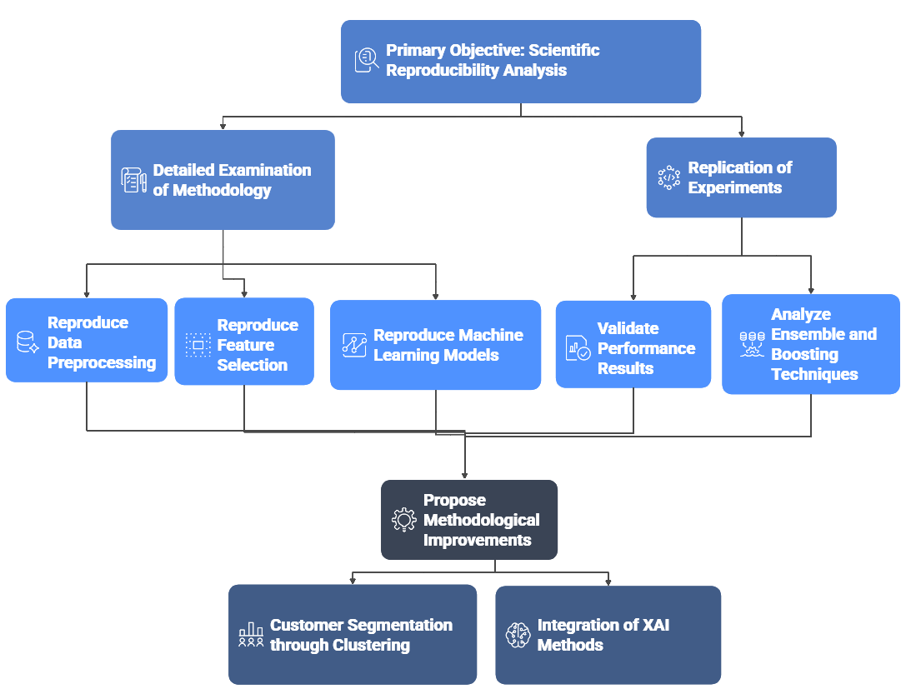
Overview of the Study Objectives and Reproducibility Framework

Scientific Reproducibility Perspective
Scientific reproducibility is a fundamental principle in data science and machine learning research. It ensures that published results can be independently verified and that conclusions are reliable and transparent. In the context of customer churn prediction, reproducibility is particularly important, as business decisions based on predictive models must be trustworthy and robust.
This study focuses on reproducing the complete experimental pipeline described in the reference article, including data understanding, preprocessing, feature selection using the Gravitational Search Algorithm (GSA), model training, and evaluation. The scope of reproduction covers the dataset structure, machine learning algorithms, experimental setup, and performance metrics such as accuracy, precision, recall, F-measure, and AUC. Any deviations between the reproduced results and the original findings are carefully analyzed and discussed.

Report Organization
This figure illustrates the overall organization of the report, outlining the progression of chapters aligned with the CRISP-DM methodology, from business understanding to deployment considerations and future work.

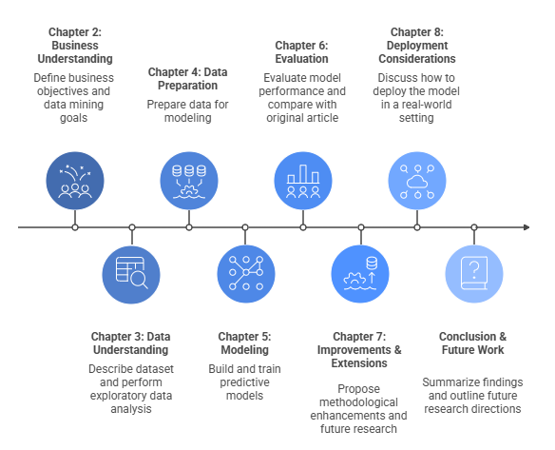
Structure and Organization of the Report Based on the CRISP-DM Methodology

Conclusion
Ajouter des citations IEEE / Springer

Chapter 2 : Business Understanding
Introduction

Business Understanding (CRISP-DM – Phase 1)

Business Objectives
- Customer retention and churn reduction
- Value of churn prediction systems

Data Mining Objectives
- Predict customer churn (Yes / No)
- Compare multiple machine learning models

Success Criteria
- Business success criteria
- Technical metrics: Accuracy, Recall, Precision, F-Measure, AUC

Conclusion

3. Data Understanding (CRISP-DM – Phase 2)
3.1 Dataset Description
- Dataset source (telecommunication churn dataset)
- Number of instances and attributes
- Target variable: Churn
3.2 Feature Description
- Categorical vs numerical features
- Feature types (as in the article)
3.3 Initial Data Exploration
- Class distribution
- Missing values analysis
- Class imbalance discussion
3.4 Exploratory Data Analysis (EDA)
- Distribution of numerical variables
- Categorical features vs churn
- Key visualizations reproduced from the article
3.5 Insights from Data Understanding

4. Data Preparation (CRISP-DM – Phase 3)
4.1 Data Cleaning
- Handling missing values
- Removing irrelevant attributes
4.2 Data Transformation
- Encoding categorical variables
- Feature scaling
4.3 Feature Selection Strategy
- Univariate feature selection
- Gravitational Search Algorithm (GSA)
- Fitness function and selection criteria
4.4 Handling Class Imbalance
- Resampling strategy used in the article
4.5 Final Prepared Dataset

5. Modeling (CRISP-DM – Phase 4)
5.1 Reproduced Machine Learning Models
- Logistic Regression
- Naive Bayes
- Support Vector Machine (Linear, Polynomial)
- Decision Tree
- Random Forest
- Extra Trees
5.2 Ensemble and Boosting Techniques
- AdaBoost
- XGBoost
- CatBoost
5.3 Experimental Setup
- Train/Test split (80% / 20%)
- Reproducibility settings
5.4 Cross-Validation
- k-Fold Cross Validation (k = 5)
- Hyperparameter tuning

6. Evaluation (CRISP-DM – Phase 5)
6.1 Evaluation Metrics
- Confusion Matrix
- Accuracy
- Precision
- Recall
- F-Measure
6.2 AUC and ROC Curve Analysis
- ROC curves for all models
- AUC score comparison
6.3 Reproduced Results
- Performance tables
- Comparison with article results
6.4 Discussion on Results
- Best performing models
- Effect of ensemble learning
- Observed deviations (if any)

7. Proposed Improvements and Extensions
7.1 Clustering for Customer Segmentation
- Motivation
- Clustering algorithms (K-Means / Hierarchical)
- Insights gained
7.2 Explainable AI (XAI)
- Importance of interpretability
- Feature importance analysis
- SHAP or LIME explanations
7.3 Comparative Analysis
- Original vs enhanced approach

8. Deployment Perspective (CRISP-DM – Phase 6)
8.1 Potential Business Deployment
- Integration into telecom decision systems
8.2 Limitations of the Study
- Dataset limitations
- Model assumptions
8.3 Ethical and Responsible AI Considerations

9. Conclusion and Future Work
9.1 Summary of Reproducibility Findings
9.2 Key Lessons Learned
9.3 Future Research Directions

References
- Lalwani et al. (2021)
- Additional academic sources

Appendices
Appendix A: Notebooks Description
Appendix B: Hyperparameters
Appendix C: Additional Figures and Tables

