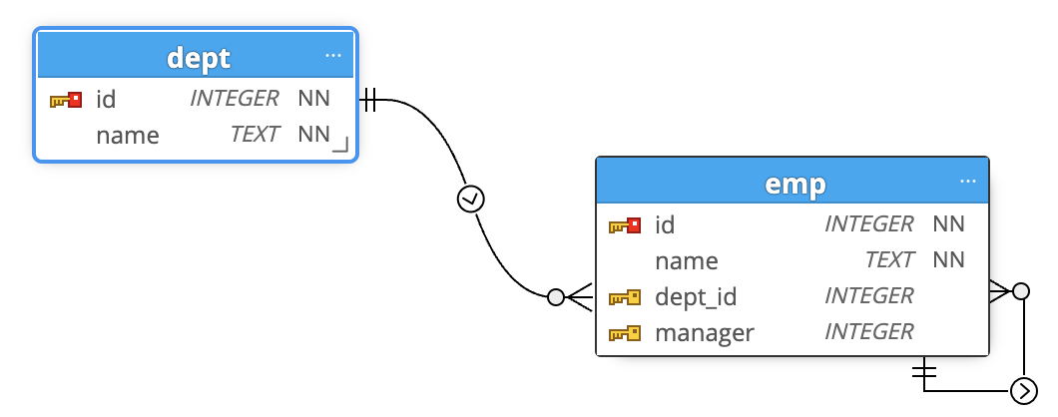

|  |  |  |
| --- | --- | --- |
| 1 | GET | / |
| 2 | GET | /emp |
| 3 | GET | /dept |
| 4 | GET | /add_emp |
| 5 | GET | /add_dept |
| 6 | GET | /update_emp/:id |
| 7 | GET | /update_dept/:id |
| 8 | GET | /delete_emp/:id |
| 9 | GET | /delete_dept/:id |
|  |  |  |
| 10 | POST | /add_emp |
| 11 | POST | /add_dept |
| 12 | POST | /update_emp |
| 13 | POST | /update_dept |

https://github.com/salrehaili/IS345_Fall2023/tree/main/lab11