ER Model

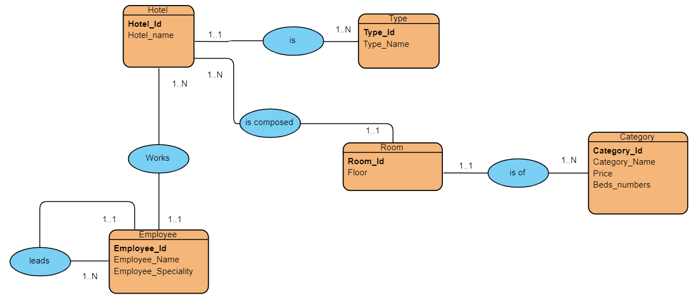

Diagram Model

Hotel(**Hotel_id**, Hotel_name, #Type_id)

Type (**Type_id**, Type_Name)

Room (**Room_id**,Floor, #Hotel_id, #Category_id)

Category(**Category_id**,Category_Name, Price, Beds_Numbers)

Employee(**Employee_id**, Employee_Name,Employee_Speciality, #Hotel_id, #leader_id)