**ANALYSIS AND DESIGN OF   
Call A Doc**

This report was made to complete a big project of

Programming Web Courses



Created by:

1. Salsabilla Rinaldi 1301184463
2. Aldilla Rafi 1301184425
3. Azka Jauhary 1301184439
4. Faisal Adly 1301184438
5. Rafly Mizalfi 1301180502

**BACHELOR OF INFORMATICS**

**SCHOOL OF COMPUTING**

**TELKOM UNIVERSITY**

**BANDUNG**

**2020**

# TABLE OF CONTENTS

TABLE OF CONTENTS i

LIST OF FIGURES ii

LIST OF TABLES iii

CHAPTER I Introduction 4

1.1. About Web 4

1.2. Limitation of Work 4

1.2.1. Pages are Built 4

1.2.2. CRUD Pages 5

1.3. Job Description 5

CHAPTER II Analysis and Design 6

2.1. Business process 6

2.2. Designing Entity Relationship Diagrams 6

2.3. *Use case Diagram* and *Use case Scenario* 7

2.3.1. *Use case Diagram* 7

2.3.2. *Use case Scenario* 8

CHAPTER III Implementation Results 13

# LIST OF FIGURES

# LIST OF TABLES

# CHAPTER I Introduction

## About Web

*Call A Doc* is an Application / Software that is accessed using web browser through a network such as the internet. This Application is made to facilitate customers who want to consult to Doctor or buy a medicine. Customers only need to register an account and login to access the Application. Then customers can choose the menu wether to consult to doctor, or buy a medicine. In Consult to Doctor menu, customers can consult to doctor by email, In buy medicine menu, Customers can choose and buy the available medicine. For the payment method it can be pay by COD (Cash On Delivery) to Courier or can be pay by Transfer Bank.

The reason why the *Call A Doc* website becomes the topic of the final project because the virus pandemic is currently occurring all over the world, with a call doc we can consult easily and buy the medicine without leaving home

## Limitation of Work

There are the explanation of the limitation of this website.

### Pages are Built

|  |  |  |
| --- | --- | --- |
| **No.** | **Pages** | **Explanation** |
| 1. | Create Account | Create Account used by Customers to create the account for access the website |
| 2. | Login | Login is used by Customers, Admin, and Doctor to Log in for access the website |
| 3. | Ask Doctor | Ask Doctor used by Customers to consult to the doctor by chat. |
| 4. | Search Doctor | Search Doctor is used byCustomers to search the Doctor. |
| 5. | Buy Medicine | Buy Medicine used by Customers to Buy the available medicine. |
| 6. | Search Medicine | Search Medicine used by Customers to search the Medicine. |
| 7. | Transaction | Transaction is used by Customers to purchase the Medicine. |
| 8. | Logout | Logout is used by Customers, Admin, Doctors to Log Out the account from the website. |

### CRUD Pages

|  |  |  |  |
| --- | --- | --- | --- |
| **No.** | **CRUD** | **Pages** | **Explanation** |
| 1. | Create | Create Medicine | Used to create new Medicine |
|  |  | Create Doctor | Used to create new Doctor |
|  |  | Create Message | Used to create Message to Doctor |
|  |  | Create Customer Account | Used to create Customer Account |
| 2. | Read | View Medicine | Used to view the Medicine |
|  |  | View Doctor | Used to view the Doctor |
|  |  | View Message | Used to view the Message from Customer |
| 3. | Update | Update Medicine | Used to update the Medicine |
|  |  | Update Doctor | Used to update the Doctor |
|  |  | Update User | Used to Update User Data |
| 4. | Delete | Delete Medicine | Used to delete the Medicine |
|  |  | Delete Doctor | Used to delete the Doctor |
|  |  | Delete Message | Used to delete the Message |

## Job Description

*Job descriptions of each group member are explained clearly and in detail.*

|  |  |  |  |
| --- | --- | --- | --- |
| No | Name | Student ID | Job Description |
| 1. | Salsabilla Rinaldi | 1301184463 |  |
| 2. | Aldilla Rafi | 1301184425 |  |
| 3. | Azka Jauhary | 1301184439 |  |
| 4. | Faisal Adly | 1301184438 |  |
| 5. | Rafly Mizalfi | 1301180502 |  |

# CHAPTER II Analysis and Design

## 2.1. Business process

*Call A Doc* is the website that run in Doctor Consult and Sell Medicine product, Customer have to create account and Login to access the website. The business process that *Call A Doc* have is selling the medicine, Customer can buy the available medicine in Buy Medicine Menu, and the payment can be payed by COD (Cash On Delivery) or by Transfer Bank, after Customer purchase the Medicine, the Medicine will be deliver by Courier.

## 2.2. Designing Entity Relationship Diagrams

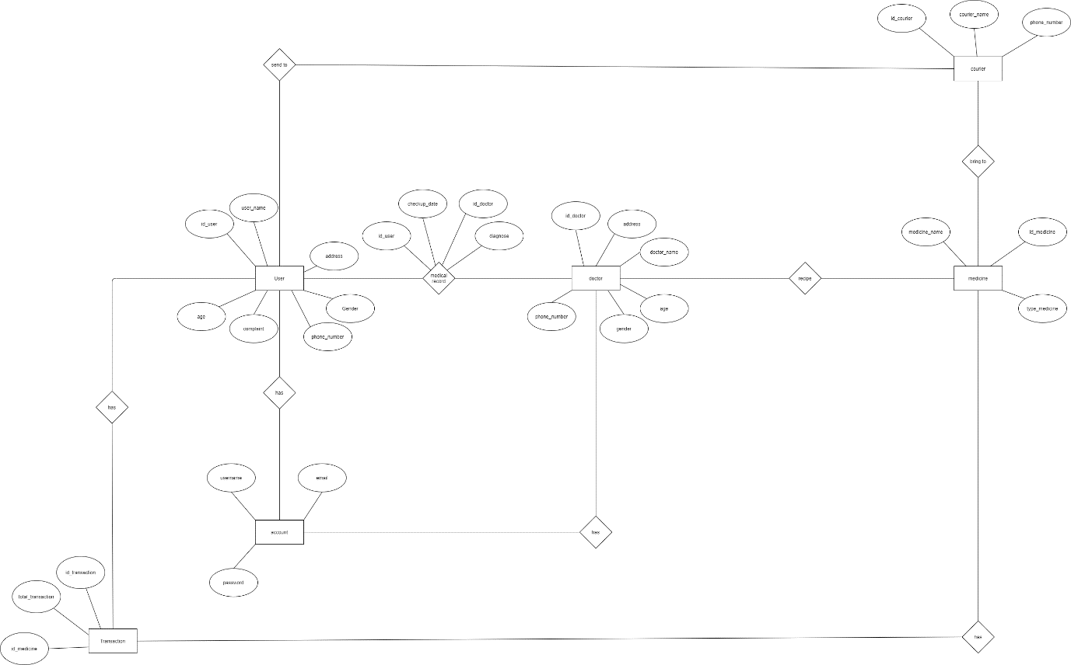

## 2.3. *Use case Diagram* and *Use case Scenario*

### 2.3.1. *Use case Diagram*

#### 2.3.1.1. Customer

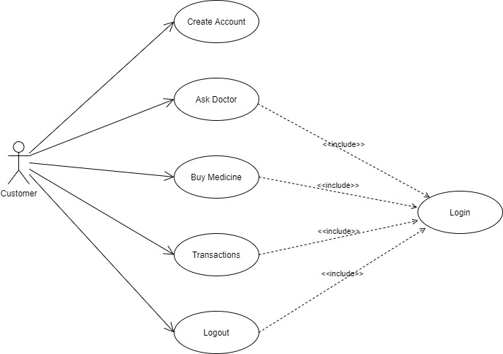

#### 2.3.1.2. Doctor

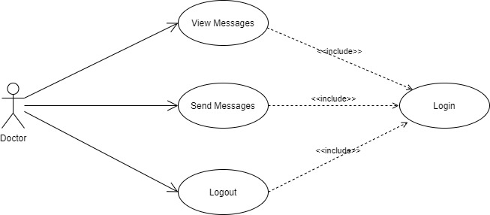

#### 2.3.1.3. Admin



### 2.3.2. *Use case Scenario*

#### 2.3.2.1. Create Account

|  |  |  |
| --- | --- | --- |
| Use Case Name | Create Account | |
| Description | Used to login | |
| Actor | Customer | |
| Pre-condition | User does not has an account | |
| Post-condition | User has an account | |
| Main Scenario |  | |
|  | Aktor | Sistem |
| 1. Customer open the website 2. Customer choose registration |  |
|  | 1. System will show the profile form |

#### 2.3.2.2. Login

|  |  |  |
| --- | --- | --- |
| Use Case Name | Login | |
| Description | To access the web | |
| Actor | Customer | |
| Pre-condition | User has an account | |
| Post-condition | User has their account to logged in | |
| Main Scenario |  | |
|  | Aktor | Sistem |
| 1. Customer log in to the app |  |
|  | 1. System will show the list of service |

#### 2.3.2.3. Ask Doctor

|  |  |  |
| --- | --- | --- |
| Use Case Name | Ask Doctor | |
| Description | Customer can ask anything | |
| Actor | Customer | |
| Pre-condition | Customer has logged in to their account | |
| Post-condition | Customer has selected consultation services | |
| Main Scenario |  | |
|  | Aktor | Sistem |
| 1. Customer click consultation menu |  |
|  | 1. System show doctor category |
|  | 1. Customer choose doctor category |  |
|  |  | 1. System will display categories doctors who have chosen |
|  | 1. Customer choose the doctor |  |
|  |  | 1. System will show chatting menu |

#### Search Doctor

|  |  |  |
| --- | --- | --- |
| Use Case Name | Search Doctor | |
| Description | Used to search the available Doctor | |
| Actor | Customer | |
| Pre-condition | Customer has select the Ask Doctor | |
| Post-condition | Customer has search the Doctor | |
| Main Scenario |  | |
|  | Aktor | Sistem |
| 1. Customer click Ask Doctor Menu |  |
|  | 1. System show the Doctor menu |
|  | 1. Customer Search the available Doctor |  |

#### Buy Medicine

|  |  |  |
| --- | --- | --- |
| Use Case Name | Buy Medicine | |
| Description | Used to buy the medicine what customer’s need | |
| Actor | Customer | |
| Pre-condition | Customer has logged in to their account | |
| Post-condition | Customer has selected Buy Medicine | |
| Main Scenario |  | |
|  | Aktor | Sistem |
| 1. Customer click the Buy Medicine menu |  |
|  | 1. System show the available medicines |
|  | 1. Customer choose the medicine |  |

#### Search Medicine

|  |  |  |
| --- | --- | --- |
| Use Case Name | Search Medicine | |
| Description | Used to search the available medicine | |
| Actor | Customer | |
| Pre-condition | Customer has select the Buy Medicine menu | |
| Post-condition | Customer has search the available Medicine | |
| Main Scenario |  | |
|  | Aktor | Sistem |
| 1. Customer click the Buy Medicine menu |  |
|  | 1. System show available medicine |
|  | 1. Customer search the medicine |  |

#### Transaction

|  |  |  |
| --- | --- | --- |
| Use Case Name | Transaction | |
| Description | Used to purchase the Customers Medicine | |
| Actor | Customer | |
| Pre-condition | Customer has logged in to their account | |
| Post-condition | Customer has selected transaction | |
| Main Scenario |  | |
|  | Aktor | Sistem |
| 1. Customer click the transaction |  |
|  | 1. System show payment method |
|  | 1. Customer choose the payment method |  |

#### Logout

|  |  |  |
| --- | --- | --- |
| Use Case Name | Logout | |
| Description | Used to logout an account | |
| Actor | Customer | |
| Pre-condition | Customer has logged in to their account | |
| Post-condition | Customer has selected logout menu | |
| Main Scenario |  | |
|  | Aktor | Sistem |
| 1. Customer click logout menu |  |
|  | 1. System will show login menu |

# CHAPTER III Implementation Results

## Screenshots

### Create Account

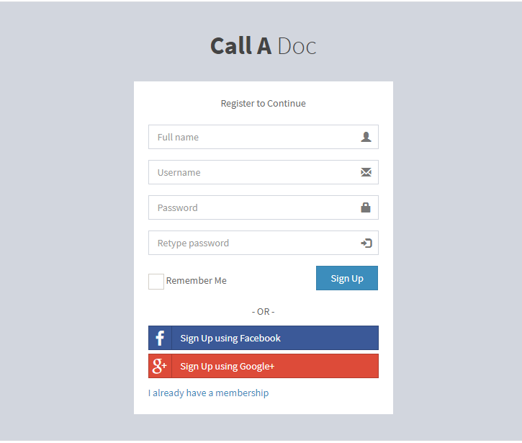

### Login

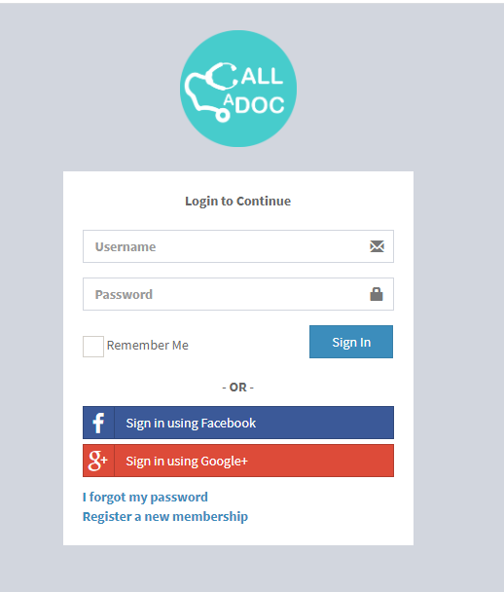

### Ask Doctor

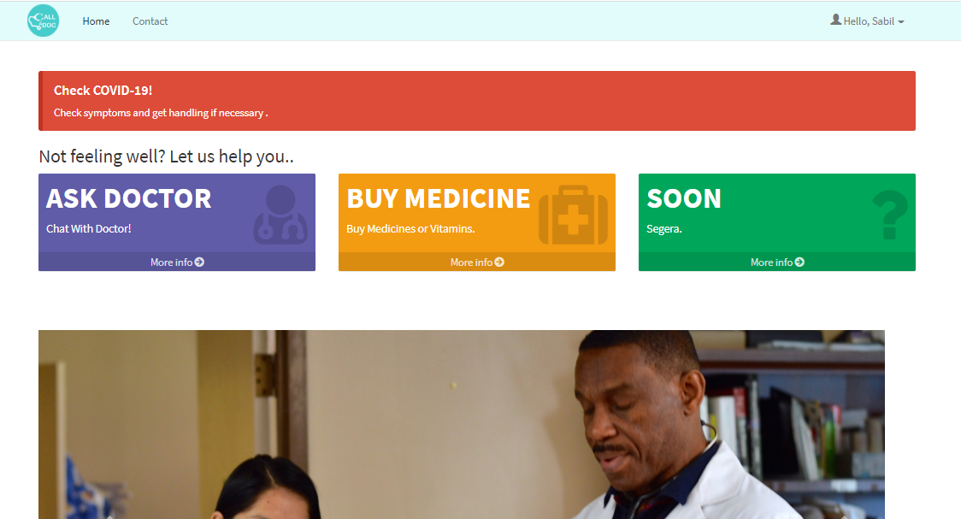

### Search Doctor

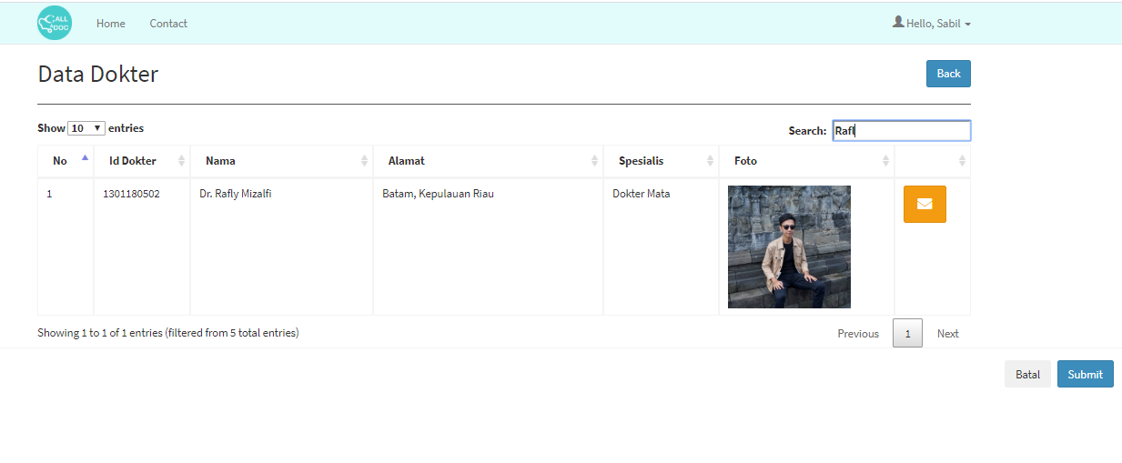

### Buy Medicine



### Search Medicine

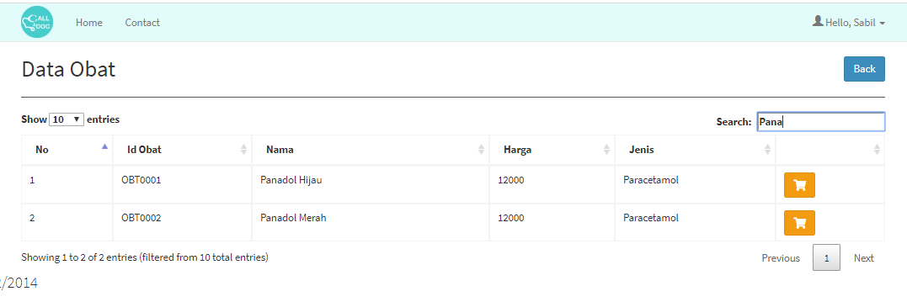

### Transaction

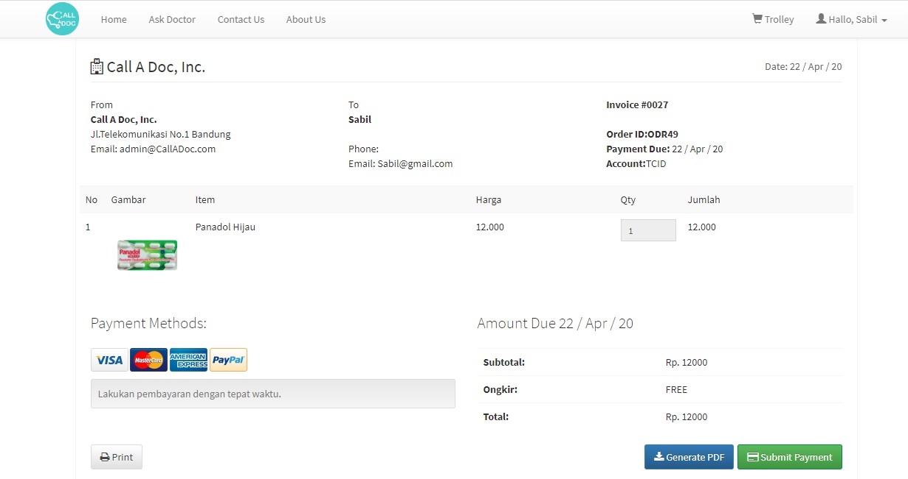

### Logout