**ANALYSIS AND DESIGN OF**

**Call A Doc**

This report was made to complete a big project of

Programming Web Courses



Created by:

1. Salsabilla Rinaldi 1301184463
2. Aldilla Rafi 1301184425
3. Azka Jauhary 1301184439
4. Faisal Adly 1301184438
5. Rafly Mizalfi 1301180502

**BACHELOR OF INFORMATICS**

**SCHOOL OF COMPUTING**

**TELKOM UNIVERSITY**

**BANDUNG**

**2020**

# TABLE OF CONTENTS

TABLE OF CONTENTS i

LIST OF FIGURES iii

LIST OF TABLES iv

CHAPTER I Introduction 5

1.1. About Web 5

1.2. Limitation of Work 5

1.2.1. Pages are Built 5

1.2.2. CRUD Pages 6

1.3. Job Description 6

CHAPTER II Analysis and Design 7

2.1. Business process 7

2.2. Designing Entity Relationship Diagrams 8

2.3. *Use case Diagram* and *Use case Scenario* 9

2.3.1. *Use case Diagram* 9

2.3.2. *Use case Scenario* 10

CHAPTER III Implementation Results 17

3.1. Screenshots 17

3.1.2. Create Account 17

3.1.3. Login 18

3.1.4. Ask Doctor 19

3.1.5. Search Doctor 19

3.1.6. Buy Medicine 20

3.1.7. Search Medicine 20

3.1.8. Transaction 21

3.1.9. Add Doctor 21

3.1.10. Edit Doctor 22

3.1.11. Remove Doctor 22

3.1.12. Add Medicine 23

3.1.13. Edit Medicine 23

3.1.14. Remove Medicine 24

3.1.15. Contact Us 24

3.1.16. About Us 25

3.1.17. Trolley 25

3.1.18. List Of Agreement 26

3.1.19. Manage Agreement 26

3.1.20. Logout 26

# LIST OF FIGURES

Figures 1. ERD 8

Figures 2. Customer Use Case Diagram 9

Figures 3. Doctor Use Case Diagram 9

Figures 4. Admin Use Case Diagram 10

Figures 5. Create Account Screenshot 17

Figures 6. Login Screenshot 18

Figures 7. Ask Doctor Screenshot 19

Figures 8. Search Doctor Screenshot 19

Figures 9. Buy Medicine Screenshot 20

Figures 10. Search Medicine 20

Figures 11. Transaction Screenshot 21

Figures 12. Add Doctor Screenshot 21

Figures 13. Edit Doctor Screenshot 22

Figures 14. Remove Doctor Screenshot 22

Figures 15. Add Medicine Screenshot 23

Figures 16. Edit Medicine Screenshot 23

Figures 17.Remove Medicine Screenshot 24

Figures 18.Contact Us Screenshot 24

Figures 19.About Us Screenshot 25

Figures 20. Trolley Screenshot 25

Figures 21. List Of Agreement 26

Figures 22. Manage Agreement 26

# LIST OF TABLES

Tables 1. Pages are Built 4

Tables 2. CRUD list 5

Tables 3. Job Description 5

Tables 4. Create Account Use Case Scenario 9

Tables 5. Login Use Case Scenario 9

Tables 6. Ask Doctor Use Case Scenario 10

Tables 7. Search Doctor Use Case Scenario 11

Tables 8. Buy Medicine Use Case Scenario 11

Tables 9. Search Medicine Use Case Scenario 12

Tables 10. Transaction Use Case Scenario 12

Tables 11. Logout Use Case Scenario 13

# CHAPTER I Introduction

## About Web

*Call A Doc* is an Application / Software that is accessed using web browser through a network such as the internet. This Application is made to facilitate customers who want to consult to Doctor or buy a medicine. Customers only need to register an account and login to access the Application. Then customers can choose the menu wether to consult to doctor, or buy a medicine. In Consult to Doctor menu, customers can consult to doctor by email, In buy medicine menu, Customers can choose and buy the available medicine. For the payment method it can be pay by COD (Cash On Delivery) to Courier or can be pay by Transfer Bank.

The reason why the *Call A Doc* website becomes the topic of the final project because the virus pandemic is currently occurring all over the world, with a call doc we can consult easily and buy the medicine without leaving home.

## Limitation of Work

There are several limitations used by this website, namely page are built and CRUD pages

### Pages are Built

|  |  |  |
| --- | --- | --- |
| **No.** | **Pages** | **Explanation** |
| 1. | Create Account | Create Account used by Customers to create the account for access the website |
| 2. | Login | Login is used by Customers, Admin, and Doctor to Log in for access the website |
| 3. | Ask Doctor | Ask Doctor used by Customers to consult to the doctor by chat. |
| 4. | Contact Us | Contact Us used to Customers to see the Contact Info. |
| 5. | About Us | About Us used to Customers to see The information of the website. |
| 6. | Trolley | Trolley used to Customers to see the Shopping list. |
| 7. | List of Agreement | List of Agreement used to Doctors or Customers to see the list of Agreement. |
| 8. | Manage Agreement | Manage Agreement used to Doctors or Customers to manage the Agreement. |
| 9. | Make Reservation | Make Reservation used to Customers to reserve and text messages for consult to the Doctor |
| 10. | Search Doctor | Search Doctor is used by Customers to search the Doctor. |
| 11. | Buy Medicine | Buy Medicine used by Customers to Buy the available medicine. |
| 12. | Search Medicine | Search Medicine used by Customers to search the Medicine. |
| 13. | Transaction | Transaction is used by Customers to purchase the Medicine. |
| 14. | Logout | Logout is used by Customers, Admin, Doctors to Log Out the account from the website. |

Tables 1. Pages are Built

### CRUD Pages

|  |  |  |  |
| --- | --- | --- | --- |
| **No.** | **CRUD** | **Pages** | **Explanation** |
| 1. | Create | Create Medicine | Used to create new Medicine |
|  |  | Create Doctor | Used to create new Doctor |
|  |  | Create Message | Used to create Message to Doctor |
|  |  | Create Customer Account | Used to create Customer Account |
| 2. | Read | View Medicine | Used to view the Medicine |
|  |  | View Doctor | Used to view the Doctor |
|  |  | View Message | Used to view the Message from Customer |
| 3. | Update | Update Medicine | Used to update the Medicine |
|  |  | Update Doctor | Used to update the Doctor |
|  |  | Update User | Used to update User Data |
| 4. | Delete | Delete Medicine | Used to delete the Medicine |
|  |  | Delete Doctor | Used to delete the Doctor |
|  |  | Delete Message | Used to delete the Message |

Tables 2. CRUD list

## Job Description

*Job descriptions of each group member are explained clearly and in detail.*

|  |  |  |  |
| --- | --- | --- | --- |
| No | Name | Student ID | Job Description |
| 1. | Salsabilla Rinaldi | 1301184463 | * Controller * Model * View/Admin * View/template * View/reservasi.php * View/pesan.php * Database * View * Config * CRUD |
| 2. | Aldilla Rafi | 1301184425 | * ERD * View/profil.php * View/sukses.php |
| 3. | Azka Jauhary | 1301184439 | * Usecase Scenario * View/login.php * View/aboutus.php |
| 4. | Faisal Adly | 1301184438 | * Report * View/obat.php * View/splash.php |
| 5. | Rafly Mizalfi | 1301180502 | * Use case diagram * View/register.php * View/kontak.php |

Tables 3. Job Description

# CHAPTER II Analysis and Design

## 2.1. Business process

*Call A Doc* is the website that run in Doctor Consult and Sell Medicine product, Customer have to create account and Login to access the website. The business process that *Call A Doc* have is selling the medicine, Customer can buy the available medicine in Buy Medicine Menu, and the payment can be payed by COD (Cash On Delivery) or by Transfer Bank, after Customer purchase the Medicine, the Medicine will be deliver by Courier.

On this website, we also have admins and doctors as actors or users. Admin has the duty to control drugs and doctors, for example admin can update new items or old items in the buy medicine menu and can invite or add new doctors and remove doctors on this website.

Like wise the doctor can see the reservation or message given by the customer and can reply to the message. Doctors can also make drug purchases on their accounts. All users must log in first to enter the website.

## 2.2. Designing Entity Relationship Diagrams

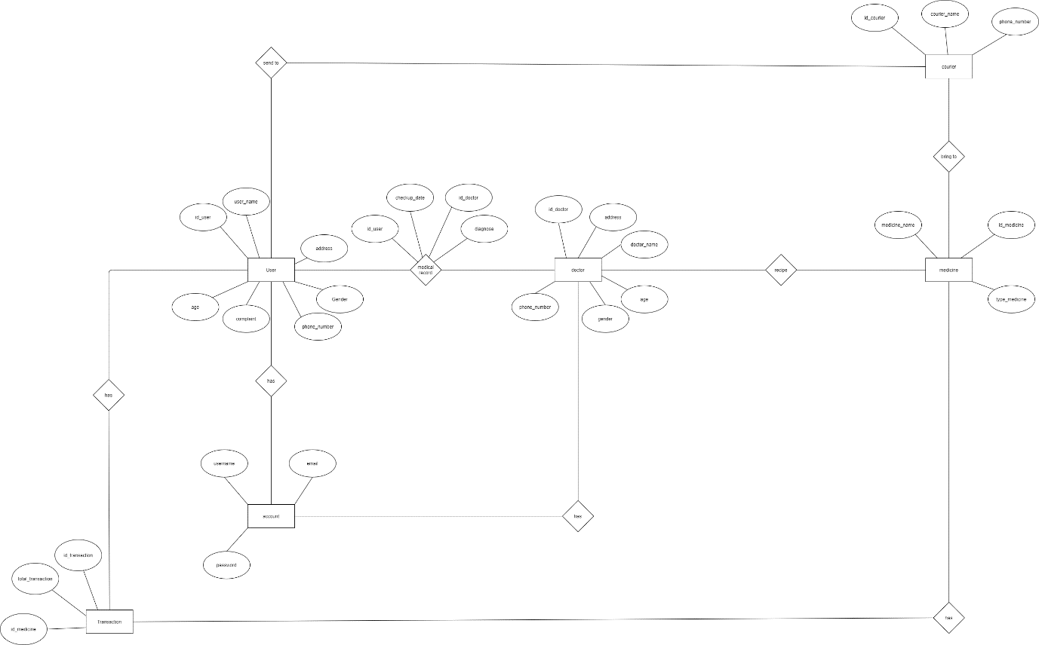

Figures 1. ERD

## 2.3. *Use case Diagram* and *Use case Scenario*

### 2.3.1. *Use case Diagram*

#### 2.3.1.1. Customer

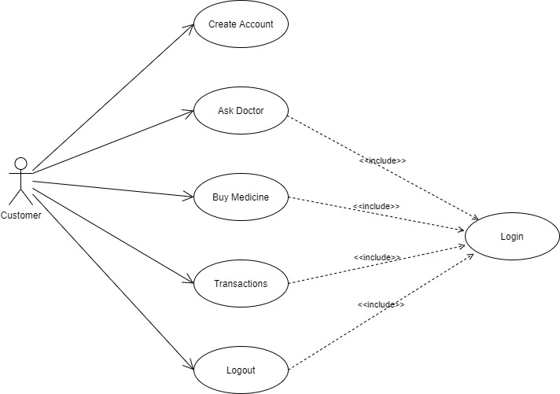

Figures 2. Customer Use Case Diagram

#### 2.3.1.2. Doctor

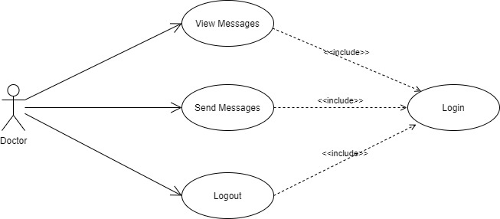

Figures 3. Doctor Use Case Diagram

#### 2.3.1.3. Admin

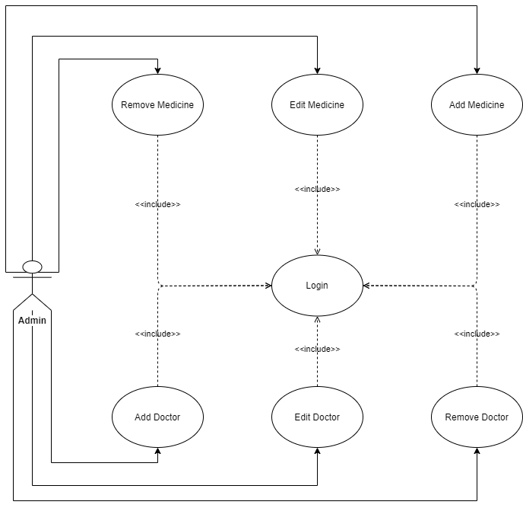

Figures 4. Admin Use Case Diagram

### 2.3.2. *Use case Scenario*

#### 2.3.2.1. Create Account

|  |  |  |
| --- | --- | --- |
| Use Case Name | Create a customer account | |
| Description | Customer can register to create new account | |
| Actor | Customer | |
| Pre-condition | Customer did not register yet in the system | |
| Post-condition | Customer registered in the system and have an account | |
| Main Scenario |  | |
|  | Aktor | Sistem |
| 1. Customer open the registration page |  |
|  | 1. Display the registration page |
|  | 1. Fill the biodata form, the click submit |  |
|  |  | 1. Doing data validation |
|  |  | 1. Display notification “Registration Success” |
|  |  | 1. Redirect actor to login page |

Tables 4. Create Account Use Case Scenario

#### 2.3.2.2. Login

|  |  |  |
| --- | --- | --- |
| Use Case Name | Login | |
| Description | Customer can login into their account | |
| Actor | Customer | |
| Pre-condition | User has an account | |
| Post-condition | User has their account to logged in | |
| Main Scenario |  | |
|  | Aktor | Sistem |
| 1. Customer open the web |  |
|  | 1. System will show the login form |
|  | 1. Customer fill login form and click login |  |
|  |  | 1. System will show the homepage of web |

Tables 5. Login Use Case Scenario

#### 2.3.2.3. Ask Doctor

|  |  |  |
| --- | --- | --- |
| Use Case Name | Ask Doctor | |
| Description | Customer can ask anything | |
| Actor | Customer | |
| Pre-condition | Customer has logged in to their account | |
| Post-condition | Customer has selected consultation services | |
| Main Scenario |  | |
|  | Aktor | Sistem |
| 1. Customer click consultation menu |  |
|  | 1. System show doctor category |
|  | 1. Customer choose doctor category |  |
|  |  | 1. System will display categories doctors who have chosen |
|  | 1. Customer choose the doctor |  |
|  |  | 1. System will show chatting menu |

Tables 6. Ask Doctor Use Case Scenario

#### Search Doctor

|  |  |  |
| --- | --- | --- |
| Use Case Name | Search Doctor | |
| Description | Customer can search the available Doctor | |
| Actor | Customer | |
| Pre-condition | Customer has select the Ask Doctor | |
| Post-condition | Customer has search the Doctor | |
| Main Scenario |  | |
|  | Aktor | Sistem |
| 1. Customer click “Ask Doctor” Menu |  |
|  | 1. System show the Doctor menu |
|  | 1. Customer Search the available Doctor |  |

Tables 7. Search Doctor Use Case Scenario

#### Buy Medicine

|  |  |  |
| --- | --- | --- |
| Use Case Name | Buy Medicine | |
| Description | Used to buy the medicine what customer’s need | |
| Actor | Customer | |
| Pre-condition | Customer has logged in to their account | |
| Post-condition | Customer has selected Buy Medicine | |
| Main Scenario |  | |
|  | Aktor | Sistem |
| 1. Customer click the Buy Medicine menu |  |
|  | 1. System show the available medicines |
|  | 1. Customer choose the medicine |  |

Tables 8. Buy Medicine Use Case Scenario

#### Search Medicine

|  |  |  |
| --- | --- | --- |
| Use Case Name | Search Medicine | |
| Description | Used to search the available medicine | |
| Actor | Customer | |
| Pre-condition | Customer has select the Buy Medicine menu | |
| Post-condition | Customer has search the available Medicine | |
| Main Scenario |  | |
|  | Aktor | Sistem |
| 1. Customer click the Buy Medicine menu |  |
|  | 1. System show available medicine |
|  | 1. Customer search the medicine what they need |  |

Tables 9. Search Medicine Use Case Scenario

#### Transaction

|  |  |  |
| --- | --- | --- |
| Use Case Name | Transaction | |
| Description | Used to purchase the Customers Medicine | |
| Actor | Customer | |
| Pre-condition | Customer has logged in to their account | |
| Post-condition | Customer has selected transaction | |
| Main Scenario |  | |
|  | Aktor | Sistem |
| 1. Customer click the transaction |  |
|  | 1. System will show payment method |
|  | 1. Customer choose the payment method |  |
|  | 1. Customer click the payment method what they choose |  |
|  |  | 1. System will show Total bill |
|  | 1. Customer click “Submit Payment” |  |
|  |  | 1. System will show “Payment Successfully” |

Tables 10. Transaction Use Case Scenario

#### Logout

|  |  |  |
| --- | --- | --- |
| Use Case Name | Logout | |
| Description | Used to logout an account | |
| Actor | Customer | |
| Pre-condition | Customer has logged in to their account | |
| Post-condition | Customer has selected logout menu | |
| Main Scenario |  | |
|  | Aktor | Sistem |
| 1. Customer click logout menu |  |
|  | 1. System will show login menu |

Tables 11. Logout Use Case Scenario

# CHAPTER III Implementation Results

## Screenshots

### Create Account

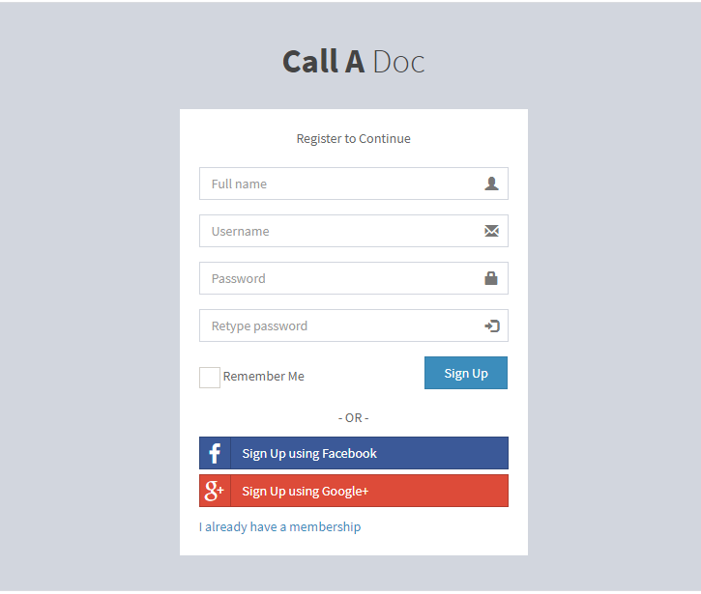

Figures 5. Create Account Screenshot

### Login

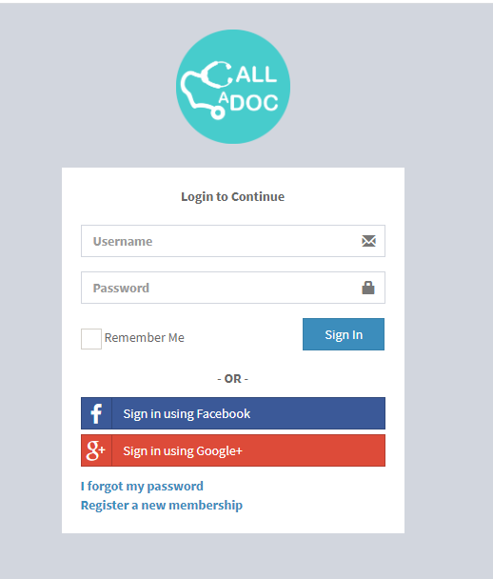

Figures 6. Login Screenshot

### Ask Doctor

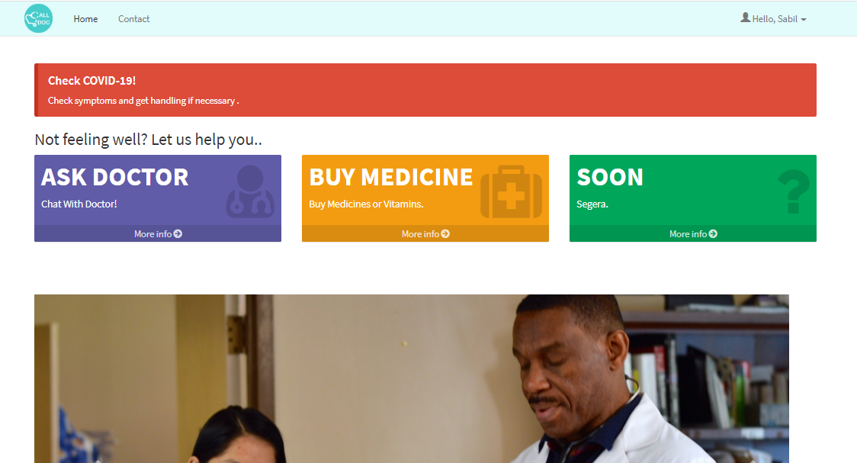

Figures 7. Ask Doctor Screenshot

### Search Doctor

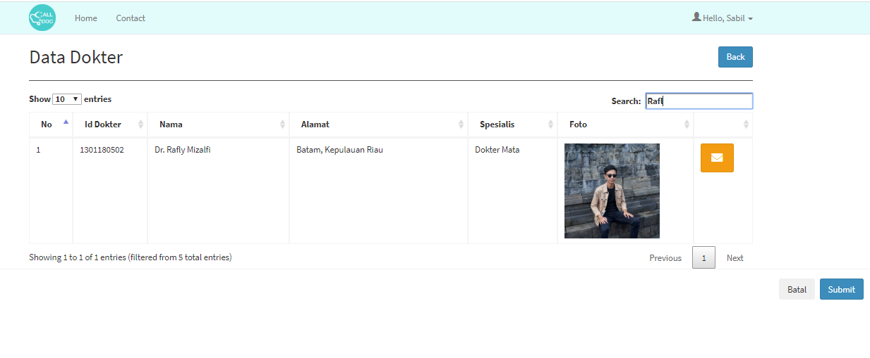

Figures 8. Search Doctor Screenshot

### Buy Medicine



Figures 9. Buy Medicine Screenshot

### Search Medicine

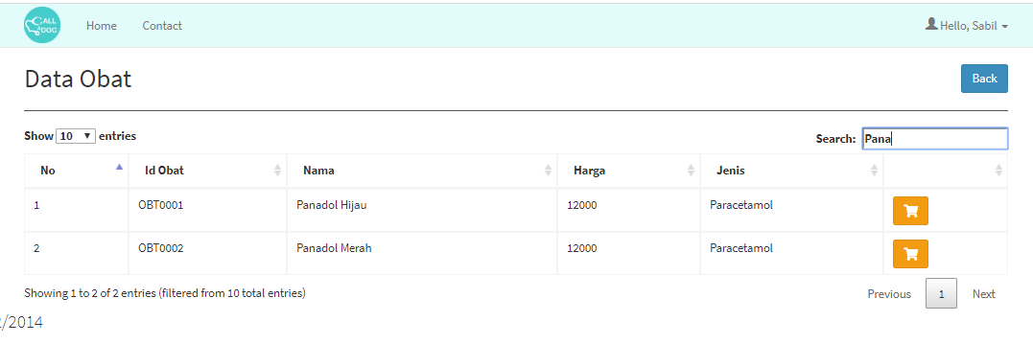

Figures 10. Search Medicine

### Transaction

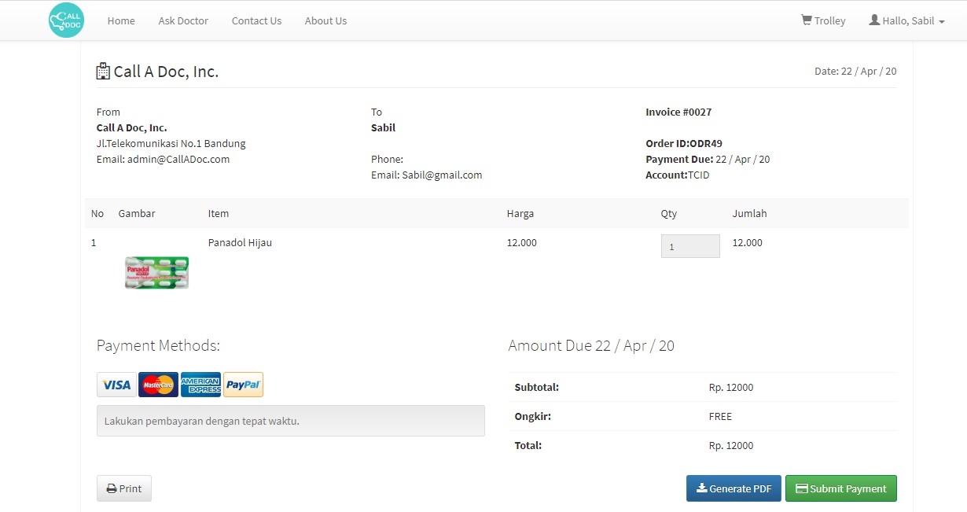

Figures 11. Transaction Screenshot

### Add Doctor

Figures 12. Add Doctor Screenshot

### Edit Doctor

Figures 13. Edit Doctor Screenshot

### Remove Doctor

Figures 14. Remove Doctor Screenshot

### Add Medicine

Figures 15. Add Medicine Screenshot

### Edit Medicine

Figures 16. Edit Medicine Screenshot

### Remove Medicine

Figures 17.Remove Medicine Screenshot

### Contact Us

Figures 18.Contact Us Screenshot

### About Us

Figures 19.About Us Screenshot

### Trolley

Figures 20. Trolley Screenshots

### List Of Agreement

Figures 21. List Of Agreement

### Manage Agreement

Figures 22. Manage Agreement

### Logout

Figures 23. Logout Screenshot