Using LiVES with pd

Important Note: as of LiVES 1.3.11, the default command port has been changed from 9999 to 49999. Other ports in the patches have been changed from 9998 to 49998 and from 9997 to 49997. Please keep this in mind when reading the documentation below.

Introduction
LiVES is a video editing and VJ application for Linux, OSX, BSD and UNIX. It can be controlled from pd using OSC either on the same machine or on a remote machine. There is a large number of commands available already and this list is growing. From pd you can do operations like: opening individual or multiple video and audio clips, opening directories of images (animations), selecting parts of clips to copy, cut, paste and insert, and encoding to various formats. For real time work, you can play video/audio clips at any frame rate (0.0 – 200.0 fps), forwards and in reverse, switch clips in real time and apply numerous realtime effects and blends. You can also record video in realtime. In future it will also be possible to use the multitrack timeline and rendering functions in LiVES directly from within pd.

Two way communication with LiVES is possible; by opening a status socket LiVES can respond to queries, for example to get the start and end points of a clip or to query the effect to effect-key mapping. Query results are returned in plain text, so there is no need to implement complex message parsing.

In addition, LiVES can be made to open a notification socket, so that the control application can be notified when certain events occur (for example, whenever a frame is displayed, or when a new clip is opened).

Note: some of the features described in this document will only work with the current trunk subversion version of LiVES. As of LiVES 1.2.2 onwards, all of the features described here will be fully implemented.

LiVES setup
If you have not used LiVES before, you need to download and install it. There are various packages for different Linux distros; for OSX you will need to compile the code from source.

For more info, see the LiVES site: http://lives.sourceforge.net

For pd working with LiVES it is best to install jack audio first (if not already installed). This will allow both applications to share the sound card.

After installing, you will need to run LiVES once to go through the initial configuration process. For pd work, it is recommended that you set up LiVES to use jack audio and to start in clip editor mode.

If you already have LiVES installed, it is recommended that you switch the audio player to jack, via Preferences/Playback (or start LiVES with lives -aplayer jack)

After installing/configuring, you need to open an OSC socket in LiVES so that it can receive messages from pd. There are two ways to do this:

- either start LiVES with the commandline option -oscstart, e.g.:

lives -oscstart 9999

  - or, in a running copy of LiVES, go to Tools/Preferences (ctrl-p) and locate the Streaming/Networking tab. Here you can check the OMC remote control enabled checkbox and select your port number (default is 9999, or in more recent versions of LiVES, 49999). You can also elect to start up OSC each time, by checking the Start OMC on startup checkbox.

Both of these methods would open a control port on UDP port 9999 (or 49999). This port can be changed and you can have multiple copies of LiVES running on the same machine using different ports.

You will need to ensure any firewall settings are not blocking the selected UDP port between the host (pd) machine and the target (LiVES) machine.

PD setup

Make sure you have pd compiled with jack support.

Note that you must start jack before starting pd, else pd will grab the soundcard and prevent LiVES from playing. To start jack from the commandline, type:

~/.jackdrc

(LiVES will have created this file when you installed it and selected jack audio).

Pd requires the external OSC. Assuming you have this installed then start pd with:

pd -lib OSC

this should start up pd with the OSC external. More current versions of pd load the OSC library automatically, so the -lib OSC may not always be necessary.

To summarize:

- start jack: ~/.jackdrc
- start pd: pd -lib OSC
- start LiVES: lives -oscstart 9999

We are now ready to test the connection from pd to LiVES.

Note: the following patches can be downloaded from the LiVES repository.

http://lives.svn.sourceforge.net/viewvc/lives/trunk/OMC/lives-simple-test.pd

http://lives.svn.sourceforge.net/viewvc/lives/trunk/OMC/lives-simple-status-test.pd

http://lives.svn.sourceforge.net/viewvc/lives/trunk/OMC/lives-simple-notify-test.pd

First we will create our sendOSC object:

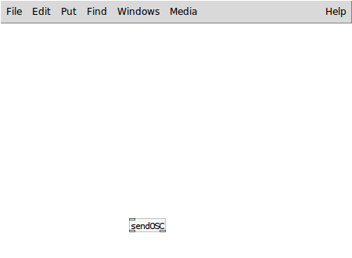

Not so hard, eh ?

Next we will add messages to connect and disconnect:

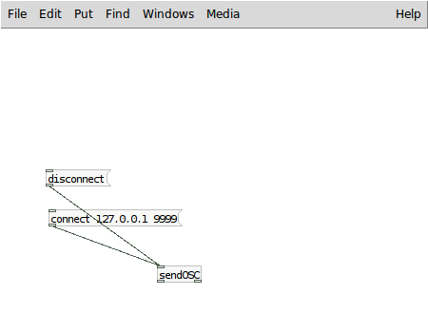

Here we assume that LiVES is running on the same machine as pd (127.0.0.1), and that we are using port 9999. If your values are different (for example you are using the newer default of 49999), you will need to adjust the connect message appropriately.

Note that you can control LiVES remotely from another machine by changing to the 127.0.0.1 to the IP address of the remote machine.

Now we can begin adding some more useful messages. The current snapshot of messages for LiVES can be found here:

http://openmediacontrol.wetpaint.com/page/LiVES+commands

For testing we will use 2 commands - /app/quit and /video/play

The first is useful if you have no clips loaded in LiVES, the second is useful if you do have some clips loaded. We will also add /video/stop so we can stop playback.

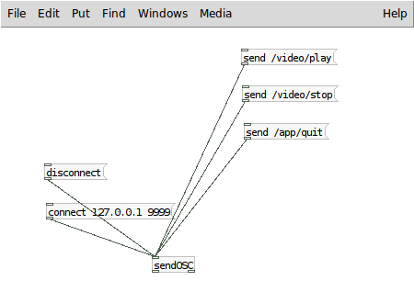

OK, now we can test ! Make sure LiVES is started and the OSC port is opened (see above). Then click on the connect message, and then either /app/quit or /video/play. The latter will only work if you have clips loaded in LiVES.

If you quit from LiVES and restart it, there is no need to click on disconnect/connect, provided you are using the same port.

Once the test patch is working, the set of command messages can be extended.

Reading from the status port
As mentioned in the Introduction, two way communication with LiVES is possible. You can query the state of LiVES and the result is received as plain text.

First we need to tell LiVES to open a notify port. We can do that by adding a message for it:

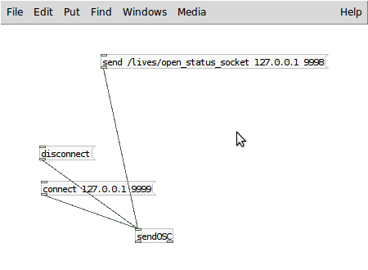

Clicking on the message above will instruct LiVES to open a status socket to send replies back to localhost (127.0.0.1) UDP port 9998. Of course you can alter these values to suit your own needs.

Now we can query LiVES; for example we can “ping” the application:

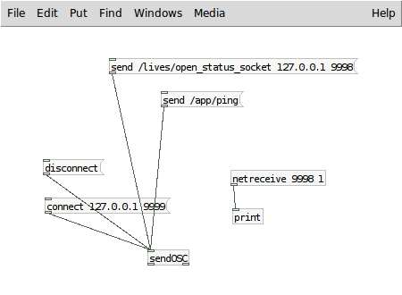

If you click on send /app/ping then you should see print: pong on the pd console.

We can also add a notify socket to inform us when various events occur in LiVES.

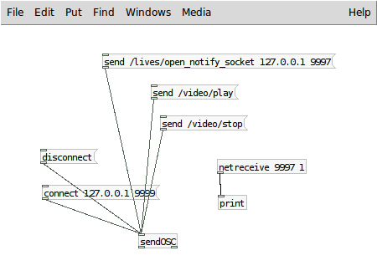

For this to work, you need to have at least one clip opened in LiVES (the simplest way is via the LiVES GUI). Then click to open the notify socket, then click on /video/play and then /video/stop.
On the pd console you should see the following:

print: 2
print: 1
print: 1
…
print: 1
print: 3

2 means play started, 1 means frame sync, and 3 means play stopped.

You can find a full list of notifiable events here:
http://lives.svn.sourceforge.net/viewvc/lives/trunk/src/osc_notify.h

Some More Example Patches

This first patch alters the frame rate of whatever video is being played back. The audio rate will also vary if Audio Follows Video Rate/Direction is checked in Preferences/Playback in LiVES.

Note: the framerate variable is to be received from another patch.

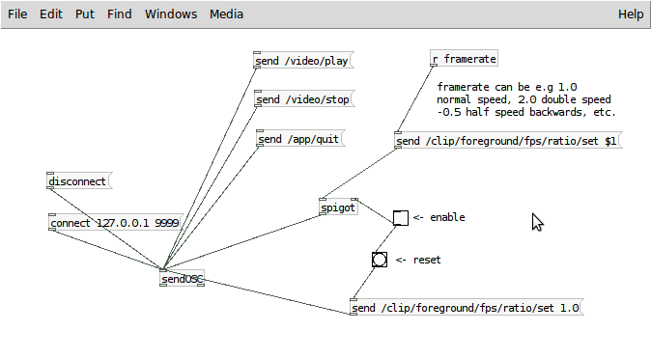
The above patch can be downloaded from:

http://lives.svn.sourceforge.net/viewvc/lives/trunk/OMC/lives-framerate.pd

How about applying some effects to video ? Sure ! First of all you need to understand how LiVES assigns effects to clips. In LiVES an effect must be bound to a key and a mode. Keys range from 1 to 9 (by default, but the maximum can be increased up to 64 via Preferences/Effects). The keys 1 to 9 correspond to ctrl and a number key on the LiVES keyboard; so if the user presses ctrl-1 then the currently active effect on key 1 is toggled. Each key also has a number of modes (0 to 7 by default). This is to enable the user to switch effects more easily from the keyboard. Ctrl-0 will switch all effects off, so effect key 0 is not generally used (and there is a separate OSC message /effect_key/reset which does the same thing).

Although it is possible to map effects to keys and modes via OSC (advanced users can look into this), the simplest way to do the mapping is via the LiVES GUI. In LiVES, you can activate the mapping window via VJ/Realtime effect mapping, or by pressing ctrl-v.

For this example, you can just map an effect to key 1, mode 0. Look at the top left combo box – make sure Mode Enabled is checked to the left, and click at the top to enable Key active. Pick an effect from the drop down list, and make sure the effect chosen has at least one numerical parameter. You can tell this by clicking on Set Parameters. A good example to pick is targeted_zoom, so I chose that one for the example. If you wish you can save the effect mapping as your new default mapping.

OK, now let's look a little at the parameters: targeted_zoom has 3 parameters: scale, which goes from 1.0 to 16.0 and x and y center which both range from 0.0 to 1.0

LiVES has various kinds of parameters, including strings, floats, ints, colours (RGB and RGBA) which can also be float or int, string choices, booleans, and arrays of all those types. To simplify things, some OSC messages refer to nparameters. The list of nparameters consists only of those parameters which are single valued float or int. For targeted_zoom, it happens that all of the parameters are also nparameters, for other effects that may not be the case.

OK, the basic point is, you should now we have targeted_zoom mapped to key 1, mode 0, and we can create a patch to control it.

The OSC commands we will use are:

/effect_key/enable 1
/effect_key/disable 1

to switch the effect on and off, and:

/effect_key/nparameter/value/set 1 x val

where x is the parameter number (0 to 2) and val is the value we are going to set it to. The patch looks something like this:

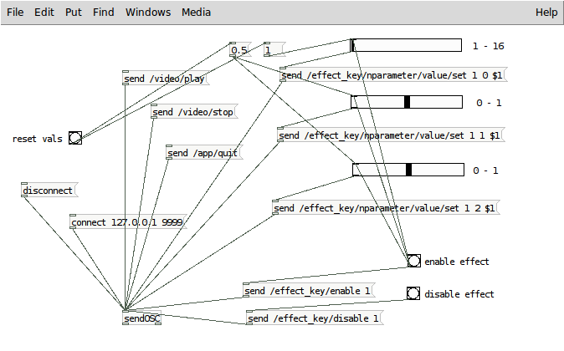
Eeek ! But it is just some sliders to control the parameters, a couple of buttons to switch the effect on and off, and a reset to reset the parameter values.

Note that when the effect is disabled and then re-enabled in LiVES, the parameter values are reset to their defaults, so we need to re-send the values when the effect is enabled. Hence the output of the “enable effect” bang is piped to the inputs of all the sliders.

The above patch can be downloaded from:

http://lives.svn.sourceforge.net/viewvc/lives/trunk/OMC/lives-effect.pd

Note for advanced users, the OSC messages:

/effect_key/nparameter/max/get,<int key>,<int nparam>
/effect_key/nparameter/min/get,<int key>,<int nparam>
/effect_key/nparameter/default/get,<int key>,<int nparam>
may be used to construct the parameter min, max and default values. The values will be returned on the status port, so you need to open the status socket first.

The message /effect_key/nparameter/count can be used to get the number of simple numeric parameters.
What about switching clips in realtime ? Easy !

LiVES uses two systems of numbering clips – an internal ordering, which may have gaps in it if files have been closed. You can if you wish, set the foreground clip using the internal numbering with:

/clip/foreground/set <clip>

If there is a transition active, you can set the background clip with:

/clip/background/set <clip>

Clip starts at 1 and increases. However as noted, the internal numbering may have gaps, so if you choose a non-existent clip, nothing will happen. So this method is not so useful.

To make things easier, LiVES also uses an external numbering system, in this system clips go from 1 to n with no gaps. This is the order which is seen in the Clips menu in the LiVES GUI for example. To use the external ordering we can send the messages:

/clip/foreground/select

and if a transition is active:

/clip/background/select

Note you can get the number of clips by sending a /clip/count message and reading the result from the status port.

If you have the option Audio follows clip switches checked in Preferences/Playback, then the audio track will also change when the foreground clip is updated.

Here is the patch...
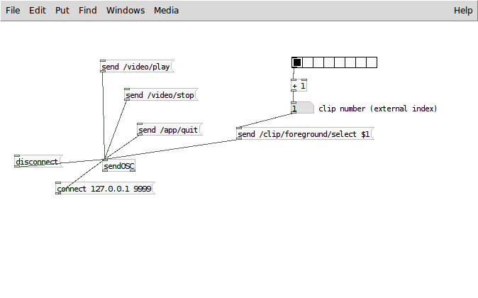

The above patch can be downloaded from:

http://lives.svn.sourceforge.net/viewvc/lives/trunk/OMC/lives-clipselect.pd

Now let's look at how to transition from one clip to another. This is done in a very similar way to the effects example above. Transitions are bound to keys and modes in exactly the same way as effects.

In LiVES, you can open the mapping window again (VJ/Realtime effect mapping or ctrl-v). By default transitions are mapped to key 8, so let us stick that. Map a transition to key 8, mode 0. Probably there is one there already. The transition parameter is generally the first one [you can verify this with /effect_key/nparameter/is_transition/get, which will return 1 for the transition parameter, 0 otherwise]. Transitions have exactly one transition parameter, it is always a simple numeric parameter, and it varies from 0 (foreground frame fully visible) to max (background frame fully visible).

The patch below shows how to implement a transition (assuming the transition parameter is the first nparameter of a transition bound to key 8). We will add to the clip selector patch from the previous section. With a transition active, both foreground and background clips can be changed.

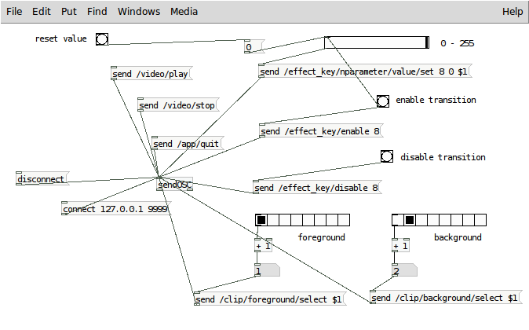
At the bottom right is out clip selector, and above that the transition control.

Note that the background “clip” doesn't have to be a clip, it could be an image, if you wanted to add a watermark or an overlay for example.

The above patch can be downloaded from:

http://lives.svn.sourceforge.net/viewvc/lives/trunk/OMC/lives-transition.pd
Well, we have just scratched the surface of what LiVES is capable of within pd. You can combine several effects together, switch effect key modes, overlay text, add multiple transitions, add speed and direction changes as you wish. LiVES also has facilities to record what is being played back and then render it afterwards. You can load in clips from video files, images and audio, and perform editing operations like cutting, inserting and deleting. You can run frame generators and mix them with existing video clips. You can save multiple clips as a clip set, and then reload them later. You can also encode to various formats all from within pd. Remember to check out the full list of OSC messages here:

http://openmediacontrol.wetpaint.com/page/LiVES+commands

this list is growing with each new release of LiVES !

Happy hacking !

Salsaman.
http://lives.sourceforge.net

