LAB 1 C#

1) Remove any one of the semicolons at the end of a statement. Run the program again. Describe what happened, explain the reason.

I got a syntax error. VS asked me to make a successful build. The program did not work!

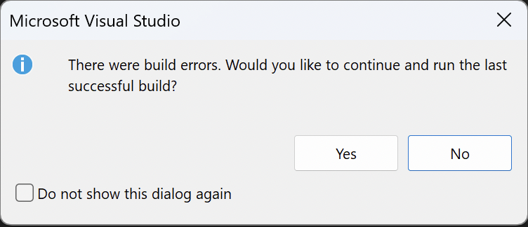

​​2) Reverse the change made at 1). At line 10, change the word string to int. Run the program again. Describe what happened, explain the reason.

I got the same message that I had build errors. The program did not work! Main method is expecting an array of strings as its parameter, but we have defined it to take an array of integers. This is causing a compile-time error.

3) Keep the change made at 2). Change, at line 16,

name = Console.ReadLine( );

to

name = int.Parse( Console.ReadLine() );

Run program again, at the prompt enter your name. Describe what happened, explain the reason. Run program again, at the prompt enter an integer, say, 16. Describe what happened, explain the reason

We are attempting to parse the user input as an integer and store it in the name variable in the line name = int.Parse(Console.ReadLine());. The name variable, however, is specified as a string. A string variable cannot be given an integer value directly. We should switch the name variable's data type from string to int to resolve this.

Near the word Console.Write("Hello " + name + "n"); combines a string with the name variable by adding them together with the + operator. But before concatenating, we must change the name variable back to a string after making it an int. Only the ToString() method can be used to accomplish this.

—----------------------------

Google phrases “ C# compiling error” and “ C# runtime error”

1)What are the differences between these two types of errors?

When a programme is being compiled, compile-time or syntax rules are broken, which results in compilation errors. They obstruct the program's successful compilation. Runtime errors happen when a programme is being executed and are brought on by unforeseen circumstances or exceptions. They might result in the programme terminating or acting strangely. Fixing runtime errors necessitates correctly identifying and managing exceptions, whereas fixing compilation errors entails fixing syntax or semantic flaws.

2) When did you encounter C# compiling error in task 5 above?

The line name = int.Parse(Console.ReadLine()); contains the compile fault. An integer can be created from a string using the int.Parse() function. We are attempting to assign the parsed integer value directly to the name variable, despite the fact that it is designated as a string. Because we cannot give an integer value to a string variable, this causes a build error.

3) When did you encounter C# runtime error in task 5 above?

After you correct the compilation mistake, the line name = int.Parse(Console.ReadLine()); may contain a runtime error. It is assumed that the user will enter a legitimate integer value in this line. An exception will be thrown at runtime if the user enters a value that isn't numeric. Instead of using int.Parse(), we should use int.TryParse() to handle input validation and gracefully manage any invalid user input in order to address this potential problem.