ST1008 - Web Client Development

ST1002 – Digital Visual Design

AY 2017/18/S2 CA2 | Report

SaltedArts Online Shop



**Name:** Seow Xuan Yi

**Admission No.:** 1727951

**Class:** DIT/FT/1A/23

**Date of Submission:** 11/02/18

**Lecturer:** Janny Chan, Ms Jan

# Previous website

After writing the evaluation report for WCD, I have planned on revamping my entire website, which includes revised layout, colour schemes, and design.

***Previous design: Home page***

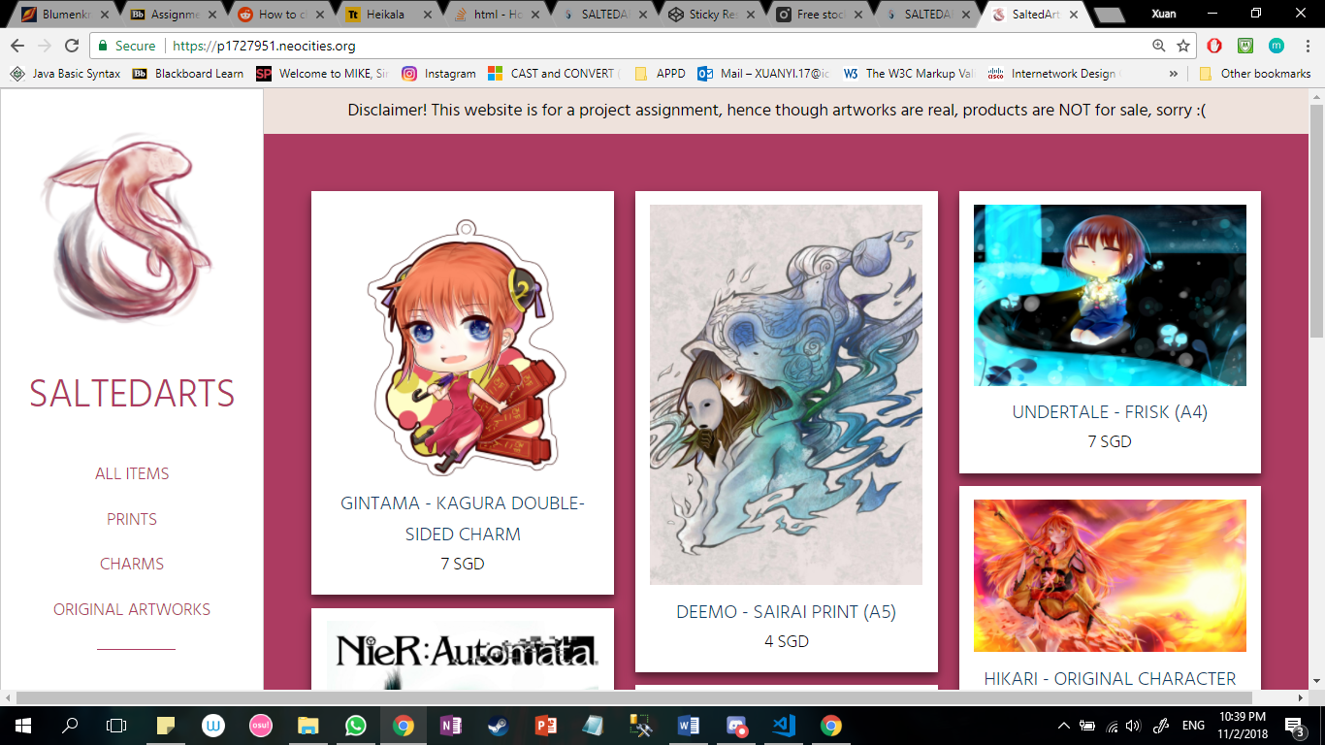

***Previous design: Prints/Charms page***

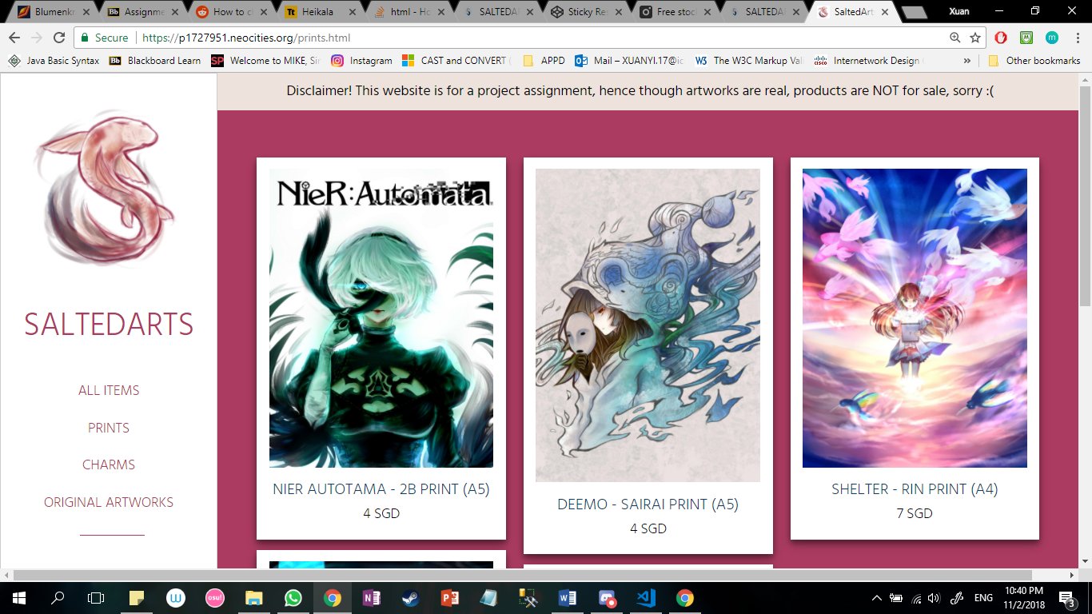

***Previous design: About page***

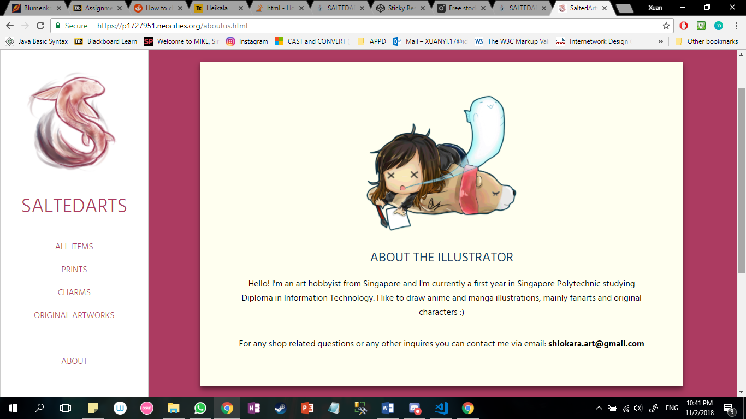

For the layout, my previous website is more simplistic and easy to navigate. Viewers can easily see the overview of the whole product scope. However, based on the feedback given and reviews, many find that the webpages are look too the same as seen above. Hence, for the new website I tried to make each webpage unique while keeping the consistency for the layout and design.

# 2.Planning and Research

I went on to research more about web designing, specifically ecommerce websites. I analysed their web structure, such as navigation bar, product layouts, overall aesthetics, and functionalities. My website is also inspired by artworks sold online, such as this shop: <http://heikala.tictail.com/>

Planning for the layout is the most time consuming part for me as it is where you start developing ideas on how to layout the different content and making sure when the viewers have a first look, they are looking at the right content. Planning also needed for both desktop and mobile view as my website is a responsive designed website, as seen in the next image.

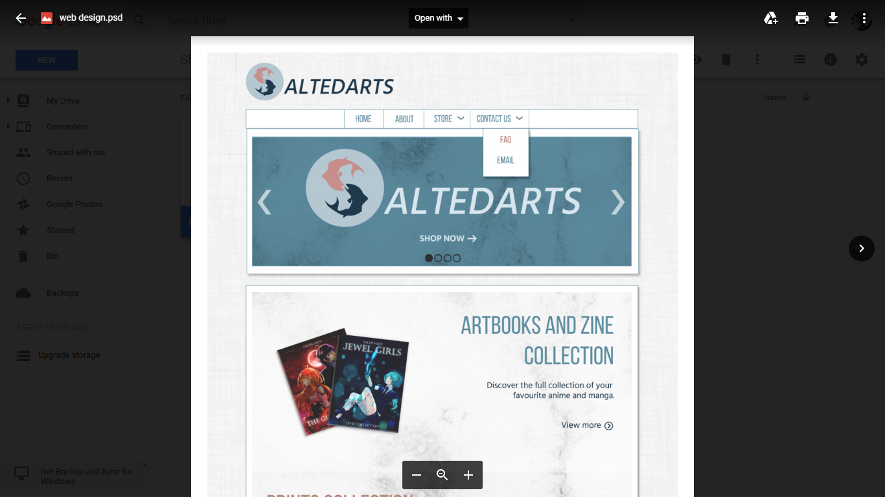 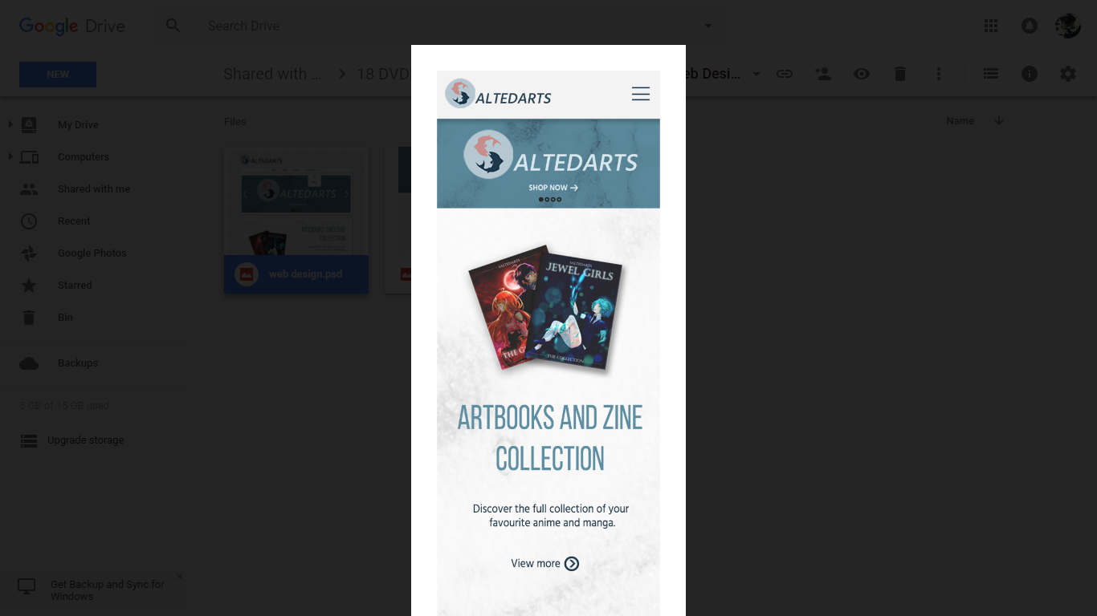

3. Revamping the website

***New design: Home page***

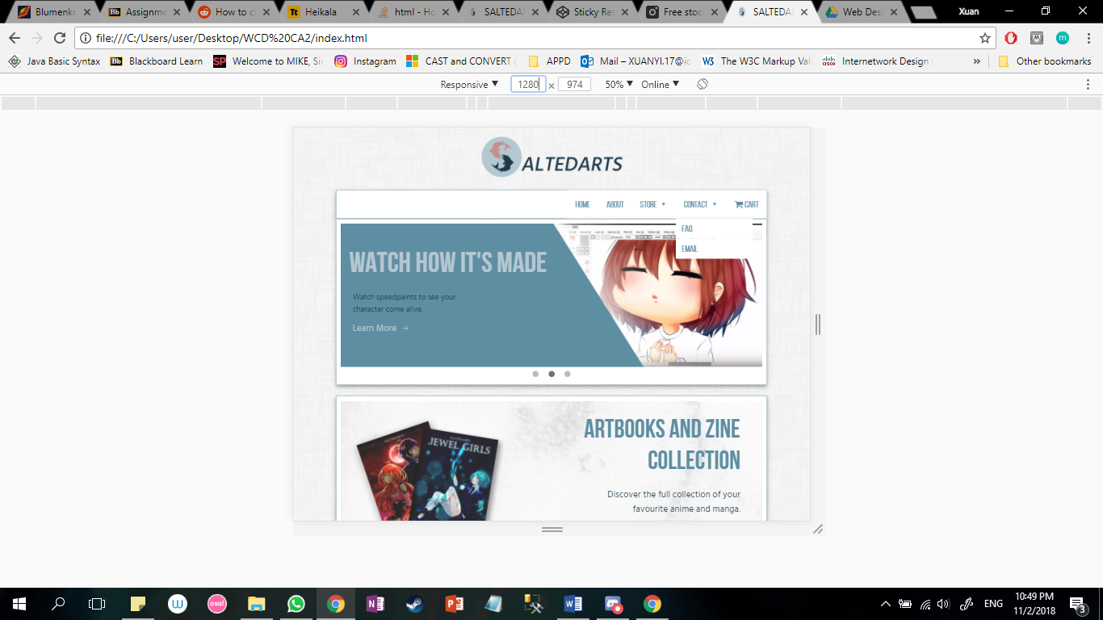

***New design: Pre-loading animation***

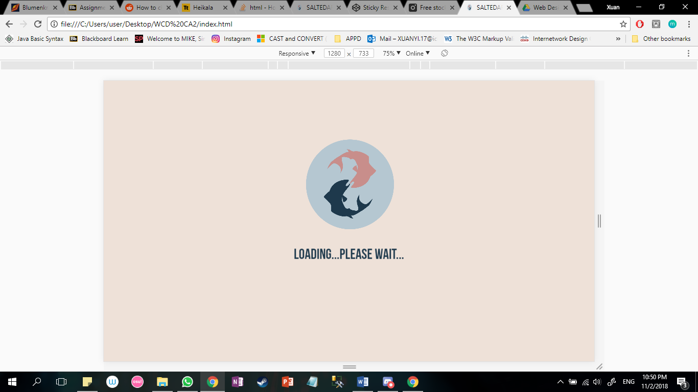

***New design: all items page***

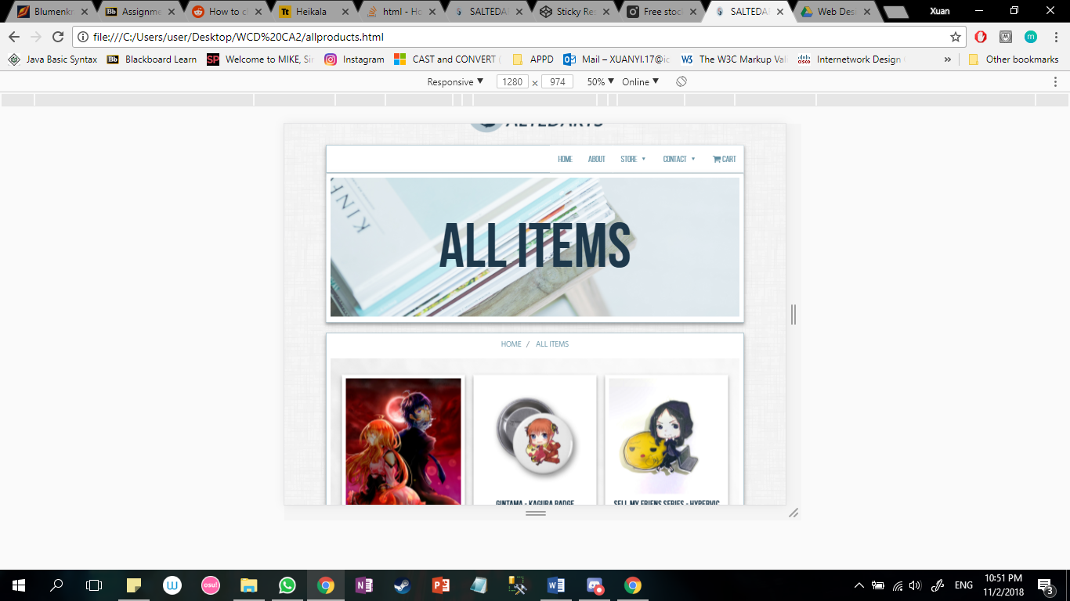

***New design: Product details page***

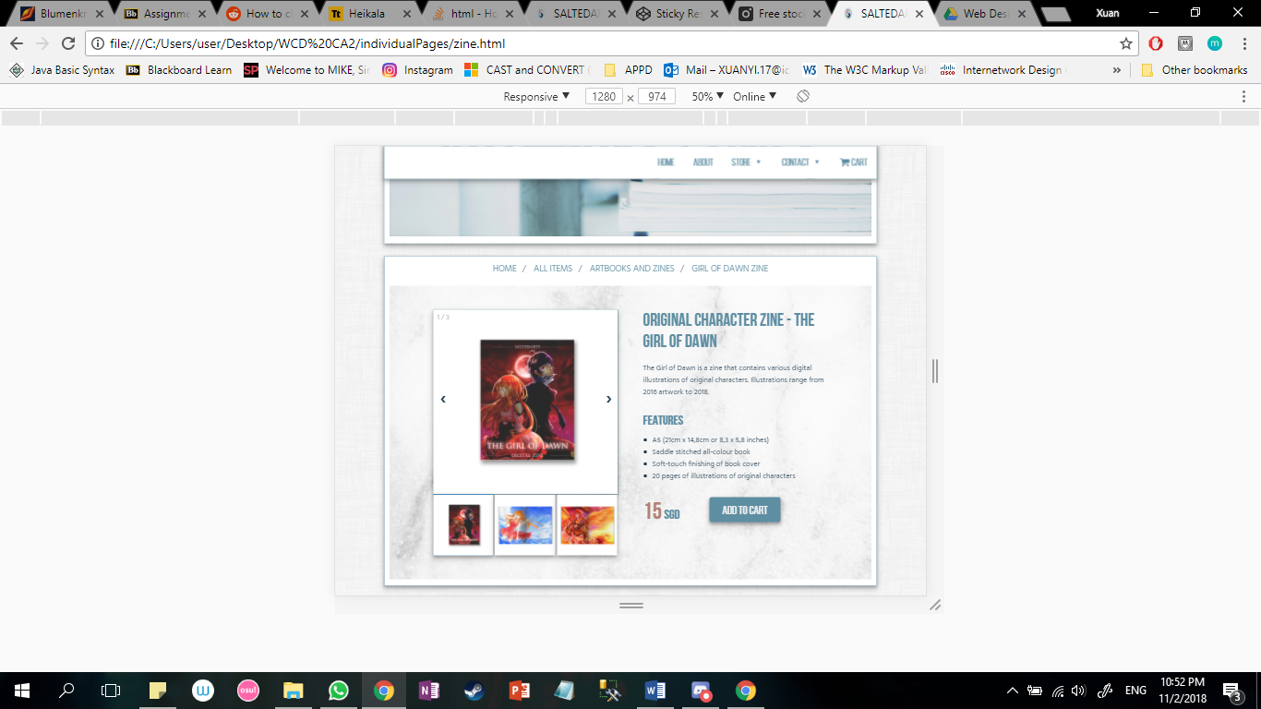

Many features were improved, and functionalities added to the new revamped website:

* Filter function on accessories page, which filters keychains and badges
* Slideshow gallery on the main page which can view slides manually and automatically
* Modal images on product details to show product contents
* Zoom in feature on hovering the product images
* Email and FAQ pages were added for a richer content and user experience
* Shopping cart is implemented with functionality and calculation pure JavaScript
* Responsive design where mobile view is also friendly

# 4. Conclusion

Hence, through this CA, I have learnt many techniques and the fundamentals of web designing, both visual and technical aspect, and how web designing can change a simple, normal website to one that gives viewers a cultural shock experience.