CoinFlip.R

riserate

Fri Apr 21 13:38:12 2017

# Extra Credit  
  
# Import Data  
library(readr)  
cointoss <- read_csv("~/Downloads/data.txt")

## Parsed with column specification:  
## cols(  
## `0` = col_integer()  
## )

# Format data   
cointoss <-unlist(cointoss)  
  
# Number of Heads 1-10  
a <-sum(cointoss[1:10])  
show(a)

## [1] 3

# Number of Heads 1-50  
b <-sum(cointoss[1:50])  
show(b)

## [1] 18

# Number of Heads 1-50  
c <-sum(cointoss[1:150])  
show(c)

## [1] 81

# Install dependencies  
library(RColorBrewer)  
  
#Plot 1  
colors <- brewer.pal(2, "Set1")

## Warning in brewer.pal(2, "Set1"): minimal value for n is 3, returning requested palette with 3 different levels

lik <- function(p) dbinom(n.heads, n.tosses, p)  
n.tosses = 10  
n.heads = 3  
curve(lik, lwd = 2, col = colors[3], xlab = "p", ylab = "likelihood", bty = "l")

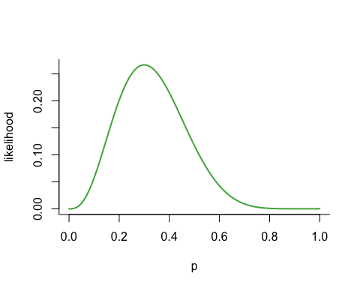

#Plot 2  
colors <- brewer.pal(2, "Set1")

## Warning in brewer.pal(2, "Set1"): minimal value for n is 3, returning requested palette with 3 different levels

lik <- function(p) dbinom(n.heads, n.tosses, p)  
n.tosses = 50  
n.heads = 18  
curve(lik, lwd = 2, col = colors[1], xlab = "p", ylab = "likelihood", bty = "l")

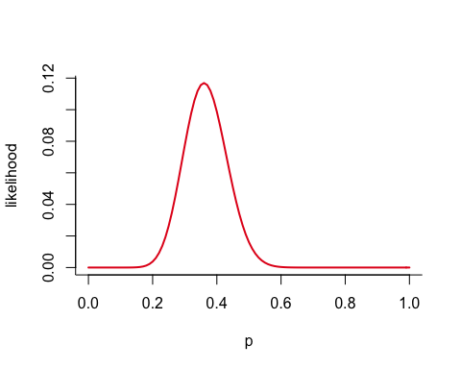

#Plot 3  
colors <- brewer.pal(2, "Set1")

## Warning in brewer.pal(2, "Set1"): minimal value for n is 3, returning requested palette with 3 different levels

lik <- function(p) dbinom(n.heads, n.tosses, p)  
n.tosses = 150  
n.heads = 81  
curve(lik, lwd = 2, col = colors[2], xlab = "p", ylab = "likelihood", bty = "l")

