jumpman.r

***Wed Sep 13 17:08:26 2017***

#load need libraries   
library(readr)   
library(dplyr)

##

## Attaching package: 'dplyr'

## The following objects are masked from 'package:stats':   
##

## filter, lag

## The following objects are masked from 'package:base':   
##

## intersect, setdiff, setequal, union

library(lubridate)

##

## Attaching package: 'lubridate'

## The following object is masked from 'package:base':   
##

## date

library(geosphere)

## Loading required package: sp

library(leaflet)

library(ggplot2)

#import the data set

df <- read.csv("~/r-code/jumpmen/CompanyData.csv",stringsAsFactors = FALSE)

head(df)

## delivery_id customer_id jumpman_id vehicle_type pickup_place

## 1 1457973 327168 162381 van Melt Shop

## 2 1377056 64452 104533 bicycle Prince Street Pizza

## 3 1476547 83095 132725 bicycle Bareburger

## 4 1485494 271149 157175 bicycle Juice Press

## 5 1327707 122609 118095 bicycle Blue Ribbon Sushi

## 6 1423142 75169 91932 bicycle Tamarind TriBeCa

## place_category item_name item_quantity

## 1 American Lemonade 1

## 2 Pizza Neapolitan Rice Balls 3

## 3 Burger Bare Sodas 1

## 4 Juice Bar OMG! My Favorite Juice! 1

## 5 Japanese Spicy Tuna & Tempura Flakes 2

## 6 Indian Dum Aloo Gobi 1

## item_category_name how_long_it_took_to_order pickup_lat pickup_lon

## 1 Beverages 00:19:58.582052 40.74461 -73.99074

## 2 Munchables 00:25:09.107093 40.72308 -73.99462

## 3 Drinks 00:06:44.541717 40.72848 -73.99839

## 4 Cold Pressed Juices 40.73887 -74.00275

## 5 Maki (Special Rolls) 00:03:45.035418 40.72611 -74.00249

## 6 Vegetarian Specialties 00:07:14.327405 40.71927 -74.00875   
## dropoff_lat dropoff_lon when_the_delivery_started

## 1 40.75207 -73.98537 2014-10-26 13:51:59.898924

## 2 40.71972 -73.99186 2014-10-16 21:58:58.65491

## 3 40.72861 -73.99514 2014-10-28 21:39:52.654394

## 4 40.75126 -74.00563 2014-10-30 10:54:11.531894

## 5 40.70932 -74.01587 2014-10-10 00:07:18.450505

## 6 40.72568 -74.00062 2014-10-22 18:56:36.348939

## when_the_Jumpman_arrived_at_pickup when_the_Jumpman_left_pickup

## 1

## 2 2014-10-16 22:26:02.120931 2014-10-16 22:48:23.091253

## 3 2014-10-28 21:37:18.793405 2014-10-28 21:59:09.98481

## 4 2014-10-30 11:04:17.759577 2014-10-30 11:16:37.895816

## 5 2014-10-10 00:14:42.702223 2014-10-10 00:25:19.400294

## 6 2014-10-22 19:18:49.953427 2014-10-22 19:27:10.57897

## when_the_Jumpman_arrived_at_dropoff

## 1 2014-10-26 14:52:06.313088

## 2 2014-10-16 22:59:22.948873

## 3 2014-10-28 22:04:40.634962

## 4 2014-10-30 11:32:38.090061

## 5 2014-10-10 00:48:27.150595

## 6 2014-10-22 19:36:53.801191

*#lets take a look at the data frame*

*#lets check the integrity of the data missing values, etc...*

*#*[*is.na*](http://is.na)*(df) # returns TRUE of data is missing but also print a lot of extra pages*

*#looks like we have some item_quantity values missing*

*#the time stamps where imported as strings we need to convert them to a date format* df$when_the_delivery_started <- ymd_hms(substr(df$when_the_delivery_started,1,19)) df$when_the_Jumpman_arrived_at_pickup <- ymd_hms(substr(df$when_the_Jumpman_arrived_at_p ickup,1,19))

df$when_the_Jumpman_left_pickup <- ymd_hms(substr(df$when_the_Jumpman_left_pickup,1,19)) df$when_the_Jumpman_arrived_at_dropoff <- ymd_hms(substr(df$when_the_Jumpman_arrived_at_ dropoff,1,19))

*#it good to code days like monday, tuesday, etc.. into integers so we can use them numer ical data. We will create new columns and*

*#add the below values.*

df$wday_delivery_started <- wday(df$when_the_delivery_started) df$weekend_delivery_started <- ifelse(df$wday_delivery_started %in% c(1,7),1,0) df$day_delivery_started <- (day(df$when_the_delivery_started))

*#creat time differenc columns for the jumpman timestamps*

df$delivery_time <- difftime(df$when_the_Jumpman_arrived_at_dropoff,

df$when_the_Jumpman_left_pickup,

units="hours")

df$loading_time <- difftime(df$when_the_Jumpman_left_pickup,

df$when_the_Jumpman_arrived_at_pickup,

units="hours")

df$jumpman_arrival_time <- difftime(df$when_the_Jumpman_arrived_at_pickup, df$when_the_delivery_started,

units="hours")

*#delivery distance based off the lat and long to meters*

df$delivery_distance <- 0

for(i in 1:nrow(df))

{

df[i,'delivery_distance'] <- distm(c(df[i,"dropoff_lat"],df[i,"dropoff_lon"]),

c(df[i,"pickup_lat"],df[i,"pickup_lon"]),

fun=distHaversine)/1609.34

}

*#compute the average jumpman speed and put in new column* df$jumpman_avg_speed <- df$delivery_distance/as.numeric(df$delivery_time)

*#calculate average jumpman speed to delivery*

df$jumpman_avg_speed <- df$delivery_distance/as.numeric(df$delivery_time)

*#lets retreive the distinct values and discard the rest*df_unique <- df %>% distinct(delivery_id, .keep_all = TRUE)

*#weekend vs weekday by dropoffs*

leaflet() %>% setView(-73.972887,40.732828,zoom=12) %>% addTiles() %>% addProviderTiles(providers$CartoDB.Positron) %>%

addCircleMarkers(data=subset(df_unique,weekend_delivery_started==0),

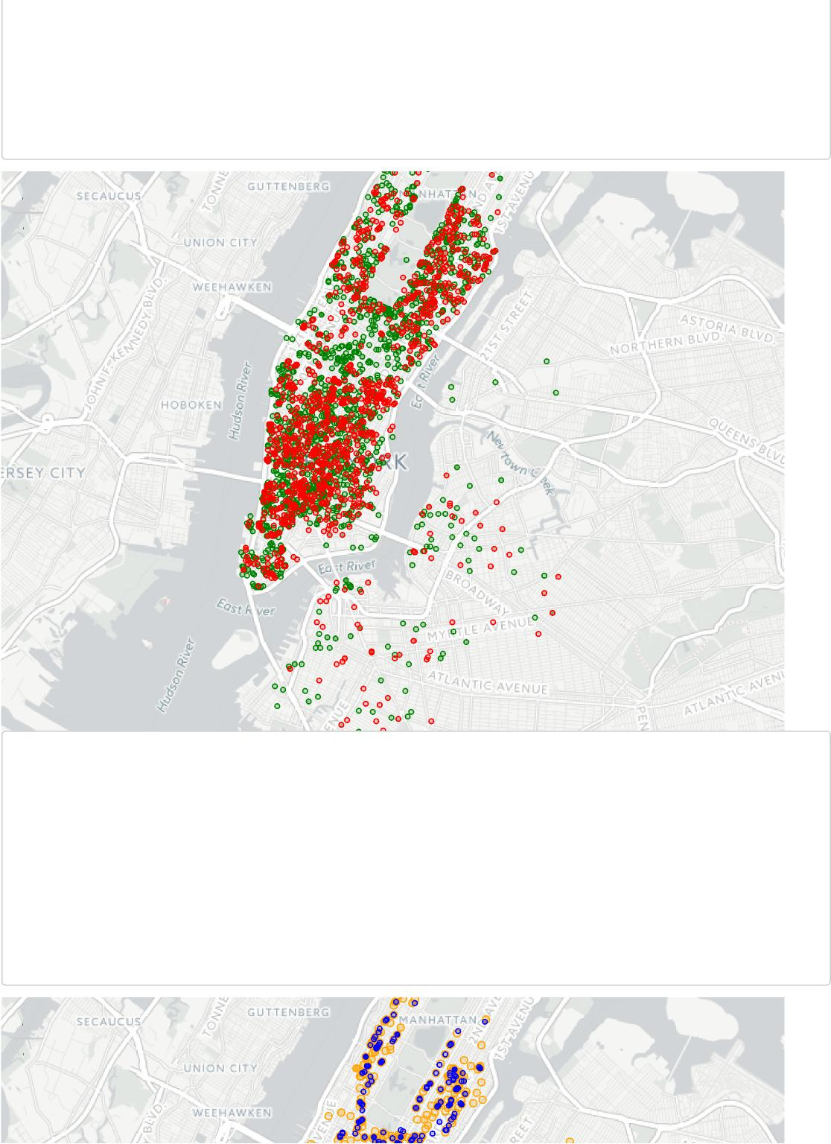

**+**

**-**

Leaflet (<http://leafletjs.com>) | © OpenStreetMap (<http://openstreetmap.org>) contributors, CC-BY-SA

Weekend

Weekday (<http://creativecommons.org/licenses/by-sa/2.0/),> © OpenStreetMap (<http://www.openstreetmap.org/copyright)> © CartoDB

(<http://cartodb.com/attributions)>

lat=~dropoff_lat,lng=~dropoff_lon,weight=1,radius=2,opacity=1,color="Green") %>% addCircleMarkers(data=subset(df_unique,weekend_delivery_started==1),

lat=~dropoff_lat,lng=~dropoff_lon,weight=1,radius=2,opacity=1,color="Red") %>%

addLegend("bottomleft",colors =c("Red", "Green"),labels= c("Weekend","Weekday"),opacit y = 1)

#weekend vs weekday by pickup

leaflet() %>% setView(-73.972887,40.732828,zoom=12) %>% addTiles() %>% addProviderTiles(providers$CartoDB.Positron) %>% addCircleMarkers(data=subset(df_unique,weekend_delivery_started==0), lat=~pickup_lat,lng=~pickup_lon,weight=1,radius=3,opacity=1,color="Or

ange") %>%

addCircleMarkers(data=subset(df_unique,weekend_delivery_started==1),

lat=~pickup_lat,lng=~pickup_lon,weight=1,radius=2,opacity=1,color="Bl

ue")%>%

addLegend("bottomright",colors =c("Blue", "Orange"),labels= c("Weekend","Weekday"),opa

city = 1)

**+**

**-**

*#unique number of customers*

paste(length(unique(df_unique$customer_id))," Unique Customers")

## [1] "3192 Unique Customers"

ggplot(data.frame(as.vector(table(df_unique$customer_id)))) + geom_histogram(bins=30,aes(x=as.vector.table.df_unique.customer_id..))+ ggtitle("Customer Order Frequency - Histogram")+ xlab("Orders/Customer")+

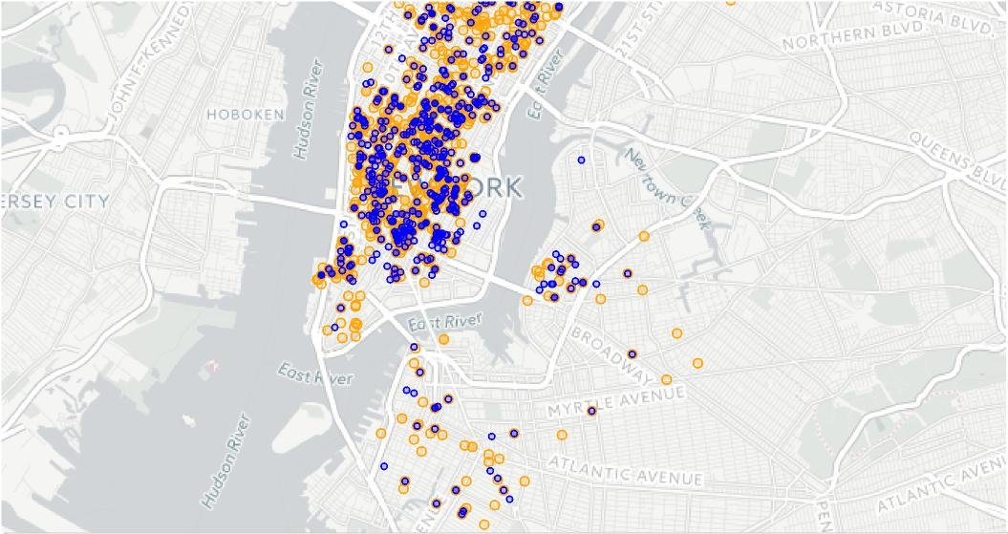

Leaflet (<http://leafletjs.com>) | © OpenStreetMap (<http://openstreetmap.org>) contributors, CC-BY-SA (<http://creativecommons.org/licenses/by-sa/2.0/),> © OpenStreetMap (<http://www.openstreetmap.org/copyright)> © CartoDB (<http://cartodb.com/attributions)>

Weekend Weekday

ylab("Number of Customers") + theme_light()

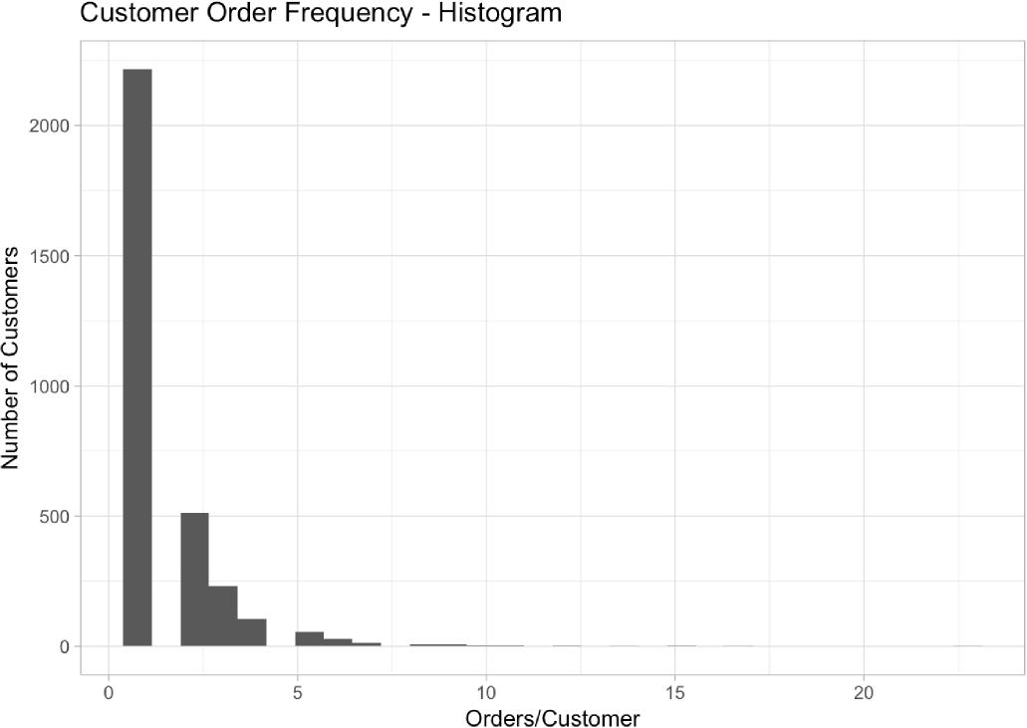

*#vehicle usage*

ggplot(df_unique,aes(x=vehicle_type, 1,group=1)) +

stat_summary(fun.y = sum,geom = "bar")+

ggtitle("Number of Deliveries by Vehicle Type")+

xlab("Vehicle Type")+ylab("Number of Deliveries") + theme_light()

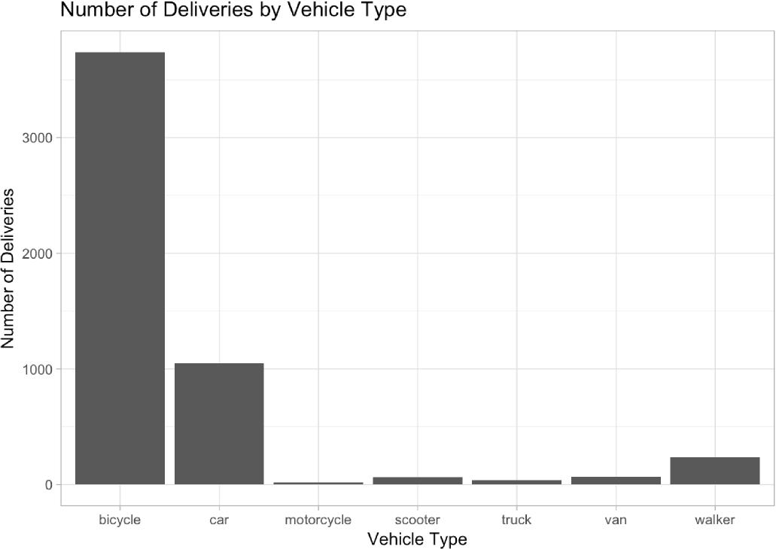

#vechile usage by days of the week

ggplot(df_unique,aes(x=wday(when_the_delivery_started,label=T), 1,group=vehicle_type,col

or=vehicle_type)) +

stat_summary(fun.y = sum,geom = "line",size=.5)+

ggtitle("Vehicle usage by Days of the Week")+

xlab("Days of the Week")+ylab("Number of Deliveries") + theme_light()

|  |
| --- |
| *#range of dates deliver start*  paste("Dates range from ",  min(df_unique$when_the_delivery_started),  " to ",  max(df_unique$when_the_delivery_started)  ) |

## [1] "Dates range from 2014-10-01 00:07:58 to 2014-10-30 23:08:43"

*#customers acquired*

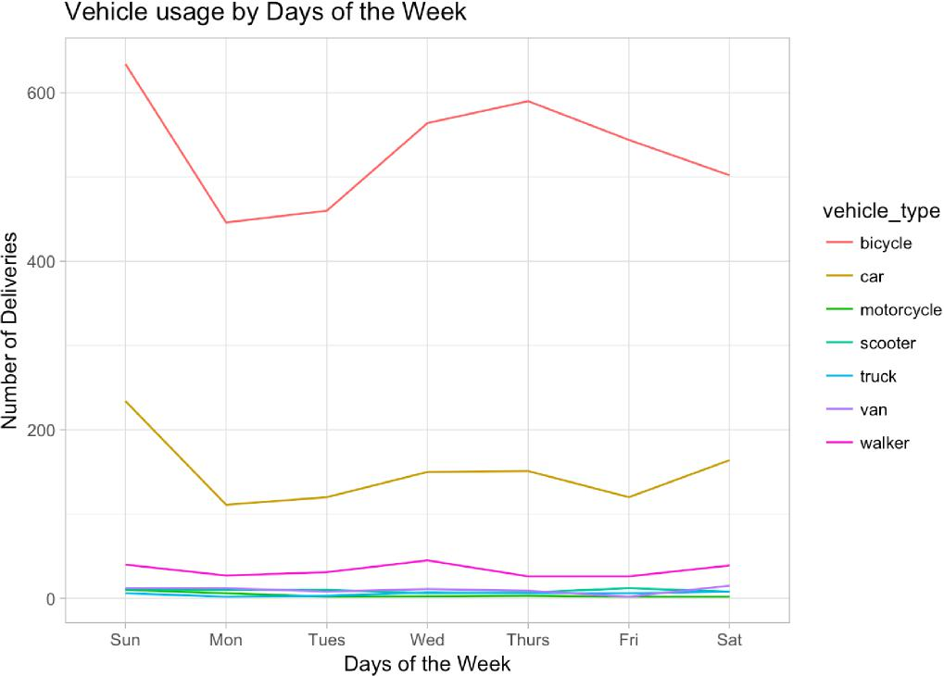

cust_acq <- df_unique %>%

group_by(customer_id) %>%

summarise(first_day=min(day(when_the_delivery_started)))

ggplot(cust_acq,aes(x=first_day,y=1)) +

stat_summary(fun.y=sum,geom="line", colour= "blue") +   
ggtitle("Number of New Customers Acquired per Day")+   
ylab("Number of Customers")+

xlab("Days in October 2014") + theme_light()

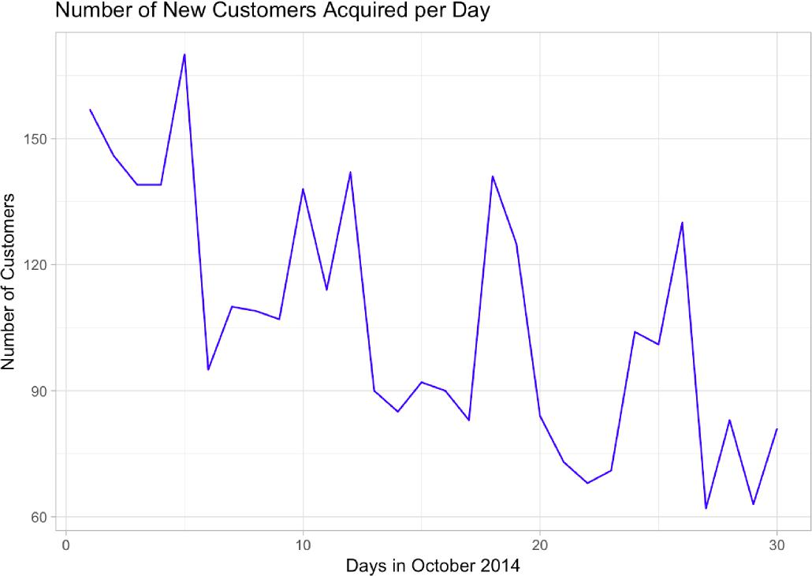

*#delivery trends*

ggplot(df_unique,aes(x=wday(when_the_delivery_started,label=T), 1,group=1)) + stat_summary(fun.y = sum,geom = "line", colour= "blue")+ ggtitle("Deliveries by Days of the Week")+

ylab("Number of Deliveries")+xlab("Days of the Week") + theme_light()

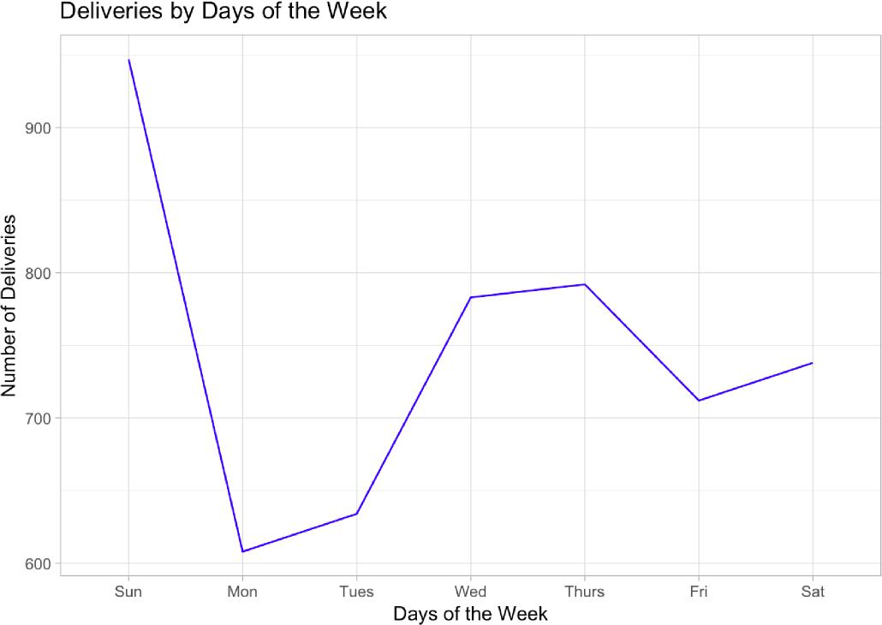

|  |
| --- |
| *#delivery time by day of the week*  ggplot(df_unique,aes(x=vehicle_type,y=delivery_time))+  geom_tile()+  ggtitle("Delivery Time variation across Vehicle Types")+  xlab("Vehicle Types")+ylab("Delivery Time (Hours)") + theme_light() |

## Don't know how to automatically pick scale for object of type difftime. Defaulting to continuous.

## Warning: Removed 495 rows containing missing values (geom_tile).

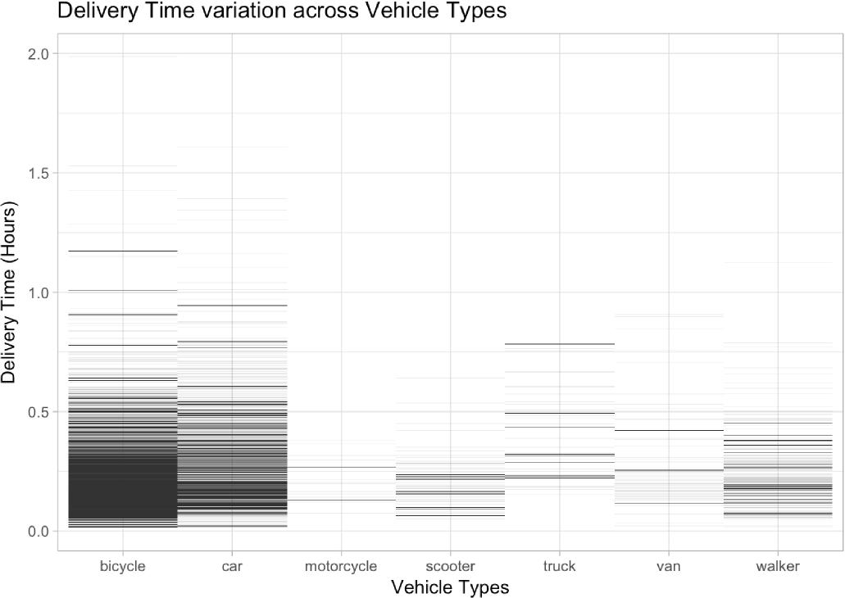

|  |
| --- |
| *#jumpman arrival by day of the week*  ggplot(df_unique,aes(x=wday(when_the_delivery_started,label=T),y=delivery_time))+  geom_tile()+  ggtitle("Loading Time variation across Days of the Week")+  xlab("Days of the Week")+ylab("Delivery Time") + theme_light() |

## Don't know how to automatically pick scale for object of type difftime. Defaulting to continuous.

## Warning: Removed 495 rows containing missing values (geom_tile).

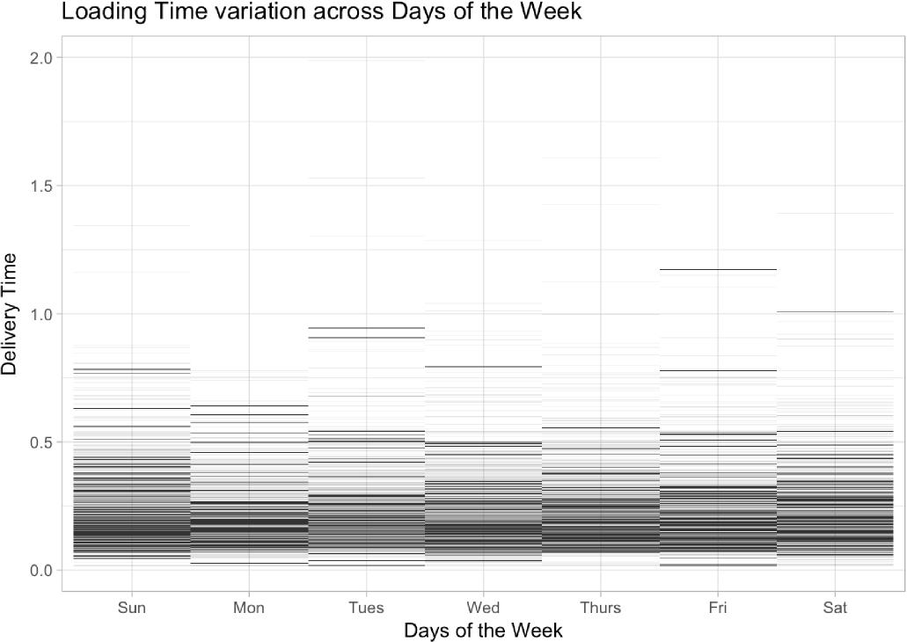

|  |
| --- |
| ggplot(df_unique,aes(x=vehicle_type,y=loading_time))+  geom_tile()+  ggtitle("Loading Time variation across Vehicle Types")+  xlab("Vehicle Types")+ylab("Loading Time (Hours)") + theme_light() |

## Don't know how to automatically pick scale for object of type difftime. Defaulting to continuous.

## Warning: Removed 495 rows containing missing values (geom_tile).

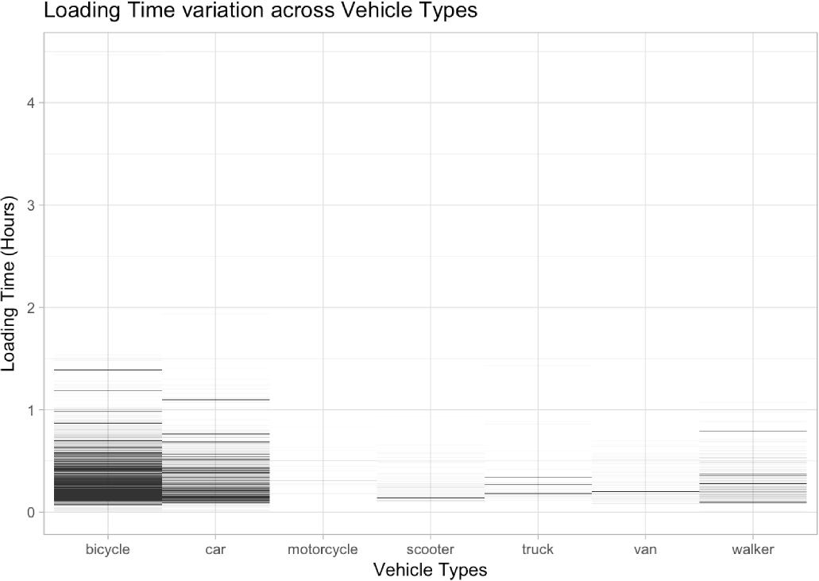

ggplot(df_unique,aes(x=vehicle_type,y=delivery_distance))+

geom_boxplot()+

ggtitle("Delivery Distances by Vehicle Type")+

xlab("Vehicle Type")+

ylab("Distance (Miles)") + theme_light()

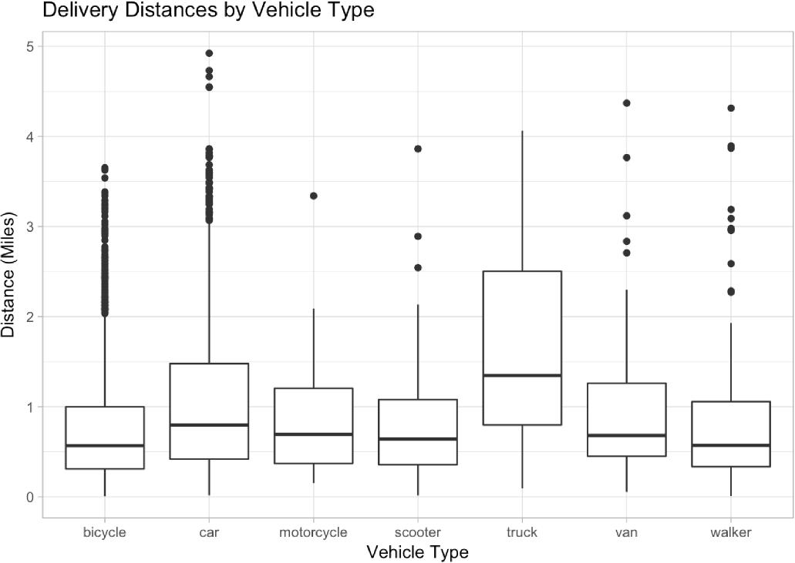

|  |
| --- |
| ggplot(df_unique,aes(x=vehicle_type,y=jumpman_avg_speed))+  geom_boxplot()+  ggtitle("Average Delivery Speed by Vehicle Type")+  xlab("Vehicle Type")+  ylab("Speed (MPH)") + theme_light() |

## Warning: Removed 495 rows containing non-finite values (stat_boxplot).

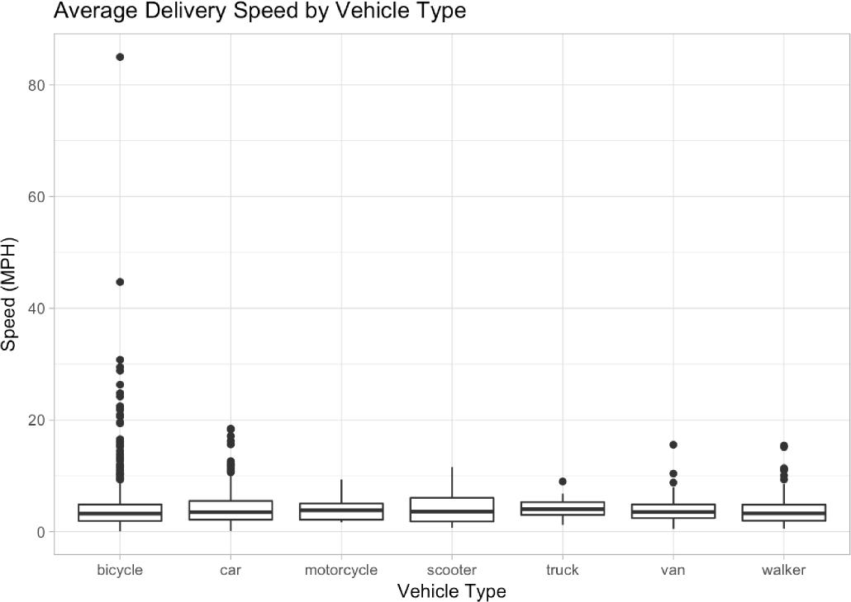

|  |
| --- |
| ggplot(df_unique,aes(x=vehicle_type,y=jumpman_avg_speed))+  geom_boxplot()+  ggtitle("Average Delivery Speed by Vehicle Type")+  xlab("Vehicle Type")+  ylab("Speed (MPH)")+ylim(0,20) + theme_light() |

## Warning: Removed 508 rows containing non-finite values (stat_boxplot).

Average Delivery Speed by Vehicle Type

20

15



I

•

•

i

•

•

•

$

i   
I

•

!

-

5

-

bicycle car motorcycle scooter

1   
truck

Vehicle Type

van walker