**App User Guide**

**Petrol Station Simulation**

Synopsys:

Use our exciting Petrol Station Application to simulate working activity on a petrol station and track results!

User Guide:

Upon opening and application, user is presented four menu options: “Run Petrol Station”, “Read transactions”, “Read counters”, “Exit”. Pic. 1 below demonstrates the menu:

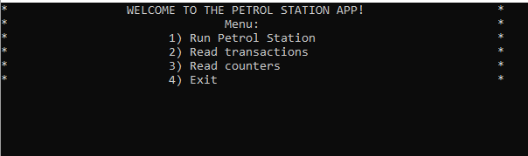

Pic. 1: *Menu*

**Option “Run Petrol Station”**

Picking the first option “Run Petrol Station” by keyboard enter 1 into the console, the application will prompt user to enter valid folder path where all transaction receipts will be written and saved. Here, valid folder path means an existing folder path that allows to open and write into it. Recommendation: it is simpler to copy full directory path and paste it into the console. After input, press Enter key. Pic. 2a below shows an example of input that is valid. Pic. 2b shows the console after pressing Enter. User presses Enter again.

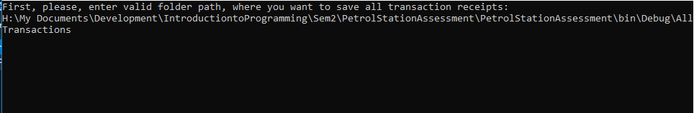

Pic. 2a: *Folder path input*

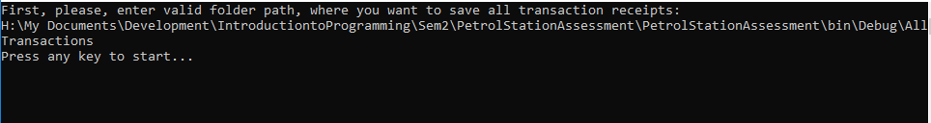

Pic. 2b: *Folder path input*

User presses Enter again.

Next, display shows text “Loading…”

On the display user sees “Vehicles Queue” queue of vehicles, “Pumps Status” pumps and their current statuses, and “Counters status”current statuses of counters to track. Pic. 3a below shows the petrol station simulation example snapshot.

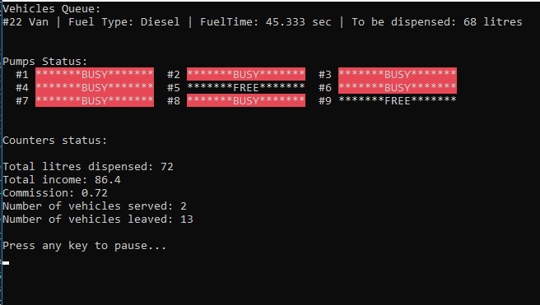

Pic. 3a: *Petrol Station simulation on display*

To pause user presses any key. Pic 3b below shows paused snapshot of the simulation.

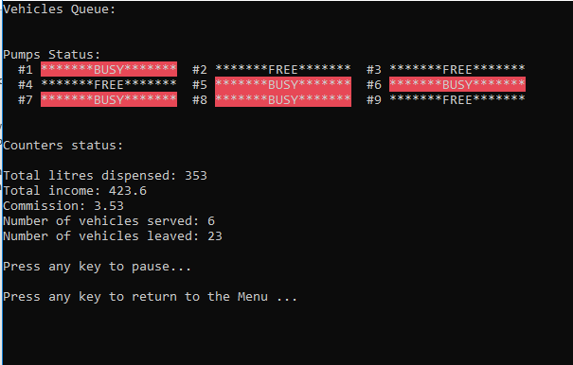

Pic. 3b: *Petrol Station simulation on display*

To return to the Menu user presses any key. However, on the background, petrol station continues to run.

**Option “Read transactions”**

Picking second option “Read transactions” by entering 2 into the console will lead user to next screen that will display all transactions at the current moment. Pic. 4 shows an example of how transactions list looks like on the display.

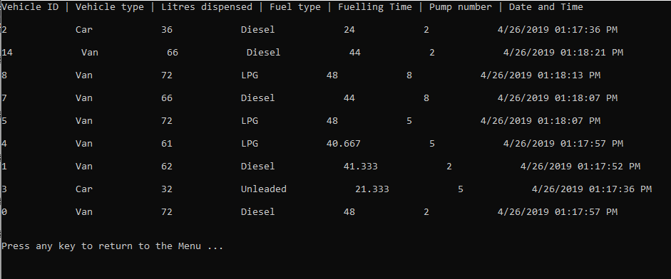

Pic. 4a: *Transactions list on display*

To return to the menu, user presses any key.

If user tries to see transactions, while petrol station simulation have not been started, no transactions will be displayed. Pic. 4b shows how an empty transactions list would look like.

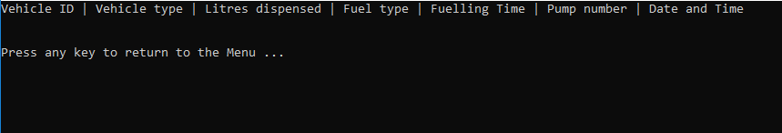

Pic. 4a: *Empty transactions list on display*

**Option “Read counters”**

Picking third option “Read counters” will show user current statuses of all necessary counters it might be useful to track .Pic 5 below shows an example of how counters statuses are displayed.

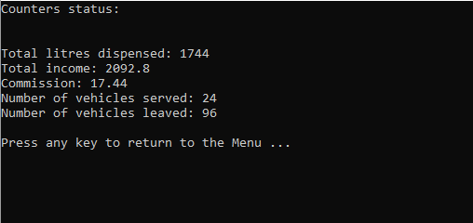

Pic. 5: *Counters status on the display*

To return to the menu, user presses any key.

If user tries to see counters information, while petrol station simulation have not been started, all of the counters will be set to zero.

**Option “Exit”**

Pick last option “Exit” will ask you to press any key to exit. After pressing, the application will close. Pic. 6 below demonstrates how exiting works. Press any key and the application will close.

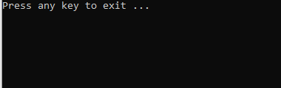

Pic. 6: *Exiting*