

Introduction to Programming
Software Project Report
SID:1813025

MOD003212

Submitted: May 2019
Table of Contents
1. Overview 3
2. App User Guide 4
3. Class Diagram 5
4. Program class 6
5. Data class 7
6. Display class 8
7. Pump class 9
7. Inheritance: Vehicle, Car, Van, HGV 9
7. Counters and Transactions 9
References 10

Overview

This report includes documentation and explanation of the software project development process.
Accourding to Assessment Secification, this project has Very High Level Functionality. In addition to standard functionality, Menu functionality, reading and writing to and from .csv files, basics of Systems.Threading library, and slightly enhanced User Interface were implemented. All of the details are described below.

Pseudocode

This section includes the pseudocode of the software project to demonstrate high level overview of the program logic.
Main method:
Call method RunMenu()
Program class:
RunMenu(){
do{
boolean variable exit assigned false
get user input;
try to parse user input;
switch(user input)
case: user input equals 1
{
call method RunPetrolStation()
break;
}
case: user input equals 2
{
call method ReadTransactions()
break;
}
case: user input equals 3
{
Call method that Displays counters;
break;
}

case: user input equals 4
{
exit assigned true;
break;
}
}while(exit is assigned false)
method RunPetrolStation(){
Create a thread that initializes and manages vehicles;
Start the sthread;
Call method PumpProcessing()
Call method UIProcessing()
}
method PumpProcessing(){

}
method UIProcessing(){

}
Method ReadTransaction(){

Data class:
Method AssingnVehicleTOPump(){
local variable v representing vehicle class;

Class Diagram

This section includes the Class Diagram and its description.

Program class

This section includes the Sequence Diagrams and their description.

Data class

This section includes the Activity Diagram and its description.

Display class

This section includes the State Diagram and its description.

Pump class

This section includes the Entity Relationship Diagram and its description.

Inheritance: Vehicle, Car, Van, HGV

Counters and Transactions

App User Guide
Synopsys:
Use our exciting Petrol Station Application to simulate working activity on a petrol station and track results!
User Guide:
Upon opening and application, you will be presented four menu options: “Run Petrol Station”, “Read transactions”, “Read counters”, “Exit”. Pic. X below demonstrates the menu:
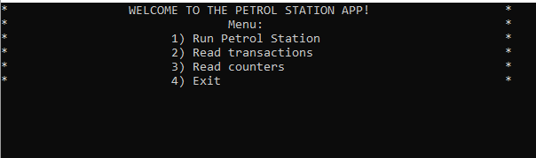
Pic. X: Menu
Picking the first one “Run Petrol Station” by entering 1 into the console, the application will run petrol station. On the display you will see queue of vehicles, pumps and their current statuses, and current statuses of counters to track. Pic. X below shows the petrol station simulation example snapshot.
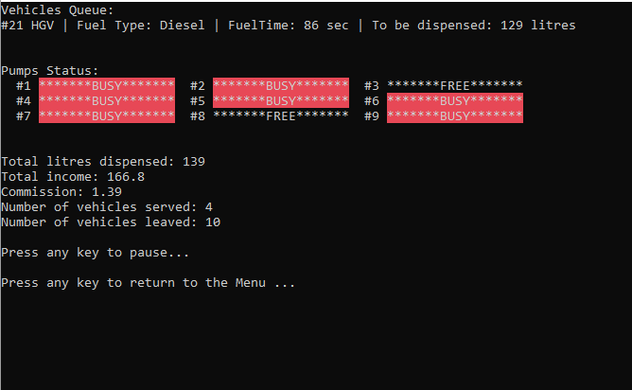
Pic. X: Petrol Station simulation on display
By pressing any key, you will pause the simulation. However, on the background, petrol station continues to run. Next, by pressing any key, you will turn back to the menu.
Picking second option “Read transactions” by entering 2 into the console will lead you to next screen that will display all transactions at the current moment. If you try to see transactions, while petrol station simulation have not been started, no transactions will be displayed. Pressing any key will return you to the menu options. Pic. X below shows an example of how the display with transactions looks like.
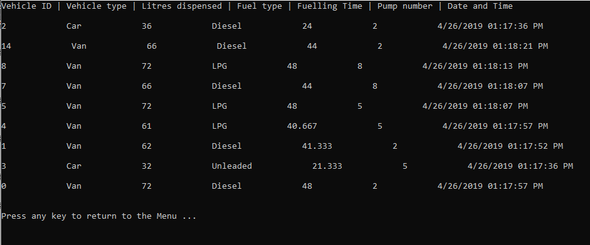
Pic. X: Transactions display
Picking third option “Read counters” will show you current statuses of all necessary counters you might want to track. Again, pressing any key will turn you back to the menu.Pic X below shows how transactions are displayed.
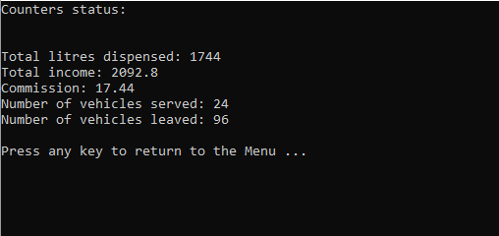
Pic. X: Counters status
Pick last option “Exit” will ask you to press any key to exit. After pressing, the application will close. Pic.X below demonstrates how exiting works.
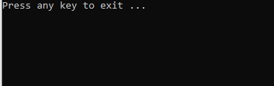
Pic. X: Exiting

References

Berndtsson, M., Hansson, J., Olsson, B. and Lundell, B., 2006. Planning and Implementing your Final year project – with Success!: A Guide for Students in Computer Science and Information Systems. Springer.
Bock, P., 2001. Getting It Right. R&D Methods for Science and Engineering. Academic Press.
Burke, R., 2004. Project Management – Planning and Control Techniques. Wiley.
Cornford, T. and Smithson, S., 2005. Project research in Information Systems: A Student’s Guide. Palgrave Macmillan.
Dawson, C. W., 2009. Projects in Computing and Information Systems: A Student’s Guide. Addison Wesley.
Depoy, E., 2010. Introduction to Research: Understanding and Applying Multiple Strategies. Mosby.
Hakim, C., 2000. Research design: Successful designs for Social Economic Research. Routledge.
Trauth, E. M., 2001. Qualitative Research in IS: Issues and Trends. IGI Publishing.
Yin, R. K., 2008. Case Study Research: design and Methods. Sage publications.

